Seventh Annual Meetings of the Boards of Governors of the WBG and IMF, Mexico City, Sept. 1952

January 2016
number 066
originally published: October 2009
The World Bank Group Archives Exhibit Series contains exhibits originally published on the Archives’ external website beginning in 2002. When the Archives’ website was transferred to a new platform in 2015, it was decided that older exhibits would be converted to pdf format and made available as a series on the World Bank’s external database, Documents & Reports.

These exhibits, authored by World Bank archivists, highlight key events, personalities, and publications in the history of the World Bank. They also bring attention to some of the more fascinating archival records contained in the Archives’ holdings.

To view current exhibits, visit the Exhibits page on the Archives’ website.

Seventh Annual Meetings of the Boards of Governors of the WBG and the IMF, Mexico City, September 1952
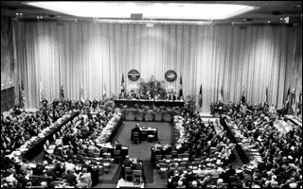
The Boards of Governors of the International Monetary Fund and the World Bank Group meet once a year in the fall to discuss the work of their respective institutions. Following the established tradition to meet in a member country every third year, the 2009 Annual Meetings take place in Istanbul, Turkey on September 6-7, 2009.
Seventh Annual Meetings participants at the session, Mexico City, September 1952
The 7th Annual Meetings were held in Mexico City, Mexico on September 3-12, 1952 under the chairmanship of the Honorable Horacio Lafer, Minister of Finance of Brazil. The Opening Session of the Meetings of the Boards of Governors of the Bank and Fund took place in the Palace of Fine Arts in Mexico City.

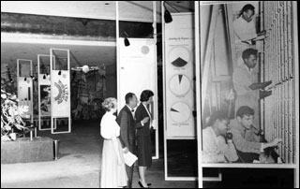
The President of Mexico, Miguel Aleman, addressed members of the Boards and the public to begin conference’s proceedings. "The care which the Bank authorities take, in the study of every project that is submitted to them, with regard to its social purpose as well as to its economic productivity and technical convenience, is a guarantee that the loans the Bank allows will never prove to be a heavy charge for the peoples that receive them as was the case in other epochs when the investing countries granted loans, to cover budget deficits or for destructive ends, that carries in themselves the uncertainty of fulfillment on the part of the debtor country." (From the Address by the President of Mexico, Miguel Aleman, September 3, 1952)
Seventh Annual Meetings participants attend the exhibit, Mexico City, September 1952
The Minister of Finance of Brazil, Horacio Lafer, who presided over the Annual Meetings continued the session with the speech about the world problems challenging Bank and Fund. He talked about the persistent inflation, the rapid growth in world population, and the widespread balance of payments disequilibrium affecting many countries.
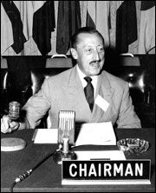
"As for the International Bank, I do not regard its mission as encompassed within the narrow definitions of reconstruction and development: its mission is ever broadening in scope. No institution is better placed to meet the long run challenge of increasing the food production and distribution for a rapidly growing world population... The great contribution that the Bank can make to all member countries is to combine sound banking principles with a creative effort to help in the world development of transportation, electric power and food production." (From the Address of Horacio Lafer, Chairman of the Board of Governors of the Bank, at the Opening Session, September 3, 1952)
Horacio Lafer, Chairman of the Board of Governors of the Bank, September 1952

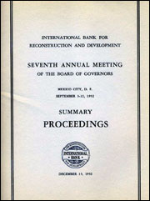
The meeting agenda included:
Summary Proceedings of the Seventh Annual Meetings, Mexico City, September 3-12, 1952
- Seventh Annual Report
- Financial Statements and Annual Audit
- Administrative Budget for Fiscal Year Ending June 30, 1953
- Allocation of Income to Reserve
- Regulations Relating to Executive Directors and Alternates
- Fourth Regular Election of Executive Directors
- Application of Republic of Indonesia for Membership in the Bank
- “Draft Resolution to be submitted by the Governor for Czechoslovakia Proposing Exclusion of the Kuomintang Group from All Organs of the Bank”
- Place and Date of Eighth Annual Meeting
- Election of Officers and Procedures Committee for 1952-53

