Report 78678 - ME

MONTENEGRO
gender diagnostic: gaps in endowments, access to economic opportunities and agency

June 2013
Poverty Reduction and Economic Management Unit
Europe and Central Asia Region



Document of the World Bank

ABBREVIATIONS AND ACRONYMS
AIDS Acquired Immune Deficiency Syndrome
APAGE Action Plan for Achieving Gender Equality
BEEPS Business Environment and Enterprise Performance Survey
CEDAW Convention on the Elimination of All Forms of Discrimination against Women
ECA Europe and Central Asia
HIV Human Immunodeficiency Virus
LFS Labor Force Survey
LiTS Life in Transition Survey
MONSTAT Montenegrin Statistical Office.
NBS National Bureau of Statistics
NHS National Health Survey
NGOs Non Governmental Organizations
OECD Organization for Economic Co-operation and Development
PPP Purchasing Power Parity
R&D Research and Development
PISA Program for International Student Assessment
UNDP United Nations Development Programme
UNFPA United Nations Population Fund
UNICEF United Nations Children's Fund
USAID United States Agency for International Development
WDI World Development Indicators
WDR World Development Report
WHO World Health Organization

Table of Contents
Acknowledgements 4
Executive summary 5
1. Introduction 7
2. Endowments 10
2.1 Education 10
2.2 Health 16
2.3 Assets, credit, and savings 19
2.3 Summary 21
3. Economic opportunities 22
3.1 Labor participation 22
3.2 Unemployment 29
3.3 Types of employment 32
3.4 Gender differences in wages 35
3.5 Entrepreneurship 42
3.6 Summary 46
4. Agency 48
4.1 Moving toward a fuller analysis of agency 51
4.2 Summary 59
5. Conclusion 61
6. Bibliography 64
Appendix 1: Data Analysis 70

Acknowledgements

This report was produced by Yumna Omar and Brandon Vick (consultants) as part of the Gender in the Western Balkans Programmatic Work (TTL: Maria E. Dávalos). The team would like to thank the peer reviewers Elizaveta Perova and Jan Rutkowski, as well as Ana Maria Munoz Boudet, for their useful suggestions.

Executive summary

Montenegro has made strides in promoting equality between men and women, but gender disparities still exist. In certain cases, such gender differences highlight barriers to wellbeing for a particular group. For instance, females live longer than males while male workers earn more than females, on average. The Government of Montenegro has made progress in bringing attention to gender issues through measures such as instituting the Department of Gender Equality and Gender Equality Offices and the creation of the Action Plan for Achieving Gender Equality. Nonetheless, significant gender inequalities remain. Key areas of concern are (i) agency, including violence against women and a lack of female representation in leadership; (ii) gender gaps in access to economic opportunities; and (iii) low educational attainment for particular population groups. Analysis undertaken for this gender assessment provides additional insights into gender gaps in Montenegro.

Agency. Significant gender gaps persist in agency. Evidence suggests that violence against women is a pervasive problem but goes widely unreported in Montenegro. Better data is needed in order to gauge the full extent of the problem. Women are poorly represented at all levels of government. For example, in 2011, only 31 percent of legislators, senior officials, and managers and 11 percent of representatives in Parliament were women. Only 2 of the 17 ministers and 26 percent of the directors in the Government of Montenegro were female. Men also hold more leadership positions in the media and there are perceptions that the media reinforces gender stereotypes.

Health. Key health indicators for Montenegro suggest a number of substantial gender gaps in this area, namely a five-year life expectancy gap that favors women. Both female and male life expectancies are falling further below EU averages. Adolescent fertility rates are moving towards the EU average. However, only 33 percent of women report regular gynecological checkups and there is wider concern that women do not engage in preventative health care. However, nearly all pregnant women (97% in 2006) receive prenatal care. Maternal mortality is low, it is estimated that 8 women per 100,000 live births died during pregnancy and childbirth in 2010; this is below the regional ECA average of 20. Little is known regarding men’s use of preventative health care. Utilization of preventative care, psychological distress, and domestic violence are areas of concern for female wellbeing in Montenegro. Higher rates of alcohol abuse, higher smoking rates, and risky sexual behavior are issues particular to men.

Access to economic opportunities. Male and female labor force participation is low compared to other countries in the region, while the gender gap in participation is relatively large. Fifty-two percent of women and 64 percent of men aged 15-64 participate in the labor force in Montenegro. Much of the inactivity gap is explained by large gender disparities experienced by rural people. Economic inactivity is especially high among women with primary schooling or less, ethnic minorities, and older women. Overall, women spend more time caring for their families and children, which contributes to reducing their opportunities to participate in the labor market in the absence of alternative childcare options. There is little difference between male and female unemployment rates in Montenegro (21 percent and 19 percent respectively), but high rates of unemployment occur among younger workers (of individuals 15-24 years, 51 percent of females and 43 percent of males). Both male and female workers experience high rates of long-term unemployment. Among those who work, a clear wage gap exists, with women earning 16 percent less than men. This gap is not explained by workers’ characteristics (e.g., education and experience) but rather by unobserved factors, of which discrimination may play a role. Finally, women self-employ less and have lower rates of firm ownership and management.
Education. On average, Montenegro has achieved gender equality in school enrollment. However, in terms of educational attainment, gender disparities exist for some population subgroups. In particular, gender gaps in educational attainment are higher among the following groups: 1) those not in the labor force – suggesting that the lack of education might represent a barrier to jobs; 2) people of non-Montenegrin nationality; and, 3) people in rural areas. Tertiary enrollment, in turn, has grown rapidly in the past decade. However, a large gender gap exists with significantly lower enrollment for men: 2010 enrollment rates were 53 percent for women and 43 percent for men. There is evidence of gender segregation in fields of study – with potential impact on labor market outcomes. Male graduation is more focused toward mathematics-, engineering-, and science-related fields than female graduation. The preferences and constraints that potentially affect gender differences in educational decisions are discussed.

Policy. Policy to address the gender issues of most concern to human wellbeing in Montenegro should be based on greater research in the following areas: (1) measuring and reducing violence against women; (2) identifying and remedying barriers to equality which relate to lower female labor force participation, earnings, and the attainment of leadership positions; (3) addressing disparities for particular to subgroups of the female population, like low primary education attainment among non-Montenegrin and rural women and poor health among Roma females; and (4) addressing the low use of preventative health care and high reported incidences of psychological distress among both men and women. Additionally, a number of differences in gender outcomes require further study, including a) the reasons for higher tertiary education enrollment among women (and the potential long-term implications of this); b) the factors related to gender differences in field of study and occupation; and c) the factors underlying the high long-term employment rates for both male and female workers. Research for this report suggests that there is a lack of NGO’s working on issues focusing on men, including increased suicide cases, poor health and psychological problems. Data on the prevalence of these men’s issues and measures to address them is needed.

1. Introduction

Montenegro is currently adjusting from the financial crisis, which has left it and other Balkan countries in what has been called a double dip recession (WB, 2012c). It is estimated that if Montenegro's historical growth rates are increased by 1-1.5 percent it will take at least 25 years for its income to converge with that of EU-27 members (WB, 2012h, p. 58). Currently, Montenegro's accession to the EU is a priority for the country. Growth strategies that focus on exports, the tourism-agriculture-energy value chain and information and communication technology industries have been proposed and the importance of improvements in knowledge, skills and education for productivity advances highlighted (WB, 2012h). Equitable growth, however, calls for a better understanding of the socio-economic issues that impact gender inequality. In 2011, women and girls represented 50.6% of the total Montenegrin population (620,029 persons). Figure 1 provides a breakdown of the female and male population by age. Different aspects of gender inequality vary by region and ethnicity.
Figure 1 Population by gender and age group, based on census 2011
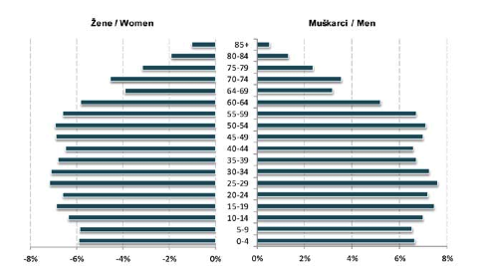
Source: MONSTAT (2012, p. 12).

The purpose of this report is to provide an overview of gender inequality in Montenegro. Using a number of data sources, gender differences in various outcomes are analyzed with the intention of highlighting gender inequalities in human wellbeing. Results are used to prioritize possible avenues for future research to better understand such inequalities and/or suggest areas that require more focus from policymakers. This report operates under the premise that gender equality is both an issue of human rights and of critical economic consequence. Gender equality is important in and of itself as an issue that affects human development and wellbeing across many dimensions of life. Moreover, equality has the potential to furnish economic improvement in several areas: productivity, through the proper utilization of men’s and women’s skills; wellbeing of future generations, through cumulative increases in human capital; and institutions and policies, through increased diversity of viewpoints and voice to issues of governance. In line with the WDR 2012, the nomenclature of gender gaps in endowments, access to economic opportunities and agency will be used to elaborate upon these arguments and their relevance to Montenegro.
The findings of this diagnostic suggest that there are gender gaps in Montenegro, particularly in (i) agency, although available data in this area is limited; (ii) access to economic opportunities; and (iii) human capital among some population subgroups. The main findings follow:
Barriers to female agency create challenges to female wellbeing and the reduction of inequality:
- Montenegro’s women are highly underrepresented in positions of leadership (in politics, the public service and education, the judiciary, trade unions, firms and media) and there are clear gender gaps in political participation.
- Domestic violence is widespread and underreported. Victims have little assistance by way of shelters or protection, and possible links exist between violence and male alcohol abuse. Little, and in some cases no, domestic violence data exists to allow for an evaluation of the problem across time or in comparison to other countries in the region. Human trafficking is another concern for women and children. Early and forced marriage and barriers to women's ability to leave a marriage are also not well understood.
- In efforts to reduce female inequality, the Montenegrin government has made significant progress in introducing institutional reforms. However, despite these improvements there are still limitations in their implementation that have been highlighted by the United Nations Convention for the Elimination of All Forms of Discrimination against Women (CEDAW) Committee.

A number of gender disparities exist with regards to health; however women’s use and access to health care and reports of high rates of psychological distress among women are areas of concern:
- Male life expectancy is lower than female expectancy, and both are falling further behind the EU average.
- High rates of psychological distress exist in Montenegro. Forty-five percent of females and 39 percent of males were found to experience psychological distress.
- Women’s utilization of preventative health care is low. More information is required regarding men’s utilization of preventative health care.
- Higher rates of alcohol use and risky sexual behavior in males are areas of great concern to male health that may have implications on family relationships.
- Infant mortality rates and fertility rates have improved in Montenegro, moving toward EU averages.
Large disparities exist in the access to economic opportunities:
- Female labor force participation is low relative to the region and lags behind male participation, with disparities larger for rural women. Differences in family caretaking duties play a major role in non-participation.
- The adjusted gender earnings gap is estimated to be 16.1 percent, and gaps are large across both male- and female-majority sectors and occupations. Gender wages gaps are shown to increase with wage – largest among the highest paid workers.
- Females engage in entrepreneurial activities, including self-employment, top-level management, and firm ownership, at lower rates than males and lower rates than females regionally.
- High rates of long-term unemployment are a major concern for both male and female workers; however, unemployment gaps are large for younger female workers, many of whom have a tertiary education.

Education indicators suggest gender inequality in school enrollment and attainment, disparities that are greater for particular subgroups of the population:
- Females are over-represented in the group of adults having low educational attainment (76 percent of those with less than a primary education are female). Large educational attainment disparities still exist among non-Montenegrin immigrants and females in rural areas.
- However, tertiary enrollment rates have more than doubled over the past decade and are moving toward the higher EU averages. Gender gaps in enrollment point the opposite direction, as males have a 10 percentage point lower tertiary enrollment rate than females.
- Working-age males study mathematics-, engineering-, and science-related fields at higher rates than females, who study fields related to services, social sciences, business, and law more often. The relationship between these differences and gender gaps in other areas of importance (i.e. political leadership and economic entrepreneurship) are largely unknown and should be a priority of future research.
The structure of the report is as follows. Section II addresses gender disparities in endowments, including education, health, and assets. Section III presents disparities in economic opportunities in the forms of labor force participation, unemployment, employment and wages, and entrepreneurship. Section IV focuses on agency and its implications for gender equality. Section V discusses relationships across issues and suggests areas for further research. The report is based on various data sources, primarily the World Development Indicators (WDI), the 2010 Labor Force Participation Survey, and the Life in Transition Survey (2010).

2. Endowments
Improving human capital accumulations in education and health is an important goal in its own right, potentially leading to greater wellbeing for the person. In addition, such improvements have a livelihood effect, as better health and education open opportunities to better-paying work and to greater ability to support one’s family. This section describes gender differences in endowments – related to education, health, and assets – and highlights those differences that have potentially harmful effects to the wellbeing of one group compared to the other.

2.1 Education
Enrollment rates in primary and secondary education are high in Montenegro for both men and women, and have been rising. Since 2003, primary and secondary enrollment rates have risen in relation to EU rates, although a lack of net enrollment data for Montenegro makes comparison difficult. Enrollment is high for both males and females, with little differences between the two. Figure 2.1a examines the movement of gross enrollment for primary and secondary education, showing strong upward movement for Montenegro. Gross enrollment can be misleading as an indicator for the access to education that children have, because it includes over-aged students due to late school entrance or grade repetition (causing rates to be greater than 100 percent). Adjusted net primary enrollment rates are available for 2011 and show that enrollment is 1.3 percentage points lower for girls than boys in Montenegro, presented in Figure 2.1b. Enrollment for girls is 3 percentage points lower than the EU average and 1.7 percentage points lower for boys. Comparisons of the net enrollment rates over time would help determine whether net enrollments are converging toward the EU rate.
Fig. 2.1a: Primary and Secondary Enrollment Rates, Montenegro and the EU
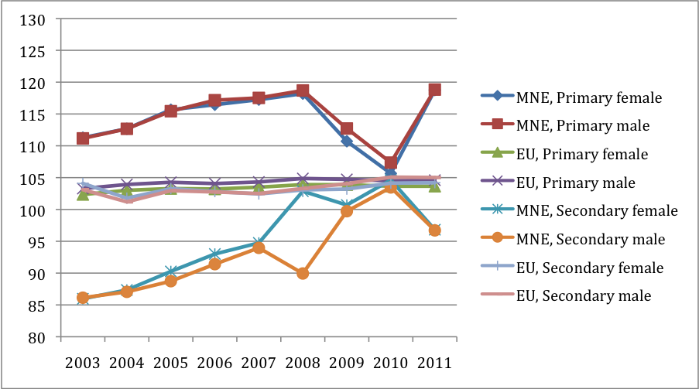

Source: WDI.
Note: Gross enrollment rates are shown; Net enrollment over time is not available for MNE.

Fig. 2.1b: Adjusted Net Enrollment for 2011, Montenegro and the EU
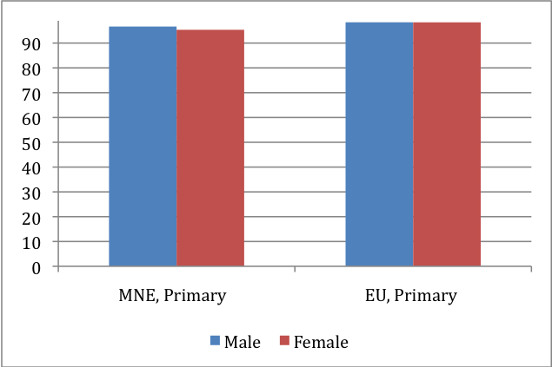
Source: WDI.
Note: Shows adjusted net primary school enrollment rates: % of school-age children

A gender gap favoring females exists in tertiary enrollment. Tertiary enrollment in Montenegro has risen over the past decade, moving closer to the EU average. Female rates have increased from 20 percent in 2003 to 53 percent in 2010, while male rates have increases from 14 percent to 43 percent in the same time span, shown in Figure 2.1c. As in the EU, males in Montenegro have substantially lower tertiary enrollment than females. This female bias in tertiary education is similar to patterns found in much of the world (WDR, 2012, Chapter 3). Multiple reasons may be driving this gender gap. More policies targeting females to increase enrollment, greater opportunities for males (e.g. in the workplace), or other factors may be important and take a particular form in Montenegro; more research is needed in this regard.
Fig. 2.1c: Tertiary Enrollment Rates, Montenegro and the EU
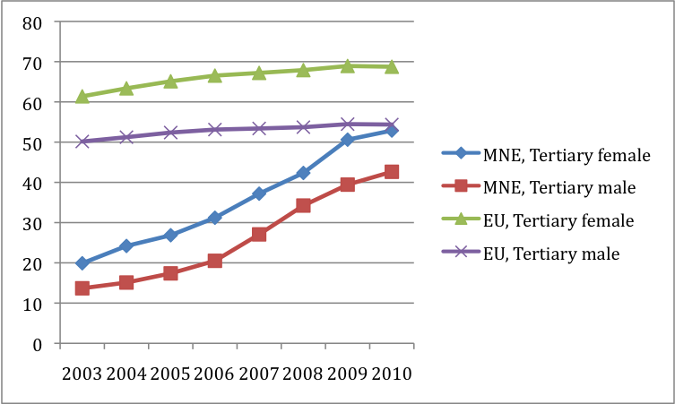
Source: WDI.
Note: Gross enrollment rates are shown.

Female educational attainment is higher than male attainment when comparing the active labor force; the opposite is true for the entire population. Figure 2.2, panel (a) examines educational achievement for the working-age labor force (ages 15-64). Almost 80 percent of females in the labor force have secondary vocational or tertiary education. Half of the active workers (employed or seeking) with a secondary education are female. Moreover, less than 2 percent of the working-age labor force has less than a primary education. The percent of the female labor force with a tertiary education lags behind the EU by 3.2 percentage points and males with tertiary education lags the EU by 4.3 percentage points.
Figure 2.2, panel (b) disaggregates the entire population (over 15 years) by levels of educational achievement. Thirty-two percent of women have a primary education or less, compared to 22 percent of men. Women comprise almost 80 percent of those with less than a primary education. Age likely plays a role in comparing results from the workforce (panel a) and the overall population (panel b), as gender attainment gaps are larger for the population than the labor force. Improvements in secondary enrollment rates suggest that primary attainment should rise in the future. However, other factors related to female non-participation in the labor force (i.e. geography and ethnicity, described below) are also related to educational attainment gaps. The effects that higher female tertiary enrollment will have on lower female primary attainment should be made a priority for education research. On one hand, continued increases in female access to education should serve to reduce the attainment gap for girls; on the other hand, a continued lag in male enrollment may serve to lead to an attainment gap for boys.

Fig. 2.2: Male and female Educational Attainment
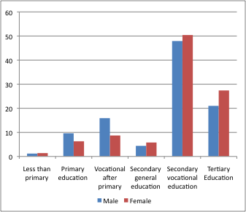(a) Percent of male and female Labor Force (ages 15-64), by education level | 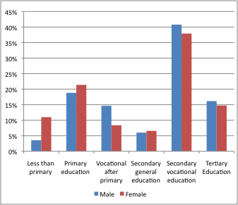  (b) Percent of male and female population (ages 15+), by education level
Source: MONSTAT LFS Report (2011, p. 9, Table 4-1 and p. 8, Table 4),

There are larger gender disparities in primary school attainment among non-ethnic Montenegrins, and those in rural areas. One-fifth of the population of Montenegro came from other countries and one-third live in rural areas (MONSTAT, 2012). Educational attainment is presented for these groups relative to the rest of the country. Figure 2.3 shows that 15 percent of ethnic Montenegrins complete only primary education or less. However, 27 percent of non-Montenegrin women have a primary education or less, and non-Montenegrin men have a lower completion rate of 22 percent. Thirty percent of those in rural areas have a primary education or less (33 percent of females and 27 percent of males). The Government of Montenegro has included plans to assist rural women (and other vulnerable groups), like increasing computer literacy among these women.

Fig. 2.3: Percentage of population with Primary Attainment or less (ages 15-64), Comparison by Ethnicity and Location
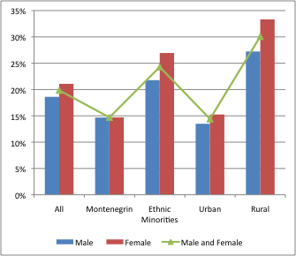
Source: Authors' calculation, LFS (2010).
Female literacy rates lag behind male rates for the entire population, but female youths have caught up. Overall male literacy in Montenegro is two percentage points higher than female rates (99.4% compared to 97.4%), but rates for males and females between the ages of 15 and 24 are close (99.35% vs. 99.31%, respectively), shown in Table 2.4. While male rates for Montenegro are similar to those in the EU, female rates are 1.4 percentage points lower than the EU among all adults but 0.4 percentage points lower among youths. Again, changes in literacy over time are not available for Montenegro, but the higher rates of youths compared to adults suggest that rates have been rising recently.

Fig: 2.4: Literacy rate, Montenegro and EU, 2010
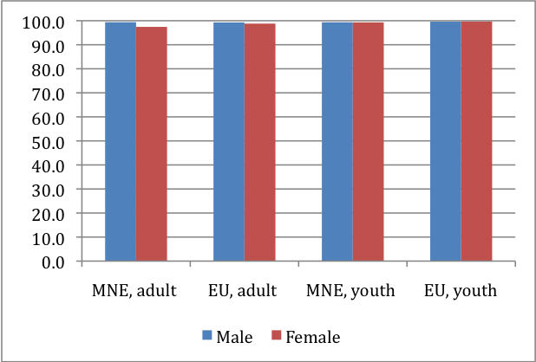
Source: WDI.
Note: Shows the % of adults age 15 and above and % of youth age 15-24.

There are large differences in the fields that males and females choose to study. Shown in Figure 2.5, more working-age males study mathematics-, engineering-, and science-related fields than females (31 percent of males compared to 9 percent of females). Again, this finding is similar to gender differences experiences in much of the world (WDR, 2012, Chapter 3). Fifty percent of women complete schooling related to services, social sciences, business, and law, compared to 38 percent of men.
Little information exists to explain whether this difference is due to preferences or constraints. From one standpoint, females in general may have less preference for engineering, as is the case in other countries (WDR, 2012, p. 115). From another, cultural attitudes may sway females’ decisions (or even their preferences) towards other fields, acting as a constraint to female education in these fields. On the other hand, male boys may experience strong cultural pressures to study engineering — 27 percent of males study engineering and males make up 80 percent of engineering students. Interestingly, the three fields most heavily studied by females (the right panel of Figure 2.5), Health, Education, and Humanities, make up a only small percentage of the overall education of people 15-64 (shown in the left panel). The Government of Montenegro has proposed the creation of a professional orientation program for the secondary and tertiary level and measures to encourage males and females to train in professions in which they are not traditionally represented (APAGE, 2013, p. 45).

Fig. 2.5: Male and Female representation across different educational categories
Percent of male and female population (age 15-64) with degree, by education category | Percent of women (age 15-64) in each education category
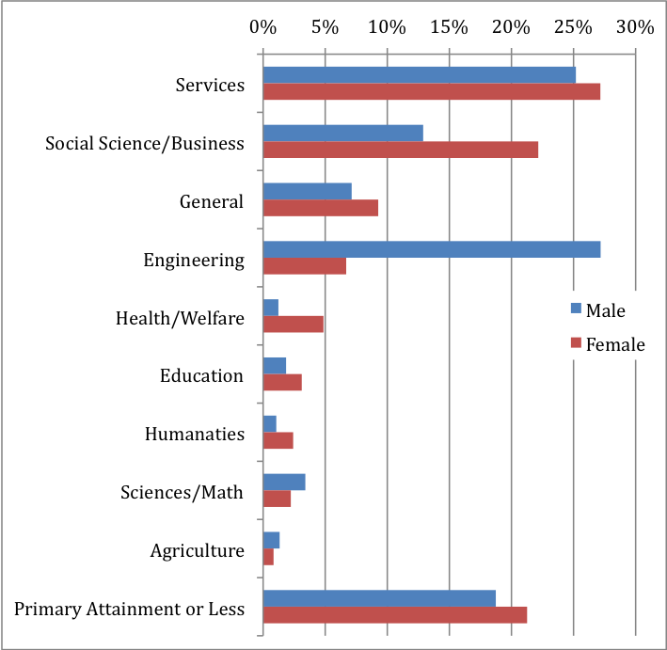 | 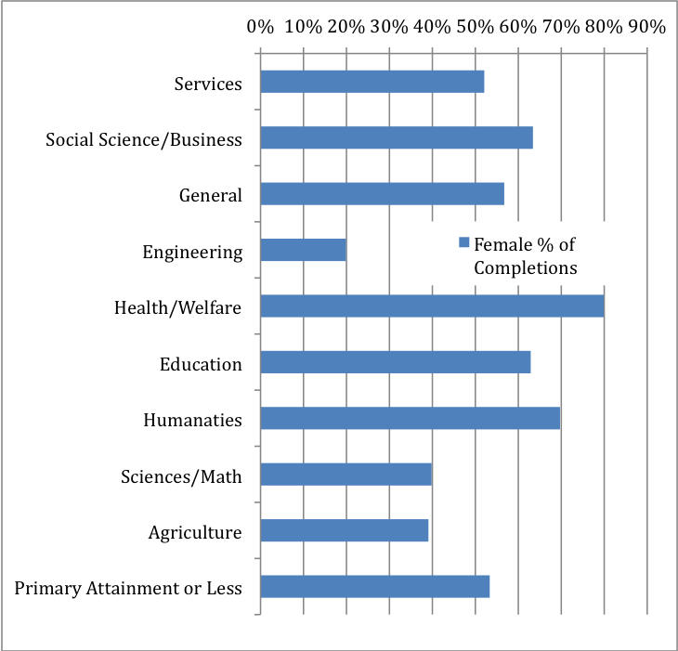
Source: Authors' calculation, LFS (2010).
Note: “Primary or Less” did not respond with an education category.

Test scores do not suggest that girls perform worse than boys in Montenegro. PISA scores for 2009 reveal that 15-year old girls perform as well as boys in math and science and excel in reading, shown in Figure 2.6. Montenegro falls below the OECD average in each of these categories.
Figure 2.6: PISA test scores of 15-year-olds, Montenegro and OECD average, 2009
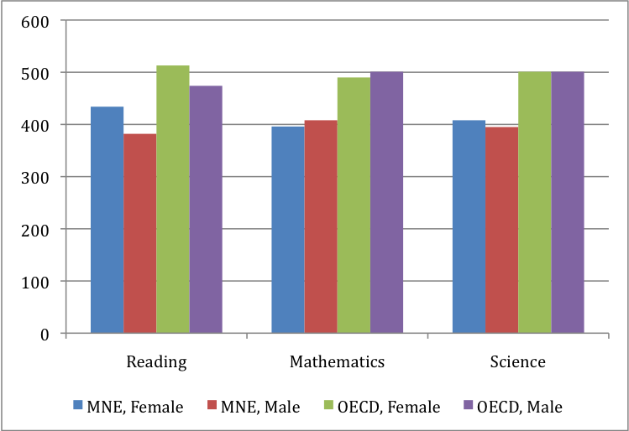
Source: PISA Database (2009).

2.2 Health
Male life expectancy is lower than female life expectancy in Montenegro, and both are falling further behind EU averages. As shown in Figure 2.7, female life expectancy for 2008-2011 was 77 years and that of men was 72 years. This gender gap is lower than the 2010 EU average of 6 years. Life expectancy differences between Montenegro and the EU have increased slightly over time. In 2003, female life expectancy was 4.0 years lower in Montenegro than the EU, increasing to a 5.8-year difference in 2010. For males, life expectancy differences with the EU increased from 3.0 years in 2003 to 4.9 years in 2010. A number of factors may be related to higher male mortality for much of the world, including generally higher male substance abuse, engagement in violent crime, risky sexual behavior, and poorer male diets (WDR, 2012, p. 134). Evidence of poorer male outcomes in some of these areas is presented below.
Fig 2.7: Male and Female Life expectancy at birth, (years), Montenegro and the EU
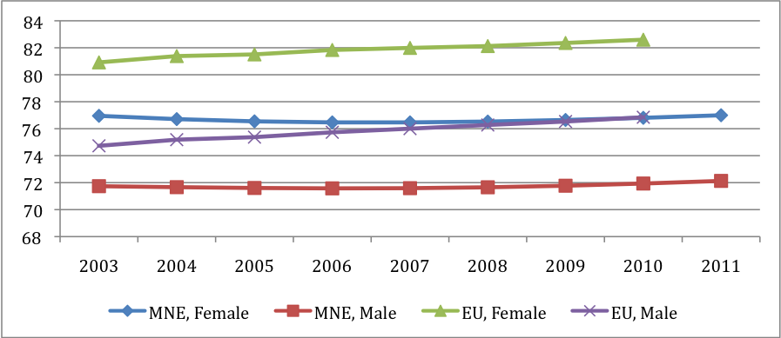

Source: WDI. Note: EU figures available through 2010.
The infant mortality rate is decreasing, moving towards the EU average. In 2003, the rate for Montenegro was 4.1 births (per 1000) higher than the EU average, decreasing to a 2.4-birth difference in 2011, shown in Figure 2.8. Differences in adult mortality rates between Montenegro and the EU have been relatively stable since 2003, but male adult mortality remains significantly higher than female mortality, and than average male mortality in the EU (Figure 2.9). Nearly all pregnant women (97% in 2006) receive prenatal care (WDI).
Fig 2.8: Infant Mortality rate, infant (per 1,000 live births), Montenegro and the EU
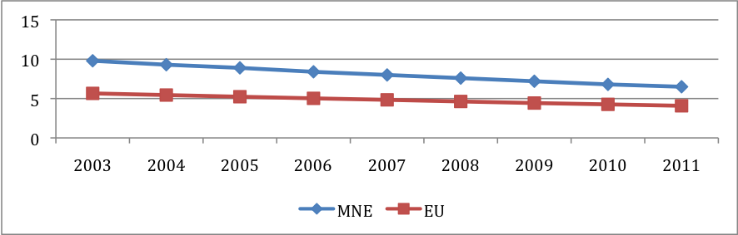
Source: WDI. Note: EU figures available through 2010.

Fig. 2.9: Mortality rate, adult (per 1,000 adults), Montenegro and the EU
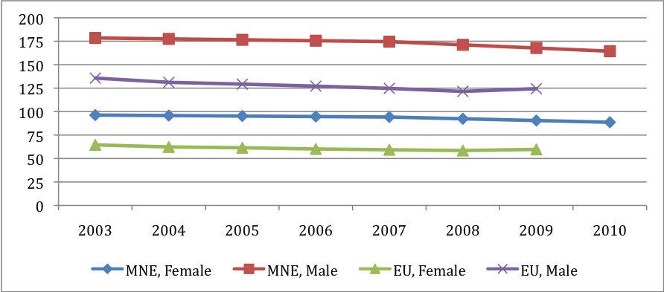
Source: WDI. Note: EU figures available through 2010.
Total fertility rates are in line with the EU average while adolescent fertility is higher but decreasing for Montenegro. Figure 2.10 shows the similar total fertility rates, fewer than 2 births per 1000 women. Among adolescents, Montenegro had a 5.4- (births per 1000) higher rate than the EU in 2003, decreasing to a 3.1-higher rate in 2010.
Fig. 2.10: Fertility rate (births per 1,000 women), Montenegro and the EU
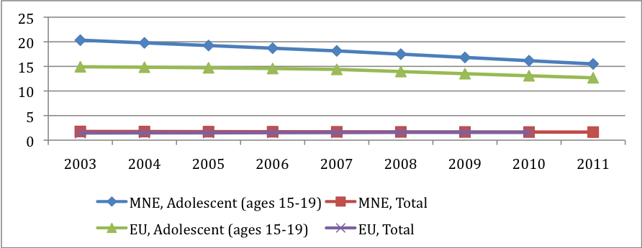

Source: WDI.
Among youth between 15 and 19, 43 percent of males and 17 percent of females have already entered into sexual relationships (IPSOS 2012, p. 52). Most report using condoms (42% use them always; 26% sometimes), while 26 percent used unreliable methods, such as interrupted intercourse (ibid., p. 53). In 2012, male adults had higher rates of having sexual relations with a non-steady partner than females, 35 percent to 16 percent (ibid., p.31). Fifty-eight percent of adults report using a condom during their last sexual encounter (ibid., p. 33).
Many women in Montenegro do not regularly use preventative health care, especially among rural women. While 90 percent of women aged 20 and over have visited a gynecologist in their lives, 33 percent of women do not go for regular gynecological health checkups. Rates are even higher in rural areas, among poorer women and among those with a primary education or less (IPSOS 2012, p. 34). Figure 2.11 shows differences across regions.
Fig 2.11: Women aged 20 years and more who do not visit a gynecologist for regular health check by type of settlement and region, Montenegro, 2012 (%)
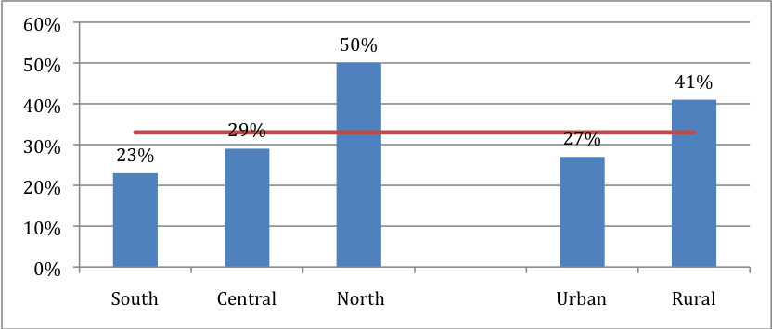
Source: IPSOS (2012, p.35, Figure 24).

Concerning the broader spectrum of healthcare services, males and females report problems with the local health clinic or hospital at similar rates. Male- and female-headed households also spend similar amounts on health per capita. Between 2008 and 2012 the percent of men and women who received diagnostics and specialist examinations in primary healthcare centers increased, although the waiting time for receiving these services also increased (IPSOS 2012, p. 9).
Vulnerable groups, the elderly and Roma females are more at risk of having poor health. Self-assessment studies of health conditions showed that one of five Roma people considered their health to be poor (compared to 1 of 10 in the non-Roma population (IPSOS, 2012a, p. 11)). Additionally, Roma youth have higher rates of sexual activity than the general population of youths (42 percent to 29 percent) (ibid., p. 14). This group suffers from inferior access to basic infrastructure – water, electricity and sanitation, which may negatively impact their health (ibid., p. 12).
Other health concerns are present in Montenegro, including alcohol consumption and psychological distress. Frequent alcohol consumption is predominantly a male problem and has increased since 2008. Four percent of men consume alcohol on a daily basis, compared to 0.5 percent of women (IPSOS, 2012, p. 30). The number of adults who consume alcohol occasionally or daily has risen from 25 percent to 32 percent between 2008 and 2012. Daily consumption of alcohol is also more prevalent among those in the age range of 45-54 years (ibid.). In addition, among Montenegrin adults, 45 percent of females and 39 percent of males experience psychological distress (IPSOS, 2012, p. 22). The prevalence of psychological distress has dropped from 51 percent in 2008 (ibid.). There is higher prevalence of smoking among males, 35 percent of males are smokers compared to 27 percent of females (IPSOS 2012, p. 8).
Improving data collection and preventative and reproductive health care provision has been placed on the agenda of the APAGE 2013-2017 (APAGE, 2013, ppg. 70-81). The Government of Montenegro proposed the regular collection of gender disaggregated health statistics, and specifically the monitoring of health statistics for poor women, women with disabilities, rural women, Roma, refugees and internally displaced women, victims of trafficking and sex workers. Improving the prevention and early detection of malignant and sexually transmitted diseases has also been highlighted. The APAGE addresses measures to support women’s reproductive health, which include: providing all women access to natural childbirth and the humanization of childbirth; supporting women after childbirth; and providing access to family planning and contraceptive use education (especially for vulnerable groups) (ibid.). The counseling aspect (to youth and pregnant women) of preventative health care is highlighted as an area for improvement, and in some municipalities these services will need to be provided for the first time (ibid.). The government also seeks to educate health care workers in gender-sensitive practices (ibid.). While this focus on female health improvements may have strong effects on wellbeing, a focus on male issues are noticeably absent, given higher rates of alcohol use, smoking, and risky sexual behavior.

2.3 Assets, credit, and savings
Household assets include those used for transport (i.e. cars, bikes), production (i.e. ovens, tools), bookkeeping and marketing (i.e. computers, internet). Available data for Montenegro does not allow a good comparison of assets that are accessible to females compared to men within the same household. As a proxy for such comparisons, differences in the accumulation of assets are compared by the gender of the household head.
- Female-headed households have lower rates of car ownership (14 percent lower rate, controlling for household characteristics), which may affect the ability to travel to and from work or the time it takes to do various household tasks. On the other hand, it may indicate that women utilize public transport or other modes of transportation. Gender differences in the usage of automobiles is not available in this data, but would inform whether the difference in car ownership reflects a constraint on female mobility or not.
- Households have similar rates of owning a home (81 percent).
- Female-headed households have lower rates of owning a mobile phone (3 percent lower rate) but similar rates of computer ownership and internet access.
- However, higher rates of females report never having used the Internet or email as a source of news compared to males (52.2 percent compared to 44.2 percent). The rate of never using the Internet is much lower for women with a tertiary education (33.1 percent for female compared to 40.6 percent for male).
- An analysis of expenditures reveals several differences between male- and female-headed households. Female-headed households spend 88.4 euro more on education than male-headed households (p<0.05). However, female-headed households have lower per capita expenditures for clothing (57.57 euro, p<0.05) and durable goods (100.25 euro, p<0.05), including furniture, household appliances, TV, and cars, compared to male-headed households.
Similarly, access to finance, savings, and other banking services can give more flexibility in handling income shocks or catastrophic expenses. The evidence for Montenegro does not suggest gender disparities in usage of financial products (see Figure 2.12), although greater disparities exist for the ECA region. More data, however, must be gathered to analyze specific regions and subgroups, as evidence suggests a large rural/urban difference (Demirguc-Kunt and Klapper, 2012). For the entire country, male- and female-headed households have similar rates of banking, debit and credit card use.
Figure 2.12 Adults with an account at a formal financial institution, by gender
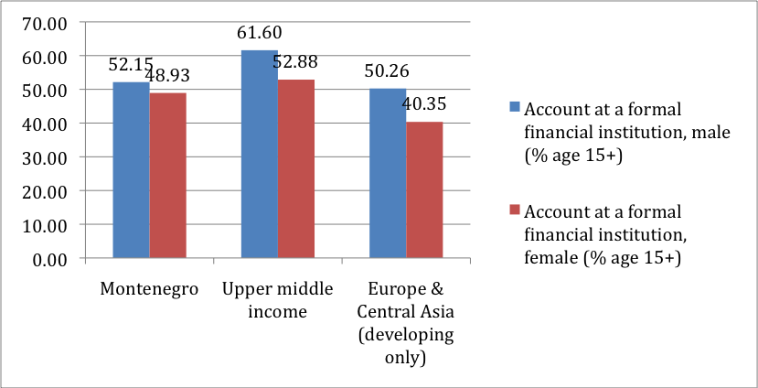
Source: Demirguc-Kunt and Klapper (2012).

2.3 Summary
Available data suggests that gender differences exist in key education and health outcomes and give evidence of gender inequalities in wellbeing; inequality in some areas for women and in others for men. Key findings of inequality in these areas follow:
Education
- Primary and secondary enrollment rates are rising, but comparisons with the EU average are difficult due to a lack of net enrollment data over time. Tertiary enrollment rates have more than doubled over the past decade and are moving towards the higher EU averages. Females have a 10 percentage point higher tertiary enrollment than males; the reasons for this difference and the potential effects in the long run, especially in terms of educational inequality, require further research.
- The group of persons who have a primary education or less is disproportionately female. Low educational attainment is higher among non-Montenegrin immigrants and in rural areas. Females have poorer attainment outcomes than males among these groups, while this is not the case for those born in Montenegro.
- Working-age males study in mathematics-, engineering-, and science-related fields at higher rates than females, who complete schooling related to services, social sciences, business, and law more often.
Health
- Female life expectancy is significantly higher than male expectancy, but both are falling further behind the EU average. While the gender gap is perhaps due to higher levels of risky behavior in males (i.e. alcohol, lack of sexual protection, smoking), the growing gap with the EU requires further study.
- Only 32 percent of women report using contraception and there is wider concern that women do not engage in preventative health care. Data is needed on the utilization of men’s preventative health care.
- Utilization of preventative care and psychological distress are areas of concern to female wellbeing in Montenegro. Higher rates of alcohol use and risky sexual behavior in males are areas of concern to male health that may have implications on family relationships. Although a number of policy initiatives have been proposed to address female health, research was unable to uncover a similar set of programs focused on male issues.
- Infant mortality rates and adult and adolescent fertility rates have improved in Montenegro, moving towards EU averages.

3. Economic opportunities

This section describes gender differences related to three work-related issues: whether to work; what work is available; and which occupations and sectors to work in. Large participation and unemployment rate differences exist between men and women, especially for certain groups in the population. The section also explores the gender gap in earnings. On average, women in Montenegro earn 16 percent less than men with a larger gap for higher-earning/higher-education occupations. The wage gap is large in both male- and female-dominated industries. Finally, two dimensions of entrepreneurship, female firm ownership and management and female self-employment will be analyzed.

3.1 Labor participation

Female labor force participation is low compared to other countries in the region, and there is a large gender disparity in participation. Figure 3.1a shows female participation rates and the ratio of female-to-male participation rates for a number of countries (Montenegro in black, EU average in Green). In 2010, the labor force participation rate of females in Montenegro was over 10 percentage points behind the regional rate (52 percent compared to 64 percent). The gap between male and female participation rates, presented by the line graph on Figure 3.1a, is also wider for Montenegro compared to the EU average. Female participation is 78 percent that of male participation in Montenegro and 83 percent of male participation for the EU average.
Fig. 3.1a: Gender participation rates, 2010, Montenegro and Other Countries
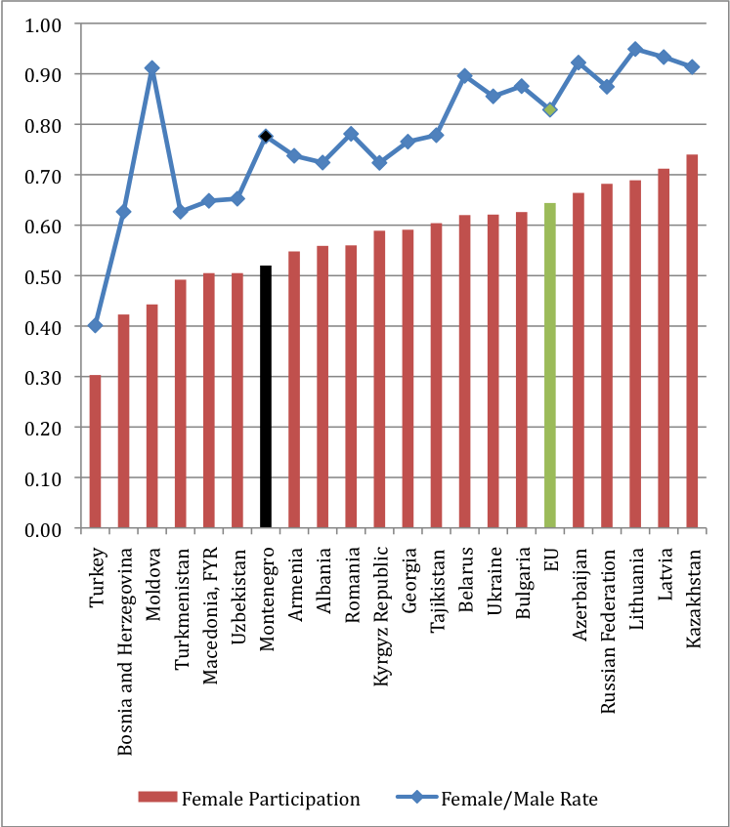
Source: WDI (2010), Gamberoni and Posadas (2013), MONSTAT (2010).
Note: Participation rates are for the population 15-64 years.

Female participation has been over 10 percentage points lower than male participation since 2009. The rate of male participation declined somewhat in 2011; the female rate has risen to 55 percent in Q3, 2012 and the gender gap has decreased from 14 percentage points in 2009 to 11 percentage points in 2012.
Fig. 3.1b: Male and Female Participation, 2009-2012.
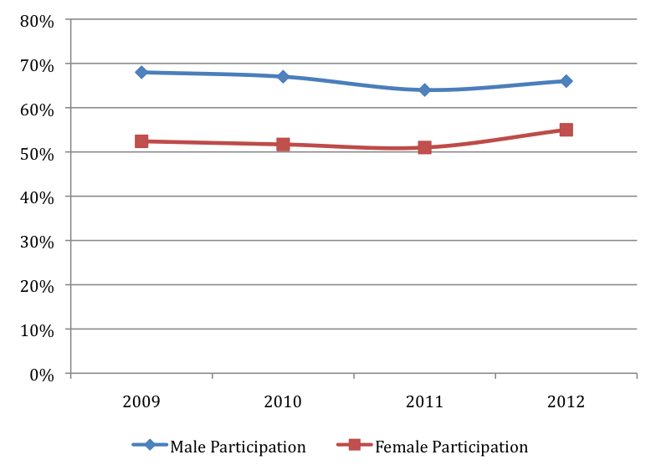
Sources: For 2009- Q3,2012, MONSTAT (2010-2012).
Note: Participation rates are for the population 15-64 years, as reported in MONSTAT (2009-2012).

For Q4 2010 and Q4 2012 respectively, male participation dropped from 68 percent to 64 percent, while female participation remained steady at just above 52 percent (MONSTAT 2010, 2011, and 2012). During this time of global recession, the number of active male workers in the industry and service sectors dropped, while the number of female workers increased, shown in Figure 3.1c. A steady increase in the number of female workers in services is shown over the three years, while male jobs remain lower than 2010 levels. The dynamics between male and female participation in Montenegro, employment opportunities, and sector trends due to global market conditions should be studied in closer detail. Research could focus on whether these trends are expected to continue — perhaps the greater number of females finishing higher education better meets the labor demand from service sector firms. On the other hand, due to consistently lower wages that females receive in Montenegro (discussed in the next sections), perhaps the trends in Figure 3.1c reflect firms responding to the global recession by substituting lower-wage female workers. Further research on the types of jobs being destroyed and created in this process, and their links to domestic and global demand for Montenegrin goods and services, will help determine the long-term effects these processes have on female labor participation.
Fig. 3.1c: Number of males and female workers in the industry and service sectors, Q4 2010, Q4 2011, and Q4 2012.
Male Workers (1000s) | Female Workers (1000s)
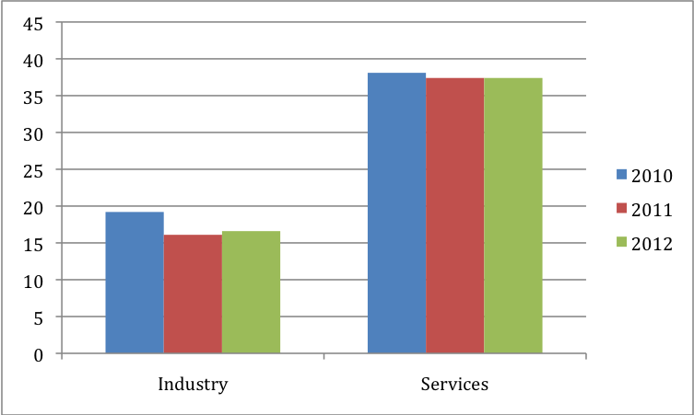 | 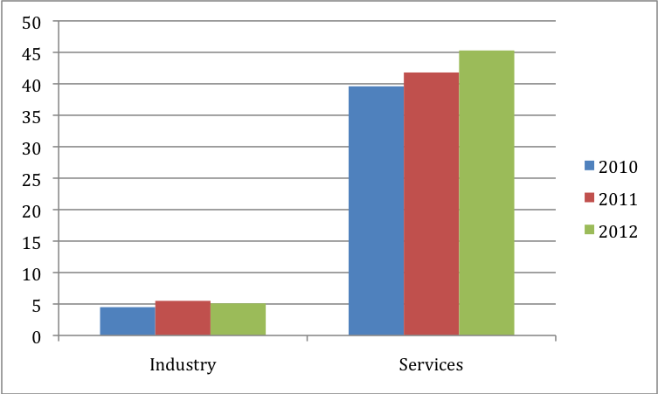

Sources: MONSTAT Quarterly LFS Reports: Q4 2010, 2011, and 2012, p.11.

Much of the inactivity gap is explained by large gender disparities experienced by rural people. As shown in Figure 3.2, the female inactivity rate is 12 percentage points higher than males in urban areas and 25 percentage points higher in rural areas. When viewed in light of rural/urban educational differences (refer to Figure 2.3 above), rural women have both lower educational attainment and labor force participation compared to urban women. The gender gaps that rural women experience in these areas are also particularly large.
Fig. 3.2: Gender inactivity rate, by urban/rural areas.
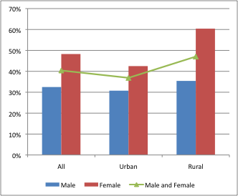

Source: Authors’ calculations, LFS (Q4, 2010).

Economic inactivity is especially high for women in three groups: those with primary schooling or less, ethnic minorities, and older women. Figure 3.3a suggests subpopulations of women that face particularly high barriers to work. For instance, Panel (a) shows that 57 percent of women in the Northern region were out of the labor force at the end of 2010. Serbian, Albanian, and Muslim females face similarly high inactivity rates (Panel (b)). While approximately 45 percent of the population has secondary/vocational training, over 40 percent of the females in this group are out of the labor force, shown in Figure 3.3a (Panel (c)). Only among the group of the population with a tertiary education do males have a lower participation rate than females.

Fig. 3.3a: Percent of men and women 15-64 not active in the workforce.
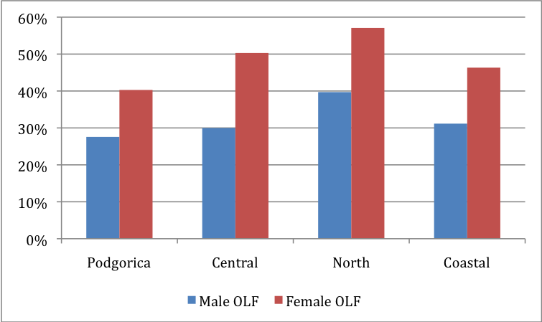(a) Regional  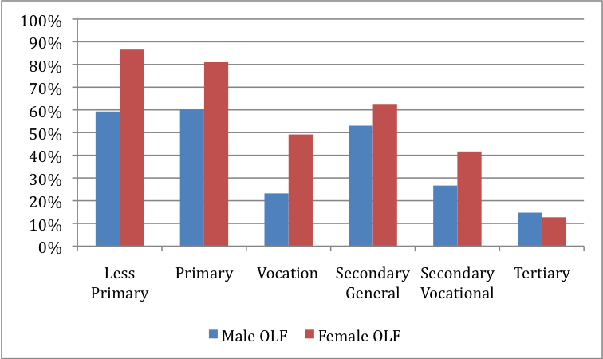(c) Education Completion | 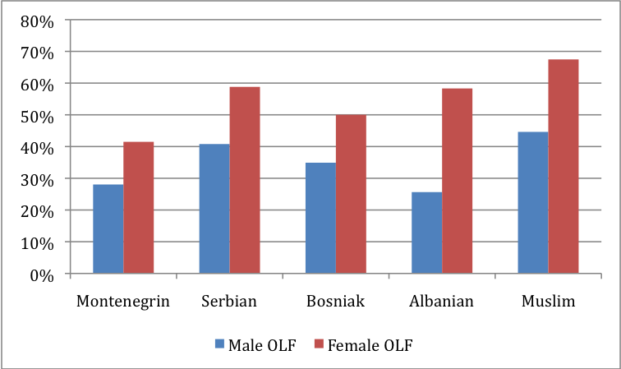(b) Ethnic Groups  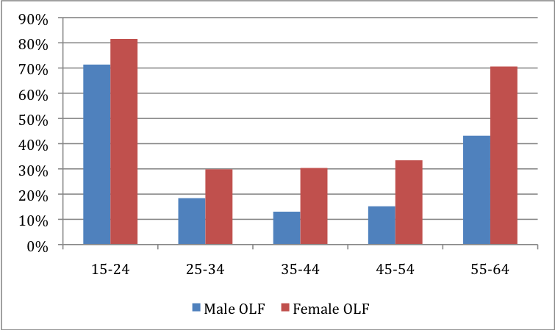(d) Age Group
Source: Authors’ calculations, LFS (Q4, 2010).

While both younger men and women have high inactivity rates (likely due to being in school), the rates for older women are particularly high at 71 percent, 28 percentage points higher than men of the same age group, Figure 3.3a (Panel (d)). Expected changes to retirement and the pension system include increasing the pension age and limiting early retirement – two proposals in a larger effort to ensure pension sustainability (World Bank, 2012h). Such changes may force people to work more years, increasing participation for older age groups.

Fig. 3.3b: Percent of men and women 15-64 not active in the workforce due to family duties.
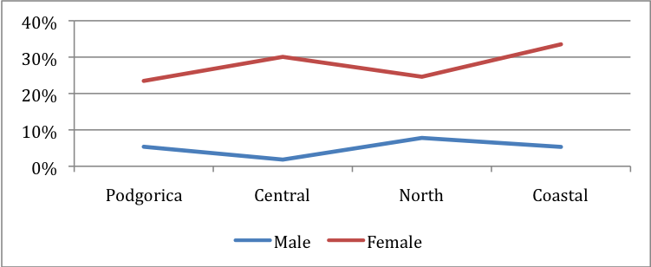(a) Regional  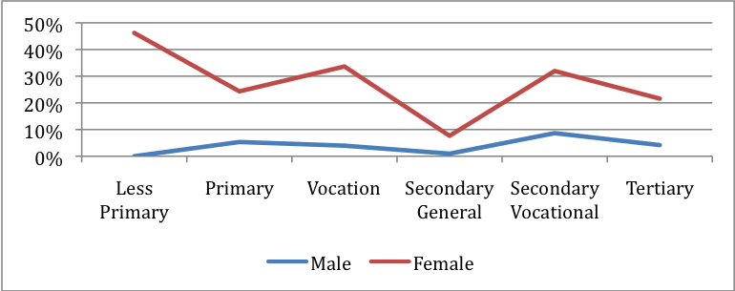(c) Education Completion | 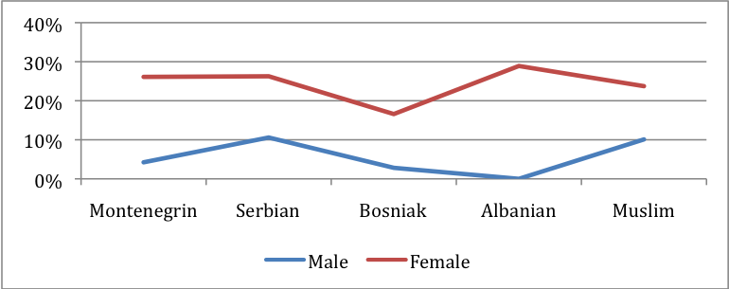(b) Ethnic Groups  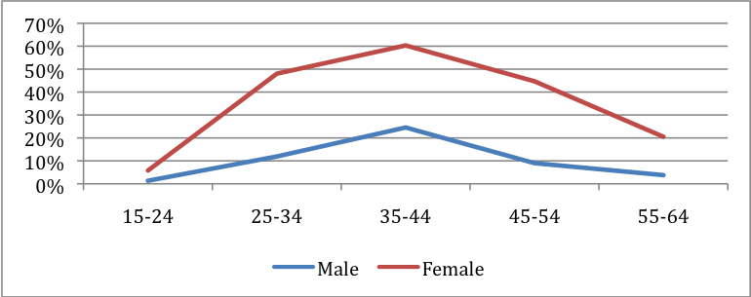(d) Age Group
Source: Authors’ calculations, LFS (Q4, 2010).

Of those out of the labor force, lower rates of women state they would like to work, compared to men. Twenty-three percent of males say they would like to have work compared to 17 percent of females. However women represent 53 percent of inactive people who want work. Women most often cite education or family responsibilities (either child or family member care) as the reason for not looking for work, shown in Figure 3.3b. The rate of women out of the labor force because of education is close to men; however, a much larger percentage of females do not work due to familial reasons. Twenty-seven percent of women are not working due to family compared to only six percent of men. Figure 3.3 suggests that the gender difference in family care as a reason for non-participation is for people ages 25-34 and 35-44 and those with less than a primary education, shown by the distance between line graphs. Cultural attitudes regarding the role of women and options that enable women to both work and care for their children are discussed in more detail in the sections below.
To address the tradeoff between labor and family obligations for men and women, the Government of Montenegro has proposed the following; the introduction of flexible-time work arrangements and opportunities to work from home (changing the law in accordance), improved facilities for childcare and care of the elderly, and awareness campaigns to encourage the equal distribution of household and family duties (APAGE, 2013, ppg. 65-68). Box A2 describes the Montenegrin Labor Law, which provides a number of restrictions and protections intended to increase equality in the workplace and protect workers.
Montenegro has generous laws on maternity leave and does not allow paternity leave. Article 108 of Montenegro’s labor law addresses protection regarding pregnancy and childcare. The World Bank Report for Europe and Central Asia states that maternity leave for Montenegro is 365 paid days, 45 of which can be taken before birth (WB, 2012g, p. 57). Additionally, Montenegro does not provide tax deductions for childcare, which may affect work decisions (WB, 2012k). Further research is needed to determine the effect of these maternity leave and childcare provisions on labor force participation for women; evidence suggests that there may be a link (WB, 2012g, p. 57).
Women have a lower probability of participating in the labor force compared to men (21 percentage points), controlling for age, education, children (under five years and between 5 and15 years), region, living in a rural area, and the presence of other workers in the household (see Probit regression results in the Appendix for more details). Having children (young or older) is associated with lower female probability of labor force participation (approximately -9 percentage points lower) but a higher male probability of labor force participation (especially younger children, increasing probability by 16 percentage points). This statistical evidence supports qualitative findings of the cultural role of women as caretakers. Additionally, living in an urban area is related to a higher probability of labor force participation for women (9 percentage points) but not men, further informing the description of rural/urban gender disparities in the previous section. For both sexes, additional education relates to a higher probability of participation. This is particularly relevant for women with a primary education or less, who experience the largest education and participation gaps.

Box A1. Workplace Protections for Female Workers

The Labor Law addresses gender equality and provisions for the protection of women in the workplace. However these measures may serve to limit the types of work and the hours that women are allowed to partake in, with some exception. For example, a female cannot engaged in a position “that requires extremely difficult manual work, underground or underwater activities nor on a position that bear high level of risk of damaging the condition and life of the referred employees” (The Labor Law of Montenegro, Article 75, 2011). Additionally, overnight work cannot be assigned to an employed woman “working in the Industry Sector or the Construction Sector unless she has previously exercised the right to a minimum of 12 hours of daily recess” (The Labor Law of Montenegro, Article 76, 2011). However, such rules do not apply to females in management positions or performing activities of health care or social and other protection (ibid.)
The Labor Law prohibits an employer from refusing to enter into an agreement with a pregnant woman, or from terminating the labor agreement due to her pregnancy or her absence due to the maturity leave (Article 108, 2011). Maternity leave rights, stated in the Labor Law, are considered generous relative to the region (WB, 2012g, p. 57). The Labor law also protects women and single parents with special circumstances related to their childcare duties. The Law of the Prohibition of Discrimination refers to gender-based discrimination and designates the role of the Protector of Human Rights and Freedoms (Ombudsman) to prohibit discrimination; and describes recourse for victims.
Discrimination against women in the labor force is addressed by the following measures in the APAGE 2013-2017 (APAGE, 2013, p.69). The Government of Montenegro proposes to harmonize national legislation with parts of the Acquis communautaire; train those responsible for the enforcement of Montenegro’s anti-discrimination law – labor inspectors and judges; collect and process data on discrimination cases; report on implemented controls; and create campaigns to encourage economic opportunities for all (ibid.). Activities to encourage women to seek out legal recourse in cases of discrimination are also stated (ibid.).

3.2 Unemployment

One-fifth of all job seekers are unemployed. As shown in Figure 3.4a, there is little difference between the overall male and female unemployment rates (21 percent and 19 percent respectively), but high rates of unemployment occur for workers 15-24 years (51 percent of females and 43 percent of males). This younger group constitutes only 9 percent of the workforce but 21 percent of unemployed. Thirty-eight percent of this group have a primary education or less and do not likely have on-the-job experience. Whether there is a lack of entry-level jobs suitable for these younger workers is a question for further research.
Fig. 3.4a: Unemployment rates are higher for younger workers groups, with the gender gap largest among these workers
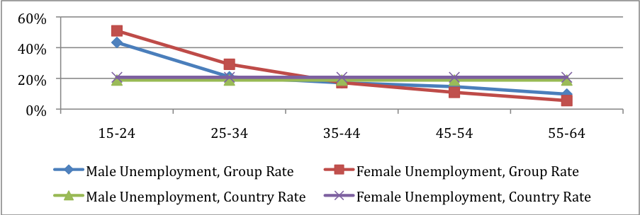
Source: Authors’ calculations, LFS (Q4, 2010).
Note: The overall country unemployment rate is presented for comparison. Ten-year age groups are used to ensure enough observations for calculation (N=2,466).
Unemployment drops for older workers groups, with greater education and work experience, but is still sizeable for the group aged 25-34 years, 29 percent for females and 21 percent for males. A striking difference in education is seen in the unemployed of this age group, shown in Figure 3.4b. A larger proportion of unemployed males have only primary or some vocational education (33 percent to 18 percent of females). However, a larger proportion of unemployed females have a tertiary education, 30 percent compared to only 9 percent of unemployed males.

Fig. 3.4b: Educational Background of Unemployed Workers, age 25-34, % of total unemployed
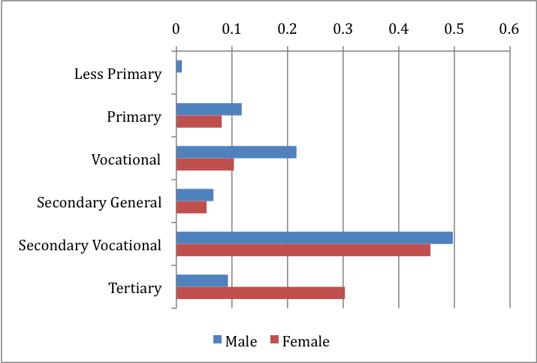
Source: Authors’ calculations, LFS (Q4, 2010).

Women are slightly less unemployed than men in urban areas but more unemployed in rural areas. Figure 3.5 (left panel) shows that gender differences in unemployment rates are largest in rural areas and that most of these are cases of long-term unemployment. Over half of unemployed persons are looking for their first employment. Sixty-four percent of unemployed women overall, compared to 47 percent of men, are actively seeking their first employment. Of these females, 24 percent are between the ages of 15 and 24, while 49 percent are 25-34 years old.
Unemployment rates are highest in the Northern region, especially for women with no work experience. In the Northern region, the number of unemployed workers is disproportional to the workforce, as the region has 37 percent of the country’s unemployed but only 27 percent of the workforce. As Figure 3.5 (right panel) shows, over 36 percent of women and 26 percent of men are unemployed in the North, far greater than the national average. The percentage of persons in the active workforce who have been unemployed for over a year and who have never had a job is also shown in the figure.
Eight of ten unemployed persons have been seeking work for over a year. According to MONSTAT, 82.2 percent of unemployment in Q3 2012 was long-term, an increase from 79 percent in Q4 2010. For women across all regions, a high proportion of the unemployed are those who a) have never had work and b) have been seeking work for over a year. This indicates significant barriers to workforce entry. The findings differ for men, as a lower proportion of men are searching for their first work and thus lacking work experience.

Fig. 3.5: There is high variation in unemployment rates across regions. High proportions of the unemployed are looking for their first job or have been looking for over a year.
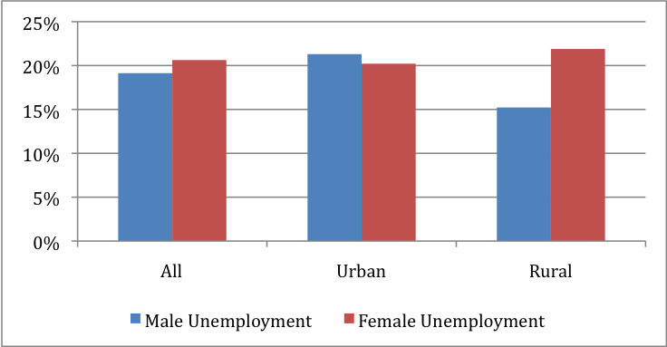(a) Rural/Urban Unemployment  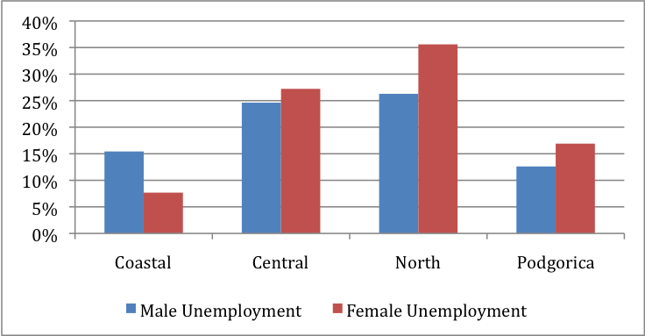(c) Regional Unemployment | 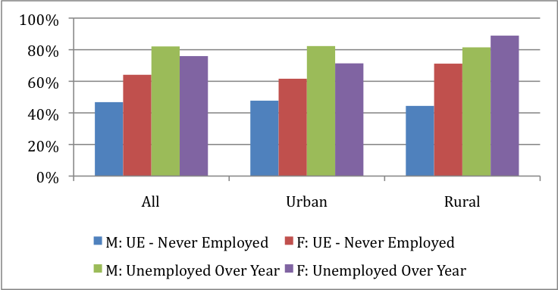(b) Rural/Urban Long-term Unemployment  (d) Regional Long-term Unemployment
Source: Authors’ calculations, LFS (Q4, 2010).

Unemployed women are not finding jobs despite greater measured search effort than men. Females contact the public employment office at higher rates than males (90 percent compared to 84 percent of unemployed workers) and search advertisements at higher rates (62 percent compared to 57 percent). Additionally, women receive unemployment benefits at lower rates than men. Of unemployed workers, 7 percent of women and 12 percent of men are receiving unemployment benefits.
The improvement of employment prospects for men and women is addressed in the APAGE 2013-2017 in the following ways. The Government seeks to: (i) enhance the collection and processing of gender disaggregated labor statistics; (ii) address the needs of specific groups – like women who are hard-to-employ or who are members of the Roma and Egyptian population, refugees or displaced persons, rural women and single parents; and (iii) eliminate the grey economy and illegal employment (APAGE, 2013, ppg. 54- 57). Related activities include: researching the needs and reasons for migration of rural women and training these women in ownership; creating economic empowerment for single parents (particularly single mothers); and implementing tax incentives for employees of vulnerable groups (ibid.).

3.3 Types of employment

Since average countrywide unemployment levels are similar for men and women (approximately 20 percent), a gap in employment rates mainly reflects the gap in participation rates. Forty-four percent of all women were employed in Q3, 2012, compared to 54 percent of all men. Figure 3.6 shows that this overall gap is mostly driven by the gap between male and female workers age 50-64.
Fig. 3.6: Percentage of the population employed (15-64 years), Q3 2012, by age groups.
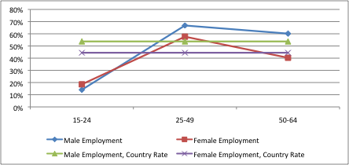
Source: MONSTAT (Q3 2012, Table 2, page 6).
Note: More detailed age-breakdowns are not available in the MONSTAT report.

The employment rate gap is large across all age groups. Figure 3.7 provides a detailed breakdown of the employment rate by age and employment type. For the middle three age groups (25-34, 35-44 and 45-54), female employment rates lag behind male rates by 14 percent. The fall in employment after age 55 is steeper for women than men, decreasing from 59 to 28 percent, a drop of 31 percentage points compared to a 21 percentage point drop for men.
Four percent of all employed workers are in part-time jobs and 16 percent are in fixed-term contracts, with little gender difference in rates. The tax and benefits system is a disincentive against low-hour and low-wage work because social assistance and family benefits pay as much or more than typical part-time employment. However, part-time work is more prevalent among those with only a primary education: 16 percent of males in this group have part-time employment compared to 24 percent of females. Nearly 16 percent of workers are employed on fixed-term contracts, with little gender difference. As shown in Figure 3.7, fixed-term work represents a larger proportion of jobs for workers 25-34, possibly acting as a gateway into the permanent labor force. Further research should focus on three aspects of fixed-term work: 1) whether it creates opportunities for workers to enter the workforce, 2) whether it helps or hinders the low rates of female labor participation, and 3) whether it hinders long-term security due to a lack of contract and short-term security arising from a potential surplus of replacements.

Fig. 3.7: Detailed age-group breakdown of employment as a percentage of the population. Part-time and temporary work constitutes a small proportion of total employment. The exception is among 25-34 year olds.
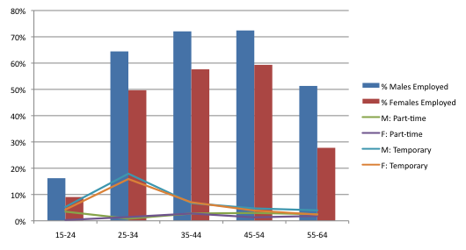
Source: Authors’ calculations, LFS (Q4, 2010).
Note: All rates are a percentage of the population.

There is minimal informal employment data available from MONSTAT and the LFS only contains a question addressing whether employees have a written, oral or no contract. Four percent of male and female workers do not have a written contract. Women represent 43 percent of all workers without a contract.
The male and female workforces have different distributions across sector and occupation groups. Eight of ten women work in service sectors, led by wholesale and retail; health and social work; and public administration. Figure 3.8 provides employment disaggregation by occupation type and gender. Although the largest proportion of employed males also work in wholesale and retail services, large numbers are employed in mining and manufacturing, transport and communications, and construction. It is important to separately highlight sectors in which females represent half of the workforce or more. Table 3.1 presents these female-dominated sectors. The most male-dominated sectors include construction, transport, manufacturing, mining, and electric/gas. Montenegro’s labor law effects women in this respect, Articles 104 and 105 limits women’s participation in industry and civil works and does not allow women to participate in night work, except under special circumstances.

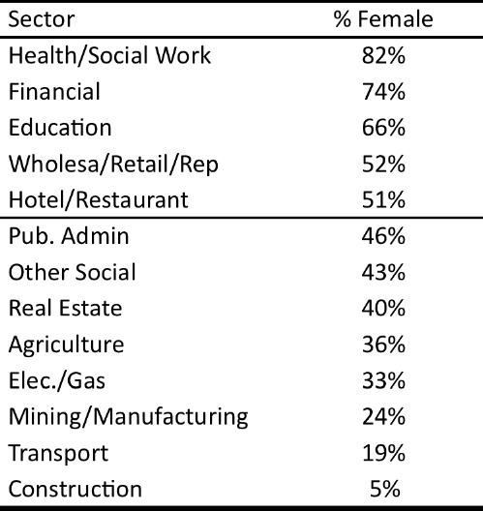
Table 3.1: Sectors with majority female workers.

Source: Authors’ calculations, LFS (Q4, 2010).

Fig. 3.8: Sector proportion of male and female workforce
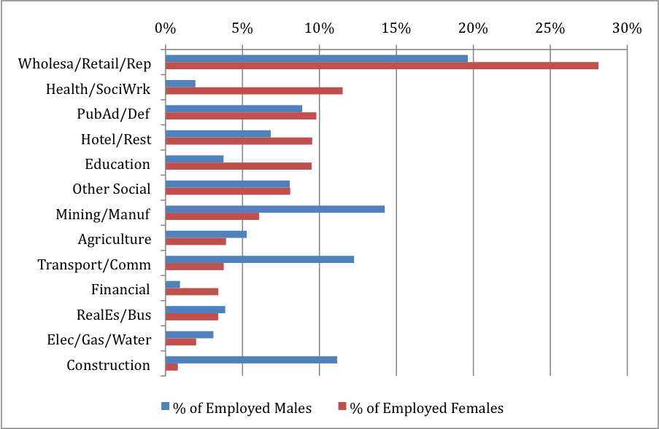
Source: Authors’ calculations, LFS (Q4, 2010).
Over two-thirds of females work in marketing, sales, technical, and professional occupations. Figure 3.9 provides a more detailed breakdown of the occupational makeup for each gender. Over half of males are employed in marketing, sales, machine operation, and crafts/trades. Table 3.2 shows the percent male and female of each occupation category. Females are underrepresented in the leadership occupations. However, most professionals, technical workers, clerks and sales/marketing are women. As discussed in the following sections, women are also underrepresented in firm ownership and management, as well as political representation and mayoral leadership.
Fig. 3.9: Occupational proportion of male and female workforce
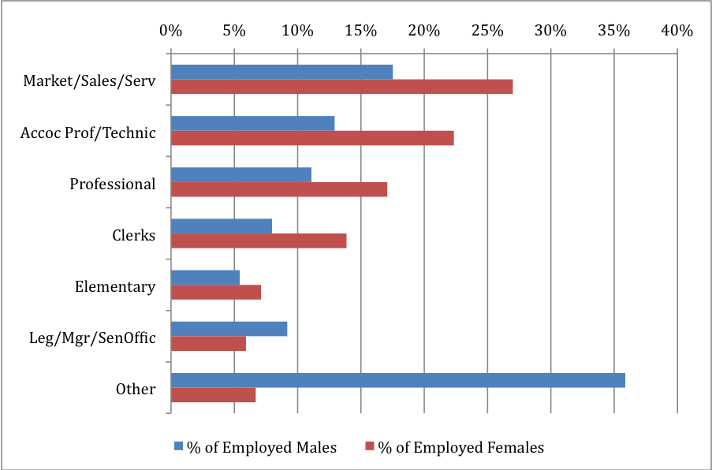
Source: Authors’ calculations, LFS (Q4, 2010).
Note: Other Occupations consists of Military, Skilled Agriculture, Plant and Machine Operators, and Crafts/Trades, all of which have too few female observations for calculation.

Table 3.2: Occupations with majority female workers
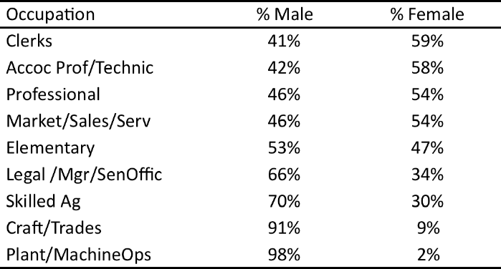

Source: Authors’ calculations, LFS (Q4, 2010).

3.4 Gender differences in wages
This section presents important differences that exist between what men and women are paid in their jobs. Descriptions of wage differences are presented for various subgroups to give a broad description of the labor market. As worker earnings, and gender differences in earnings, depend on a complex set of interactions between employers, market conditions, geography, and worker characteristics (including age, education, and household factors), a model controlling for these factors simultaneously, accounting for participation decisions as well, is also presented.
As educational attainment rises, male and female employment rates rise, the employment rate gap closes, but the differences between earnings for the highest educated is above 15 percent. As shown in Figure 3.10, the employment-to-population ratios (i.e. employment rates) are above 70 percent for tertiary-educated males and females. The largest gap in employment rate is for those with primary plus some vocational education, as 58 percent of males are employed compared to 33 percent of females. Regional differences in employment rates are also shown in Figure 3.10, Panel (b).

Fig. 3.10: Employment rates (employment-to-population ratio) and unadjusted wage gaps by education and area.
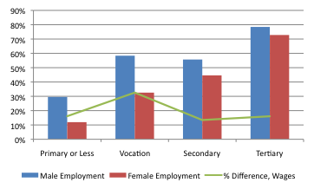 | 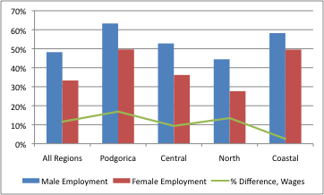
Source: Authors’ calculations, LFS (Q4, 2010).

Although women have achieved equal representation in the services sector, average female wages are 8 percent lower than males. Services, broadly defined, comprise 73 percent of all jobs in Montenegro and 85 percent of all female jobs. This female skew towards service jobs has led to parity in the service-sector workforce, a near 50/50 male-to-female balance. Jobs in industrial sectors represent 20 percent of all jobs, with only two of ten workers being female. Figure 3.11 Panel (a) highlights this difference. Panel (b) compares average male and female wages in these sectors. While female wages are approximately the same for both sectors, male wages are 8 percent higher in services and 17 percent higher in industry.

Fig. 3.11: Sector size and female representation (Panel (a)) and comparisons of male and female average wages (Panel (b)).
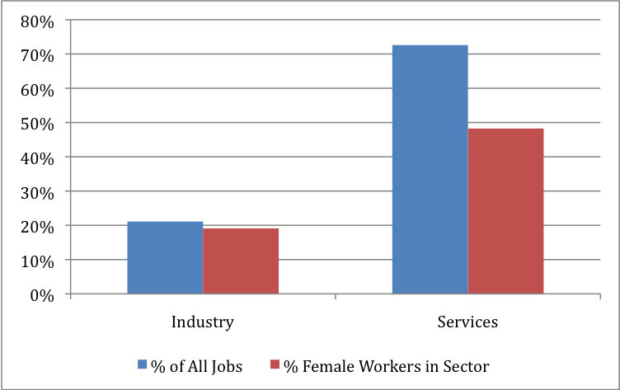(a) Sector size (by workforce) and percent female workers. | 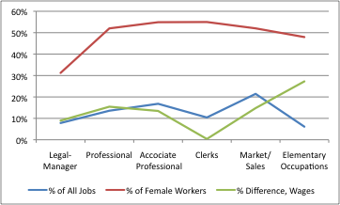  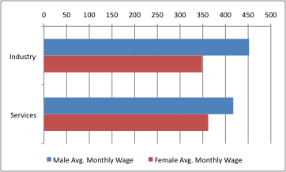  (b) Male and female wages by sector.
Source: Authors’ calculations, LFS (Q4, 2010). Gender differences in hours worked are not statistically significant (approximately 43 hours per week); monthly wage differences in Panel (b) are statistically significant.

That is not to suggest that the wage gap is largest for male-dominated sectors. When disaggregating the overall services sector, the female wage gap is actually the largest for two female-majority sectors – health/social work and wholesale/retail trade. Table 3.3 shows the three sectors with the largest, statistically significant, wage gaps and restates female representation.
Despite their high participation (nearly 40 percent of employed women) in health and wholesale/retail, women experience the largest wage gaps in these female-dominated sectors and earn approximately 20 percent less than men. It should be noted that women earn 20 percent less than men in mining and manufacturing, and represent 24 percent of the mining and manufacturing workforce.
Table 3.3: Sectors with Largest Wage Gaps and the Percent of Female Workers in the Sector.
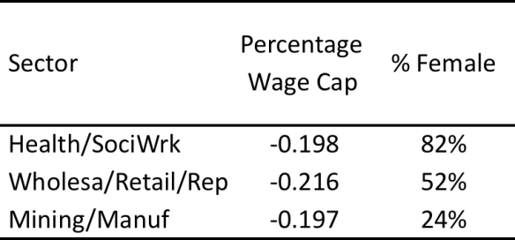

Source: Authors’ calculations, LFS (Q4, 2010).
Note: Largest, statistically significant (at 5%) gaps are shown.
The presented wage gaps are unadjusted.
Differences controlling for other factors are presented in the next section.

A higher percentage of females are employed in the public sector compared to males (41 percent compared to 31 percent). Public-sector jobs have a lower gender wage gap than private-sector jobs. Over one-third of employed persons work in the public sector or for a government-owned enterprise. Fifty-two percent of workers with tertiary education are in the public sector, of which 65 percent are females. In a survey of job preferences and the ability to find jobs, women report they would choose to work in a publicly owned or government enterprise at higher rates than men. Wage decomposition results suggest that the earnings gap is 11.8 percentage points lower for female workers in the public sector and 17.4 percent lower for females in the private sector (FREN 2013, p. 25). In this sense, public sector jobs are more desirable for females than private-sector ones. The possible effects of regulated salary scales in the public sector in countering unobservable factors that favor males (in terms of wage decompositions above) should be considered for future research.
Female-dominated occupations also have large gender earnings gaps. Also shown in Table 3.4, the earnings gap is over 13 percent for professional, marketing/sales, and assistant professional/technical occupations. Moreover, the gap is 27 percent for elementary (low-skill) workers, who are paid approximately half of professionals, on average. Figure 3.12 shows how female participation in each occupation and overall occupation size relate to average monthly earnings for men and women.
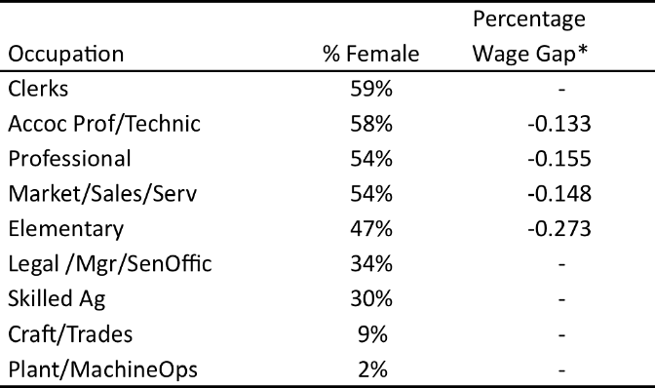
Table 3.4: Occupations with majority female workers.

Source: Authors’ calculations, LFS (Q4, 2010).
Note: Wage gap only included for occupations with a gap that is statistically different from zero.
The presented wage gaps are unadjusted.
Differences controlling for other factors are presented in the next section.

Fig. 3.12: Occupation size and female representation Panel (a)) and comparisons of male and female average wages (Panel (b)).
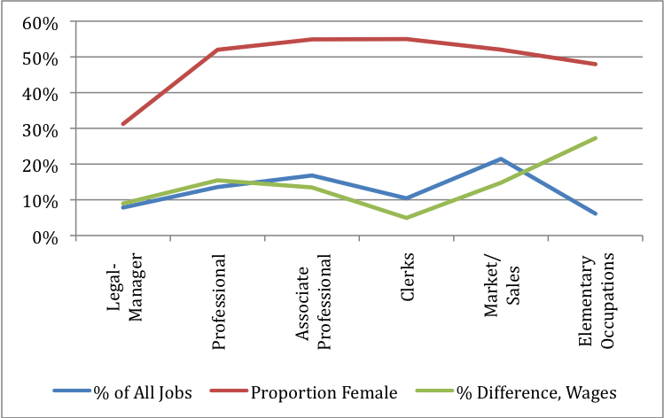(a) Occupation size (by workforce) and percent female workers. | 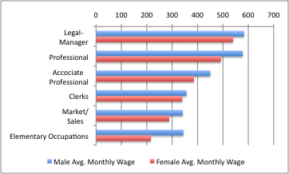  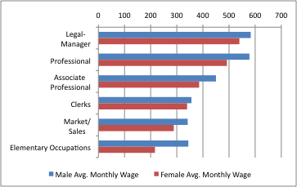  (b) Male and female wages by occupation.
Source: Authors’ calculations, LFS (Q4, 2010).

After simultaneously controlling for the educational, occupational, and sector makeup of the labor force, the adjusted gender earnings gap is estimated to be 16.1 percent (FREN, 2013, p. 13). Estimates also account for gender differences in the probability of labor force participation, which were described in the discussion above and may affect earning potential.
Decomposition of the gender earnings gap shows that differences in observable characteristics account for very little of the difference in pay. Using a two-step Heckman selection model and Blinder-Oaxaca methodology, a recent study separates the gender earnings gap into two pieces: an endowment effect that is explained by observable differences in male and female characteristics (i.e. age, level of education); and a coefficient effect that is explained by differences in male and female returns to these characteristics (i.e. the effect that increasing experience or attaining higher education has on increasing ones wage). Regarding the endowment effect, the gender wage gap would not decrease if females had similar observed characteristics to males. As shown above, female workers have higher educational attainment and have lower participation in low-paying rural areas than male workers. On the other hand, males work in higher-paying sectors (i.e. industry) and occupations (i.e. management) at higher rates than females. Were female workers to have these combined characteristics of male workers (i.e. lower education but male occupation distribution), average female earnings would not be expected to rise (ibid., p. 14).
On the other hand, gender differences in the returns to higher educational attainment, tenure, and the sector breakdown of workers serve to increase the gap. If female workers had similar returns to these characteristics, then female wages would increase by approximately 4 percentage points (FREN 2013, p. 16). For example, male workers in Montenegro receive a higher wage increase for an additional degree or an additional year of tenure than female workers do (ibid, 2013, p.14).
Additionally, unobserved differences in male and female workers account for 75 percent of the wage gap, (ibid. p. 16). These factors may not be measured in the available data but may include barriers that keep females from working the same hours or jobs as male workers or potential discrimination by employers. Previous discussions on differences in education type, family responsibilities, ethnicity differences, and cultural roles may inform the interpretation of these unobservable factors.
The gender wage gap has changed considerably in the past five years. Wage gap analysis over time shows a decreasing gap (adjusted and unadjusted) from 2008 to 2010 followed by an increase in 2011, shown in Figure 3.13 (FREN, 2013). After 2011, the gap fell sharply from 18.2 percent to 12.2 percent. A number of factors may be influencing this trend. First, the labor force participation rate for men, discussed in the previous section, has fallen sharply for industrial workers, where the gender gap is greater relative to the service sector. If this represents a long-term shift in the economy from industry to services, the wage gap would be expected to remain low. However, if the relative drop in the industrial workforce (and relatively greater job loss experience by male workers) is due to factors related to the global recession, then the wage gap may begin to rise with economic activity.
Second, legal changes may have caused the sudden drop in the wage gap. In 2011, the minimum wage increased from 55 euro to 147.50 euro (U.S. Dept. of State, 2010, 2012c). Female workers are more affected by the minimum wage change as they make up a larger proportion of low-wage workers (see Figure 3.14 below). However, causal effects of the minimum wage law need further econometric study, especially to distinguish this from the possible effects of the global recession on the gender pay gap. Minimum wages are expected to increase to 193 euros starting in April 2013 (Sredanović, 2013). Investigations of the dynamic effects that these changes have on labor outcomes should be made a high priority, considering the high labor non-participation and unemployment rates of female workers.
Fig. 3.13: Gender wage gap, Q4 2008 to Q4 2011
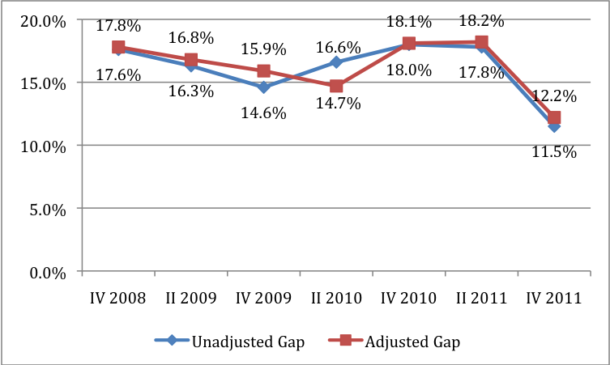
Source: FREN, 2013 (Graph 6.13, p.21).

The earnings gap is highest among top earners. Figure 3.14 describes inequality by looking at the bottom-, middle-, and top-third of earners separately. In the left panel, women are shown to be greatly overrepresented among the bottom-third of wage earners, and underrepresented in the top third. The right panel compares average male and female wages, showing that the difference grows at higher earnings levels. Quantile regression suggests that the percentage difference in male and female earnings also increases for higher-earning workers, from 12.6 percent for the bottom-third, 11.8 percent for the middle, and 14.4 percent for the top-third. Other research estimating Blinder-Oaxaca decomposition for low- and high-earning males and females also finds evidence of an increase in the earnings gap moving up the wage distribution, moving from 13.8 percent earnings gap for the bottom quintile of earners to 16.2 percent for the top quintile (FREN, 2013, p.20).

Fig. 3.14: Female percentage of employment and gender wages gaps, by wage tertile.
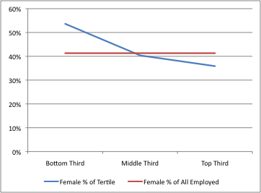 | 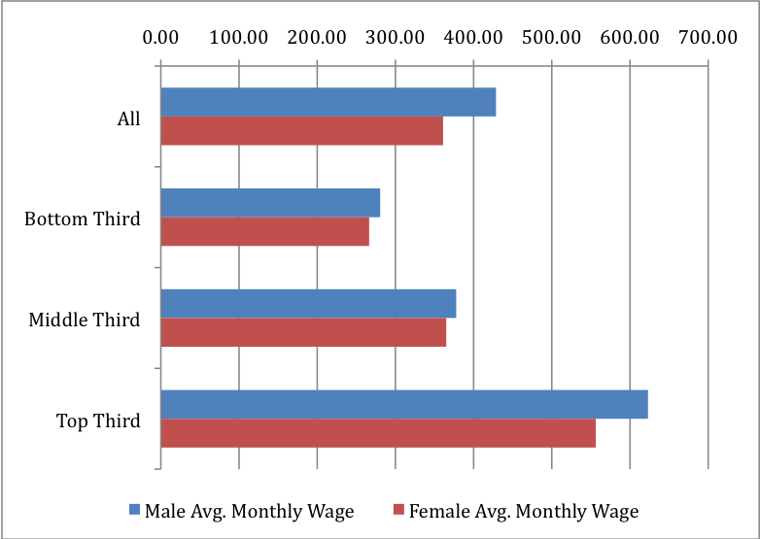
Source: Authors’ calculations, LFS (Q4, 2010).

As shown in the descriptive statistics of the health sector above, despite women forming over 80 percent of workers, they are not represented in the highest-paying jobs and make 20 percent less than men on average. In education, females make up 66 percent of all jobs, shown above in Table 3.1. However, only 26 percent of education directors are female (MONSTAT, 2012, p. 55).
While there is little gender difference in reporting dissatisfaction with a job, about half of individuals report that the economic crisis reduced either hours or wages for someone in the household. This response does not vary by gender for the overall population, but females with a tertiary education report higher rates of hours/wage reduction than males with the same education (70 percent compared to 48 percent).

3.5 Entrepreneurship
Self-employment is a large part of the economy, especially among low-earning workers. Twenty-two percent of employed males are self-employed compared to 12 percent of employed females. Self-employment rates are much higher for workers with lower education (42 percent of workers with a primary education or less). Self-employment is also much more common in rural areas, making up 29 percent of all employment compared to 12 percent in urban areas. Figure 3.15 shows the large gender difference in self-employment for rural and urban groups. Self-employment is higher for certain sectors: over half of self-employed workers in Montenegro work in the agriculture and wholesale/retail service sectors. As shown in Table 3.5, many of the sectors with large percentages of self-employed workers are predominantly male, while predominantly female sectors (i.e. health and education) have low rates of self-employment.
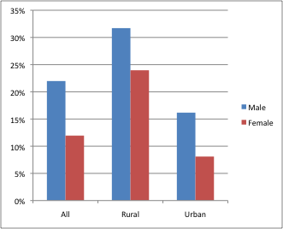
Fig. 3.15: Percent of workers self-employed

Source: Authors’ calculations, LFS (Q4, 2010).
Opportunities for self-employment in agriculture and farm management are much lower for women. Approximately 16 percent of the population is hired on farms, 40 percent of whom are female and 23 percent are over the age of 65. While female workers hold a large proportion of farm jobs, farm holders are 87 percent male (MONSTAT, 2012, ppg. 95-96). The large gender gap in farm ownership is similar to large gaps seen in female ownership and management of firms in other sectors, discussed in the next section.
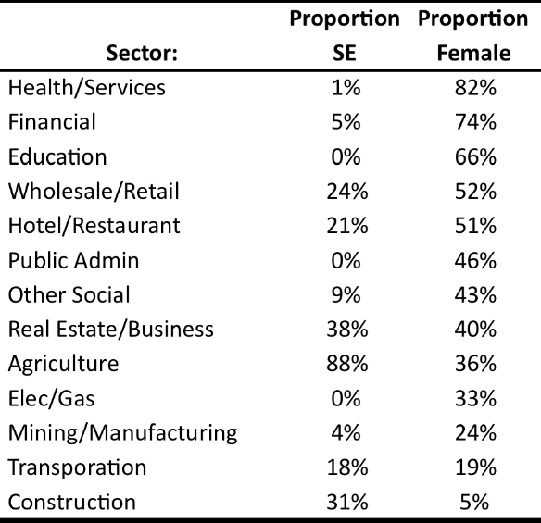
Table 3.5: Percentage of self-employed and females working in various Occupation Types

Source: Authors’ calculations, LFS (Q4, 2010).
Females report they would prefer to be self-employed less often than males (-7 percentage points). However, the direction of the gap differs by subgroups. While Orthodox Christian women have an 11 percentage point lower preference rate for self-employment than men, Muslim women have a 7 percentage point higher rate of preference. Females with a secondary or tertiary education have lower rates of self-employment preference than men, while females with a primary education have higher rates than males.
Gender differences in both the preferences for starting a business and the constraints to doing so are critical to understanding inequality in entrepreneurship. Do females want to start small-, medium-, or large-scale businesses in the same way males do? Do females have less access to the necessary inputs to start businesses? Findings presented in the previous paragraphs suggest that constraints (i.e. lower farm holdings) and preferences (i.e. lower measured desire to self-employ) may combine to play roles in lower self-employment. Ownership of financial and physical assets, access to banking services, and maneuverability within the regulatory environment partially dictate the ability to start one’s business, be it small or large. The findings for Montenegro are mixed in this area, as described in the previous section. On the one hand, evidence suggests that access to banking and financial services does not differ greatly by gender. However, female-headed households have lower asset ownership; asset ownership may be helpful for starting a business. Additionally, lower second-home ownership may suggest differences in inheritance and ownership laws that affect intergenerational asset accumulation. Both findings also suggest that women potentially have less ability to use assets as collateral for business financing. As such findings are preliminary; more research is needed on the barriers to female entrepreneurship.
In a survey of 116 Montenegrin firms, 26 firms were female owned and 20 had a top female manager. Regionally, Montenegro ranks eighth out of 30 countries in terms of the percentage of firms with a female top manager, shown in the left panel of Figure 3.16. On the other hand, Montenegro ranks 26th of 30 countries in terms of the percentage of firms with a female among its owners. According to responses to the LiTS (2010) survey, females report lower rates of business startup than males (-9 percentage points), with especially large differences for rural females (-14 percentage points), those in the Eastern region (-18 percentage points), and Muslim females (-20 percentage points). Females rate themselves as less willing to take risks than males, with a 13 percentage point higher rate of males reporting “somewhat” to “very much” willingness to take risk.
To reduce gender inequality in self-employment and entrepreneurship, the Government of Montenegro has focused its measures towards specific groups of women (APAGE, 2013, ppg. 59-67). These groups consist of women starting private business and owning small and medium enterprises (SME’s), women in rural areas and agriculture, and those who are hard-to-employ. It aims to provide a strategy for women entrepreneurship; create a database on women entrepreneurship; provide tax incentives for women who are self-employed, entrepreneurs or women in agriculture; train women starting business or owning SME’s; and promote the visibility of women who are self-employed or entrepreneurs through fairs, the media and the observance of the International Day of Women Entrepreneurs (ibid.). Special provisions have been made for rural women, women in agricultural areas and the hard-to-employ – these include financial support, assistance in diversifying rural economies and the launching of craft cooperatives (aimed particularly towards the hard-to-employ) (ibid.).

Fig. 3.16: Comparison of Montenegro to the region in terms of the percentage of female-managed and female-owned firms.
% Firms with Female Top Manager | % Firms with Female Owner
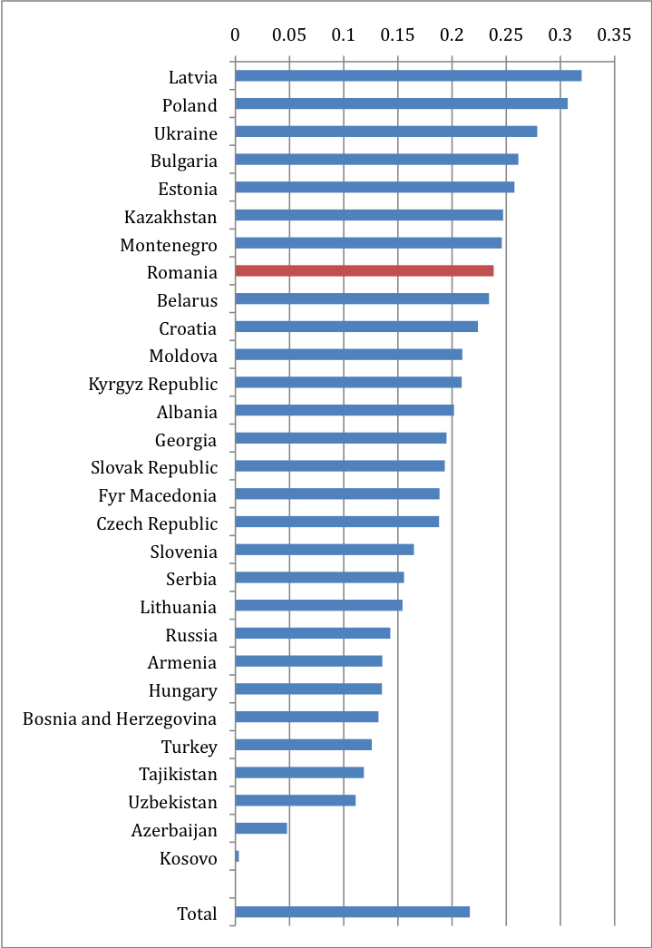 | 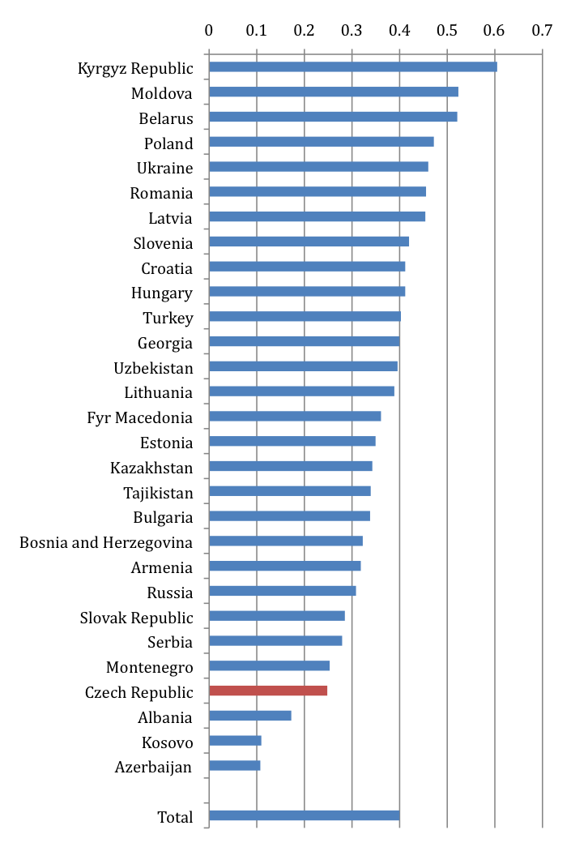
Source: Authors’ calculations (BEEPS, 2009).

3.6 Summary
Participation:

- Labor force participation for women is lower than many countries in the region and lags behind the EU average by 12 percentage points. Female participations rates are 11 percentage points lower than males, 55 percent vs. 66 percent, a gap that has decreased since 2009.
- Male participation dropped between 2010 and 2012, with a large number of jobs being lost in high-paying industrial jobs. Whether this reflects a long-term trend or a more intermediate result of the global recession is a question for further research.
- Inactivity gaps in rural areas are twice the rate of the rest of the country, similar to educational attainment gaps for these areas.
- A larger proportion of inactive women do not work due to family duties compared to men, especially among people ages 25-34 and 35-44 and those with less than a primary education.
- Having children lowers the probability of female participation but increases male probability. Living in an urban area increases the probability of female participation but has no effect on male probability, controlling for other factors. Additional education increases the probability of participation for both sexes. Overall, being female is related to a 21 percentage point lower probability of participating in the labor force.

Unemployment:

- Overall unemployment is 21 percent for women and 19 percent for men. Unemployment gaps are largest for younger workers. Among those between ages 25-34, 30 percent of unemployed females have a tertiary education compared to only 9 percent of males.
- High rates of male and female workers are seeking their first job and even higher rates have been seeking work for a year or more. Females contact public employment offices and search advertisements at higher rates than males.

Employment and wages:

- After controlling for the educational, occupational, and sector makeup of the labor force, the adjusted gender earnings gap is estimated to be 16.1 percent. A gap of twelve percent is determined by factors not included in the model, possibly relating to variables that are difficult to measure, such as discrimination or constraints that keep women from working certain jobs.
- Eight of ten women work in service sectors, led by wholesale and retail; health and social work; and public administration. Over two-thirds of females work in marketing, sales, technical, and professional occupations.
- Females are underrepresented in leadership occupations, as well as craft, operations, and elementary jobs. However, most professionals, technical workers, clerks and sales/marketing workers are women.
- As educational attainment rises, male and female employment rates rise and the employment rate gap closes. Differences between earnings for the highest educated are above 15 percent.
- Although women have achieved equal representation in the services sector, average female wages are 8 percent lower than males in these sectors.
- Despite their high participation (nearly 40 percent of employed women) in health and wholesale/retail, women experience the largest wage gaps in these female-dominated sectors and earn approximately 20 percent less than men.
- Women over-represent the bottom-third of workers and under-represent the top third. The earnings gap is highest among top earners.
- Recent changes in the minimum-wage law may have lead to reductions in the gender earnings gap. However, the role of such laws must be disentangled with effects due to relatively higher job losses in predominantly males sectors – the loss of such high-paying jobs may also have the effect of reducing the wage gap.

Entrepreneurship
- Over one-fifth of male workers are self-employed, mainly in management, legal, and skill agriculture occupations, compared to one-tenth of female workers.
- Montenegro ranks eighth out of 30 countries in terms of the percentage of firms with a female top manager and 26th of 30 countries in terms of the percentage of firms with a female owner.

4. Agency
The perception that women face major obstacles to equality and agency in Montenegro is widely held among government and non-government advocates. The United Nations Convention on the Elimination of Discrimination against Women (CEDAW) Committee highlighted a number of barriers, and the Montenegrin government’s progress and shortcomings in adopting new legislation and institutional reforms in response to these obstacles (CEDAW, 2011). In interviews with various government officials and advocacy groups, USAID lists a number of potential constraints on agency, highlighting a widely held view that social norms and stereotypes serve to hinder female agency (USAID, 2010). Box A2 describes the legal frameworks implemented to promote greater equality.
However, little data is available to identify actual constraints on women’s agency in Montenegro, the prevalence thereof and their effects on other aspects of life. Likewise, little empirical research has been performed to estimate such effects and inform the positions of government and non-government advocates.
This section uses the available data for Montenegro to identify and describe areas of concern that require greater understanding and to pinpoint specific indicators and research needed to inform policy. Agency, broadly defined, is the ability of a person or group to achieve goals for their lives. Such autonomy is an important aspect of wellbeing in and of itself. As such, indicators of agency, or the deprivation thereof, are important measures of a person’s overall wellbeing. Furthermore, agency is the process by which people transform their endowments into desired outcomes by making use of economic opportunities (WDR, 2012, p. 6). In this sense, agency acts as a means to attaining greater wellbeing in other aspects of life. The discussion which follows covers a number of areas related to agency and includes: the justification for studying each area based on available evidence in Montenegro; the related research that supports studying the area; the types of indicators needed to better measure deprivation or constraints to agency; and the potential links to other areas of life that constraints on agency may affect.

Box A1. Institutional and Legal Framework for Gender Equality

Various laws in Montenegro promote gender equality. For example, the Constitution of Montenegro guarantees the equality of women and men and the development of policy of equal opportunities by the state (Article 18, the Constitution of Montenegro, Official Gazette 1/2007). It also states that all statistical data collected by the state and private sector, must be gender disaggregated and should be part of the state statistical records and accessible to the public in accordance with the law (Article 14, ibid). The Law of Gender Equality (Gazette 46/07) establishes the methods by which gender equality rights will be provided and implemented; in this regard the role of the Ministry for Human and Minority Rights is defined; and a framework for the creation of the Action Plan for Achieving Gender Equality (APAGE) is established. It is to be developed within the context of Montenegro’s accession to the EU, national strategies and international conventions and treatises. The Law on the Protection against Domestic Violence defines forms of violence, the rights of victims, types of victim protection and penalty provisions.
Between 2010 and 2011, the following laws were instituted to specifically combat domestic violence. The Law on Protection from Domestic Violence was the first to state punishments for perpetrators of family violence. The Strategy for the Fight against Family Violence and the Protocol on the Rules of the Procedure of Institutions was another set of reforms. The government has also embarked on a yearly campaign called “Sixteen Days of Activism against Violence against Women” in cooperation with non-governmental and international organizations (CEDAW, 2010, p. 31). In drafting the domestic violence portion of the Action Plan for the Achievement of Gender Equality in Montenegro, Montenegrin government worked closely with a non-governmental organization assisting victims of domestic violence (ibid., p. 31).
The extent to which the legislation has been effectively implemented is unclear and reports from international agencies and NGO’s raise concern. The United Nations Convention on the Elimination of Discrimination against Women (CEDAW) Committee has drawn attention to: (1) the lack of gender disaggregated data and qualitative data on the situation of women in areas covered by the Convention; (2) questions over the legal complaint mechanism provided in the Law on the Prohibition of Discrimination; (3) limited financial and human resources of the Gender Equality Office and non-cooperation of the majority of municipalities to establish gender equality structures and develop local action plans; (4) slow implementation of gender equality plans; and (5) ongoing discrimination and violence against women and low participation of women in political and public life (CEDAW, 2011). Inadequate protection of women victims of violence has also been highlighted (CEDAW, 2011; US Dept of State, 2012b). The Government of Montenegro seeks to address some of these concerns in the APAGE 2013-2017.
For instance, the APAGE 2013-2017 proposes the following to combat domestic violence, developing implementation strategies for existing measures, educational programs, and data collection to aid the reduction of domestic violence (APAGE, 2013, ppg.82-94). The plan highlights: (i) the implementation and monitoring of the Strategy for the Protection against Domestic Violence; (ii) the maintenance of statistical records and plans to research the causes, impact and consequences of violence against women and domestic violence; (iii) the strengthening of support and protection for victims of violence ; (iv) and awareness campaigns on gender-based violence and its consequences.

4.1 Moving toward a fuller analysis of agency
Domestic Violence
Domestic violence is seen as a key barrier to gender equality. USAID reports that interview respondents widely held the view that domestic violence affects many families and that the media fails to present the victims in a positive light or challenge discrimination (USAID, 2010, p. 9). A number of other indications of the type of domestic violence are found in the context of Montenegro:
- Abuse is usually recurrent and linked to alcohol usage by the abuser (ibid., p. 9). According to National Health Survey (NHS) findings, presented above, alcohol usage in Montenegro is on the rise and is more prevalent among men (IPSOS, 2012). Recent public opinion poll findings suggest that Montenegrins also perceived abuse of family power, addiction diseases, economic crisis and a patriarchal society to be factors causing family violence (CEED, 2012, p3).

- Thirteen percent of respondents to the CEED survey have personally experienced family violence and 38 percent have known someone in their community who was a victim of violence (13% and 38% of respondents respectively) (CEED, 2012, p. 5).

- Of female victims of domestic violence who were interviewed for a study on domestic violence, most indicated that their perpetrators were spouses (67% of respondents) or former spouses (22% of respondents). Another study also identifies partners as perpetrators. Although there are high rates of family members’ knowing about the abuse (81% of respondents stated that family members had such knowledge), relatively few victims receive assistance (29% of respondents received protection, 25% of victims (and their children) were offered shelter and 12% had a police report filed as a result) (CEED, 2012, p. 6). Another finding of the study suggests two barriers to women’s ability to leave an abusive relationship, and hence female agency: the perpetrators’ control over assets and threats to women’s lives. Twenty-seven percent of respondents experienced family violence as children.

- Table 4.1 provides 2006-2009 data from Montenegro’s Police Directorate showing women and children as the typical victims of violence and men the perpetrators. Based on 2008 data from the Social Welfare Center on the number of women victims of violence (by age, employment status, marital status and education), the highest numbers of victims were unemployed, married, and or had no more than an elementary school attainment (CEDAW, 2011, p.29). Figure 4.1 provides the total number of cases of domestic violence reported to social welfare centers by type (man, woman and child victim) for 2011.

- The CEDAW committee cites the following as major areas of concern: high incidences of family violence (data provided in Table 4.1); lenient sentences to offenders; perceived problems with the prosecution of marital rape; lack of state-run women’s shelters, rehabilitation clinics and support of NGO’s working in the field; and the lack of other forms of assistance to victims of violence, including protection orders (CEDAW, 2011, p.5).

Table 4.1. Domestic violence statistics from the Police Directorate
 | 2006 | 2007 | 2008 | Jan-Nov 2009
# of criminal offences of DV and family violence reported | 511 | 565 (10.5 % incr. from 2006) | 507 (10.3% decr. from 2007) | 395
Based on data for criminal charges
# of criminal charges filed with prosecutors | 499 (against 514 persons) | 556 (against 580 persons) | 503 (against 520 persons) | 394(against 406 persons)
% of male perpetrators | 95% (187 or 36.4% were reoffenders) | 95% (255 or 44% were reoffenders) | 94% (212 or 40.8% were reoffenders) | 95% (144 or 35.5% were reoffenders)
Total of DV violence victims | 571 | 676 | 561 | 429
% of female victims | 78% (approx 445 cases) | 72.9% (493 cases) | 81%(454 cases) | 77% (359 cases)
% juvenile victims | 9.3% (53 cases- 50% were children under 14) | 8.1% (55 cases - 72% were children under 14) | 8.4% (47 cases - 25.5% were children under 14) | _
Source: Police Directorate (as cited in CEDAW, 2010, p 29)
Figure 4.1 Number of cases of domestic violence reported to social welfare centers by type for 2011.
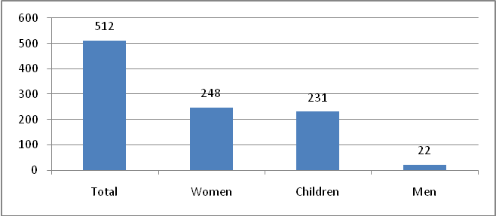
Source: Social welfare centers (as cited in MONSTAT, 2012, p122).
There is a lack of research and disaggregated data on domestic violence. Better information on the prevalence of violence is needed. A number of links between domestic violence and various spheres of economic life have been found in other countries but should be analyzed in greater detail for Montenegro. These include: the links between asset accumulation by women and incidences of domestic violence and the intergenerational transmission of family violence. For Montenegro a link between family violence and education and employment has been suggested and should be further explored. Social norms regarding domestic violence are unclear and more qualitative research is needed.
Human Trafficking
The Trafficking Victims Protection Act (TVPA) indicated that Montenegro does not meet minimum standards to stop trafficking and has significant or significantly increasing cases of severe forms of trafficking. Montenegro is, however, making efforts to bring about compliance. The CEDAW committee and the US Department of State have also communicated problems with the exploitation of prostitution, which is illegal in Montenegro. Victims include women and girls from Eastern Europe and other Balkan countries (like Serbia and Kosovo), who were frequently used for sex trafficking. The US Department of State suggests that the severity of the problem has been underreported due to the position of the government that trafficking incidences were “isolated” and “not prevalent” (US Dept of State, 2012b, p. 54). Underreporting may also be due to missing protocols and limited capacity of authorities to identify victims, especially among vulnerable groups, such as Roma, Ashkali and Egyptian (RAE) women and girls, displaced women, prostitutes, and unaccompanied or street girls (CEDAW, 2011, p. 6; USAID, 2010, p. 14). As such, the government has only identified one trafficking victim for 2011 (US Dept of State, 2012b, p. 254).
Concern has also been raised regarding the low number of prosecutions and lenient sentencing given to traffickers; no offenders were prosecuted during 2011 (CEDAW, 2011; US Dept of State, 2012b). Police complicity has been linked to sex trafficking and prostitution. Victim protection and compensation is also lacking; NGO’s have reported the lack of government protective action for potential victims brought for social work (CEDAW, 2011; US Dept of State, 2012b). The CEDAW committee suggested that Montenegrin government could benefit from increasing cooperation with NGO’s to improve monitoring of trafficking violations and notes the implementation of the National Strategy and the Action Plan for the Fight against Trafficking in Human Beings (CEDAW, 2011, p. 6).
Inheritance and Access to Assets

Gender indicators for Montenegro and Serbia in 2009 suggest disparities in inheritance and women’s access to land. The inheritance indicator measures the extent to which inheritance practices are in favor of men (a level between 0=no and 1=yes), the measure for Montenegro and Serbia was 0.5. The women’s access to land indicator measures the extent to which women have access to land ownership (between 0=full and 1=impossible), the measure for Montenegro and Serbia was 0.5. Figure 4.2 shows these indicators for Serbia and Montenegro as compared to four other Western Balkan countries. The score of zero for Bosnia and Herzegovina and Moldova suggest equality between men and women in these areas.

Figure 4.2 Inheritance and women's access to land indicators for four Western Balkans countries.

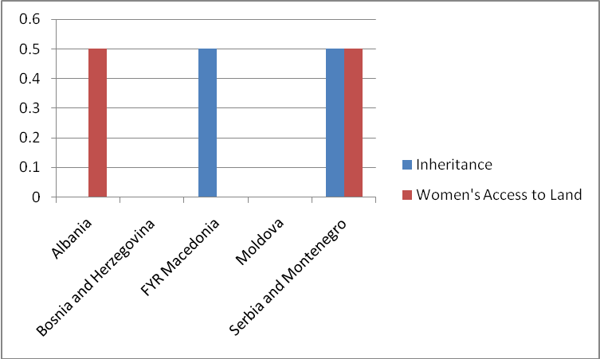
Source: OECD. Gender, Institutions and Development Database 2009

Reports based on in-country interviews suggest that women’s ability to generate income and accumulate assets may be constrained by gender-biased social norms regarding inheritance (USAID, 2010, p. 15). Although Montenegro’s laws call for the equal division of inheritance among children of both genders, USAID respondents suggest that inheritance favors males in practice. The report asserts that women typically do not receive inheritance; instead this goes directly to or is passed along to male heirs (ibid., p. 15).
Quantitative data could help discern gender gaps in receiving inheritance. This relates to the need for research on female ability to accumulate assets more generally. Preliminary findings using the LiTS survey data indicate that females have a lower ability to accumulate assets but more directed research is required to determine control over such resources and the effects they have on the wellbeing of children, female bargaining power, and the ability to engage in entrepreneurship.
Family Decisions
Forced and arranged early marriages still occur among Roma, Ashkali and Egyptian (RAE) communities. Girls and boys subject to these marriages are usually between 14 and 16 (CEDAW, 2011, p. 10). The US Department of State has also cited cases where RAE children have been forced into servile marriages (US Dept of State, 2012b, p. 254). Little data is available with regard to the prevalence of these marriages.
There are limited findings on the impediments to both family formation and the ability to enter or exit a marriage. The CEDAW committee and Blagojević (2012) have identified a number of issues as potential problems for single mothers in Montenegro. The CEDAW committee highlighted a lack of government support programs for single mothers and their children and their perception that these women were more susceptible to discrimination and abuse (CEDAW, 2011, p. 9). The issue of single parents and motherhood is recognized in Montenegro’s APAGE (Goal 4.4.7).
Better data on early marriage is needed to identify the extent of this human rights violation. Evidence from other countries suggests that freedom over family formation and the ability to choose when to enter a marriage can be linked to educational and economic outcomes for women. Analytical research into these areas is needed for Montenegro.
Political Leadership and Participation
Montenegro’s women are highly underrepresented in positions of leadership (in politics, the public service and education, the judiciary, trade unions, firms and media). In 2009, women represented 11 percent of Members of Parliament (9 of 81 MPs), 6 percent of the cabinet (1 of 17 ministers), 15 percent of municipal councilors (92 of 632 councilors) and 5 percent of mayors (1 of 21 mayors) and women held no parliamentary positions in Committees for Security and Defense, Economy and Finance, Tourism and the administrative committee (2009 Gender Equality Office data as cited in CEDAW (2010, ppg. 33-39) and CEDAW (2011, p. 6)). This gender disparity carries into political parties’ leadership and internal bodies, trade unions’ leadership as well as senior positions in the public service and media. Consistent with findings in the economic opportunities section, despite female-dominance in the education sector, most school principals are male (CEDAW, 2011, p. 6). There are few women leaders in media; they form 20 percent of managers, 41 percent of editors, 22 percent of chief editors in press and media and 25 percent of chief editors in television (Pesic (2010) as cited in USAID (2010, p. 9)).

In the judiciary there are few women leaders, however the President of the Supreme Court is female and there is a larger representation of women in general in this sector compared to others. The judicial council is run by a women, and women represent one third of the council itself (3 of 9 members) (ibid., p. 37). Twenty-seven percent of Supreme Court judges, 25 percent of prosecutors in basic courts and 62 percent of deputy prosecutors are female.

Figure 4.3. Percent of Women Members in National Parliament
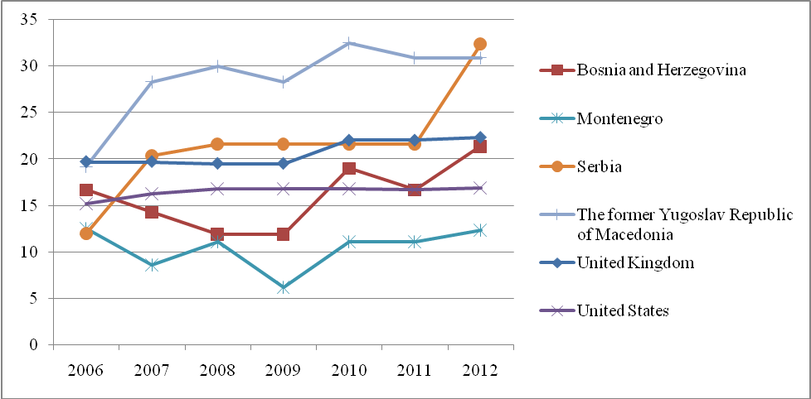
Source: UNECE

Between 2006 and 2012 Montenegro’s percent of women members of parliament (MP’s) was steadily low compared to other countries in the region (Figure 4.3). Data from a sample of countries from the region (Bosnia and Herzegovina, Serbia and Macedonia) reveals that women’s participation in general was below 35%. However, most of these countries experienced an increase in women MP’s, whereas Montenegro stayed in the 5-15% range. The relative increase from 2006-2012 was particularly notable for Serbia followed by FYR Macedonia, investigations into these countries’ policies could potentially provide direction as to mechanisms for improving Montenegro’s women’s participation in leadership. When compared to OECD countries, the US and UK which were in the 15-25% range, Montenegro was not lagging as far behind (Figure 4.3).
The barriers keeping females out of political positions of leadership have yet to be clearly identified. Research suggests that educated women are more likely to become members of political parties than uneducated women and that rural woman participated less than urban women, although participation for both was low.

Gender differences in political participation are larger in some parts of Montenegro. For instance, there is greater female participation in Primorje and more male participation in Podgorica. However, more females, especially rural women, women 18-24 and those with a primary education or less, state that they will never partake in these activities. For the Podgorica and Primorje regions, large gender differences exist in the rates of political participation, including demonstrations, strikes, joining a political party, or petition. In Podgorica, a lower rate of females report having participated in these activities (21.4 percent compared to 31.5 percent of men), while in Primorje higher rates of females reported participation (33.7 percent of women compared to 14.9 percent of men). Forty-six percent of women compared to 34 percent of men reported that they would never participate in these activities. This gap is especially large for rural women, women 18-24 and those with a primary education or less. Various initiatives to improve the participation of women in politics and women’s networks have been implemented but little information exists as to their effects.
Gender disparities in leadership and participation in politics, public life and media are addressed in the APAGE 2013-2017 as follows. In the areas of politics and public life, the Government of Montenegro will redefine the quota system in the Law of Election of Councilors and MP’s; create public awareness of the Europe Resolution (2003) for the balanced participation of men and women in political life; disperse gender disaggregated statistics on positions of legislative and executive power on the state and local level; apply the CEDAW recommendation on implementation of Article 10 of the Law of Gender Equality; and empower political parties to introduce gender equality into their programs and statutes (APAGE, 2013, ppg.103-111). The Government of Montenegro has also committed to encourage (through media campaigns) and train young females of ethnic minorities and Roma women to engage in politics (ibid.). The Ministry of Defense and Internal Affairs has been given the mandate to implement Resolution 1325 of the UN Security Council to incorporate women in peacekeeping and security operations (ibid.). In media, the Gender Equality Department and Ministry of culture are to: co-finance programs and projects and create workshops promoting gender equality in the field of culture; and create ongoing programs to promote successful women in electronic and print media and science (APAGE, 2013, ppg.99-101).

Social Norms and Attitudes
Available research presents a strong perception that social norms, cultural roles, and stereotypes are major barriers to women’s agency. Respondents to USAID interviews suggest that norms and stereotypes assign women the role of family caregiver and men the role of household head (USAID, 2010, p. 14-15). While respondents view such roles as being entrenched in the North, they expressed signs of greater flexibility in the South and Podgorica (USAID, 2011, p 14). Respondents also expressed the opinion that most people in Montenegro do not view gender issues as a priority despite their potentially harmful effects on women (ibid., p. 14). Montenegrin government has taken some initiatives to address social norms. The extent that norms and attitudes play to constrain agency is difficult to measure, as are the effects that constraints on agency have on other spheres of life. The possible “modernization” or movement away from traditional views of the female role is also difficult to measure. While the information on education and labor markets presented in previous sections does not dispute the hypothesis of a bias against females in some segments of Montenegro, the direct effects of such bias and discrimination could be studied.
Preventing gender stereotyping has been coupled with the task of introducing gender equality policy in the media and culture in the APAGE 2013-2017 (APAGE, 2013, ppg.99-101). The Government of Montenegro’s planned activities include promoting the APAGE, creating an annual press conference of the Gender Equality Department, analyzing media reporting and coverage from the perspective of gender equality, educating media employees about gender equality and establishing gender equality in the field of culture through co-financing of projects and education (ibid.).
Based on OECD gender indicators for 2009, there are certain areas for which gender disparities in agency did not appear to be a constraint, although data is presented for Montenegro and Serbia. These included: equal granting of parental authority to men and women, freedom of movement, women’s access to bank loans and women’s access to property other than land.

4.2 Summary
Women’s Agency
- Domestic violence is seen as a key barrier to gender equality, however research and disaggregated data on domestic violence is lacking and is needed. Links between domestic violence and various spheres of economic life have been found in other countries and should be analyzed in greater detail for Montenegro.
- Montenegro’s women are highly underrepresented in positions of leadership (in politics, the public service and education, the judiciary, trade unions, firms and media) and there are clear gender differences in political participation. The reasons behind low participation in Montenegro and its impact on agency and outcomes for the society are unclear. The impact of implemented initiatives to promote women's leadership is not well documented.
- Montenegro is in violation of the Trafficking Victims Protection Act and better information on the prevalence of this problem is needed.
- Gender indicators for 2009 suggest that gender disparities in inheritance and women's access to land could exist for Montenegro.
- Better data on early and forced marriage is needed to identify the extent of the problem in Montenegro. Barriers to women's ability to leave a marriage and family formation are not well understood.
- Research presents a strong perception that social norms, cultural roles, and stereotypes are major barriers to women’s agency. Finding measures for such stereotypes and their effects on other aspects of life requires further research.

5. Conclusion
Policy to address the gender issues of most concern to human wellbeing in Montenegro should be based on greater research in the following areas.

Violence against women, likely a major constraint on female agency, is perceived to be widespread and underreported. Domestic violence victims have little assistance by way of shelters or protection, and a believed link exists between violence and male alcohol abuse. Data on the prevalence of domestic violence and its changes over time is not available. Few studies specific to Montenegro have investigated the links between domestic violence and the ability to divorce or separate from a violent relationship, or the splitting of assets upon separation. Policies to address domestic violence should address 1) prevention – proper law enforcement and education and awareness programs; and 2) the timely and effective assistance of victims. Improving women’s voice- through, for instance, participation in local politics may be one avenue to address underreporting of violence.

Better information is needed to evaluate female utilization and access to health care and the particular problems that psychological distress may have on the population. Although mortality and fertility rates are in line with regional averages, more specific health issues appear to be problematic for women. High rates of women report not engaging in preventative health care; higher rates of women report psychological distress than men. Research into the causes of these outcomes, and whether they are related to other aspects of female inequality are needed. For example, research on a potential causal relationship between cultural bias or domestic violence and psychological distress should be undertaken.
On the other hand, males experience a number of health problems that are not shared by females. Male life expectancy is five years lower than female expectancy and is falling further behind the EU average male expectancy. Males experience higher levels of alcohol abuse, smoking, and risky sexual behavior, compared to females. Males also experience high levels of psychological distress. While proposals have been made to address some of the female-specific health concerns, research may find that programs focused on male health may also have large benefits. Studying the relationship between these male outcomes to a) issues of female agency (i.e. domestic abuse and violence) and b) poor labor market outcomes (i.e. high unemployment and recent job loss) could shed considerable light on barriers undermining wellbeing to both males and females.
As women make up a vast majority of people with primary education or less, policies intended to reduce gender inequality should prioritize the reduction of this gap. While high primary and secondary enrollment rates are promising, policy evaluation should ensure that certain groups of women are not being left behind. Gender inequalities in primary education attainment are largest in rural areas and among women of non-Montenegrin nationality or ethnicity, and programs should be identified to target reducing the gap for these women. A study of barriers to education for adults that are out of the labor force may uncover reasons also underlying gender inequalities in labor markets and entrepreneurship.

Higher unemployment and non-participation rates suggest possible barriers to women to enter or return to the labor force. A greater understanding is needed in Montenegro as to why women are particularly affected by lower participation in the labor force, higher long-term unemployment, and lower ability to gain entry to the workforce. Potential research should investigate: 1) whether recent trends of growing female participation, falling male participation, and female employment in services are expected to continue; 2) the effects that discrimination and cultural norms have on women’s decisions of what to study, whether to work (or to take care of family), and what types of jobs to pursue; 3) the types of jobs that women are seeking compared to the types of jobs that are available – is there a gap between women’s training and the needs of the labor force. Qualitative research regarding institutions (educational, cultural, and civil society) and how they promote or hinder women’s roles in economic activity may be informative. Additionally, research should focus on whether the trends of higher female tertiary education and the shifting of economic activities towards services may result in female equality in labor participation, or possible a longer-run gap in participation against male workers.
Female returns to experience are lower than male returns – both in terms of wage and upward career mobility. Although women form 82 percent of the health and social work sector, they earn 20 percent less than males in that sector. The reasons why women are not progressing to the highest-paying jobs include combinations of the choices that women make, the barriers that they face, and a lack of opportunities that women have. Certain types of barriers (i.e. cultural) may limit the choices they can make. Disaggregated studies of individual sectors could enlighten whether the earnings gap and lack of top-level positions is due to a) discrimination, b) women choosing not to work the high-paying jobs, c) women not being allowed to work the high-paying jobs, or d) a combination of the above. Although research from this report finds that women are more risk-averse than men in terms of labor market choices (generally defined in the available survey data), the available research has not disentangled whether that difference is due to individual preferences or cultural influences. Research should also focus on the recent shrinking of the wage gap and attempt to estimate the effects of various factors: namely recent losses of industrial jobs (which had a greater effect on relatively higher paid male workers) and recent increases in the minimum wage (which had a greater effect on relatively lower paid females).
As with overall female labor force participation, female entrepreneurship is hindered by stereotypes of female versus male work – and to a lack of time due to such stereotypes. Due to their responsibility to childcare and household duties, women are constrained by time. While many entrepreneurs are constrained by a lack of financing and credit, women tend to have lower asset ownership, farm ownership or management rates, and less access to inheritances. Findings in this report suggest that constraints (i.e. lower farm holdings, greater self-employment in male-dominated sectors) and preferences (i.e. lower measured desire to self-employ) may combine to play roles in lower self-employment. Additionally, self-employment is more prevalent in rural areas, where gender gaps against females in education and economic participation are greater. Future research should attempt to disentangle the factors influencing the self-employment decisions (i.e. culture, sector, education, region) to identify where the main gender barriers lie.

In general, women are underrepresented in leadership positions — business, politics, trade unions, public service and education, the judiciary, and the media. Women, for example, make up most of the education sector but few reach director positions. Interventions to redress this issue in other countries have included: quotas and other affirmative action methods, marketing and the use of the media, and the utilization of professional women’s networks. Although some of these measures are already in place in Montenegro, their effectiveness needs to be assessed.

Policies and measures to aid minorities, in particular Roma, Ashkali and Egyptian (RAE) women should be guided by further research in this area. These women and girls are susceptible to greater violations of human rights. They experience greater gender disparities in endowments, education and health, and have also been found to become victim to trafficking and early and forced marriage, prohibited by law. Basic service provision and registration, to avoid statelessness, is needed for women and their children in refugee camps. Given their unique set of characteristics, this group of women and girls cannot be treated in the same way as other groups of females in Montenegro.

6. Bibliography

Aizer, Anna. 2010. “The Gender Wage Gap and Domestic Violence.”American Economic Review 100 (4): 1847–59.
Action Plan for the Achievement of Gender Equality in Montenegro (2008-2012).[Online] Available: http://www.undp.org.me/si/projects/Gender%20Programme/docs/National%20Action%20Plan%20for%20GE.pdf
Barker, Gary, Manuel Contreras, Brian Heilman,Ajay Singh, Ravi Verman, and Marcos Nascimento. 2011. “Evolving Men: Initial Results from the International Men and Gender Equality Survey (IMAGES).” Men and Gender Quality Policy Project Coordinated by the International Center for Research on Women and Instituto Promundo, Washington, DC.o
Bargain, Olivier, Libertad González, Claire Keane, and Berkay Özcan. 2010. “Female Labour Supply and Divorce: New Evidence from Ireland.” Discussion Paper Series 4959, Institute for the Study of Labor,Bonn.

Ban, Radu, and Vijayendra Rao. 2008. “Tokenism or Agency? The Impact of Women’s Reservations on Village Democracies in South India.” Economic Development and Cultural Change 56 (3): 501–30.
Beaman, Lori, Esther Duflo, Rohini Pande, and Petia Topalove. Forthcoming. “Political Reservation and Substantive Representation: Evidence from Indian Village Councils.” In India Policy Forum, 2010, ed. Suman Berg, Barry Bosworth, and Arvind Panagariya. Brookings Institution Press, Washington, DC; National Council of Applied Economic Research, New Delhi.
BEEPS 2008/2009: Business Environment and Enterprise Performance Survey: Sample of 116 interviews for the Montenegro was selected using stratified random sampling, providing unbiased estimates for the non-agricultural economy. Three levels of stratification were used in this country: industry, establishment size, and region.
Bhavnani, Rikhil R. 2009. “Do Electoral Quotas Work after They Are Withdrawn? Evidence from a Natural Experiment in India.” American Political Science Review 103 (1): 23–35.
Blagojević‬, M. “Single parents in the Western Balkans: Between emotion and market.” ‪In Gendering Post-Socialist Transition‬: ‪Studies of Changing Gender Perspectives‬, 2012, ed. ‪Krasimira Daskalova‬, ‪Caroline Hornstein Tomić‬, ‪Karl Kaser‬, ‪Filip Radunović‬. ‪LIT Verlag Münster‬
CEDAW. 2010. Consideration of reports submitted by States parties under article 18 of the Convention on the Elimination of All Forms of Discrimination against Women Initial report of States parties Montenegro.
CEDAW. 2011. Concluding observations of the Committee on the Elimination of Discrimination against Women. Fiftieth session, Geneva 3-21 October 2011. [Online] Available: http://www2.ohchr.org/english/bodies/cedaw/docs/co/CEDAW-C-MNE-CO-1.pdf
CEED, 2012. Study on Family Violence and Violence against women in Montenegro
Chattopadhyay, Raghabendra, and Esther Duflo. 2004. “Women as Policy Makers: Evidence from a Randomized Policy Experiment in India.” Econometrica 72 (5): 1409–43.
CIA, 2012. The World Factbook. Montenegro. [Online] Available: https://www.cia.gov/library/publications/the-world-factbook/geos/mj.html
Caiazza, Amy. 2002. “Does Women’s Representation in Elected Office Lead to Women-Friendly Policy?” Research-in-Brief Series 1910, Institute for Women’s Policy Research, Washington, DC.
EC, 2012. Commission Staff Working Document. Montenegro 2012 Progress Report. [Online] Available: http://ec.europa.eu/enlargement/pdf/key_documents/2012/package/mn_rapport_2012_en.pdf
FREN Report, 2013. “Gender Pay Gap Analysis: Montenegro.
Goldin, Claudia, and Lawrence F. Katz. 2008. “Transitions: Career and Family Life Cycles of the Educational Elite.” American Economic Review 98 (2): 363–69.
Gender Inequality Act [Online] Available: http://www.legislationline.org/documents/id/3922
Government of Montenegro, General Secretariat, Gender Equality Office, 2007. Research Barometer in Montenegro.

González, Libertad, and Berkay Özcan. 2008. “The Risk of Divorce and Household Saving Behavior.” IZA Discussion Paper Series 3726, Institute for the Study of Labor, Bonn.
Hjort, Jonas, and Espen Villanger. 2011. “Backlash: Female Employment and Domestic Violence.” University of California, Berkeley, CA. Processed.
Hoff, Karla, and Ghazala Mansuri. 2011. “Gender In- equality beyond the Law: Causes and Policy Im- plications.” Background paper for the WDR 2012.
Hindin, Michelle J., Sunita Kishor, and Donna L. Ansara. 2008. “Intimate Partner Violence among Couples in 10 DHS Countries: Predictors and Health Outcomes.” DHS Analytical Studies 18, U.S. Agency for International Development, Washington, DC.
IFC, 2012. IFC in Montenegro. [Online] Available: http://www1.ifc.org/wps/wcm/connect/region__ext_content/regions/europe+middle+east+and+north+africa/ifc+in+europe+and+central+asia/countries/montenegro+country+landing+page?Montenegro
International Finance Corporation, 2012. IFC in the Western Balkans. [Online] Available: http://www1.ifc.org/wps/wcm/connect/ac9e65004cc2e9ebbc21fdf81ee631cc/IFCintheWesternBalkans2012.pdf?MOD=AJPERES
International Labor Organization, 2012. Global Employment Trends for Women. [Online] Available at: http://www.ilo.org/global/research/global-reports/global-employment-trends/WCMS_195447/lang--en/index.htm
Ipsos Strategic Marketting/ UNDP/ EU, 2011. Women in Entrepreneurship in Montenegro
Ipsos Strategic Marketing, 2012. Montenegro Health System Improvement Project Households Report. July/ August 2012.
Ipsos Strategic Marketing, 2012p .Women in Politics. June 2012. [Online] Available: http://issuu.com/undp_in_europe_cis/docs/women-in-politics1?mode=window&pageNumber=1
ICRW (International Center for Research on Women), and Instituto Promundo, 2010. “What Men Have to Do with It: Public Policies to Promote Gender Equality.” ICRW, Washington, DC.
Iyer, Lakshmi, Anandi Mani, Prachi Mishra, and Petia Topalova. 2010. “Political Representation and Crime: Evidence from India’s Panchayati Raj.” International Monetary Fund, Washington, DC. Processed.
Johnson, Michael P., and Alison Cares. 2004. “Effects and Non-effects of Childhood Experiences of Family Violence on Adult Partner Violence.” Pennsylvania State University, State College, PA. Processed.
Krook, Mona Lena. 2006. “Reforming Representation: The Diffusion of Candidate Gender Quotas Worldwide.” Politics & Gender 2 (3): 303–27.
Kittilson, Miki Caul. 2008. “Representing Women: The Adoption of Family Leave in Comparative Perspective.” Journal of Politics 70 (2): 323–34.
Kaminski, Michelle, and Elaine K. Yakura. 2008. “Women’s Union Leadership: Closing the Gen- der Gap.” Working USA: The Journal of Labor and Society 11 (4): 459–75
Kishor, Sunita, and Kiersten Johnson. 2004. Profil- ing Domestic Violence—A Multi-Country Study. Calverton, MD: ORC Macro.
LFS 2010, 2011, 2012,
LFS: Labor Force Survey, Q4 2010. Whole population of age groups between 15 and 74 years old excluding the following groups: Persons living in institutions. Covers only the usual residents present. Two-stage sampling, stratification by geographic region, urbanisation, household size. Sample of 10,920 households per year.
LiTS 2010. Life in Transition Survey, 2010. A total of 1,000 face-to-face household interviews with adult (18 years and over) occupants and with no upper limit for age. The sample was nationally representative. The EBRD’s preferred procedure was a two stage sampling method, with census enumeration areas (“CEA”) as primary sampling units and households as secondary sampling units. To the extent possible, the EBRD wished the sampling procedure to apply no more than 2 stages.
MONSTAT, 2012. Men and Women in Montenegro [Online] Available at:
http://www.monstat.org/userfiles/file/publikacije/ZENE%20I%20MUSKARCI%20U%20CRNOJ%20GORI%202012.pdf

Montenegro’s Constitution [Online] Available:
http://www.comparativeconstitutionsproject.org/files/Montenegro_2007.pdf

Montenegro Labor Law [Online] Available: www2.ilo.org/dyn/natlex/docs/ELECTRONIC/.../MGO80457.pdf
Montenegro Law of the Prohibition of Discrimination [Online] Available:
http://legislationline.org/topics/country/57/topic/84

Montenegro Law on the Protection against Domestic Violence [Online] Available:
http://legislationline.org/download/action/download/id/3405/file/Montenegro_Law%20against%20Family%20Violence_2010_en.pdf.

Montenegro Investment Law [Online] Available: http://www.mipa.co.me/userfiles/old/pdf/zakoni/Foreign%20Investment%20Law.pdf
Miller, Grant. 2008. “Women’s Suffrage, Political Responsiveness, and Child Survival in American History.” Quarterly Journal of Economics 123 (3): 1287–327.

OECD, 2012. Assessment of Montenegro March 2012
OECD.Stat. Gender, Institutions and Development Database 2009 (GID-DB) [Online]Available: http://www.oecd.org/dev/poverty/theoecdsocialinstitutionsandgenderindex.htm
Panda, Pradeep, and Bina Agarwal, 2005. “Marital Violence, Human Development and Women’s Property Status in India.” World Development 33 (5): 823–50.
Pesic, Tamara (2010). Report on the Status of Gender Equality in Montenegro.

Pezzini, Silvia. 2005. “The Effect of Women’s Rights on Women’s Welfare: Evidence from a Natural Experiment.” Economic Journal 115 (502): C208– C227.
Pronyk, Paul M., James R. Hargreaves, Julia C. Kim, Linda A. Morison, Godfrey Phetla, Charlotte Watts, Joanna Busza, and John D. H. Porter, 2006. “Effect of a Structural Intervention for the Prevention of Intimate-partner Violence and HIV in Rural South Africa: A Cluster Randomized Trial”. Lancet 2368 (9551): 1973–83.
Rajaraman, Indira, and Manish Gupta. 2011. “Public Expenditure Choices and Gender Quotas.” Indian Statistical Institute and National Institute of Public Finance and Policy, New Delhi. Background paper for the WDR 2012.
Stevenson, Betsey, and Justin Wolfers. 2006. “Bargaining in the Shadow of the Law: Divorce Laws and Family Distress.” Quarterly Journal of Economics 121 (1): 267–88.
Stevenson, Betsey. 2007. “The Impact of Divorce Laws on Marriage-Specific Capital.” Journal of Labor Economics 25 (1): 75–94.
Sredanović, Zorica. 2013. “Minimalna zarada prešla liniju siromaštva.” Pobjeda.me, March 31, 2013. [Online] http://www.pobjeda.me/2013/03/31/minimalna-zarada-presla-liniju-siromastva/
Swaminathan, Hema, Cherryl Walker, and Margaret A. Rugadya, eds, 2008. “Women’s Property Rights, HIV and AIDS, and Domestic Violence: Research Findings from Two Rural Districts in South Africa and Uganda.” Cape Town: HSRC Press.
Tinker, Irene. 2004. “Quotas for Women in Elected Legislatures: Do They Really Empower Women?” Women’s Studies International Forum 27 (5–6): 531–46.
UNDP, 2012. Human Development Indices & Data. [Online] Available at: <http://hdr.undp.org/en/statistics/>
UNDP. United Nations, Millennium Development Goals in Montenegro Progress Report
United Nations, 2010 Medium-term Report on Millennium Development Goals in Montenegro
UNHCR/UNICEF, 2009. Civil Registration and the Prevention of Statelessness:a Survey of Roma, Ashkaelia and Egyptians in Montenegro

United Nation, 2004. Millenium Development Goals Report
UNICEF, 2005. Montenegro Multiple Indicator Cluster Survey 2005

UNDP, 2009. National Human Development Report 2009

UNWOMEN,UN Women in Montenegro

US Department of State, 2010. Country Reports on Human Rights Practices for 2010. [Online] http://www.state.gov/j/drl/rls/hrrpt/2010/eur/154441.htm
US Department of State, 2012a. Montenegro (04/18/12). [Online] Available: http://www.state.gov/outofdate/bgn/montenegro/201133.htm
US Dept of State. 2012b. Office to Monitor and Combat Trafficking in Persons Fact Sheets 2012. [Online] Available at: http://www.state.gov/j/tip/rls/fs/2012/index.htm
US Department of State, 2012c. Country Reports on Human Rights Practices for 2012. [Online] http://www.state.gov/j/drl/rls/hrrpt/humanrightsreport/index.htm?year=2012&dlid=204320#wrapper
UNECE statistical database on public life and decision making. [Online] Available:
http://w3.unece.org/pxweb/database/STAT/30-GE/05-PublicAnddecision/?lang=1
United States Agency for International Development / Montenegro, 2010.Gender Assessment USAID/Montenegro[Online] Available: http://transition.usaid.gov/our_work/crosscutting_programs/wid/pubs/Montenegro_Gender_Assessment_2010.pdf
Venter, Christoffel, Vera Vokolkova, and Jaroslav Michalek. 2007. “Gender, Residential Location, and Household Travel: Empirical Findings from Low-Income Urban Settlements in Durban, South Africa.”Transport Reviews 27 (6): 653–77.
World Bank, 2012a. Financial Inclusion Data: Europe & Central Asia (Developing only, regional averages). [Online] Available: http://datatopics.worldbank.org/financialinclusion/region/europe-and-central-asia
World Bank, 2012b. Financial Inclusion Data (Montenegro). [Online] Available: http://datatopics.worldbank.org/financialinclusion/country/montenegro
World Bank, 2012c. From Recession to Reform: The Western Balkans and the Impacts of a Double Dip Recession. [Online]Available: http://www.worldbank.org/en/news/2012/12/18/from-recession-to-reform-western-balkans-and-impacts-of-double-dip-recession>
World Bank, 2012d. Gender Disparities in Montenegro
World Bank, 2012e.“Gender in the Western Balkans: A snapshot of Key Issues and Indicators.”
World Bank, 2012f. Montenegro Partnership Country Program Snapshot October 2012 [Online] Available: http://www.worldbank.org.me/WBSITE/EXTERNAL/COUNTRIES/ECAEXT/MONTENEGROEXTN/0,,contentMDK:21369725~menuPK:3339584~pagePK:141137~piPK:141127~theSitePK:3339535,00.html
World Bank, 2012g. Opportunities for Men and Women in Emerging Europe and Central Asia. [Online] Available: http://web.worldbank.org/WBSITE/EXTERNAL/COUNTRIES/ECAEXT/0,,contentMDK:23062543~menuPK:460403~pagePK:2865106~piPK:2865128~theSitePK:258599,00.html
World Bank, 2012h. Republic of Montenegro: Preparing for Prosperity Ensuring Sustainability, Connectivity, and Flexibility for Dynamic Growth Country Economic Memorandum

World Bank, 2012i. Voice, Agency and Participation: Concept note for a new report (Poverty Reduction and Economic Management)
World Bank, 2012k. Women, Business and the Law (Montenegro Data 2011) [Online] Available: http://wbl.worldbank.org/data/exploreeconomies/montenegro/2011#accessing-institutions
[WDR, 2012] World Bank, 2011.World Development Report 2012: Gender Equality and Development [Online] Available: http://siteresources.worldbank.org/INTWDR2012/Resources/7778105-1299699968583/7786210-1315936222006/Complete-Report.pdf
World Bank, 2011m .ANNEX 1: DRAFT FY11-14 RESULTS MATRIX FOR THE MONTENEGRO COUNTRY PARTNERSHIP STRATEGY[Online]Available: http://siteresources.worldbank.org/INTMONTENEGRO/Resources/8_EEAP_rus_Jan11.pdf
World Bank.World Development Indicators. [Online] Available: http://data.worldbank.org/indicator
World Bank, Women Business and Law (Montenegro)[Online] Available: http://wbl.worldbank.org/data/exploreeconomies/montenegro/2011#accessing-institutions

Appendix 1: Data Analysis

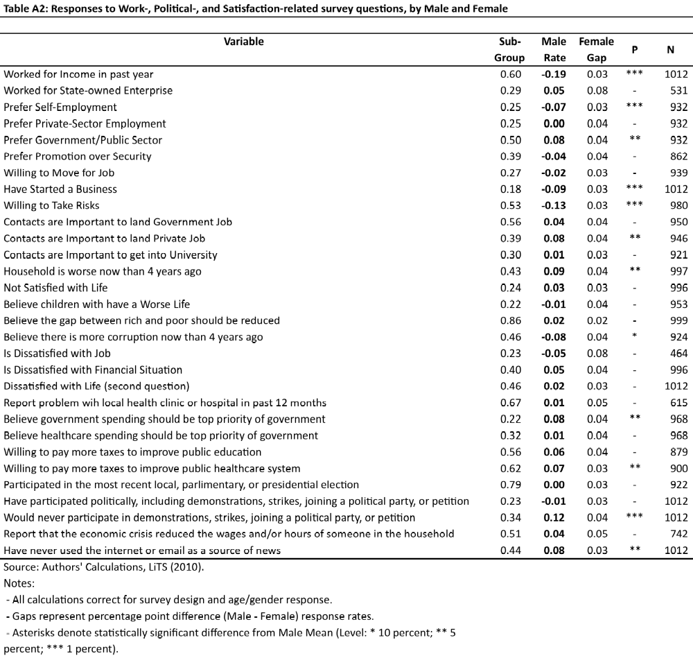

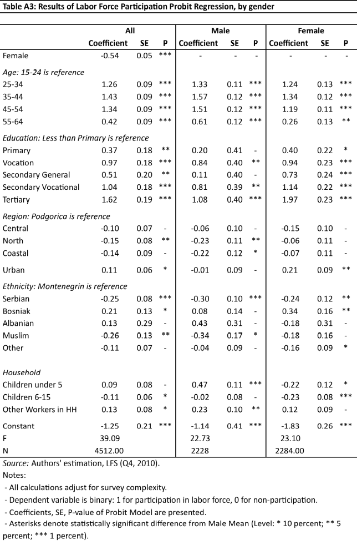
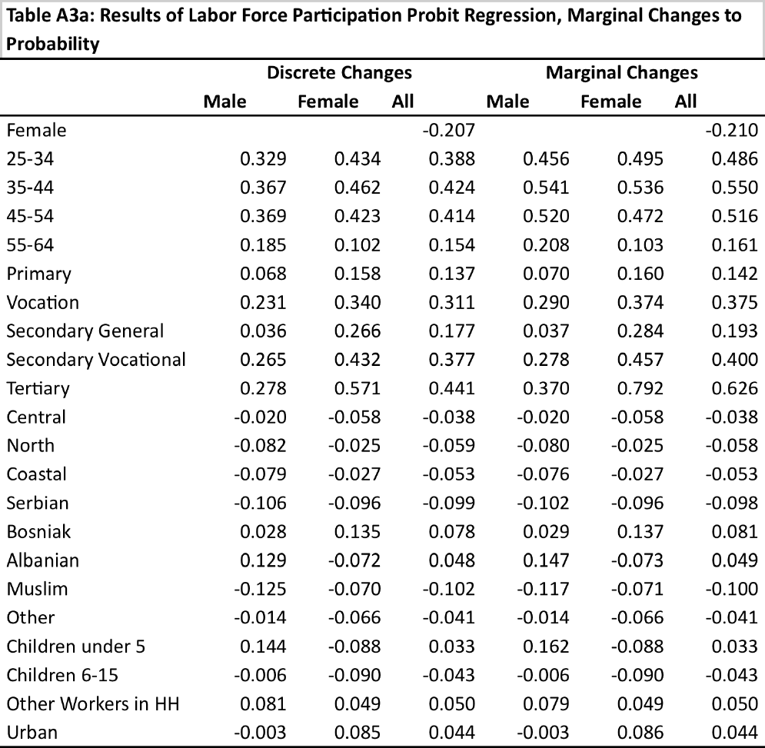

Montenegro has started to implement structural reforms to improve its competitiveness (WB, 2012f). In light of this, its accession status was updated in October 2011 from official candidate in December 2010 to a stage where formal membership negotiations were opened. The present World Bank country partnership strategy in Montenegro is based on two pillars that include supporting Montenegro’s accession to the EU through boosting institutions and competitiveness (as well as improving environmental management) (WB, 2011m).
Source: MONSTAT, 2012, p. 11
In 2011, 34.5 percent of females lived in rural areas and 65.5 percent in urban; their rate urbanization from 2003-2004 was 4 percent (3.7 percent for males) (MONSTAT, 2012, p. 14).
Based on the 2003 census, the female population is represented by the following self-identified national/ethnic affiliations: Montenegrins-43.5%; Serbs- 31.7%; Yugoslavs- 0.3%; Albanians- 4.9%; Bosniaks- 7.7%; Macedonians- 0.2%; Hungarians- 0.1%; Muslims- 4%; Roma- 0.4%; Russians- 0.1%; Slovenes 0.1%; Croats – 1.3%; Others- 0.3%; Undeclared and neutral- 4.5%; Regional affiliations- 0.2%; and Unknown- 1% (2003 Census data as cited in CEDAW, 2011, p. 7).
Source: Authors’ calculations from LFS (2010) and WDI.
The Government of Montenegro seeks to include excluded groups, like the Roma, Egyptian, refugees and displaced people in the educational system. This will require research on the current status of this group and workshops and campaigns to encourage these populations (parents and children) to increase enrollment (APAGE, 2013, p. 48).
Results from IPSOS (2012) are based on the National Health Survey (NHS). The NHS was conducted in 2012 by the Ministry of Health and is representative of the Montenegrin population aged seven years and older in urban and rural areas, and for three regions (north, central and south Montenegro).
Authors’ calculations, LiTS (2010).
A scale of psychological distress was used that indicates the presence of nervousness, anxiety, depression, exhaustion and fatigue.
Estimates for the bullet list below are from the authors’ calculations, LiTS (2010). See the Appendix for statistical comparisons of gender averages. OLS regression coefficients for female household head are presented for asset, expenditure, and income comparisons. Regressions control for household-head age, education of parents, presence of two or more adults, and presence of zero, one, or more children.
Ten-year age groups are used to ensure enough observations for statistical comparisons.
Reforms made to the pension system are discussed in WB (2012h, p. 15).
Authors’ calculations, LFS (2010) and LFS (2010). Please see the Appendix for details.
Marginal effects in participation probability are reported here. Probit regression coefficients, discrete, and marginal changes to probability are reported in the Appendix.
Labor laws are outlined in the Official Gazette of Montenegro 49/08, 59/2011. “Employees are equally treated in achieving their labour-based rights, regardless of their … gender (The Labor Law of Montenegro, Article 3, 2011).” Provisions protecting women are found in Section 2 of the Labor Law of Montenegro (Official Gazette of Montenegro 46/07)
Article 110, the Labor Law of Montenegro (Official Gazette of Montenegro 49/08, 59/2011)
Official Gazette of Montenegro 46/10
As reported in Figure 3.3, 76 percent of this group is inactive.
Estimates for job search are from the authors’ calculations, LFS (Q4, 2010).
Source: Work Disincentives Technical Note (2012, p. 2).
Source: Authors’ calculations, LFS (Q4, 2010)
Less than four percent of women work in agriculture.
When employed women are in management positions or performing work related to health, social and other protection or in times of natural disasters when it is vital that work is not interrupted.
Wage differences reported here are raw/unadjusted gaps for descriptive purposes. Adjusted wage differences are reported below.
Disaggregation results are withheld for some sub-sectors, due to low observations.
After controlling for selection effects, the adjusted gap increases to 17.6 percent (FREN, 2013, p .23). Estimates are for the years 2008-2011.
Methods and results of the report produced by FREN (2013) are presented here.
Male workers have higher coefficient effects in these areas.
Authors’ calculations, LFS (2010). Quantile regression run at the .165, .500, and .835, or the median representing each wage tertile.
Fluctuation in the middle three quintiles should be noted, with the fourth quintile having lower estimates gap of 13.1 percent. The authors state that gap differences between quintiles are statistically significant (p. 19).
Authors’ calculations, LiTS (2010).
Source: Authors’ calculations (LiTS, 2010; LFS, 2010)
Source: Authors’ calculations (LiTS, 2010)
The promotion of successful rural women entrepreneurs has been suggested (APAGE, 2013, p. 63).
The methodology of USAID was to conduct interviews “with key donors (UNDP, OSCE), Government of Montenegro officials (from the office of the Anti-Trafficking Coordinator, The Human Resources Department, the Head of the Board on Gender Equality in the Parliament, the Montenegrin statistical agency MONSTAT, the Department for Gender Equality, the State Employment Agency, and the Ministry of Labor and Social Care), NGOs (Foundation Open Society Institute, Nansen Dialog Center, SOS Nikšić, Center for Economy and Entrepreneurship, Women’s Safe House, Montenegrin Female Lobby), implementers of current USAID activities (ORT, NDI, AED), and USAID/Montenegro staff (USAID, 2010, p. 4).”
The 2012 World Development Report has highlighted the following areas of agency: women’s access to and control over resources; freedom of movement; freedom from the risk of violence; decision making over family formation and having voice in society and influencing policy (WDR, 2012).
National strategies include the National Program for Integration of Montenegro into the EU 2008-2012; National Strategy for Sustainable Development with the Action Plan 2011-2012; National Strategy of Employment and Human Resource Development 2012-2015; Strategy for the Protection against Domestic Violence 2011-2015; Strategy to Combat Human Trafficking 2012-2018; Strategy for the Improvement of the Position of the Roma and Egyptians in Montenegro with the Action Plan 2012-2016; Strategy for Integration of People with Disabilities in Montenegro; and Strategy for Preservation and Improvement of Reproductive Health. International treatises include the Convention of the Elimination of Discrimination against Women (CEDAW).
Official Gazette of Montenegro 46/10
SOS Hotline for Women and Children Victims of Violence
This includes an analysis of the current situation and key issues; provision of marriage and family counseling for victims of domestic violence in Social Welfare Centers and the Center for Mental Health; provision of a 24-hour SOS hotline to report domestic violence cases; strengthening the capacity of social services and NGO’s; providing safe and child-friendly spaces in police stations and courts for victims of violence where women can be interviewed or wait, separately from the defendant; creating educational materials on the protection available to victims of violence; monitoring regulation and enforcement of anti-violence against women laws (APAGE, 2013, ppg.82-94).
This includes developing and licensing an educational program and material on gender-based violence, non-violence and conflict resolution and training civic education teachers in elementary schools to administer these programs; awareness campaigns linked to the 16 days of Activism against Violence against Women Campaign; creating internet presence on this issue; and organizing campaigns in Roma settlements(APAGE, 2013, ppg.82-94).
USAID respondents link the overall attitude of media towards females to a lack of gender sensitivity by journalists. There is also a shortage of women leaders in the media (USAID, 2010, p. 9).
A public opinion poll conducted by CEED consulting as part of the “Study on family violence and violence against women” in 2012, cosponsored by the EU, UNDP and Government of Montenegro. The sample included 1103 respondents in 17 municipalities of Montenegro.
CEED broadly defines violence as the behavior of forcing, intimidating or controlling, directly or by threat, another person with the intention of harming or abusing them psychologically, physically, sexually or financially. Family violence exists between partners and or family members. Partner violence is defined as abusive or coercive behavior with the purpose of establishing control over a partner and may involve: physical injury; psychological and sexual abuse; social, physical or financial isolation; extreme jealousy and possessiveness; and threats and intimidation (CEED, 2012, p1).
Face-to-face interviews conducted by CEED consulting as part of the “Study on family violence and violence against women” in 2012, cosponsored by the EU, UNDP and Government of Montenegro The sample included “100 women victims of violence in the premises of SOS Nikšić and Women’s Safe House Podgorica” (CEED, 2012, p10).
Survey by Dr. Jelena Radulović for the project “Gender, Violence and Democracy on the Western Balkans” implemented by the Centre for Gender Research at the University of Oslo and Faculty of Philosophy of the University of Montenegro, 2007 (as cited in CEDAW, 2010, p. 30).
The authors are aware of the following shelters available to women victims of violence: “Crisis Centre for Women” established by “SOS Hotline” in Nikšić in 2009; “Women’s Safe House” (est. 1999); and a shelter for single and unmarried mothers (not juvenile), “The House of Hope” (est. 2009) (CEDAW, 2010, p31).
In other countries increased incomes and improved asset accumulation and bargaining power within the household have been linked to reduced incidences of domestic violence (Pronyk et al., 2006). In one study, a reduction in the male-female wage gap could explain 9 percent of the reduction in domestic violence (Aizer, 2010, p. 2). In the US, domestic violence fell by approximately 30 percent with the implementation of laws halving household wealth upon divorce (Stevenson 2007; Stevenson et al., 2006).
Based on the survey by Dr. Jelena Radulović for the project “Gender, Violence and Democracy on the Western Balkans” implemented by the Centre for Gender Research at the University of Oslo and Faculty of Philosophy of the University of Montenegro, 2007 (as cited in CEDAW, 2010, p. 30).
The TVPA defines “severe forms of trafficking in persons” as: “sex trafficking in which a commercial sex act is induced by force, fraud, or coercion, or in which the person induced to perform such an act has not attained 18 years of age; or the recruitment, harboring, transportation, provision, or obtaining of a person for labor or services, through the use of force, fraud, or coercion for the purpose of subjection to involuntary servitude, peonage, debt bondage, or slavery. A victim need not be physically transported from one location to another in order for the crime to fall within these definitions (US Dept of State, 2012b, p8).”
Gender, Institutions and Development Database 2009 (GID-DB) from OECD.Stat. Only data for Montenegro and Serbia together was available. “The Gender, Institutions and Development Data Base presents comparative data on gender equality. It has been compiled from secondary sources such as Gender Stats and the Human Development Report as well as from in-depth reviews of country case studies. The data are divided into six categories: (i) general country information, (ii) social institutions, (iii) access to resources, (iv) political empowerment, (v) economic status of women, and (vi) composite indicators of gender equality (OECD, 2012).”
The WDR 2012 measures women’s access to control over resources by the ease with which women can “earn and control income and own, use, and dispose of material assets” (WDR, 2012, p 150). The accumulation of women’s physical and financial assets, including pensions and insurance and its effects on bargaining power in households may help mitigate the repetition of gender inequality in future generations (WDR, 2012, p. 224, p. 152, p. 68).
Twenty-five semi-structured interviews were conducted with single parents (10 from Serbia, 10 from Bosnia and Herzegovina and 5 from Montenegro) (Blagojević, 2012).
This was also identified in Blagojević (2012)
UNICEF identifies early marriage as a human rights violation.
In some countries early marriage and childbearing have been linked to lower educational achievement and earning potential for women in adulthood (WDR, 2012, p159).
Two women MP’s were appointed presidents of the Committee for Gender Equality and the Committee for Health, Labor and Social Welfare (2009 Gender Equality Office data as cited in CEDAW (2010, p. 35)). Women in local government generally hold positions in areas related to family, culture and education (ibid.).
Women are presidents for only 4 of 24 sectoral trade unions (CEDAW, 2010, p38).
Judicial Council data as of 31 December 2009, cited in CEDAW (2010, p. 37).
UNDP Status of Women in Montenegro - Fact sheet as cited in USAID (2010, p. 9).
Gender Barometer Survey (2007), conducted for the Gender Equality Office by the agency Altera MB; as cited in CEDAW (2010, p. 39).
Authors’ calculations, LiTS (2010). Only subgroups with a minimum of 100 observations were analyzed. Only results with statistically significant differences are presented.
The Law of Elections of Councilors and Representatives now includes a 30 percent quota for women candidates of political parties on electoral lists. The CEDAW committee, however, perceives this measure to be inadequate as it does not ensure that every third rank be given to a woman. More information on perceptions of women in leadership was collected in 2012 with the sponsorship of the EU, Government of Montenegro and UNDP. The "Attitude Toward Women in Politics" report written by Ipsos Strategic Marketing in June 2012 was sponsored by the EU, Ministry of Justice, Government of Montenegro and UNDP.). The “Women can do it” project to improve women’s participation in politics through education has also been implemented by the Gender Equality Office in cooperation with non-governmental organizations. Various women’s networks have been started which include: the “Women’s Network of the Confederation of Trade Unions of Montenegro”, an important part of the Confederation of Trade Unions of Montenegro (est. 2008); and the “National Network of Mentors for Women Entrepreneurs in Montenegro” (est. 2011), started by the Centre for Entrepreneurship and Economic Development (CEED) and the Chamber of Commerce. The Business Women Association of Montenegro has been noted as another women’s network (Ipsos, 2011, p.13).
These include, for example, Article 4 of the 2007 Gender Equality Act to address gender sensitive language and campaigns such as “Sixteen Days of Activism against Violence against Women” aimed at Montenegrin men.
Gender, Institutions and Development Database 2009 (GID-DB) from OECD.Stat.
Article 39 of the Constitution of Montenegro states the right to freedom of movement to all citizens.

