MINISTRY OF INDUSTRY AND TRADE
SFG2809 V2 REV
INDUSTRIAL UNIVERSITY OF HO CHI MINH CITY

SUPPORT FOR AUTONOMOUS HIGHER EDUCATION PROJECT (SAHEP)
(Project Code: P156849)

SUBPROJECT
ESTABLISHMENT OF TRAINING, SCIENCE RESEARCH INFRACSTRUCTURE OF INDUSTRIAL UNIVERSITY OF HO CHI MINH CITY IN DISTRICT 12

ENVIRONMENTAL AND SOCIAL MANAGEMENT PLAN
(Final)

24th January 2017

TABLE OF CONTENTS

1. INTRODUCTION 1

2. POLICY, LEGAL AND ADMINISTRATIVE FRAMEWORK 2

2.1 Government Regulations 2

2.2 Applicable World Bank Safeguard Policies 3

2.3 Applicable International Standards and Prudent Practices in the Laboratory 4

2.4 Sustainable Design Guide 5

3. SUBPROJECT DESCRIPTION 5

3.1 Overall Project Development Objective 5

3.2 Subproject Objective(s) 5

3.3 Subproject location 6

3.4 Subproject components 8

3.4.1 Construction work items under Sub-component 1.1 10

3.4.2 Investment in laboratory equipments under Sub-component 2.2 11

3.5 Subproject implementation 16

3.5.1 Excavation volume 16

3.5.2 Method of material provision and disposal areas 16

3.5.3 Construction methods for the subproject 17

3.5.4 Subproject implementation progress 20

3.5.5 Total investment cost 21

4 NATURAL ENVIRONMENTAL AND SOCIO–ECONOMIC CONDITIONS IN THE SUBPROJECT AREA 21

4.1 Natural Environmental Condition 21

4.1.1 The condition of topography and geology 21

4.1.2 Climate conditions 22

4.1.3 Hydrological Conditions 22

4.1.4 Climate change and sea level rise 22

4.1.5 Current quality of environmental components 22

4.1.6 Quality of air, surface and groundwater, and noise level 24

4.1.6.1 Heavy metals in the soils 25

4.1.7 Ecological characteristic 25

4.2 Infrastructure, socio-economic development status 25

4.2.1 Socio-economic status 25

4.2.2 Existing IUH infrastructure 25

4.2.3 Traffic status 26

4.2.4 Water supply 26

4.2.5 Drainage system 26

4.2.6 Solid waste collection 26

5 ENVIRONMENTAL AND SOCIAL IMPACTS 26

5.1 Positive impact 26

5.2 Potential negative impacts 27

5.2.1 Generic construction impacts during pre-construction 27

5.2.2 Generic impacts during construction 28

5.2.3 Site-specific impacts during pre-construction 32

5.2.4 Site-specific impacts during construction 33

5.2.5 Potential impacts during operation 35

6 MITIGATION MEASURES FOR POTENTIAL NEGATIVE IMPACTS 38

6.1 Mitigation measures for generic construction related impacts during pre-construction and construction phases 38

6.1.1 Mitigation measures for site-specific impacts during pre-construction 51

6.1.2 Mitigation measures for site-specific impacts during construction. 53

6.1.3 Mitigation Measures for Environmental Impacts during Operation Phase 59

7 INSTITUTIONAL ARRANGEMENTS 68
7.1 Implementation Arrangements 68
7.2 Environmental Compliance Framework 70
7.3 Grievance Redress Mechanism (GRM) 73
7.4 ESMP implementation plan 75
7.5 Capacity development and training 76

8 ENVIRONMENTAL MONITORING PLAN 76

8.1 Monitoring of compliance with mitigation measures 76

8.2 Ambient Environmental Quality Monitoring 77

9 COST ESTIMATES 77

10 PUBLIC CONSULTANT AND INFORMATION DISCLOSURE 79

10.1 Public Consultation 79

10.2 Information disclosure 82

11 REFERENCES 83

12 APPENDIX 1. INTERNATIONAL BEST-PRACTICES IN THE LABORATORY SAFETY 84

13 APPENDIX 2. SUSTAINABLE DESIGN GUIDE 88

LIST OF TABLES

Table 1. Summary on the construction work items under Sub-component 1.1 10
Table 2. Listed of equipment in sub-component 2.2 11
Table 3. Summary on grading volume 16
Table 4. Details of the subproject cost in work items 21
Table 5. Locations of air, noise, soil and groundwater and surface water sampling 23
Table 6: Dust emission from material transportation for leveling 28
Table 7. Noise level from construction vehicles 29
Table 8. Classification of Impact on Land Owners 32
Table 9. Classification of acquired land 32
Table 10. Environmental Codes of Practice (ECOP) for Addressing Generic Construction Impacts 40
Table 11. Mitigation measures for site-specific impacts on sensitive receptors 55
Table 12. Assignment of Tasks for Laboratory Waste Handling 64
Table 13. Roles and responsibilities of key parties 69
Table 14. Regular Reporting Requirements 73
Table 15. Environmental Monitoring Plan during construction phase 77
Table 16. Environmental Monitoring Plan during operation phase 77
Table 17. Cost estimates for ESMP implementation 78
Table 18. Summary of public consultant results 81
Table 19. Information disclosure 82

LIST OF FIGURES

Figure 1. Subproject location on the map of HCM City 6
Figure 2. Land planning at District 12 7
Figure 3. General subproject construction area (26.7 ha) 7
Figure 4. Construction area funded WB (5.98 ha) in the overall area (26.7 ha) 8
Figure 5. Background environmental monitoring locations 23
Figure 6: Generator noise sources (estimated sound power level) 36
Figure 7: Typical genset installation showing noise control measures 59
Figure 8. Laboratory fume hoods 63
Figure 9: Flowchart for categorizing unknown chemicals for waste disposal 64
Figure 10. Autoclave in IUH for sterilizing 65
Figure 11. Safety shower available in the area where chemicals are handled in IUH 67
Figure 12. Overview of Laboratory Environmental, Health and Safety Management System 68
Figure 13. Organization chart for ESMP Implementation 69
Figure 14. The project owner’s presentation 82
Figure 15. Local people present their views 82

ABBREVIATIONS

BOD₅ Biochemical Oxygen Demand (5 days)
C/D/PPC Commune/District/Provincial People‘s Committee
COD Chemical Oxygen Demand
CSC Construction Supervision Consultant
DONRE Department of Natural Resources and Environment
ECOP Environmental Codes of Practice
EHS Environmental, Health and Safety
EIA Environmental Impact Assessment
EMP Environmental Management Plan
ESIA Environmental and Social Impact Assessment
ESMP Environmental and Social Management Plan
HCM Ho Chi Minh
HCMC Ho Chi Minh City
IUH Industrial University of Ho Chi Minh City
LEED Leadership in Energy and Environmental Design
MONRE Ministry of Natural Resources and Environment
OHS Occupational Health and Safety
OP / BP Operational Policy / Bank Procedure
PMU Project Management Unit
QCVN / TCVN National Technical Regulation of the Government of Vietnam
TSS Total Suspended Solid
US EPA United States Environmental Protection Agency
USD U.S Dollar
USGBC United States Green Building Council
VNĐ Vietnam Dong
VOC Volatile Organic Compound
WB World Bank

INTRODUCTION
The subproject "Establishment of training, scientific research infracstructure of Industrial University of Ho Chi Minh City in District 12" is under the Support for Autonomous Higher Education Project (SAHEP) (P156849) which is financed by the Bank World.
The subproject was designed with four main components: (1) Improved teaching; (2) Improved research; (3) Improved institutional management; and (4) Project management. Basically, the subproject includes two main activities: i) Investment in construction of facilities for 7 faculties/institutes and laboratory equipment procurement; ii) improve the quality of training, scientific research, management and education, labs practice.
The subproject is implemented in Tan Chanh Hiep Ward, District 12, Ho Chi Minh City with a total land acquisition area of 26.7 hectares, of which construction of the civil works to be financed by the World Bank will be implemented within 5.98 hectares, accounting for 22.4% total land area. The remaining area will be used for development in the next phases.
The subproject is proposed to meet the development needs of infrastructure, creating the foundation for the capacity building for management staffs and faculties, expanding the scale of training, promoting international cooperation, scientific research. The most important objective is to have training capacity for the labor force qualified with a university or college degree to meet the needs of human resources with high qualifications for socio-economic development of Ho Chi Minh City and the nation.
The subproject has a total investment of US$52.8 million, of which the World Bank will finance US$45 million, and the rest is counterpart fund of the IUH. The implementation period is expected from 2016 and 2022.
In addition to the positive impacts, implementation of the subproject is expected to cause potential adverse environmental and social impacts. In particular, the typical negative impacts may include those associated with: i) land acquisition area of ​​26.7 hectares in Tan Chanh Hiep Ward affecting 331households (263 land owner households, 01 company, and 68 renter households); ii) exhaust emission, noise of construction machines and dust from site clearing; iii) waste water, domestic waste generated from 377 workers who participated in the construction; iv) exhaust emission and noise generated from cars and motorcycles of 4.494 students and the university personnel; v) localized flooding; vi) wastewater, domestic waste, and hazardous wastes generated from laboratories; and vii) health risks associated with operation of the laboratories. However, these impacts are in significant and manageable through application of mitigation measures.
To ensure that the potential negative impacts are identified and mitigated during the subproject implementation and in compliance with the World Bank policy on Environmental Assessment (OP 4.01), an Environmental and Social Management Plan (ESMP) has been prepared. This ESMP summarizes the subproject description, the environmental background, potential negative impacts, proposed mitigation measures to be carried out during preconstruction, construction, and operation phases, and implementation arrangement. It also includes environmental codes of practice (ECOP) to apply for the subproject, to be incorporated into the bidding documents and construction contracts as well as a scope for environment quality monitoring. The Resettlement Action Plan (RAP) has been prepared and presented separately.
The Government’s regulation on EIA requires preparation and submission of an EIA report for the subproject. The EIA has been prepared based on this final ESMP by the IUH and submitted to HCMC DONRE for review. The EIA report is tentatively approved by Ho Chi Minh City People’s Committee by mid-February.

POLICY, LEGAL AND ADMINISTRATIVE FRAMEWORK

Government Regulations
The following national laws and regulations are applied for the subproject:
- Law of Environmental Protection no. 55/2014/QH13 of National Assembly issued on June 26, 2014.
- Land Law No.45/2013/QH13 dated November 29, 2013.
- Construction Law no. 50/2014/QH13 of National Assembly issued on June 18, 2014.
- Labor Law No.35-L/CTN dated June 23, 1994 with some amendment under Document No.84/2007/QH11 by the National Assembly.
- The Law of Cultural Heritage No.28/2001/QH10 promulgated on June 29, 2001, with some amendment in 2009 by the National Assembly (No.32/2009/QH12).
- Law on Fire Prevention and Fighting No.27/2001/QH10 dated June 29, 2001.
- Law on Electricity No.28/2004/QH11dated December 14, 2004.
- Law on Electricity (supplement and adjutment) No. 24/2012/QH13 dated November 20, 2012.
- Decree No.14/2014/ND-CP on Electricity Safety dated February 26, 2014.
- Decree No.117/2009/ND-CP dated December 31, 2009 on sanction of violations in the field of environmental protection.
- Decree No.59/2007/ND-CP dated April 9, 2008 on solid waste management.
- Decree 174/2007/ND-CP dated November 29, 2007 of GOV on environmental protection charges for solid wastes.
- Decree No.98/2010/ND-CP of the Government dated September 21,2010 on detailing the implementation of some articles of the Law on Cultural Heritage and the Law amendingand supplementing some articles of Law on cultural heritage.
- Decree no. 59/2015/ND-CP of Vietnam Goverment issued on June 18, 2015 on Construction Investment Project Management.
- Decree no. 46/2015/ND-CP of Vietnam Goverment issued on May 12, 2015 on Construction Work Maintenance and Quality Management.
- Decree no. 18/2015/ND-CP of Vietnam Goverment issued on Feb 14, 2015 on Environmental Protection Planning, SEA, EIA and Environmental Protection Plans.
- Decree 19/2015/ND-CP of Vietnam Goverment issued on Feb 14, 2015 on detailing some articles of Law of Environmental Protection.
- Decision no. 214/QD-TTg issued on Dec 24, 2004 on Establishment of Industrial University of Ho Chi Minh City.
- Document no. 11181/BCT-KT dated Nov 20, 2012 of Minister of MoIT on making the construction investment project of IUH in Tan Chanh Hiep Ward, 12 Dist.
- Circular no. 27/2015/TT-BTNMT dated May 29, 2015 on SEA, EIA and EPP.
- Circular no. 36/2015/TT-BTNMT dated June 30, 2015 on Hazardous Waste Management.
The main applicable National Technical Regulations include:
- QCVN 14:2008/BTNMT- National technical regulation on domestic wastewater.
- QCVN 01:2009/BYT- national technical regulation on drinking water quality.
- QCVN 02:2009/BYT- national technical regulation on domestic water quality.
- QCVN 06:2009/BTNMT - air quality -specified maximum allowable concentrations of certain hazardous substances in ambient air.
- QCVN 07:2009/BTNMT - National Technical Regulation on Hazardous Waste Thresholds.
- QCVN26:2010/BTNMT- National technical regulation on maximum noise limit in public and residential areas.
- QCVN 27:2010/BTNMT- National technical regulation on vibration.
- QCVN 40:2011/BTNMT- National technical regulations on industrial wastewater.
- QCVN 05:2013/BTNMT- National technical regulation on ambient air quality.
- QCVN 08-MT:2015/BTNMT - National technical regulation on surface water.
- QCVN 09-MT:2015/BTNMT - National technical regulation on groundwater.
- QCVN 03-MT:2015/BTNMT - National technical regulation on the allowable limits of heavy metals in the soils.
- QCVN 43:2012/BTNMT - National technical regulation on sediment quality.
- TCVN 7222:2002 - General environmental requirements for central domestic (municipal) wastewater treatment plants.
- QCVN 18:2014/BXD - National technical regulation on Safety in Construction.
- Decision no. 3733/2002/QD-BYT dated Oct 10, 2002 of Minitry of Health on publishing 21 occupational sanitation standards, 05 principles and 07 parameters of occupational sanitation.
- Other relevant sector technical regulation and standards.

Applicable World Bank Safeguard Policies
2.2.1 Project level
An environmental and social screening of the Project was undertaken in line with the OP 4.01 and it showed that the World Bank’s safeguard policies on Environmental Assessment (OP/BP 4.01), Physical Cultural Resources (OP/BP 4.11), Involuntary Resettlement (OP/BP 4.12), and Pest Management (OP 4.09) will be triggered for the Project. The screening has also resulted in categorizing the Project as Category B. In addition, the Bank’s requirements on public consultation and information disclosure will need to be followed.
2.2.2 Subproject level
Environmental Assessment (OP/BP 4.01):
Environmental Assessment (EA) is an umbrella policy for the Bank’s safeguard policies. The overarching objective is to ensure that Bank-financed projects are environmentally sound and sustainable, and that decision-making is improved through appropriate analysis of actions and of their likely environmental impacts. The EA process is intended to identify, avoid and mitigate potential impacts of Bank operations. EA takes into account the natural environment (air, water, and land); human health and safety; social aspects (involuntary resettlement, indigenous peoples, and physical cultural resources); and trans-boundary and global environmental aspects. EA considers natural and social aspects in an integrated way.
This subproject triggers OP 4.01 because it involves the construction and operation of the university which would likely cause potential negative environmental and social impacts. As required by OP 4.01 and the GoV’s EA regulation, the subproject has prepared an ESMP that meet the GoV’s regulations and the World Bank’s safeguard policy requirements. By the appraisal, the subproject draft ESMP was disclosed locally at the subproject areas and through the Bank’s Operations Portal as required by OP 4.01 and the Bank’s policy on access to information. The final subproject ESMP will be disclosed locally at the subproject sites and through the Bank’s information system.
Physical Cultural Resources (OP/BP 4.11):
This policy is triggered because the subproject would involve relocation of 31 graves which are also considered physical cultural resources. Mitigation measures for the relocation of the graves have been included in the Resettlement Action Plan (RAP) and ESMP.
Involuntary Resettlement (OP/BP 4.12):
The Involuntary Resettlement policy seeks to prevent severe long-term hardship, impoverishment, and environmental damage to the affected peoples during involuntary resettlement. OP 4.12 applies whether or not affected persons must move to another location. The Bank describes all these processes and outcomes as “involuntary resettlement,” or simply resettlement, even when people are not forced to move. Resettlement is involuntary when the government has the right to expropriate land or other assets and when affected people do not have the option to retain the livelihood situation that they have.
This policy is triggered because the subproject would have impacts involving the temporary and permanent involuntary taking of land and the loss of structures and assets associated with the land for the construction of the university. By appraisal, the subproject has prepared and disclosed RPF and RAP. The RPF and RAP have been included the measures to ensure that displaced people are: (i) informed about the options regarding resettlement; (ii) consulted and offered alternative resettlement choices; and (iii) provided with effective compensation and livelihood restoration.
World Bank Group Environmental, Health, and Safety Guidelines:
World Bank-financed projects should also take into account the World Bank Group Environmental, Health, and Safety Guidelines (known as the "EHS Guidelines"). The EHS Guidelines are technical reference documents with general and industry-specific examples of Good International Industry Practice.
The EHS Guidelines contain the performance levels and measures that are normally acceptable to the World Bank Group and are generally considered to be achievable in new facilities at reasonable costs by existing technology. The environmental assessment process may recommend alternative (higher or lower) levels or measures, which, if acceptable to the World Bank, become project-or site-specific requirements. This subproject should conform to the General EHS Guidelines.

Applicable International Standards and Prudent Practices in the Laboratory
ISO 17025:2005. The laboratories will be constructed towards achieving ISO 17025:2005. ISO/IEC 17025:2005 specifies the general requirements for the competence to carry out tests and/or calibrations, including sampling. It covers testing and calibration performed using standard methods, non-standard methods, and laboratory-developed methods.
It is applicable to all organizations performing tests and/or calibrations. These include, for example, first-, second-, and third-party laboratories, and laboratories where testing and/or calibration forms part of inspection and product certification.
ISO/IEC 17025:2005 is applicable to all laboratories regardless of the number of personnel or the extent of the scope of testing and/or calibration activities. When a laboratory does not undertake one or more of the activities covered by ISO/IEC 17025:2005, such as sampling and the design/development of new methods, the requirements of those clauses do not apply.
ISO/IEC 17025:2005 is for use by laboratories in developing their management system for quality, administrative and technical operations. Laboratory customers, regulatory authorities and accreditation bodies may also use it in confirming or recognizing the competence of laboratories. ISO/IEC 17025:2005 is not intended to be used as the basis for certification of laboratories. Compliance with regulatory and safety requirements on the operation of laboratories is not covered by ISO/IEC 17025:2005.
Prudent Practices in the Laboratory (ISBN 978-0-309-13864-2|DOI 10.17226/12654). The Prudent Practices (1995) has been used worldwide and has served as a leading reference source for laboratory practice. This new edition of the book (2011) will expand upon that tradition, and that this edition will assist the universities to provide a safe and healthy laboratory environment in which to teach, learn, and conduct research.

Sustainable Design Guide
The subproject is encouraged to apply the Sustainable Design during engineering design for buildings and other facilities to help protect the human health and the environment. The main objectives of sustainable design are to reduce, or completely avoid, depletion of critical resources like energy, water, and raw materials; prevent environmental degradation caused by facilities and infrastructure throughout their life cycle; and create built environments that are livable, comfortable, safe, and productive.
Buildings use resources (energy, water, raw materials, and etc.), generate waste (occupant, construction and demolition), and emit potentially harmful atmospheric emissions. Building owners, designers, and builders face a unique challenge to meet demands for new and renovated facilities that are accessible, secure, healthy, and productive while minimizing any negative impacts on society, the environment, and the economy. Ideally, building designs should result in net-positive benefits to all three areas (Source: EPA, USGBC – Leadership in Energy and Environmental Design (LEED)). See Appendix 2 for detailed guide on Sustainable Design.

SUBPROJECT DESCRIPTION

Overall Project Development Objective
The project development objective (PDO) is to improve teaching, research and institutional capacity at selected autonomous universities and to strengthen national higher education system.

Subproject Objective(s)
General objective:
Improving the quality of education and scientific researches to meet the market demand in the country and regions, and effectively serving the industrialization and modernization process of the country and the strategy for developing Vietnam’s industry towrds 2025 and 2035 vision.
- Developing the rules and governance structures to ensure autonomy
- Sustainable financial plan.
- Developing high-quality training programs.
Specific objective:
- Objective 1: Extending/Developing high-quality training programs, improving the research and creative abilities, practice skill for students in 8 selected falculties; attracting excellent and international students to study in our university.
- Objective 2: Building new facilities, improving research conditions, attracting talented staffs, foreign experts, universities, recognised science research institutions to participate in teaching and researching activities in our university; improving the quality of the lectures and research participation of students, master students and research students; thereby improving the quality and effectiveness of training and research.
- Objective 3: Enhancing linkage, cooperation in training and research with other universities in the country and foreign countries through the programs on training cooperation, implementation coordination of scientific and technological activities, sharing usage of research laboratories and research results.
- Objective 4: Improving the effectiveness of training, research and technology transfer activities; increasing the revenues for reinvestment and improving the capacity of staffs, building a strong financial foundation to ensure the successful and sustainable implementation of innovative process of university activities following the comprehensive autonomous mechanism.

Subproject location
The subproject is located in Tan Chanh Hiep ward, District 12, HCM City, Viet Nam. The overall subproject location is shown in Figure 1 below:
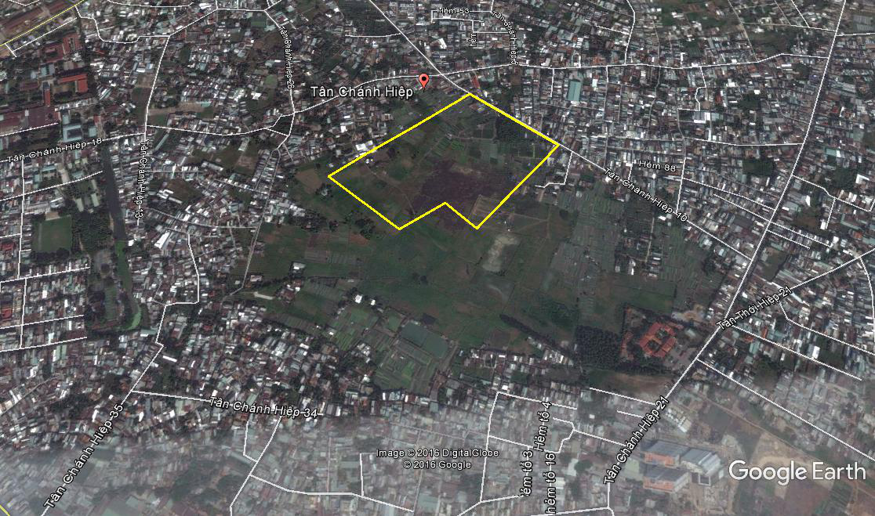
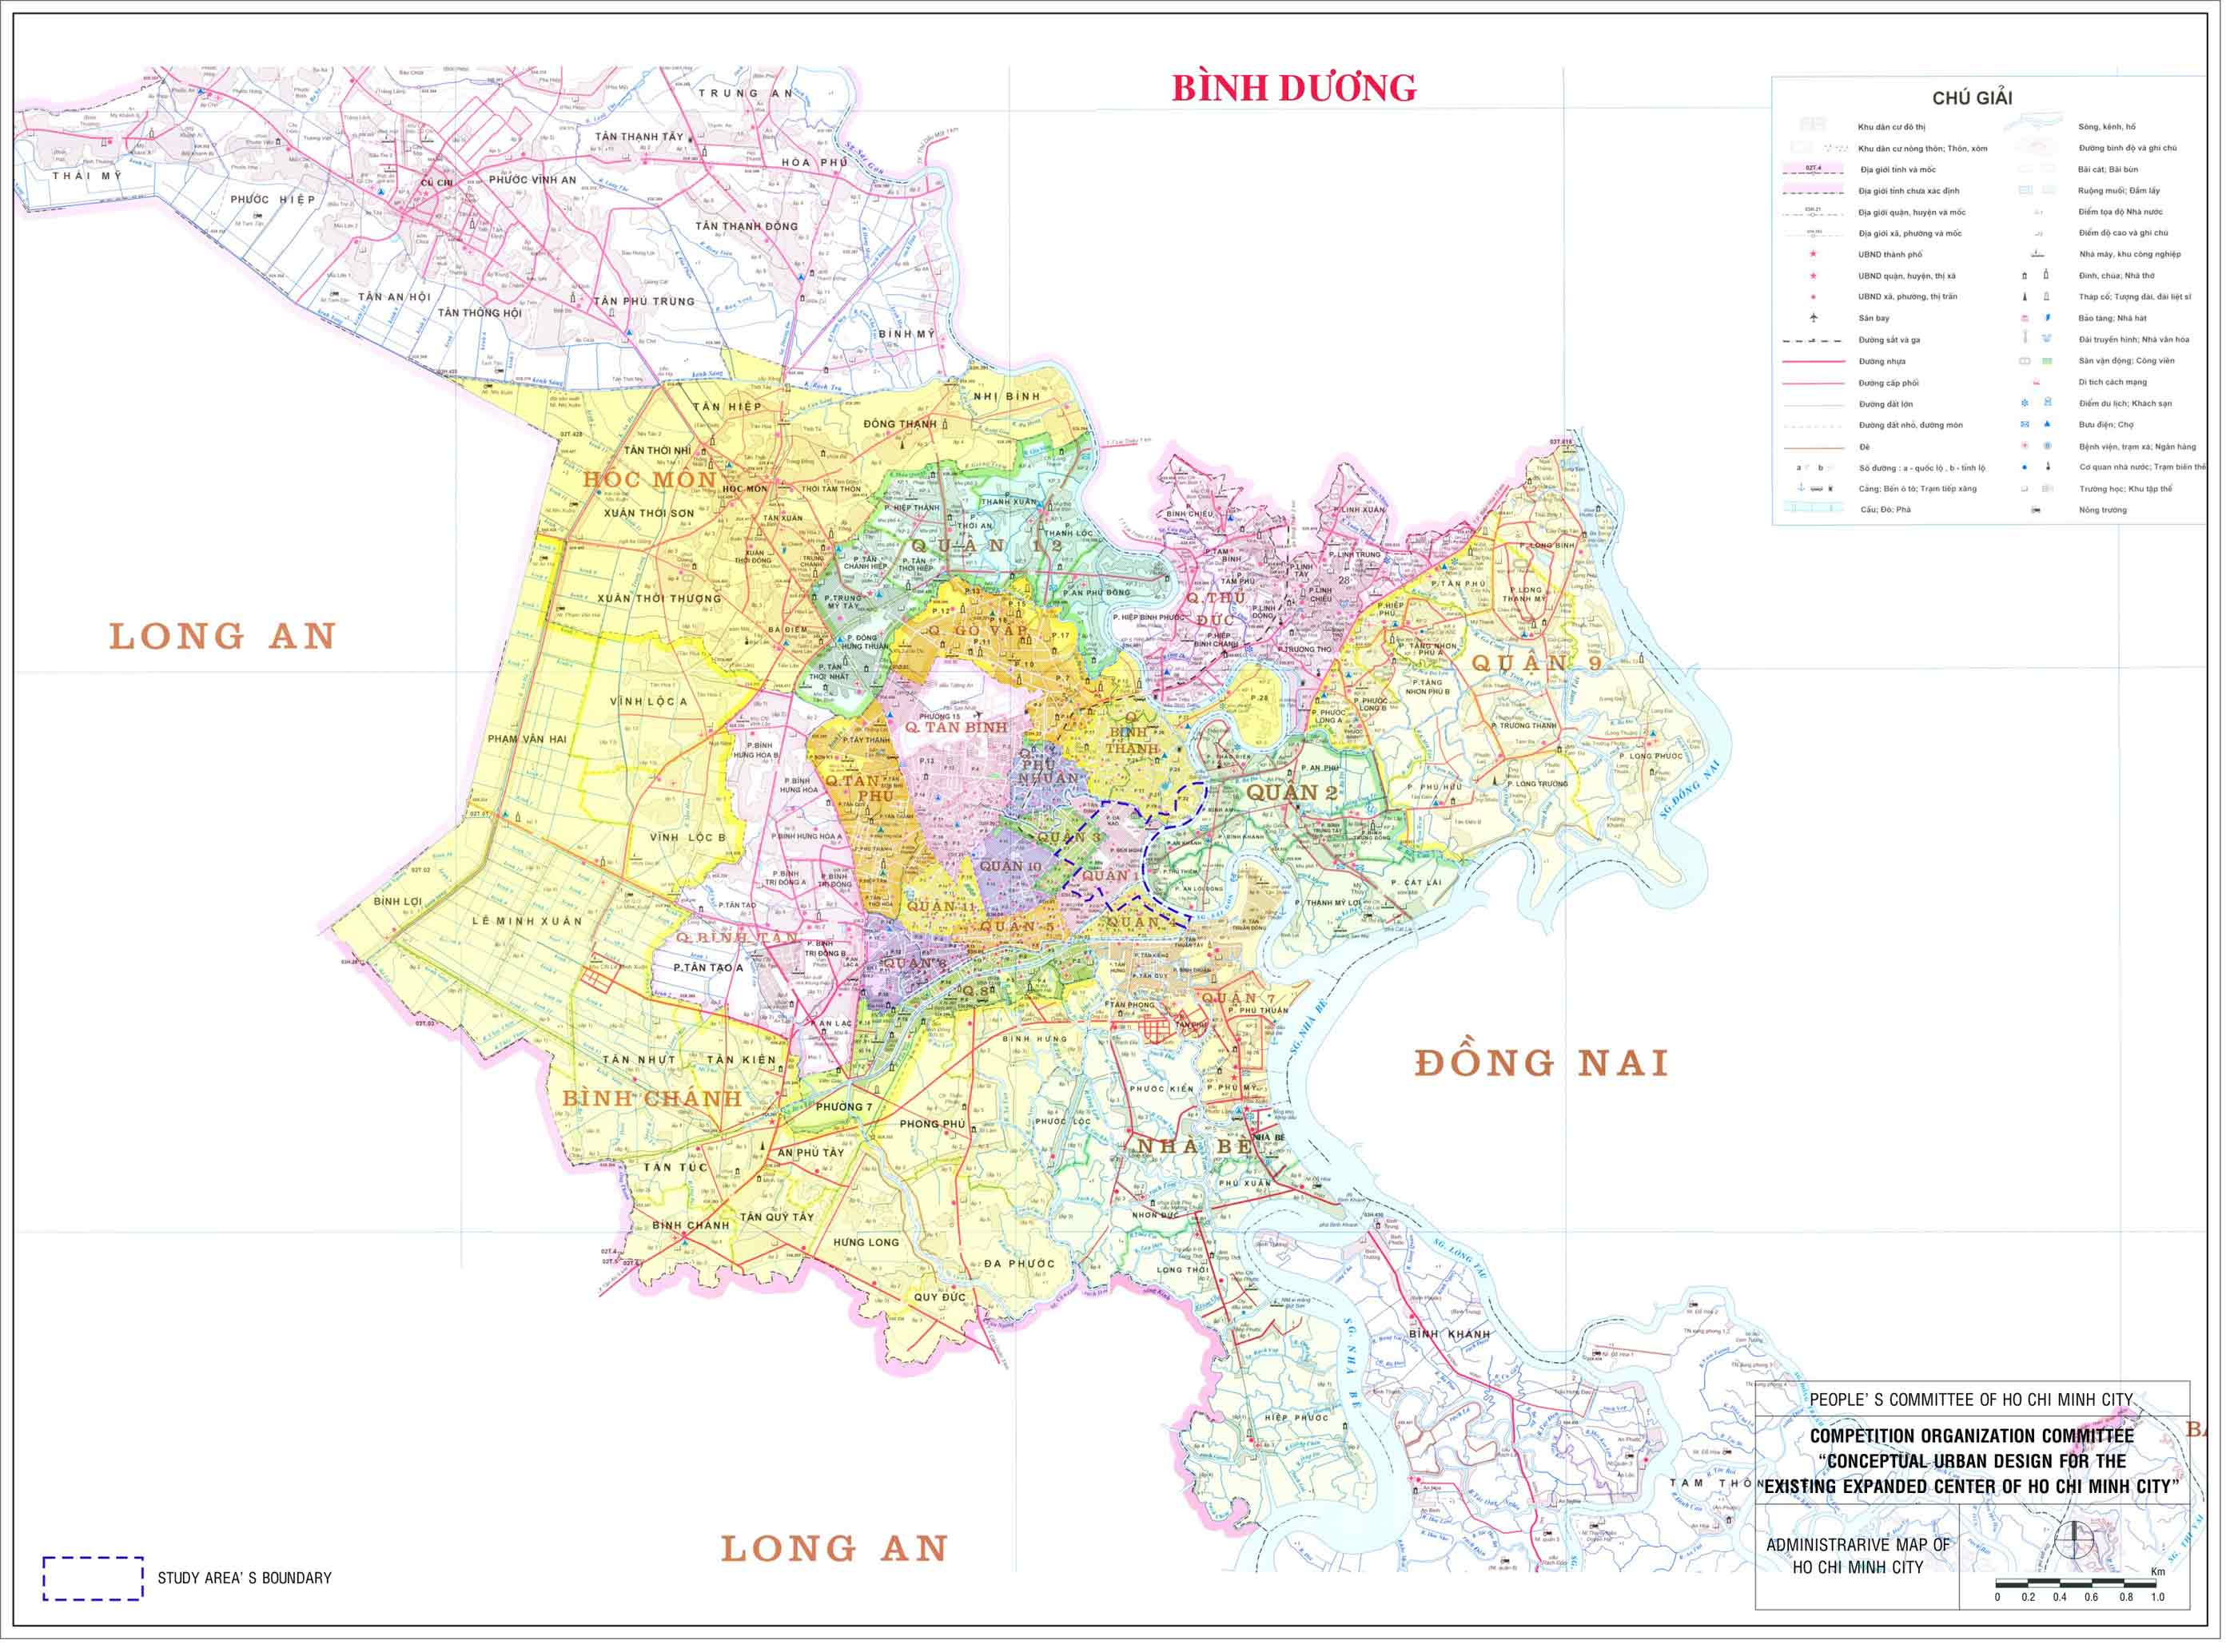
Figure 1. Subproject location on the map of HCM City
Figure 2 and Figure 3 below describe in more detail of the location of the land acquisition area of 26.7 ha to serve the overall demand of IUH.

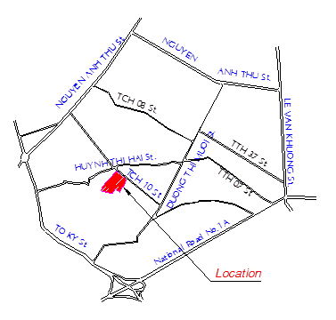
Figure 2. Land planning at District 12

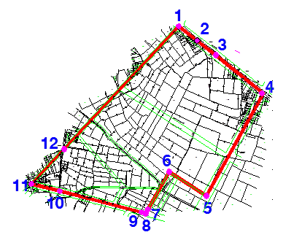
Figure 3. General subproject construction area (26.7 ha)
The land for overall project has an area of 26,7 ha with the location as below:
- Bordered on the North by Tan Chanh Hiep 10 Street which is also the subproject demarcation line with the length of 381,5 m (following the land acquisition demarcation line from point 1 to point 4).
- Bordered on the South and the West by the residental households with the length of 1,181.34 m (following the land acquisition demarcation line from point 8 to point 1).
- Bordered on the East by agricultural land with the length of 726.27 m (following the land acquisition demarcation line from point 4 to point 8).
This subproject will be constructed on a part of the overall land with an area of 5.98 ha, accounting for 22.4% of the total land acquired, as shown in the figure 4 below:

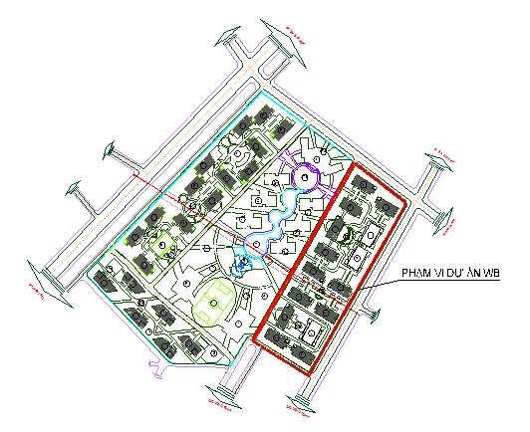

Subproject area of 5.98 ha financed by the Bank

Figure 4. Construction area funded WB (5.98 ha) in the overall area (26.7 ha)

Subproject components
The subproject is designed with four main components as follows: (1) Improved teaching; (2) Improved research; (3) Improved institututional management; and (4) Project management, specifically as follows:
Component 1: Improved teaching
Component 1 consists of two sub-components:
Sub-component 1.1: Developing new teaching programs
Activities: i) Training lectures on developing new programs; ii) Develop training programs following standardized ABET (Accreditation Board for Engineering and Technology) and AUN-QA (ASEAN University Network-Quality Assurance) format; iii) Hiring for evaluation of traning programs following standardized ABET format; and iv) Buying new examination programs.
Sub-component 1.2: Construction of university buildings for the eight key faculties
Activities: Construction and installation of equipments of the buildings for training (classrooms, working rooms, practice room, training room, conference room) of 8 key faculties and infrastructure systems in the area of 5.98 ha.
Component 2: Improved research
Component 2 consists of two sub-components:
Sub-component 2.1: Improving the capacity of science research
Activities: i) Hiring local consultant experts for professional training in research, ii) Organizing training courses/ conferences on professional training in research; iii) Sending reseachers to participate in short-term training courses abroad; iv) Organizing international scientific conferences; v) Assigning staffs to participate in international scientific conferences; vi) Buying textbooks and monographs in Vietnamese and monographs in foreign languagues; vii) Supporting the establishment of enterprises on science and technology in the university; viii) Supporting participation in national and international competitions on science technology creaction; ix) Supporting the registration of patents and utility solutions and industrial property registration; and x) Supporting the implementation of scientific and technological projects and services.
Sub-component 2.2: Equipment of laboratory and practice rooms
Activities: i) Buying equipments for testing and practice for 8 faculties in the program of lecture halls with equipments for 8 faculties. ii) Training human resources on operation and maintenance; and iii) Network connection with other library centers.
Component 3: Improved institutional management
Activities: i) Organizing training for governance staffs; ii) Buying server; iii) Upgrading governance software; iv) Software for management of scientific journal and thesis; v) Organizing training for Middle-level management staffs; vi) Pedagogical professional supplement training; vii) Study tour on university management aboard; and viii) Training for improvement of IT level.
Component 4 Project management
Activities: i) Hiring local project management expert for project coordination, management and technology expert for preparing progress reports, hiring local procurement expert, hiring secretary/translator, updated Resettlement Action Plan (RAP) report and Environmental Impact Assessment (EIA); ii) Training Financial Officer, Procurement expert, Information Technology (IT) expert, improving the proficiency of IT staffs; iii) Buying office equipment and machines, the subproject management expenses; iv) Developing Project Operation Manual (POM), establishing the Project Management Unit when the subproject starts including the personnel appointment/ recruitment, developing the information sharing system, project operation and management regulations, Communication activities as of the scientific research innovation, project activities; v) Organizing workshops (inception, mid-term, final) in order to announce, review and share information on the activities and results of the project; and vi) Implementing periodical project audits (mid-term, end of period) or unscheduled audits following the request of the competent and relevant authorities.

Construction work items under Sub-component 1.1
Construction items for the faculties/ institutes as well as the numbers of students, lectures and management staffs using the construction works in Sub-component 1.1 are shown in the following table:
Table 1. Summary on the construction work items under Sub-component 1.1
No | Construction work | Construction area (m²) | Total floor area (m²) | Student (person) | Lecture (person) | Management staff (person) | Lab/practice room
1 | Faculty of Mechanical Technology | 2,580 | 9,360 | 2,000 | 100 | 3 | 1
2 | Institute of Biotechnology and Food Technology | 1,376 | 4,992 | 1,200 | 60 | 3 | 1
3 | Institute for Environmental Science, Technology and Management | 1,147 | 4,160 | 1,000 | 50 | 4 | 1
4 | Faculty of Information Technology | 2,580 | 9,360 | 2,000 | 100 | 5 | 2
5 | Faculty of Electrical & Electronics Engineering | 4,257 | 15,444 | 3,300 | 207 | 6 | 2
6 | Faculty of Chemical Engineering | 1,720 | 6,240 | 1,500 | 104 | 3 | 4
7 | Faculty of Automobile Technology | 1,290 | 4,680 | 1,000 | 98 | 3 | 1
 | Total | 14,950 | 54,236 | 12,000 | 719 | 27 | 12
The construction works of the Sub-component 1.1 also includes technical infrastructure system constructed on an area of 5.98 ha: Internal transportation systems; water supply and drainage systems; power supply system, lighting system; communication systems.
In addition, grading and technical preparation of construction land for the overall area of 26.7 hectares are also implemented.
Buildings of the faculties/ institutes are 5-storey buildings without basement, the height of 1st floors is 4.2 m, and from 2nd to 5th floors is 3.5 m; total building height is 18.6m.
The construction works are designed with uniform architecture with all the lecture halls of all faculties, ensuring the aesthetics.

Investment in laboratory equipments under Sub-component 2.2
List of equipment invested for laboratories of 5 faculties and 2 research institutes is shown in the following table:
Table 2. Listed of equipment in sub-component 2.2
No | Name of Laboratory | Equipment
I | Faculty of Mechanical Technology
1 | Measurement Laboratory | - 3D measuring machine, 3D scanner  - Material analysis machine  - Machine for detecting defects of welded joints, materials, equipment
2 | CAD - CAM - CNC Laboratory | - CNC lathe machine, 8-axis CNC lathe machine  - CNC milling machine
3 | Lathing- Milling- welding machine Practice Room | - Cylindrical Grinding Machine Universal Surface Grinding Machine.  - Universal gear-milling machine Máy phay lăn răng vạn năng  - TIG welding machine, MIG welding machine.
4 | Electro-mechanical reparation practice room | - Dynamic balancing machine, static balancing machine  - Vibration analysis machine  - Vibrograph
5 | Mechantronics Lab | - Testing kits of Pendulum, balance, magnetic levitation….  - Testing on control, shock absorber, fluctuation
6 | Precision machining center UMPC | - Nano superfinish grinding machine  - Electrical Discharge Machine EDM, CNC EDM wire-cutting machine  - CNC laser cutting machine, CNC plasma machine
II | Institute of Biotechnology and Food Technology
1 | Microbial Technology Laboratory | - Biosafety Cabine class 1  - Deionized water making machine  - Sanger sequencing machine  - PCR machine and real time PCR machine system  - Centrifuge machine system and Ultracentrifuge machine system  - Flow Cytometry system  - Automatic cell counting system  - Deep-freezing cabinets -20 to -80ºC
2 | Food biological features Analytical Testing Laboratory | - Fourrier Transformation InfraRed analytical system (FT-IR)  - Physical mechanical properties analytical machine system  - Gas Chromatography machine systme FID/ECD  - High Performance Liquid Chromatography machine system  - Material structure analytical system  - Water activity analytical system
3 | Food Technology Laboratory | - Sausage manufacturing system  - Wine, beer fermentation equipment system  - Homogenizer  - Canning machine, Vacuum Packing Equipment  - Wine, beer fine filtration system  - Ultra High Temperature (UHT) system  - Industrial steaming system
III | Institute for Environmental Science, Technology and Management
1 | Microbiology and Toxicology Laboratory | - Bacteria identification analytical equipment  - Mini magnetic resonance analytical system  - Tube Rotator and its Accessories Microbiology water bath
2 | Odor Laboratory | - Odor analytical system GFC  - Computer and software controlling the process and reporting the odor result  - EPD system  - Standard material for taking odor samples  - Set of materials, devices, equipments E-NOSE
3 | Classic spectrum Laboratory | - TOC/TN analytical machine  - Rotary Evaporator  - Atago Polarimeter  - Oil content checking machine  - Shaker
4 | Microelement laboratory | - Gas chromatography-high-resolution mass spectrometry  - GC/MS system  - High Performance Liquid Chromatography system (HPLC)  - IC analytical system  - Fourrier Transformation InfraRed analytical system (FT-IR)
5 | Environmental Monitoring Laboratory | - Gas Sampler SIBATA  - Low flow air pump (0,5 – 3 times/min)  - High flow air pump (5 – 20 times/min)  - Dust Sampler SIBATA  - Particle Counter PM10  - Soil sampling equipment
6 | Investment in upgrading the environmental technology practice room | - Waste water treatment model by SBR technology  - Waste water treatment model by UASB technology  - Waste water treatment model by Arotank technology  - Waste water treatment model by Membrane technology  - Waste water treatment model by biotechnology  - Exhaust gas treatment model by biotechnology  - Exhaust gas treatment model by Adsorption technology  - Exhaust gas treatment model by sleeve dust filtration technology  - Exhaust gas treatment model by electrostatic dust filtration technology  - Exhaust gas treatment model by web-scrubber technology  - Solid waste treatment model by aerobic technology  - Solid waste treatment model by anaerobic technology  - Hazardous Waste treatment model by Incinerator
7 | Research department on GIS-RS, modeling and climate change | - Desktop computer  - Specialized software  - Processing table for aerial photography  - Projectors
IV | Faculty of Information Technology
1 | - Mobile Application Development Laboratory  - Laboratory on management of software developing activities | - Computer, server  - Telephone  - Connection devices  - Table, chair, cabinet  - Software  - Toolkits  - Training
2 | - Data Analysis Laboratory  - ERP system governance laboratory | - Computer, Server, UPS  - Connection devices  - Table, chair, cabinet  - Software  - Projector, printer
3 | Multimedia Networking Laboratory | - Computer, server  - Mobile devices  - Connection devices  - Table, chair, cabinet  - Software  - Specialized equipment
4 | High Performance Computing Laboratory | - GPU Cluster  - 40Gb Infiniband cable  - InfiniBand Switch  - Screen  - Gigabit switch 24 ports  - UPS  - Table for computer
5 | Information security Laboratory | - Computer, Server  - HP Z840 Workstation  - Information security specialized equipment  - Table, chair, cabinet  - Software  - Projector, printer
6 | IT practice room 1 (Matlab) | - Computer, server  - Connection devices  - Table, chair, cabinet  - Software
7 | IT practice room 2 | - Computer, server  - Connection devices  - Table, chair, cabinet  - Software
V | Faculty of Electrical Technology
1 | Automatic control laboratory | - Model of inverted pendulum 2-degree-of-freedom/ arm crane  - High accuracy linear control system  - Model of 3-degree-of-freedom helicopter  - Denso 6 degree- of- freedom system – Robot system with open architecture  - Model of 3-degree-of-freedom motion Gyroscope  - Model of double inverted pendulum rotation  - Computer  - Software
2 | Electrical circuit and measuring Laboratory | - Oscilloscope  - Automatic power grid control system and software  - Accessories accompanying equipment  - Computer  - Changeable AC, DC source
3 | Electrical drive Laboratory | - Module: Rotor Field Oriented Control using Matlab-Simulink  - Servo 1Kw engine testing and software  - Module: Inverters  - Frame for attaching the screen and keyboard  - Specialized computers in the laboratory  - Machine for analysis of engine drive  - Computer  - Software
4 | Smart grids and renewable energy laboratory | - Module: manual and automatic circuit  - Module: Power transmission systems and power distribution + line protection.  - Module: Power consumption measurement and peak load monitoring  - Module: Wind power plan, DFIG Generator  - Module: luminous energy system  - Module: pumped storage hydropower plant  - Module: High Voltage Direct Current (HVDC)  - Computer  - Software
VI | Faculty of Electrical & Electronics Engineering
1 | Electronics and communication Laboratory | Supplement, upgrade the laboratories for university training postgraduate training in Electronics and communication.
2 | Integrated Circuit Design Laboratory | Supplement, upgrade the laboratories for university training in IT Technology and for postgraduate training in Electronic Engineering.
3 | Smart system Laboratory | Providing new equipment for university training in IT Technology and for postgraduate training in Electronic Engineering.
4 | IoT sytem laboratory | Providing new equipment for university training in IT Technology and for postgraduate training in Electronic Engineering.
5 | Electronics – Biomedical Laboratory | Providing new equipment and modernization of the laboratories for university training in Electronics - Biomedicine and for postgraduate training in Electronic Engineering
6 | Textbook/ lectures/e-learning system | - Develop the distance study support system E-learning for all the subjects of training system in the faculty.  - Compiling 30 electronic lectures for the subjects in English.  - Compiling 30 textbooks/ electronic lectures for the subjects in Vietnamese.
7 | Technology research and transfer | Study to design 02 models of application of Electronics – communication- computer- biomedicine.  - Smart Agriculture model  - High-tech aquaculture model.
VII | Faculty of Chemical Technology
1 | Physicochemical Testing | - Electrochemical testing  - Kinematic Testing  - Corrosion testing  - Distillation testing
2 | Material testing | - X-ray diffraction machine  - Scanning Electron Microscope  - Equipment for determining the area & size of the object holes  - Thermal analysis TGA  - Nuclear magnetic resonance machine NMR  - Measure the size of nano-particles
3 | Dyeing testing | - Infrared sample dyeing machines  - High-pressure dyeing machines  - Light Color fastness tester.  - Color fastness after washing tester.  - Color assessment  - Low-pressure dyeing machines
4 | Polymer Testing | - Membrane Making Line  - Plastic resins making line  - Equipment for measuring the oxidation stability  - Equipment for measuring the breaking of membrane  - Melt flow index  - Aging oven tester
5 | Petrochemical testing | - Measure sulfur content by ASTM 429 X-ray  - Pilot Oil processing at atmospheric pressure  - Research equipment for electrochemical corrosion  - Equipment for direct observation of emulsification  - Equipment for measuring Oxidation ASTM D525  - Determination of emulsification ability ASTM 1401  - Measure the index of acid, bases, bromine, the mercaptan and chlorine content, ASTMD 664
6 | Specialized basic analytical Testing | - SPE system  - Protein titrated Burette  - Microwave digestion system  - Automatic Fixed Volume Sampler  - Exhaust gas sampler  - Magnetic stirrer with heating
7 | Laboratory on stimulation of process, equipment in biotechnology | - Server  - Workstation  - AspenPlus V9 Software  - Chemlab V2.6.2 software  - VASP V5.3 software
8 | In-depth analysis Laboratory | - Small Visible Spectrophotometer  - ICP-MS machine
VIII | Faculty of Automobile Technology
1 | Physicochemical Testing | - Electrochemical testing  - Kinematic Testing  - Corrosion testing  - Distillation testing
2 | Material testing | - X-ray diffraction machine  - Scanning Electron Microscope  - Equipment for determining the area & size of the object holes  - Thermal analysis TGA  - Nuclear magnetic resonance machine NMR  - Measure the size of nano-particles
3 | Dyeing testing | - Infrared sample dyeing machines  - High-pressure dyeing machines  - Light Color fastness tester.  - Color fastness after washing tester.  - Color assessment  - Low-pressure dyeing machines
4 | Polymer testing | - Membrane Making Line  - Plastic resins making line  - Equipment for measuring the oxidation stability  - Equipment for measuring the breaking of membrane  - Melt flow index  - Aging oven tester
5 | Petrochemical testing | - Measure sulfur content by ASTM 429 X-ray  - Pilot Oil processing at atmospheric pressure  - Research equipment for electrochemical corrosion  - Equipment for direct observation of emulsification  - Equipment for measuring Oxidation ASTM D525  - Determination of emulsification ability ASTM 1401  - Measure the index of acid, bases, bromine, the mercaptan and chlorine content, ASTMD 664
6 | Specialized basic analytical Testing | - SPE system  - Protein titrated Burette  - Microwave digestion system  - Automatic Fixed Volume Sampler  - Exhaust gas sampler  - Magnetic stirrer with heating
7 | Laboratory on stimulation of process, equipment in biotechnology | - Server  - Workstation  - AspenPlus V9 Software  - Chemlab V2.6.2 software  - VASP V5.3 software
8 | In-depth analysis Laboratory | - Small Visible Spectrophotometer  - ICP-MS machine

Subproject implementation

Excavation volume
Grading for an area of 25.29 ha. During grading, all the existing ditches are maintained to ensure runoff drainage. At the locations where the ditches connect the construction area with the outside land, reinforced concrete box culverts (2x2m) must be placed. Filling with materials include sand or soil.
Table 3. Summary on grading volume
No | Work components | Unit | Volume
I | Grading area
1 | Excavation area | m² | 35,525.39
2 | Filling area | m² | 196,368.59
II | Grading volume
1 | Excavation volume | m³ | 8,250.,47
2 | Filling volume k = 0,9 | m³ | 109,301.59
3 | Volume of organic soil excavation with the thickness of 0.5 m | m³ | 98,184.30
4 | Volume of filling organic soilwith the thickness of 0.5 m | m³ | 98,184.30
Total excavation volume |  | m³ | 117,552.06
Total filling volume |  | m³ | 207,485.89
Total additional filling soil |  | m³ | 199,335.42

Method of material provision and disposal areas
Material provision:
In order to serve the grading works, it is planned to use sand to increase the foundation and create construction land area for implementation of the subproject. Sand and other construction materials will be bought from the dealers located in Disctrict 12 and transported to the construction sites over a distance of 7-10 km. Ready-made concrete will be provided quite conveniently to the construction site by tank truck. Construction iron, steel are popularly and conveniently provided in HCMC with the famous trademarks such as Pomina, Việt Nhật, Hoà Phát.
Other construction materials such as: brick, ashlar brick/stone, corrugated iron/ clay plate, water supply and drainage pipe/ culvert are always ready to meet the demand of the construction. They are provided by the factories, agencies, distribution outlets in District 12, neighboring districts or in the area of HCMC.
Equipments and materials for the university: HCMC is major economic center of Vietnam so purchasing equipment and materials is quite easy. Especially, there is Tan Son Nhat International airport, the harbors such as Cat Lai, Hiep Phuoc. Therefore, it is very convenient to import the equipments and materials from foreign countries by air line or sea line.
Power and fuel supply:
In this area, there are medium voltage grids 110kV, 22kV and low voltage grids 0,4kV managed by EVN HCM City. Types of fuels as petrol, oil have plentity supply sources from the petrol stations in the area of District 12 and in HCMC.
Clean water supply:
Construction area is supplied with clean water by Trung An Water supply JSC from D180 pipe. Currently, the Company has implemented the 3 next investments in order to cover the entire water supply network in Tan Chanh Hiep Ward, ensuring the water supply capacity for the subproject in both construction and operation stages.
Disposal areas
Currently, domestic wastes from residents in Tan Hiep Chanh Ward are collected by District 12 Public Services Company Limited by garbage trucks and taken to the Da Phuoc Solid Waste Treatment Complex (Da Phuoc Disposal Site) in Binh Chanh District for treatement. In Februray 2015, the EIA report for increasing the treatment capacity from 3,000 tons/day to 10,000 tons/day of Da Phuoc Disposal Site was approved by MONRE. Thus, it would meet requirements for taking additional solid wastes generated from operation of the univeristy about 6.373 tons/day.

Construction methods for the subproject
Work structure
Foundation solution:
- Based on the geological conditions of this area and the construction size of the project, it is scheduled to use shallow foundation in strip footing type with the in-situ reinforced concrete frame, foundation bottom layer is placed on parent rock layer with the SPT index N30 ≥ 40.
- Based on the size, nature, load and geological conditions of the work, the design uses the foundation treatment method as follows:
- Using concrete piles, pile tips are put into the soil layer.
- Foundation frameworks are linked by foundation bracing system which has function of increasing the hardness and limiting the settlement difference for the whole construction work structure.
Structural solutions for the body of construction work:
- Load bearing structure is plain concrete cement structure which shall bear all the vertical load and horizontal load impacting on the work.
- Structure of the body of the work is beam-column frame, cast in-situ reinforced concrete floor for all the work floors and attic floor.
Water supply system
- Water from the roof tank is supplied for cleaning equipment in the vertical pipes and branch pipes following the layered water supply scheme.
- The vertical pipes are placed in technical cabinets, branch pipes are placed inside the walls, floors. Water supply pipes are HDPE pipes.
Water drainage system
- Drainage system inside the building catches all the waste water and raining water on the roof and bring to the outside drainage network.
- Wash water drains off following the wash water catching vertical pipe. Toilet water drainage is collected in the septic tanks placed outside of the buildings.
- Raining water on the roof, gutter flows through the vertical pipes into the ditch system around the buildings and drains to the common water drainage system of the university.
- Practice rooms have their own manholes to catch the lubricants. Wastewater is collected and transported to the treatment area of the city.
Power supply system
- At the 1st floor of each building, there is a general electric cabinet to supply power for the cabinets of all the floors by the main cable system following the load groups. Electric cables from the cabinet of the floor to the cabinet of the rooms put in plastic pipes inside the walls, ceiling or on the suspended ceiling.
- Lighting system inside the building: using ceiling fluorescent lights. Lighting system is controlled manually by the electric switches;
- To protect the electric wire and cable from the electric overload and short circuit, circuit breakers are used in the electric cabinets located at the beginning of the wire.
- Arrange bonding to ensure R_{earthing} ≤ 4 ohm for earthing for work of the buildings
- Arrange bonding to ensure R_{earthing} ≤ 10 ohm for earthing for lighting protection of the buildings.
Air conditioning and ventilation systems
- Using VRV air conditioning system, wall mounted or ceiling mounted.
- Ventilation system: Mechanic practice rooms are equipped with wall mounted air supply system to provide fresh air. Other rooms are equipped with the system to exchange the natural air with the outside air.
- Toilet exhaust air system: Use the exhaust air pipe and exhaust fans on the roof to suck the toilet exhaust air.
Fire prevention and fighting system
It includes fire alarm system and fire hydrant system combining with foam extinguishers.
Technical Infrastructure System
Internal transportation system:
- Yard, square: consisting of 1 layer of terrazzo bricks or natural stones+ cement concrete layer class 200 with the thickness of 100mm.
- Transportation road
- The road with cross-section:
  - Usable width : 3,75x2 = 7,5 m
  - Pavement : 3,0 x 2 = 6,0 m
  - Right of way : 13,5m
- Specifications are as below:
  - Minimum required E: 1.270 daN/cm2.
  - Standard Loading Axe: 10T.
  - Tire Pressure: P = 6.0 daN/cm2.
  - Wheel Path Dimension: D = 33cm.
- Pavement structure:
  - Asphalt concrete with the thickness of 5cm (hot).
  - Pouring Tack coat TCN 0,5kg/cm2 (liquid).
  - Asphalt Treated Base course with the thickness of 7cm.
  - Pouring Tack coat TCN 1,0kg/cm2 (hot).
  - Crushed aggregate base course: 20cm.
  - Crushed aggregate sub base course: 25cm.
  - Compaction of the foundation bed layer 30 cm (k=0,98).
Water supply system:
- Supply water for construction area is taken from the living water supply pipe system on the Tan Chanh Hiep 10 Street.
- Water supply network is the water supply network for fire fighting, plant watering and living water. All the outside building supply water pipes are placed under the ground surface from 0.5-0.7m
- Water from water supply network on the street is taken into the underground water tank and pumped into the water tank on the roof.
- Water supply pipes are HDPE pipes.
Outside building water drainage system:
- Wastewater drainage: Wastewater from the toilet is collected in the septic tank placed outside of the buildings. Domestic wastewater after being treated in the septic tank will be discharged into the outside drainage system, and conveyed to the treatment station and discharged into local drainage system. Wastewater drainage pipes are made of uPVC.
- Rain water drainage: Rain water will be collected into rain water drainage system on the roof and in the yard and then is discharged into the outside drainage system and conveyed to local drainage system. Outside drainage system is ditches B300-B1000 constructed with brick and covered with reinforced concrete slabs.
Outside building power supply system:
- Building 22/0,4KV-250KVA substation to provide electricity for the university
- When the primary power source fails, the important part of the load will be powered by a diesel standby power. The generator set is placed next to the substation with sound proofing cover.
- ~ 0.4 kV voltage taken from the substation is divided into supply power cables to the distribution cabinet located in the building by an underground low voltage cables directly placed in the ground at a depth of 0.8 m. Grounding ensures earthing ≤ 4 Ohm for earthing for work for the building.
- In the yard area, internal transportation roads are equipped with ball lamps for lighting and decoration. The distance between two lighting poles is 25m to 30 m.
Information network:
Investment on the underground pipes for holding cables. The TV network and internet suppliers undertake to provide television and internet services for the project. The TV network and internet suppliers will bring its network to each building through the cable or signal pick up.
Trees - Fences:
- Use two types of tree: shade trees and decorative trees. Use some types of middle size and big size trees that are newly domesticated and preliminarily adjusted for shade trees.
- Decorative trees are used in some flower gardens, square just for highlighting.
- In order to protect the university campus, it should be invested to build the fence system whose structure includes brick wall with steel frame on the top.

Subproject implementation progress
Subproject implementation period is from 2017 to 2022, devides into 3 stages:
- Stage 1: Preaparation for investment.
- Implementation time: From 2016-2017
- Contents: This stage is for preparation works of investment including establishment of pre-feasibility study report outline, submission for approval in principle of the investment, signing consultant contract for establishment of detail planning of 1/500, organizing the contest for selecting the architectural plan, making feasibility study report and submission for approval, completing the documents for signing loan agreement for the project, establishing project management unit, carrying out land acquisition and resettlement works, selecting the survey contractor, making the basic design, shop drawing and total cost estimate for all the construction work items.
- Stage 2: Implementation of the investment.
- Implementation time: From 2017-2020
- Contents: Implementing the construction and buying equipment, construction investment on the items. Some training activities such as improving the capacity of the lectures, researchers, managers, developing and buying training programs…will be also implemented.
- Stage 3: From 2020-2022: continue the completion of construction works including transportation routes, water supply and drainage systems, lighting system. Implementing the acceptance, payment and settlement works and putting the subproject into official operation.

Total investment cost
Estimated total investment of the subproject is US$ 52,822,000 (In words: Fifty two million, eight hundred and twenty two thousand US dollars) equivalent to 1,154.69 billion VND.
Capital (rounded):
- World Bank loan : US$45,000,000
- IDA : US$40,500,000
- On-lending capital : US$4,500,000
- Counterpart fund : US$4,500,000
- IUH Capital : US$4,500,000
- Capital raised by IUH : US$3,322,000
Table 4. Details of the subproject cost in work items
Items | Cost
Items | US$ | VND (million)
Construction | 25,238,182 | 551,706.65
Goods | 20,172,117 | 440,962.47
Consultant service | 3,247,714 | 70,995.02
Training | 610,219 | 13,339.39
Supporting / Scholarships | 710,770 | 15,537.43
Operation expense | 2,843,020 | 62,148.41
Total | 52,822,021 | 1,154,689.37
(Exchanged following the accounting exchange rate in the Announcement of Ministry of Finance in September, 2016 as USD/VND = 21,860).

NATURAL ENVIRONMENTAL AND SOCIO–ECONOMIC CONDITIONS IN THE SUBPROJECT AREA

Natural Environmental Condition

The condition of topography and geology
Topographical conditions
The subproject area is relatively flat terrain, low-sunken, mostly farmland, surrounded by houses, roads, with average height from 3-5m. The highest elevation is located in the eastern area with altitude of about + 6 meters. Geological structure of the land is favorable for subproject construction. In the subproject area, there are still a number of existing buildings as temporary houses, level 4 houses.
Geological conditions
Based on the geological investigation result at the construction area, the stratigraphy is divided into the following layers:
- Layer 1: Soil layer: Clay sand, clay loam in dark grey, grey brown color with grass roots.
- Layer 2: Clay loam in yellow brown, yellow grey color and in plastic soft state. Conventional bearing capacity R0 = 0,85 kGf/cm2.
- Layer 3: Clay loam in yellow brown, grey brown, grey color, spotted appearance and in plastic hard state. Conventional bearing capacity R₀ = 1,15 kGf/cm2.
- Layer 4: Light loamy sand in grey, white grey color, Medium dense, plastic state. Conventional bearing capacity R₀ = 1,35 kGf/cm2.

Climate conditions
The climate has the nature of the tropical equatorial monsoon region, the temperature remains the same level in the whole year, there are 2 seasons: rainy season and dry season. Rainy seasons start from May to November (account for 90% of the total rainfall), dry seasons start from December to the next year April. The average temperature is 27°C, the highest temperature is 40°C, the lowest temperature is 13,8°C.
Raining: The total average annual rainfall is 1909.9 mm/year. Highest rainfall is often in September and October.
Wind Direction: HCMC is influenced by two main wind directions that are West – Southwest direction from June to October with the average speed of 3.6 m / s and North - Northeast dirrection from November to February with the average speed of 2.4 m / s. In addition, there is South – outheast monsoon from March to May with the average speed of 3.7 m/s.

Hydrological Conditions
There is natural water drainage canal passing through the subproject construction area and flowing into Tham Luong canal which is 1.5 km far to the East; this is the main drainage canal of this area. The canal with the width of 1,5-2m, the depth of 0,5-1m and the speed of 0,3-0,8 m/s; this drainage canal is polluted by wastewater from the residents, the wastewater is in brown grey color and contains garbage and dregs.

Climate change and sea level rise
Like most cities in the delta region, HCMC is facing serious challenge due to climate change. The main challenges are as follows:
- Sea level rise: The city is frequently flooded, sea level rise will continue causing impacts on the city.
- Flooding caused by rivers: Heavy rains and lack of water reservoir also cause flooding. This problem will become more seriously as a result of increased rainfall due to climate change.
- Water availability: water (quality, reliability) can be a factor which directly restricts the development of the economy in the coming years. The saltwater intrusion is gradually increasing.
- Temperature: The temperature in the city, especially in the areas with high building density is gradually rising.
Though the subproject area is not affected by flood, the elevation of university foundation and wastewater and runoff drainage system, and capacity for flood drainage of Tan Chanh Hiep ward and district 12 will be taken into account during topography survey and egineering design to ensure no flooding during university operation.

Current quality of environmental components
To assess the quality of background environmental components such as air, noise, groundwater, surface water, soil, the Consultant, in collaboration with the Consultancy Center of Occupational Safety Health and Environmental Techonology (COSHET) – a competent agency with a function of environmental monitoring in Ho Chi Minh City has conducted examination, measurement and sampling of environmental components in the subproject area during the period of from 18 November 2016 to 22 November 2016.
Locations of background environmental monitoring:
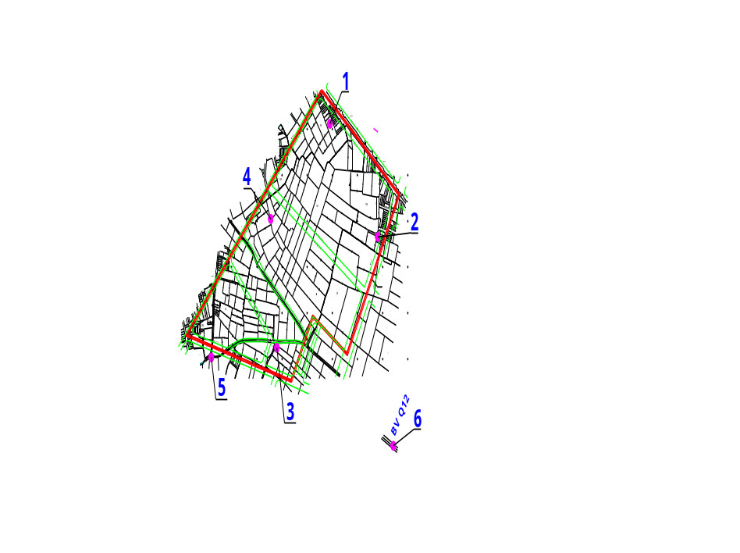
Figure 5. Background environmental monitoring locations
Coordinates and marks of samples of environmental monitoring components are shown in the following table:
Table 5. Locations of air, noise, soil and groundwater and surface water sampling
Location | Co-ordinate |  | Environmental monitoring components / Sample marks
Location | X | Y | Environmental monitoring components / Sample marks
1 | 0595674 | 1201809 | Air, noise: KK-01  Groundwater: NN-01  Soil: Đ-01
2 | 0595906 | 1201575 | Air, noise: KK-02  Soil: Đ-02
3 | 0595340 | 1201493 | Air, noise: KK-03
4 | 0595435 | 1201664 | Air, noise: KK-04  Groundwater: NN-02  Soil: Đ-03
5 | 0595264 | 1201660 | Surface water: NM-01
6 | 0596105 | 1201117 | Surface water: NM-02
Locations of background environmental monitoring are selected as below:
- Air, noise: The selected locations are located within the subproject area at the end of the main direction and near the residential areas such as locations 1, 2 to the West – Southwest wind direction; locations 3, 4 to the North – Northeast wind direction; and locations 1, 4 to the South – Southeast wind directions. Monitoring results will serve as a basis for comparison and assessment of the impact of dust and air quality during the construction and later operation of the work.
- Soil: The selected location is located in the area of dredging and excavation during the ground leveling and foundation excavation of buildings. Monitoring results of soil quality in this area will serve as a basis for comparison with the standard and for proposal of treatment of excess soil from excavation activities.
- Surface water: Water sample is taken from two points, one in the upstream and one in the downstream of the ditch which is currently running through the subproject area. The monitoring results will be compared with the criteria to assess the current contamination level of surface water, thereby, proposing measures to the treatment of wastewater from the construction and operation activities before being dischaged into this receiving-water source.
- Groundwater: Water sample is taken from wells of the residents in the subproject area and used for assessing the impact of the subproject on groundwater and the possibility of use of groundwater for the project.
Monitoring parameters of the selected environmental components are the basic parameters listed in the National Technical Regulation on the ambient air quality (QCVN 05:2013/BTNMT); noise (QCVN 26:2010/BTNMT); heavy metals in the soils (QCVN 03-MT:2015/BTNMT); surface water quality (QCVN 08-MT:2015/BTNMT); and groundwater quality (QCVN 09-MT:2015/BTNMT).
The monitoring time is from 2 PM to 4 PM on the date of 18 November 2016. The weather is recorded as sunny with temperature of 32,2-33,8°C, light wind of 0,3-2,4 m/s and humidity of 54,3-63,9%.

Quality of air, surface and groundwater, and noise level
The results from measuring and analysing air samples at specific locations in the subproject area in comparision with the National Technical Regulation on the ambient air quality - QCVN 05:2013/BTNMT indicate that the air quality is within the limits. The contents of SO₂, CO, NO₂ in the air is several times lower than the limit; however the total suspended particulate (TSP) level is approximately reaching the limit (0,19-0,25 mg/m³ compared to 0,3 mg/m³), so the implementation of the subproject requires high attention to the sources of dust and mitigation measures taken.
The results from noise monitoring at the locations near existing residential houses and streets in comparision with the National Technical Regulation on the noise QCVN 26:2010/BTNMT of a normal area from 6 AM to 21 PM indicates that the noise is within the limits. The noise level of the area near the Tan Chanh Hiep Street (Locations 1 and 2) (57 – 58 dBA) is higher than that of the inner residential area (53-54 dBA) as a result of the traffic noise; therefore, high attention shoud be paid to the noise resonance during the subproject implementation.
The results from analysing samples of surface water taken from the existing sewage canal in the subproject in comparision with the National Technical Regulation on the surface water quality - QCVN 08-MT:2015/BTNMT – Column B: Requirement for water quality indicates that the surface water of the ditch is seriously polluted by indicators of BOD5 (40-80mg/l), COD (77-154mg/l), PO₄³⁻ (0.53-0.73mg/l), NH₄⁺ (22.86mg/l). The surface water of the ditch is currently contaminated by domestic wastewater. Therefore, the wastewater from the subproject must be treated before discharged into this receiving source.
The results from analysing groundwater samples (30m-deep drilled wells) at the specific locations in the subproject area in comparision with the National Technical Regulation on the groundwater quality QCVN 09-MT:2015/BTNMT indicates that the groundwater quality is within the limit, except for the water sample taken from Location 1 which has the indicator of NH4+ (1.48 mg/l) – 1,48 times higher than the limit. The groundwater in the shallow layer has quite good quality but at high risk of pollution, therefore it is not suitable to be used for water supply for the project.

Heavy metals in the soils
Analysis of soil samples taken from the selected locations of excavation in the subproject area and its comparision with the National Technical Regulation on the allowable limits of heavy metals in the soils (QCVN 03-MT:2015/BTNMT) indicates that the heavy metal contents in the soils are within the allowable limit. Therefore, the surplus soils from excavation can be utilized for planting or filing and leveling.

Ecological characteristic
Construction area is a small area, the land is mostly agricultural and residential land for growing vegetables, decorative plants and some buildings such as the level 4 houses and fences. Therefore, it is relatively poor ecosystem, as follows:
Terrestrial ecosystem:
- Flora: Through field surveys at planned construction area, flora is mianly planted by local people such as grass, vegetables, bonsai, coconut-palm trees, acacia and fruit trees and weeds.
- Fauna: Land animals are mainly cattle of the local people include beef and dairy cattle, and some wild animals such as frogs, toad, snails, insects, ...
Aquatic ecosystem:
There is no any water bodies within or adjacent to the subproject area. In the subproject area there is only a local domestic wastewater drainage canal with occurence of anabas, water-fern and algae.

Infrastructure, socio-economic development status

Socio-economic status
Population and Ethnic people
According to the Statistical Yearbook 2015 of the HCMC, District 12 has 510,326 people, the population growth rate is 7.87%; in which, Tan Chanh Hiep Ward has a population of over 50,000 people.
Mainly ethnic composition of Tan Chanh Hiep Ward and the subproject area is the Kinh, there is no ethnic minorities.

Existing IUH infrastructure
IUH has the main office located at no. 12 Nguyen Van Bao street, Ward 4, Go Vap District, Ho Chi Minh City, with a construction area of ​​2 hectares, with training scale of more than 43,000 students in 19 faculties, institutes, and departments. Besides, there are 10 functional departments assissting the Management Board in the management activities and student dormitories to meet the scale of 5,000 students.
Currently, the facilities, especially libraries, lecture halls, laboratories, practice rooms are asynchronous and inadequate. The average floor area of ​​the entire university (including dormitory) was only 3.36 m²/student, 50% less than the minimum requirement. The University does not have separate specialized and overview classrooms, the amphitheaters are used in common (between general/specialized) and mixed (between the majors). Total floor area of ​​classrooms, laboratories, practice is 79,704 m², 2.51 m²/student in average, meeting 40% of the requirement.

Traffic status
Status map of the connection route to the construction area of the subproject is shown in Figure 2. Overall, the subproject area is located in a favorable position for transportation, about 0,8km from the national road #1A and 1,8km from nationa road #22. Surrounding the subproject area is the paved routes with 2 to 8 lanes, facilitate the movement of local people and vehicles.
The construction area is adjacent to Tan Chanh Hiep 10 street to the north, or can access the site from Huynh Thi Hai street by the west alley; this is 8 m wide asphalt-paved road with two lanes. This can also be connected to Nguyen Anh Thu Street to national road #22, or Duong Thi Muoi, Dong Bac, To Ky to national road #1A. Roads at the subproject area is quite favorable, facilitate the transport of construction equipment, construction materials, equipment, as well as transport of excavated materials, sand for leveling transportation of solid waste to the processing site.

Water supply
Saigon Water Supply Corporation - Limited and Trung An Water Supply JSC are the water suppliers, management and development of water supply network, connecting households to Tan Chanh Hiep Ward area.
In the subproject area it has water supply pipeline D180 which is located on the Tan Chanh Hiep 10 street so it very convenient to connect and provide clean water for the subproject from the construction phase to the operations phase.

Drainage system
According to the survey of current situation, some roads in Tan Chanh Hiep ward has sewer/drainage ditches along the roadside serving for stormwater drainage and wastewater drainage from local households. However, in the subproject area, adjacent road to the construction area is 10 Tan Chanh Hiep and it doesn’t have stormwater drainage, only street Huynh Thi Hai has been constructed stormwater drainage along the road so the construction wastewater of subproject can be discharged by this direction coming out of the alley.
In addition, the construction area is quite favorable for drainage to natural drainage ditches because it goes across the construction area. This natural drainage ditches is 1.5-2m wide, 0.5-1m deep, velocity of 0.3 to 0.8 m/s and flow to Tham Luong channel in distance of 1.5 km downstream. However, drainage channel is contaminated by domestic wastewater from households, the water is brown, gray, and contains garbage and residue. Therefore, the subproject's wastewater must be treated to achieve discharge requirements before discharged into the ditches to avoid exacerbating pollution.

Solid waste collection
At present, domestic soild waste in Tan Hiep Chanh ward is being collected by District 12 Public Service Co., Ltd by specialized vehicle trucks and transported to Da Phuoc solid waste processing complex area (Da Phuoc landfill) in Binh Chanh district.

ENVIRONMENTAL AND SOCIAL IMPACTS

Positive impact
In general, the sub-project will bring positive impacts. The building investment of a complete and comprehensive of works is to get a modern facilities catering training, international cooperation, improve the quality of scientific research, simultaneously with the enhancing capacity of university governance is indispensable objective to implement the tasks and objectives of development of science and technology following the requirements of that the Party, Government and Ministry of Industry and Trade (MOIT).

Potential negative impacts

Generic construction impacts during pre-construction
Dust emission
Demolition of the existing structures would generate dust. Dust emission rate from demolition is estimated about 0.961 kg/h. According to documents on air pollution in construction, TSP accounts for 10% of dust emission (equal to 0.096 kg/h). The existing residential areas located downwind along Tan Chanh Hiep 10 and Huynh Thi Hai would be affected by dust. However, dust emission from demolition happens in a short time (around 1 month) and the volume of demolition is small, so the impact is low.
Exhaust emission
Use of equipment such as excavator, sawmill, lawnmower and vehicle trucks for demolition, cutting down trees, grass clearance, and transportation of debris to disposal sites, would cause exhaust emission such as SO₂, Particulate Matter, NO_{x}, CO and VOC. These waste gases may cause impact on workers and local people within 26.7 hectares. However, the period of site clearing is short (about 1 month) and consumption of fuel is low (about 0.739 kg gasoline/h for sawmill and lawnmower; 8.45 kg diesel/h for excavator), so the impact is low.
Solid waste
Total amount of solid watse from demolition is estimated about 5,196 tons (or equal to 3,248 m³ due to density of 1.6 tons/m³). Besides, there is small amount of domestic waste generated from worker activities, about 12 kg/day (15 workers x 0.8 kg/worker/day). If domestic waste is not properly managed, it would cause generation of unpleasant odor, aesthetic problem, and create habitats for rats, cockroaches, and flies as vector-born diseases and affect local people and worker health. However, the amount is not very large and domestic waste will be daily collected and transported to local disposal site, so the impact is considered low.
Wastewater
Wastewater is mainly generated from worker activities. According to TCVN4474-87 (inside drainage), wastewater generated per worker on site is about 40 liters/day. Thus, total wastewater volume is estimated about 0.6 m³ (15 workers x 40 l/worker/day). Wastewater from domestic activities would contain many suspended solids, organic matters, nutrients and microorganisms. Without proper management, domestic wastewater will deteriorate the landscape, pollute land, water, and air environment, and create favorable conditions for pathogens to proliferate. These, in turn, will adversely affect the health of communities and workers. However, the wastewater amount is small and its impact is mitigable so the impact is considered low.
Noise impact
Use of equipment and machineries for site clearing would cause noise impacts. For example, noise from excavator is 78 dBA at 1 m in distance and 52 dBA at 20 m in distance; truck 88 dBA at 1 m in distance and 62 dBA at 20 m in distance; sawmill and lawn-mower 77 dBA at 1 m in distance and 51 dBA at 20 m in distance. Thus, workers who directly operate these equipment and machineries would be affected by noise. The resident areas more than 20 m far from noise sources would not be affected by noise. The impact is considered low (according to QCVN 26:2010/BTNMT, permissible noise level is 70 dBA that applies to normal areas during from 6 a.m. to 9 p.m).
Social issues
Appearance of 15 workers mobilized for site clearing may cause security, order, and social evil issues such as abuse of alcohol, gambling, and conflict with local people. However, the period of site clearing is short, about one month and the number of worker are small. These issues are manageable, so the impact is considered low.
Accident risks
Site clearing activities might cause accident risks to workers and local people due to operation of equipment and machineries, transportation, falling and collapse from demolition process and cutting down trees. However, the volume of work is not large and the impact is manageble through good construction pactices. Thus, the impact is considered low.

Generic impacts during construction
(a) Dust emission from leveling
Emission factor of dust from 1 m³ of leveling material sush as sand, soil is 0.062kg. Excavated soil to be removed is 98,184 m³; volume of soil and sand to be transported to the site is 199,335 m³. Estimated time of leveling work is 9 months, working 30 days/month and 8 hours/day. Dust emission rate is (98,184 + 199,335) x0.062/(9x30x8) = 8.54 kg/hour. According to the documents on air pollution in construction, TSP accounts for approx. 10% of dust emission corresponding value is 0.0854 kg/hour. Dust generated by leveling occurs about 9 months, affecting mainly to workers and local people within 26.7 hectares. The impact is considered moderate.
(b) Dust and exhaust emission from material transportation for leveling
Dust: transportation includes spoil removing out of the construction site, soil and sand transportation from mines to the site for leveling shall generate dust from road surface. To remove 98,184 m³ of spoil and transportation of 199,335 m³ of sand and soil, the trucks of 15 tons shall be used. Estimated time of leveling work is 9 months, working 30 days/month and 8 hours/day. Number of transportation trips is (98,184 + 199,335)x1.4/(15x9x30) = 103 trips/day and the emission rate shall be 0.008g/m.s. With the calculated value and compared to the QCVN 05:2013/BTNMT, the level of dust generation by the transportation activities is lower than the permissible threshold (see Table 6).
Table 6: Dust emission from material transportation for leveling
Distance (m) | 1 | 5 | 10 | 50 | 100
Concentration (mg/m³) | 0.2271 | 0.0031 | 0.0016 | 0.0005 | 0.0003
QCVN 05:2013/BTNMT (mg/m³) | 0.3
Exhaust emission: The trucks used to transport the spoil from construction sites, sand from the mine, use the diesel engine so their operation will generate fumes containing the components that pollute the air environment include: dust, SO₂, NO_{x}, CO, volatile organic compounds (VOC), ... Number of transportation trips as calculated above is 103 trips/day, and transport distance for one trip is 30 km. Fuel consumption norms of 15 tons truck types is from approximately 0.0025 to 0.003 tons diesel/10 km; such fuel consumption is about: 0.773 to 0.927 tons of diesel/day. TSP emissions rate is approximate 3.3 - 3.9 kg/day; SO₂ 0.008-0.009 kg/day; NO_{x} 42.4 - 50.0 kg/day; CO 21.6 - 25.9 kg/day; VOC 9.2 - 11.1 kg/day. Exhaust emission will affect workers and local people living near construction site. Since the period of leveling is about 9 months, the impact is moderate.
(c)Dust and exhaust emission from construction material transportation
Dust: The volume of construction materials such as sand, stone, cement, brick, steel, paint. for the works is estimated about 1.5 ton/m² floor; with 54,236 m² floor, construction materials volume is: 54,236 x 1.5 = 81,354 tons. Period of construction is about 24 months, using 15 tons vehicle truck type, number of transportation is: 81,354/(15x24x30) = 8 trips/day. Emission rate will be 0.001 g/m.s. In comparison with the result of dust emission by leveling it shows that this value is less than 8 times so dust emission rate is small.
Exhaust emission: Number of transportation as calculated above is 8 trips/day, and transport distance for one trip is 30 km. Fuel consumption norms of 15 tons truck types ranges from 0.0025 to 0.003 tons diesel/10 km so fuel consumption is about: 0.06 to 0.072 tons of diesel/day. TSP emission rate is approximate 0.258-0.310 kg/day; SO₂ 0.0006-0.0007 kg/day; NO_{x} 0.0006-0.0007 kg/day; CO 1.680-2.016 kg/day; VOC 0.720-0.864 1 kg/day. Exhaust emission will affect workers and local people living near construction site. Since the period of transportation is about 24 months, the impact is moderate.
(d) Wastes generation
Wastewater: The estimated number of workers and security guards are 379 persons. According to TCVN 4474-87, domestic wastewater generated in the field is 40 liters/person/day and total volume is 379 x 40 = 15.16 m³/day. Besides, about 15 m³/day of wastewater is generated from washing/cleaning concrete mixer/pump, bricklayer tool; concrete maintenance sprinkle; tire washing before leaving site. Construction wastewater has a high TSS content and sometimes contains oil. The impact is considered moderate.
Domestic solid waste: As per the statistics data and construction planning projects approved by HCM City, domestic solid waste per capita is 0.8 kg/person/day. Therefore, with the number of 379 workers the volume of waste generation is 0.8 x 379 = 303.2 kg/day. Without proper management, such amounts of generated domestic waste would become a pollutant source, giving rise to bad smells and pathogenic factors from microorganisms. However, the amount of this domestic waste is not large, the impact is considered low.
Construction solid waste: About 81,354 tons of construction materials shall be used so it probably generates the construction debris such as rubble, sand, stone, concrete… and scrap such as leftover steel, emptied cement bags, cartons, and plastic. Without proper collection and recycling, these would have negative on the environment and be wasteful. This type of waste is composed of inert and non-toxic substances, some of which can be recycled or re-used for other purposes. The impact is considered low.
Oil waste: According to the circular no. 36/2015/TT-BTNMT, waste oil is defined as hazardous waste (code: 17 02 03). Estimate of construction machine on site: 30 construction machineries/day. Estimate of generated waste oil: 30-75 litres/month. Without appropriate management, these types of construction waste would have negative impacts on the soil, water, and air environment; residual grease and oil in containers can penetrate into the ground, causing soil pollution. The impact is considered moderate.
(e) Noise impact
Noise from operation of construction equipment and machineries shall impact on wokers and local people living near construction site and along transportation route of Tan Chanh Hiep road. For each work item, the resonant noise level will be estimated from separate noise level of the machines and equipment. The distance for noise impact assessment on the surrounding residential area is selected from 20m-50m. The results of separate noise level assessment of individual construction and transport vehicles as well as resonant noise level are calculated.
Table 7. Noise level from construction vehicles
No. | Vehicles/Equipment | Noise 1m far from the source (dBA) |  | Noise level 20m far from the source | Noise level 50m far from the source
No. | Vehicles/Equipment | Variation | Average | Noise level 20m far from the source | Noise level 50m far from the source
01 | Bulldozer |  | 93.0 | 67.0 | 59.0
02 | Roller | 72.0 - 74.0 | 73.0 | 47.0 | 39.0
03 | Excavator | 72.0 - 84.0 | 78.0 | 52.0 | 44.0
04 | Land scrapers | 80.0 - 93.0 | 86.5 | 60.5 | 52.5
05 | Road pavings | 87.0 - 88.5 | 87.7 | 61.7 | 53.7
06 | Truck | 82.0 - 94.0 | 88.0 | 62.0 | 54.0
07 | Concrete mixer | 75.0 - 88.0 | 81.5 | 55.5 | 47.5
08 | Resonant noise level |  | 84.5 | 58.5 | 50.5
 | QCVN 26/2010/BTNMT, common areas: 6 pm to 21 pm is 70 dBA; 21 pm to 6am is 55 dBA
 | Decision 3733/2002/QD-MOH: Noise at production area: contact time 8hours is 85 dBA
The results showed that, at the distance of 20 meters from the sources of noise, the noise levels from vehicles are all within the allowable limits of QCVN 26:2010/BTNMT and the standards of the Ministry of Health. The impact is considered moderate.
(f) Vibration impact
There are three primary types of receptors that can be adversely affected by ground vibration: people, structures, and equipment. Ground vibration can be annoying to people. The primary effect of perceptible vibration is often a concern. However, secondary effects, such as the rattling of a china cabinet, can also occur, even when vibration levels are well below perception. Vibration generated by construction activity has the potential to damage structures. This damage could be structural damage, such as cracking of floor slabs, walls, foundations, columns, beams, or wells, or cosmetic architectural damage, such as cracked plaster, stucco, or tile. Construction equipment and machineries to be used may include pile drivers, rammers, bulldozers, and heavy trucks. At a distance of 7.62 m, vibration from pile drivers is 112 dB, rammer 94 dB, pile driving hammer 87 dB, big bulldozer 87 dB, driller 87 dB, heavy truck 86 dB, drilling hammer 79 dB and small bulldozer 58 dB (D.J. Martin. 1980, J.F. Wiss.1974, J.F. Wiss. 1967, David A. Towers. 1995). The safe distance for bearing strong impacts from vibration is about 10 meters from the generating source. Since the residential area is located along Tan Chanh Hiep road – transportation route, about 20 meters far from construction sites, it will be mainly affected by vibration from movement of heavy trucks. The impact is considered low.
(g) Impacts from risks and incident accidents
Labor accidents. In general, labor accidents may happen at any stage during construction phase, the causes include:
- Environmental pollution may cause fatigue, dizziness or fainting for workers during their work.
- The installation, construction and transport of materials with a lack of focus can cause labor accidents, traffic accidents, etc.
- Accidents due to negligence in work, lack of PPE, or due to lack of awareness of labor safety rules.
Fire, explosion and leakage of fuel. Fire and explosion may occur in the case of transport and storage of fuel, or lack of safety of the temporary power supply system, causing the loss of life and damage to property during the construction process. The specific causes are identified as follows:
- The temporary fuel and material warehouse (gas, DO oil, FO oil, welding gas, etc.) are the source of fire and explosion. The occurrence of such incidents can cause serious damage to people, society, economy and the environment.
- Fire risk may happen when operating construction machineries, welding and vehicles using gasoline and diesel without compliance with fire regulations. The amount of fuel used is as follows: 64 liters of gasoline/day and 240 liters of diesel/day during site clearance, and 915-1.097 liters of diesel/day during site leveling, and 71-85 liters diesel/day during transporting of construction material.
- The subproject owner will implement the fire prevention and strictly comply with measures to prevent leakage, fire or explosion. The fire prevention shall be done regularly to minimize the possibility of incidents and the levels of impact.
Welding: Welding creates an extremely bright and intense light that may seriously injure a worker’s eyesight. In extreme cases, blindness may result. Additionally, welding may produce noxious fumes to which prolonged exposure can cause serious chronic diseases.
Short-circuit and electric shock: Construction activities may cause risks of short-circuit affecting worker’s and local people’s health and their assets. Temporary power supply system for machines and equipment during construction can cause problems of short-circuit, electric shock, etc., leading to economic damage and labor accidents for workers. The impact level is considered moderate.
Community Health and Safety Risk. Construction activities may result in a significant increase in movement of heavy vehicles for the transport of construction materials and equipment increasing the risk of traffic-related accidents and injuries to local communities. Since there are households living along the transportation route in the proximity of construction site, traffic accident may happen. The incidence of road accidents involving project vehicles during construction should be minimized through a combination of education and awareness-raising. Increased incidence of communicable and vector-borne diseases attributable to construction activities represents a potentially serious health threat to the subproject personnel and residents of local communities. Communicable diseases pose a significant public health threat worldwide. Health hazards typically associated with activities are those relating to poor sanitation and living conditions, sexual transmission and vector-borne infections. Communicable diseases of most concern during the construction phase due to labor mobility are sexually-transmitted diseases (STDs), such as HIV/AIDS.
Since the construction period is about three years and the number of workers is about 377 workers, the impact is considered moderate.
(h) Impact on traffic and traffic safety
15-ton truck shall be used during construction to transport construction waste and materials. Numbers of transportation trips are about 103 trips/day for leveling. During construction, it is 8 trips/day. The operation of these trucks will increase the density of traffic, impede/affect the traffic of local people, causing damage to roads and traffic congestion and possible traffic accidents if not following traffic law and having proper transportation and traffic arrangement. Given that the period of construction is about 3 years, the impact is considered moderate.
(i) Impacts due to influx of worker in the area
The construction activities require a labour force about 377 workers. Thus, social impacts such as social security and order disturbance, especialy: i) potential impact of spreading infectious disease from employees to local communities and vice versa; ii) potential impact of prostitution, drugs and gambling; iii) potential conflict between workers and local communities because of differences of culture, behavior; and iv) conflict on the need for using local service infrastructures such as electricity and water supply and traffic system that lead to lack of power and water supply, and traffic congestion for the region. Given that the construction period is about three years, the impact is considered moderate.
(j) Chance finding
The excavation activities may find PCRs under the ground. However, this is planned area and to be cultivated for a long time, so probability of chance finding of significant PCRs is very low.

Site-specific impacts during pre-construction
The subproject will permanently acquire an area of 267,019m² of land for the purpose of construction of the new campus of IUH in Tan Chanh Hiep Ward, District 12. This land acquisition would potentially affect an estimated 331 households (263 land owner households, 01 company, and 68 renter households).
The affected households are classified as in Table 1 below.
Table 8. Classification of Impact on Land Owners
Ward | # severely affected HHs |  |  |  |  | Businesses | Vulnerable | #marginally affected HHs | Total
Ward | Losing 10-70% (for the poor/vulnerable) | Losing 20-70% | Losing >70% | Relocation | Subtotal | Businesses | Vulnerable | #marginally affected HHs | AHs | APs
Tan Chanh Hiep | 4 | 11 | 167 | 82 | 230 | 38 | 22 | 2 | 263 | 1,315
Impact on Land
The construction of Industrial University of Ho Chi Minh City will require a permanent acquisition of 267,019m² of land for the two phases, as follows:
- Residential land: 19,399 m² belonging to 108 households.
- Agricultural land: 240,252m² belonging to 178households, including:
  - Annual cropland: 129,487m² belonging to 153 households.
  - Perennial land: 110,765 m² belonging to 25 households.
- Public land: an area of 7,367.7m² consisting of the existing road (Tan Chanh Hiep 10 Street), and canal will be part of the subproject area. However, these public areas (road and canal) are kept intact.
Table 9. Classification of acquired land
Ward | Residential land (m²) | Agriculture land  (m²) |  | Other land (canal + existing road) | Total (m²) | Land tenure status
Ward | Residential land (m²) | Annual cropland | Perennial land | Other land (canal + existing road) | Total (m²) | LURC | No LURC
- Tan Chanh Hiep | 19,399 | 129,487 | 110,765 | 7,367.7 | 267,019 | 94.3%  (248 HHs) | 5.7%  (15 HHs)
Impact on Crops and Trees
The total affected crop areas are 27,751m², including King grass (elephant grass), sugar cane, morning glory, bitter melon. About 2,963 trees will be affected, primarily coconut, acacia, guava, star apple, mango, banana, custard, jack fruit, plum, breadfruit.
Impact on business
There are 38 households whose businesses are to be affected. Of this total, only 9 businesses are registered with regular tax payment. The remaining 29 businesses are not paying tax. Most of small business who do not pay tax are related to services such as tailor, barber, house rental, junk shop, coffee shop, motor repair, etc. Of the 38 affected businesses, 29 businesses will be permanently affected because their houses are affected and need relocation. The remaining are temporarily affected as the houses they rent for doing their business are affected.
Impact on livelihood
In term of impact on agricultural land, despite 178 HHs are considered severely affected households due to losing 20% (10% for poor and vulnerable) or more of their total agricultural land holding, the loss of agriculture land does not appear to affect all the households’ income. Indeed, only 12 households who are using land for growing crops are affected their income because of crop-based income. Therefore, they will be covered by the livelihood restoration programs as they are directly engaged in agriculture.
In terms of impact on residential land with both houses and businesses on it are affected, 29 households who have business running in the house will be included in the livelihood restoration programs as these household does not only need to relocate but also need to re-set their business to recover/maintain their income generation activities.
For those who face cumulative impact – for example, losing residential land, house, and business, they will be consulted carefully at a later stage when they can figure out how and where they would relocate so that practical advice on job change/training could be effectively provided to them.
Temporary impact
If additional land is temporarily acquired for the purpose of support the construction operation, such as worker camp, material storage the affected land should be compensated for duration of temporary use according to regulations of the RAP. Upon return of affected land to local people, the affected land must be restored to its pre-project condition – as agreed with the affected households.
In case the construction affects temporarily the business activities of local households outside the project area, resulting in loss of income that derive from such business, loss of income should be compensated for the entire period of impact – as agreed with the affected households.
Impact due to relocation of graves
There are 31 graves to be affected. The relocation of graves will be done on the basis of full consultation with the affected households to meet their customs and habits regarding to relocation of graves. Construction of the university building will requires relocation of 31 graves of 7 households in Tan Chanh Hiep ward. To the Vietnamese, grave is the religious and spiritual matters which should be respected carefully. Household and individual graves are considered PCRs, and the Bank’s OP/BP 4.11 applies for this subproject. However, the consultation with the households affected by grave relocation reveals that people are still willing to move the graves to another location to give land for construction if the subproject owner supports sufficiently to ensure the grave relocation. The level of the impact caused by this activity is assessed as moderate.
Impact due to UXO clearance
The university will be constructed on mainly agricultural land and small residential land area of 84 households. According to interview with local people and the local government, this area is detection of mine had been conducted for this area. However, to ensure safety for the clearance and construction, UXO clearance will be conducted for the entire area of 26.7 hectares. This work will be carried out by specialized units of the Army Demining Team such such as 7 Military Zone based in HCM City. During UXO clearance, danger to humans might happen if they are not informed and warned.

Site-specific impacts during construction

No. | Sensitive receptors and their relation to subproject activity | Potential impacts | Impact rating
1 | 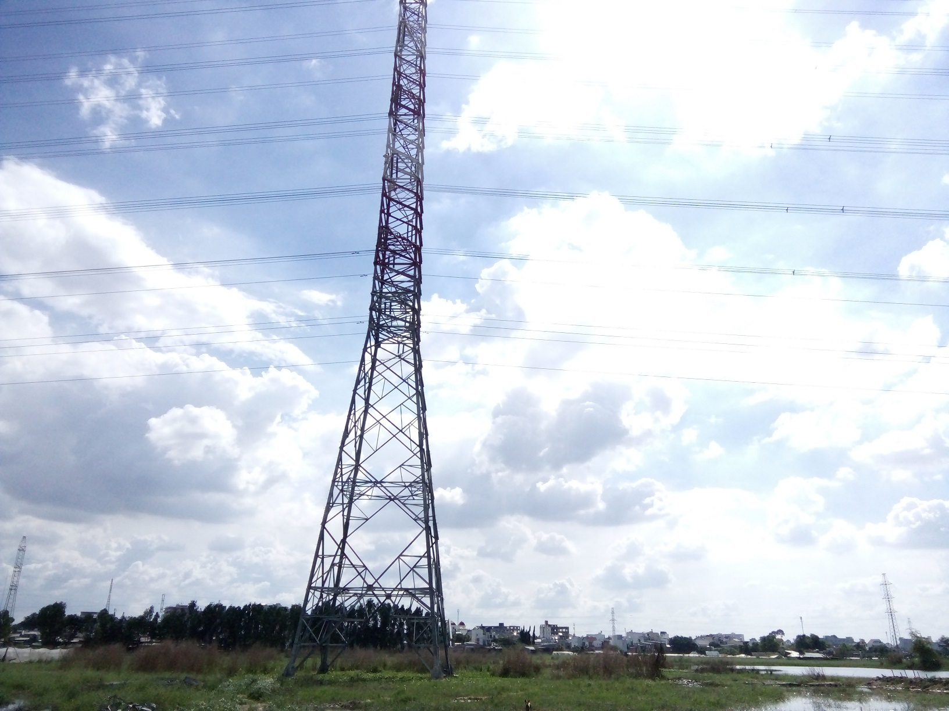  Transmission Line 110 kV across construction site | Construction activities may pose damage to the transmission line due to short-circuit by operation of cranes and concrete-ready pump trucks close to the transmission line i.e. within safety corridor of the transmission line.  Overhead wires can be struck by metal devices, such as poles or ladders, and by vehicles with metal booms. Vehicles or grounded metal objects brought into close proximity with overhead wires can result in arcing between the wires and the object, without actual contact.  Workers working within safety corridor may be affected by magnetic field or electric shock, i.e. at a distance less than 7 meters from the transmission line. | Moderate
2 | 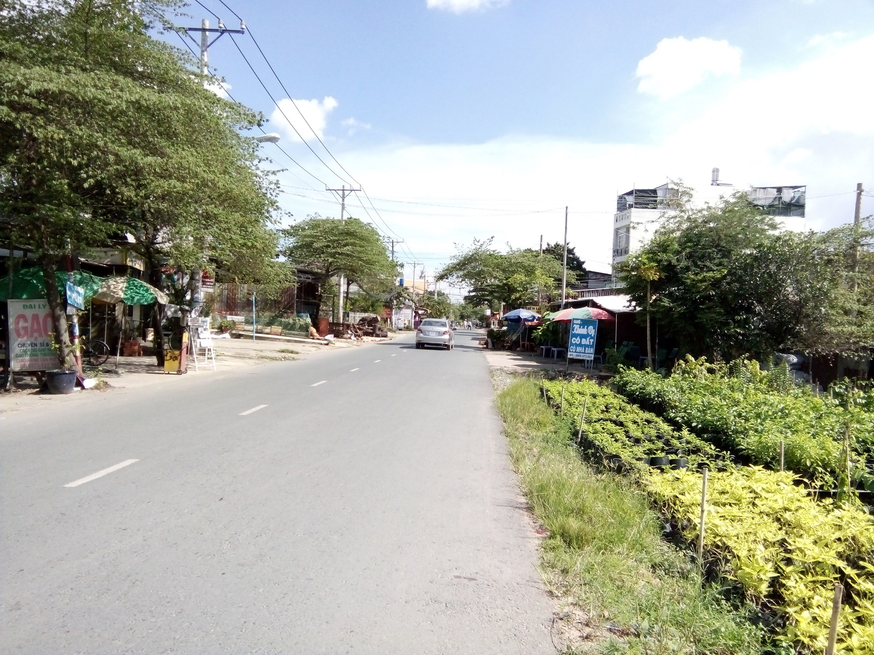  Tan Chanh Hiep 10 road with 8 meters wide – main access road to construction site | Transportation of construction material and construction wastes would cause (i) damage of the road, (ii) dust, exhaust emission, noise and vibration impacts on residents living along both sides of the road, and (iii) traffic accident risks and congestion. | Moderate
3 | 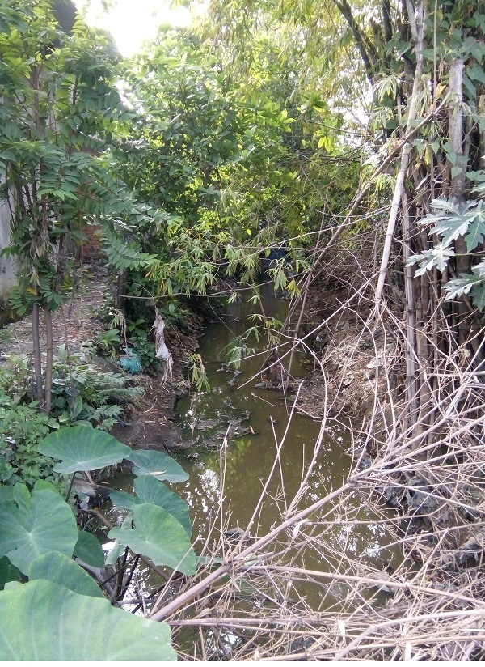  The local existing drainage canal in the subproject area, 70 m far from construction site, will be used for draining wastewater from construction site | Construction activities may cause blocking of water flows due to sedimentation and disposal of construction spoils and wastes.  Worker’s health might be affected by unpleasant odor and mosquitoes from the canal if worker’s camps located near to the canal, i.e. less than 20 meters far from the canal bank. | Low
4 | 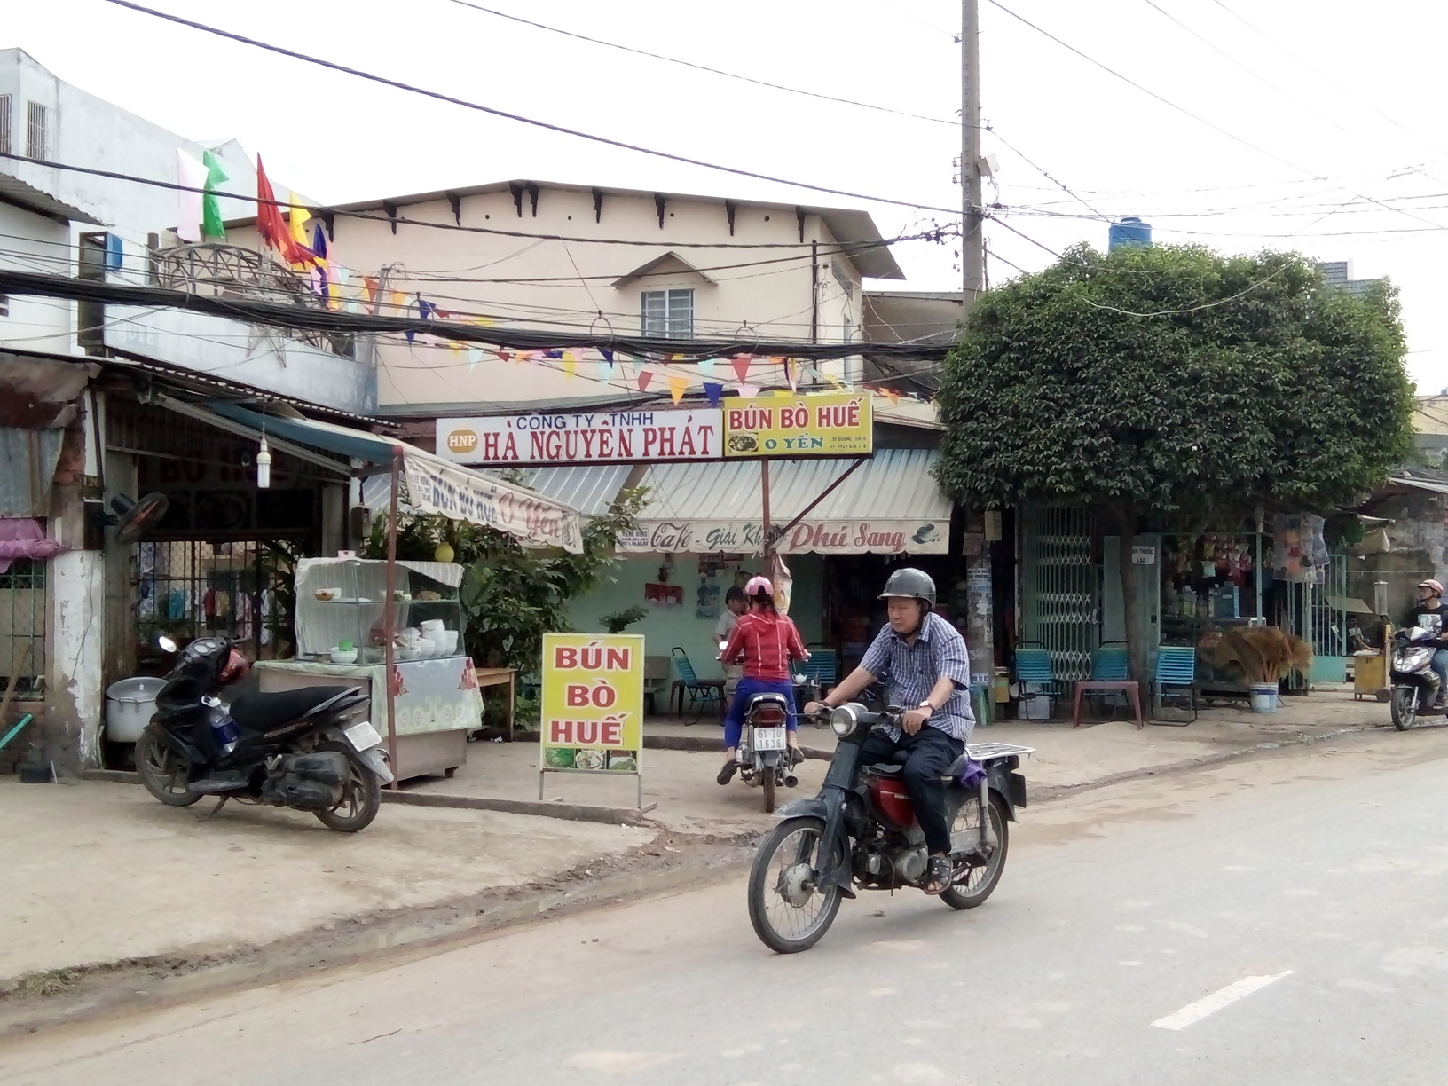  One of family restaurants on Tan Chanh Hiep road, 100 meters far from construction site | Food will be contaminated by dust due to transportation of construction wastes and materials.  Client’s and the restaurant owner’s health will be affected by dust, exhaust emission and noise.  Business will be temporarily affected due to reduction in the number of regular clients, especially 9 businesses are registered with regular tax payment.  It leads to loss of income due to loss of regular clients. | Moderate
Fall risk due to working at heights
Due to construction of buildings with 18.6 meters high, worker is exposed to the hazard of falling more than two meters; into operating machinery; into water or other liquid; into hazardous substances; or through an opening in a work surface. Falls from height are responsible for many serious and fatal injuries every year. If a person falls from a height above two metres the likelihood is that they will sustain serious injury. Many work activities involve working at heights. Working from ladders, scaffolds and platforms are obvious examples, but there are many more activities where people are required to work at heights. The main hazards associated with working at height are people falling and objects falling onto people below. These may occur as a result of inadequate edge protection, or from objects in storage being poorly secured. The impact is considered moderate.

Potential impacts during operation
(a) Gases and noise emission from standby generator
The university shall install one generator with capacity of 250 kVA to maintain power supply in case of power failure from the national power grid. Exhaust gases from the standby generators using DO fuel contain components causing air pollution such as SO₂, NO_{x}, CO, volatile organic compounds (VOC).
During operation, the generator will generate noise impact. Generator set noise is produced by six major sources (see Figure 6):
- Engine noise – This is mainly caused by mechanical and combustion forces and typically ranges from 100 dB(A) to 121 dB(A), measured at one meter, depending on the size of the engine.
- Cooling fan noise – This results from the sound of air being moved at high speed across the engine and through the radiator. Its level ranges from 100 dB(A) to 105 (A) dB at one meter.
- Alternator noise – This is caused by cooling air and brush friction and ranges from approximately 80 dB(A) to 90 dB(A) at one meter.
- Induction noise – This is caused by fluctuations in current in the alternator windings that give rise to mechanical noise that ranges from 80 dB(A) to 90 dB(A) at one meter.
- Engine exhaust – Without an exhaust silencer, this ranges from 120 dB(A) to 130 dB(A) or more and is usually reduced by a minimum of 15 dB(A) with a standard silencer.
- Structural/mechanical noise – This is caused by mechanical vibration of various structural parts and components that is radiated as sound.
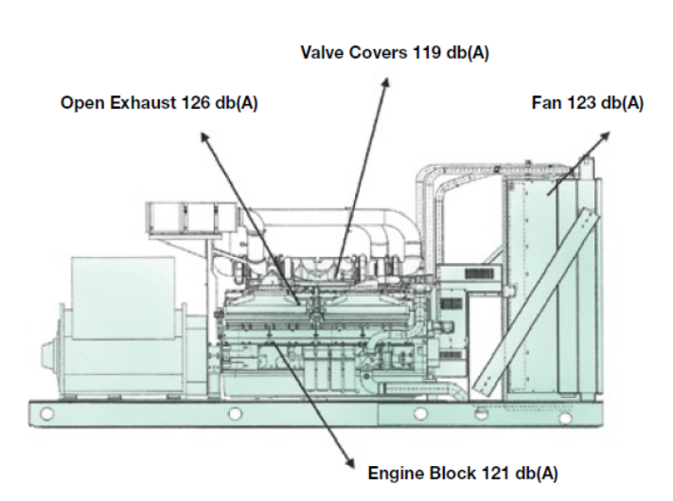
Figure 6: Generator noise sources (estimated sound power level)
The total noise level from a generator set is the sum of all the individual sources, regardless of frequency. For example, if one noise source produces 90 dB(A) and a second noise source also produces 90 dB(A), the total amount of noise produced is 93 dB(A) – not 180 dB(A). An increase of 3 dB(A) represents a doubling of the sound power; yet, this increase is barely perceptible to the human ear. However, the generator operates only in case of power outage so it should operate infrequently, approximately 8-16 hours/month. Thus, the level of impact is low.
(b) Domestic wastewater
Due to concentration of many students, lecturers (12,000 students and 746 lecturers, management) and visitors, according to TCVN 4474-87 domestic wastewater generation is estimated about 20 liters/person/day, and thus total volume of wastewater is (12,000 + 746) x 20 = 254.9 m³/day. Domestic wastewater contains residues, suspended solid (SS), organic compounds (BOD, COD), nutrients (N, P) and bacteria. Thus, when it is discharged into the environment it would cause pollution if there is no remedial measures applied. The impact level is moderate.
(c) Solid wastes
Sources of solid waste from the study include domestic waste, office garbage (paper, packaging, pens...) with the amount of 0.5 kg/person/day as per CENTEMA - 2002. Thus, total volume of domestic solid waste is (12,000 + 746) x 0.5 = 6.373 tons/day. Composition of domestic waste includes paper, glass, metal, plastic, food waste, wood, rubber, porcelain, etc. Besides, the amount of domestic solid waste will also be produced as a result of formualtion of various services to aim to serve the student’s needs in the areas around the university. Domestic solid waste may include hazardous wastes such as battery, neon light, mouse glue, multi-insect spray, empty detergent containers. Hazardous waste accounts for about 1% of the generated solid waste.
The sludge is from cleaning up of manholes in the campus of 5.98 hectares once a year. As per TCVN 7957: 2008 (Drainage and sewerage - External Networks and Facilities - Design Standard) 1 manholes will serve 40x40 = 1,600 m², so with 5.98 hectares will need 37 manholes and average volume of sludge is 37 x 1.2 x 1,2 x 0,3 = 16 m³ (1.2 x 1.2 x 0.3 = area x depth of sediment traps) and septic tanks sludge: 60 mg/liter x 254.9 m³/day x 365 days = 5.582 tons/year. Sludge mainly contains organic matter and may has alkaline or acidic properties, stink, especially high bacteria.
If not properly managed, domestic solid waste will generate bad smell and leachate, and create habitats for rats, flies, mosquitoes and cockroaches as vector-born diseases. As a result, it will affect student’s health and staff. However, collection and treatment of this domestic solid waste will be regularly done by local URENCO, so the impact is low.
(d) Traffic Safety
Operation of about over 4,400 motorbikes of students and lecturers at rush hours (i.e. 6-8 a.m. and 4-6 p.m.) will put a pressure on local traffic, especially in the areas around the university, including routes such as Tan Chanh Hiep 10, Tan Chanh Hiep 10B, Huynh Thi Hai, Duong Thi Muoi, and Dong Bac. Thus, traffic accident would likely happen and the impact is considered moderate.
(e) Social issues
The university attracts a large number of students from different regions with diverse culture so it can cause conflict between students and with local people due to unsound behavior. Issues of order and security disorder such as unregistered staying, abuse of alcohol, and gambling might happen if there is no good coordination between the local authority and the university in management of students. In addition, formulation of various services with the aim of serving the student needs in areas around the university such as food and vegetable shops, groseries, motorbike repair shops, restaurants, student guest-houses, open markets and supermarkets, etc. will also lead to an exacerbation of presure on the service, social and traffic infrastrcutures in the region. Students may be affected by unstable prices and food safety. The impact is considered moderate.
(f) Fire, explosions and short-circuit risks
The university is fully equipped with the facilities so the need for electricity for lighting, air conditioners, computers, laboratory equipment... is quite large and thus there is a potential risk of failure of electrical safety. Especially, there is the 110 kV transmission line accorss the univeristy. In addition, repair and maintenance activities with electric and oxyacetylene welding would also potentially cause fire and explosion risks. The univeristy has plenty of combustible materials such as furniture, books, materials, chemicals and large number of motorcycles using gasoline at the garage and parking lots and a standby generators using diesel oil, so there is a potential risk of fire if fire regualtions are not compliant. Fires and or explosions resulting from ignition of flammable materials or gases can lead to loss of property as well as possible injury or fatalities to the students and the university staff. Since the university has a huge number of students and staff and various activities, the impact is considered moderate.
(g) Laboratory wastes
Wastewater: Activities of the laboratory serve the department/institute such as: Biotechnology & Food, Environment, Chemical Technology. The wastewater can be alkaline or acidic, containing organic solvents and hazardous substances such as salts of heavy metals and cyanide. The composition, properties and concentration of laboratory wastewate is unstable that changes a lot depending on the frequency, number, type and purpose of the experiment. Estimated amount of wastewater is 5 liters/student/week (7 days), and thus total amount is 5 liters/student/week x (1,200 + 1,000 + 1,500) students/7 = 2.6 m³/day. This wastewater will affect water quality of receiving water bodies and soil if not carefully treated. However, there is no any water bodies around the univeristy as receiving sources and this wastewater will not be discharged onto land.
Waste gases: During operational phase, the operation of the laboratory of Institute of Biotechnology and Food; Institute of Technology and Environmental Management; Faculty of Chemical Technology will generate odors and toxic gases such as chlorine, CH₄, H₂S, NH₃, acid, organic solvent vapor and other gases. Although the amount of gases emitted during experiments is small but it will directly affect the health of students and staff working in the laboratory. The impact level is considered moderate.
Solid waste: The laboratories activities would generate hazardous wastes, such as broken chemical containers; empty chemical containers; expired chemicals; fats and oils, lubricants from maintenance activities; broken electrical equipment such as lights, computer, keyboard; failure battery; sprayers; and medical waste from the health clinic of the university, such as bandages, injection needles.
Oil and grease waste: For Faculty of Motivation Technology, oil and grease waste volume of one semester (5 months) is 200 liters.
The laboratory wastes will be properly collected and treated in line with suggested good practices and the GoV’s regualations to reduce negative impacts to acceptable level. However, due to hazardous properties of wastes, the impact is considered moderate.
(h) Laboratory risks
Laboratory activities may cause risk to the health of students and laboratory personnel due to potential exposure to chemicals especially toxic chemicals such as acids, bases, salt of heavy metals and cianide, organic solvents, etc. Health hazards include:
• acute toxicity;
• skin corrosion or irritation;
• serious eye damage or eye irritation;
• respiratory or skin sensitization;
• germ cell mutagenicity;
• carcinogenicity;
• reproductive toxicology;
• target organ systemic toxicity—single exposure;
• target organ systemic toxicity—repeated exposure; and
• aspiration hazard.
The risk of toxic effects is related to both the extent of exposure and the inherent toxicity of a chemical. Exposure to even large doses of chemicals with little inherent toxicity, such as phosphate buffer, presents low risk. In contrast, even small quantities of chemicals with high inherent toxicity or corrosivity may cause significant adverse effects. The duration and frequency of exposure are also critical factors in determining whether a chemical will produce harmful effects. A single exposure to some chemicals is sufficient to produce an adverse health effect; for other chemicals repeated exposure is required to produce toxic effects. For most substances, the route of exposure (through the skin, the eyes, the gastrointestinal tract, or the respiratory tract) is also an important consideration in risk assessment. For chemicals that are systemic toxicants, the internal dose to the target organ is a critical factor. Exposure to acute toxicants can be guided by well defined toxicity parameters based on animal studies and often human exposure from accidental poisoning.

MITIGATION MEASURES FOR POTENTIAL NEGATIVE IMPACTS

Mitigation measures for generic construction related impacts during pre-construction and construction phases
As part of the Environmental and Social Management Plan (ESMP) for the subproject, these general measures have been translated into standard environmental specifications to be incorporated into the bidding and contract documents. These mitigation measures are referred to as Environmental Codes of Practice (ECOP), and they will be applied to mitigate typical impacts of the subproject’s civil works.
The ECOP describe typical requirements to be undertaken by contractors and supervised by the construction supervision consultant during construction. The ECOP will be incorporated into the bidding and contractual documents (BD/CD). The scope and content of the ECOP is as follows:
Scope: Construction activities for civil works governed by these ECOP are those whose impacts are of limited extent, temporary and reversible, and readily managed with good construction practices.
The measures identify typical mitigation measures for the following aspects:
- Dust and exhaust emission
- Noise and vibration impacts
- Wastewater management
- Management of solid wastes
- Management of chemical and hazardous wastes
- Traffic safety management
- Interruption to the existing service infrastructures
- Management of social issues related to workers
- Chance Find Procedures
- Health and Safety for workers and the public
- Management of stockpiles and borrow pits
- Communication with local communities
Table 10. Environmental Codes of Practice (ECOP) for Addressing Generic Construction Impacts
Environmental and social issues | Mitigation measures | Applicable the GoV’s regulations | Responsibility
Environmental and social issues | Mitigation measures | Applicable the GoV’s regulations | Implementation | Supervision
1) Dust and exhaust emission | - The Contractor is responsible for compliance with relevant Vietnamese legislation with respect to ambient air quality.  - The Contractor shall ensure that the generation of dust is minimized and is not perceived as a nuisance by local residents and shall implement a dust control plan to maintain a safe working environment and minimize disturbances for surrounding residential areas/dwellings.  - The Contractor shall implement dust suppression measures (e.g. use water spraying vehicles to water roads, covering of material stockpiles, increased moisture content for open materials storage piles, etc.), as required.  - Material loads shall be suitably covered and secured during transportation to prevent the scattering of soil, sand, materials, or dust.  - Exposed soil and material stockpiles shall be protected against wind erosion and the location of stockpiles shall take into consideration the prevailing wind directions and locations of sensitive receptors.  - Dust masks should be used where dust levels are excessive  - All vehicles must comply with Vietnamese regulations controlling allowable emission limits of exhaust gases.  - Vehicles in Vietnam must undergo a regular emissions check and get certified named: “Certificate of conformity from inspection of quality, technical safety and environmental protection” following Decision No. 35/2005/QD-BGTVT;  - There should strictly be no burning of solid wastes or construction materials (e.g. wood, rubber, oil-based rag, emptied cement bags, paper, plastic, bitumen, etc.) on site. | - TCVN 6438-2005: Road vehicles - Maximum permitted emission limits of exhaust gas  - Decision No. 35/2005/QD-BGTVT on inspection of quality, technical safety and environmental protection  - QCVN 05: 2013/MONRE: National technical regulation on ambient air quality | Contractor | PMU, CSC
2) Noise and vibration impacts | - The contractor is responsible for compliance with the relevant Vietnamese legislation with respect to noise and vibration.  - All vehicles must have appropriate “Certificate of conformity from inspection of quality, technical safety and environmental protection” following Decision No. 35/2005/QD-BGTVT; to avoid exceeding noise emission from poorly maintained machines.  - Measures to reduce noise to acceptable levels should be implemented, including:  - Selecting equipment with lower sound power levels  - Installing silencers for fans  - Installing suitable mufflers on engine exhausts and compressor components  - Installing acoustic enclosures for equipment casing radiating noise  - Installing acoustic barriers without gaps and with a continuous minimum surface density of 10 kg/m2 in order to minimize the transmission of sound through the barrier  - Barriers should be located as close to the source or to the receptor location to be effective  - Installing vibration isolation for mechanical equipment  - Limiting the hours of operation for specific pieces of equipment or operations, especially mobile sources operating through community areas  - Re-locating noise sources to less sensitive areas to take advantage of distance and shielding  - Siting permanent facilities away from community areas if possible  - Taking advantage of the natural topography as a noise buffer during facility design  - Reducing project traffic routing through community areas wherever possible  - Developing a mechanism to record and respond to complaints | - QCVN 26:2010/BTNMT: National technical regulation on noise  - QCVN 27:2010/BTNMT: National technical regulation on vibration | Contractor | PMU, CSC
3) Wastewater management | - The Contractor must be responsible for compliance with the relevant Vietnamese regulations on wastewater discharges into surroundings.  - Portable or constructed toilets must be provided on site for construction workers.  - Consider hiring local workers to reduce wastewater generation on site.  - Provide septic tanks for collecting and treating wastewater from toilets.  - Wastewater from kitchens, showers, sinks shall be discharged into a local sewerage system.  - Wastewater from washing vehicles and construction equipment shall be collected into a settling pond before discharged into local drainage system.  - At completion of construction works, wastewater collection tanks and septic tanks shall be safely disposed of or effectively sealed off | - QCVN 14:2008/BTNMT: National technical regulation on domestic wastewater;  - QCVN 40: 2011/ BTNMT: National technical regulation on industrial wastewater | Contractor | PMU, CSC
4) Management of solid wastes | - Before construction, a solid waste control procedure (storage, provision of bins, site clean-up schedule, bin clean-out schedule, etc.) must be prepared by Contractors and it must be carefully followed during construction activities.  - Before construction, all necessary waste disposal permits or licenses must be obtained.  - Measures shall be taken to reduce the potential for litter and negligent behavior with regard to the disposal of all refuse. At all places of work, the Contractor shall provide litter bins, containers and refuse collection facilities.  - Solid waste may be temporarily stored on site in a designated area approved by the Construction Supervision Consultant and relevant local authorities prior to collection and disposal through a licensed waste collector, for example, URENCO.  - Waste storage containers shall be covered, tip-proof, weatherproof and scavenger proof.  - No burning, on-site burying or dumping of solid waste shall occur.  - Recyclable materials such as wooden plates for trench works, steel, scaffolding material, site holding, packaging material, etc shall be collected and separated on-site from other waste sources for reuse, for use as fill, or for sale.  - If not removed off site, solid waste or construction debris shall be disposed of only at sites identified and approved by the Construction Supervision Consultant and included in the solid waste plan. Under no circumstances shall the contractor dispose of any material in environmentally sensitive areas, such as in areas of natural habitat or in watercourses. | - Decision No. 59/2007/NĐ-CP on solid waste management;  - Decree No. 38/2015/NĐ-CP dated 24/04/2015 on waste and scrap management | Contractor | PMU, CSC
5) Management of chemical and hazardous wastes | - Chemical waste of any kind shall be disposed of at an approved appropriate landfill site and in accordance with local legislative requirements. The Contractor shall obtain needed disposal certificates.  - The removal of asbestos-containing materials or other toxic substances shall be performed and disposed of by specially trained and certified workers.  - Used oil and grease shall be removed from site and sold to an approved used oil recycling company.  - Used oil, lubricants, cleaning materials, etc. from the maintenance of vehicles and machinery shall be collected in holding tanks and removed from site by a specialized oil recycling company for disposal at an approved hazardous waste site.  - Used oil or oil-contaminated materials that could potentially contain PCBs shall be securely stored to avoid any leakage or affecting workers. The local DONRE must be contacted for further guidance.  - Unused or rejected tar or bituminous products shall be returned to the supplier’s production plant.  - Relevant agencies shall be promptly informed of any accidental spill or incident.  - Store chemicals appropriately and with appropriate labeling.  - Appropriate communication and training programs should be put in place to prepare workers to recognize and respond to workplace chemical hazards.  - Prepare and initiate a remedial action following any spill or incident. In this case, the contractor shall provide a report explaining the reasons for the spill or incident, remedial action taken, consequences/damage from the spill, and proposed corrective actions. | - Decree No. 38/2015/NĐ-CP dated 24/04/2015 on waste and scrap management  - Circular No. 36/2015/TT-BTNMT on hazardous waste management | Contractor | PMU, CSC
- 6) Traffic safety management | - Before construction, carry out consultations with local government and community and with traffic police.  - Significant increases in number of vehicle trips must be covered in a construction plan previously approved. Routing, especially of heavy vehicles, needs to take into account sensitive sites such as schools, hospitals, and markets.  - Installation of lighting at night must be done if this is necessary to ensure safe traffic circulation.  - Place signs around the construction areas to facilitate traffic movement, provide directions to various components of the works, and provide safety advice and warning.  - Avoid material transportation for construction during rush hours.  - Passageways for pedestrians and vehicles within and outside construction areas should be segregated and provide for easy, safe, and appropriate access. Signpost shall be installed appropriately in roads where necessary. | - Law on traffic and transport No. 23/2008/QH12;  - Decree 46/2016/ND-CP on administrative penalty for traffic safety violation  - Law on construction No. 50/2014/QH13;  - Circular No. 22/2010/TT-BXD on regulation on labour safety in construction | Contractor | PMU, CSC
- 7) Interruption to the existing service infrastructures | - Planned and unplanned interruptions to water, gas, power, internet services: the Contractor must undertake prior consultation and contingency planning with local authorities about the consequences of a particular service failure or disconnection.  - Coordinate with relevant utility providers to establish appropriate construction schedules.  - Provide information to affected households on working schedules as well as planned disruptions (at least 5 days in advance).  - The contractor should ensure alternative water supply to affected residents in the event of disruptions lasting more than one day.  - Any damages to existing utility systems of cable shall be reported to authorities and repaired as soon as possible. | - Decree No. 167/2013/ND-CP on administrative penalty for violations related to social security, order and safety issues | Contractor | PMU, CSC
- 8) Workers’ camp management | - Employ local laborers for reducing influx of workers to the area.  - The Contractor and worker camps will be constructed on the land acquired by the University.  - The worker camps will provide appropriate piped clean water supply, garbage collection, hygienic toilets, mosquito net, fire extinguishers, Aid Kits, and other health protection measures to all workers.  - All the workers need to be registered for temporary stay with the local police.  - Worker camp related social disturbance to local communities are prohibited. Provide training of workers on safety, worker camp environmental issues, safety and health, and prohibited activities. Communicate to migrant workers on local customs, practices and habits in order to avoid conflicts with local people. | - Law on Labor No.10/2012/QH13 | Contractor | PMU, CSC
- 9) Management of social issues related to workers | - Employ local laborers for simple tasks.  - It is advisable to communicate to migrant workers on local customs, practices and habits in order to avoid conflicts with local people.  - The subproject owner and contractors cooperate with local authorities in preventing and fighting against social evils.  - Strengthen communication campaigns for abolishment of social evils  - Liaise with local organizations to ensure effective monitoring and a GRM to which locally-affected people can rely on.  - Workers temporarily residing at the camps and rented houses must be registered with the local authorities for temporary residence.  - Prohibit workers from:  - Consuming alcoholic drinks during working  - Quarreling and fighting  - Gambling and indulging in social evils such as drug use and prostitution  - Disposing of garbage indiscriminately | - Decree No. 167/2013/ND-CP on administrative penalty for violations related to social security, order and safety issues | Contractor | PMU, CSC
- 10) Chance Find Procedures | If the Contractor discovers archeological sites, historical sites, remains and objects, including graveyards and/or individual graves during excavation or construction, the Contractor shall:  - Stop the construction activities in the area of the chance find;  - Delineate the discovered site or area;  - Secure the site to prevent any damage or loss of removable objects. In cases of removable antiquities or sensitive remains, a night guard shall be arranged until the responsible local authorities or the Department of Culture and Information takes over;  - Notify the Construction Supervision Consultant who in turn will notify responsible local or national authorities in charge of the Cultural Property of Viet Nam (within 24 hours or less);  - Relevant local or national authorities would be in charge of protecting and preserving the site before deciding on subsequent appropriate procedures. This would require a preliminary evaluation of the findings to be performed. The significance and importance of the findings should be assessed according to the various criteria relevant to cultural heritage; those include the aesthetic, historic, scientific or research, social and economic values;  - Decisions on how to handle the finding shall be taken by the responsible authorities. This could include changes in the layout (such as when finding an irremovable remain of cultural or archeological importance) conservation, preservation, restoration and salvage;  - If the cultural sites and/or relics are of high value and site preservation is recommended by the professionals and required by the cultural relics authority, the subproject owner will need to make necessary design changes to accommodate the request and preserve the site;  - Decisions concerning the management of the finding shall be communicated in writing by relevant authorities; and  - Construction works could resume only after permission is granted from the responsible local authorities concerning safeguard of the heritage. | - Law on cultural heritage No. 28/2001/QH10;  - Amended and supplemented Law on cultural heritage No. 32/2009/QH12;  - Amended and supplemented Decree No. 98/2010/ND-CP | Contractor | PMU, CSC
- 11) Health and safety for workers and local communities | - Provide training in OHS to workers and raise their awareness of infectious diseases especially HIV/AIDS within 2 weeks prior to the commencement of packages for construction items lasting at least 6 months.  - Provide training in first-aid skill and first-aid kit to workers and site engineer.  - Regularly exam worker’s health to ensure occupational health.  - Provide workers with PPE such as masks, gloves, helmets, shoes/boots, goggles, safety belt, etc. and enforce wearing during working especially working at heights and in dangerous areas.  - Provision of proper eye protection such as welder goggles and/or a full-face eye shield for all personnel involved in, or assisting, welding operations. Additional methods may include the use of welding barrier screens around the specific work station (a solid piece of light metal, canvas, or plywood designed to block welding light from others). Devices to extract and remove noxious fumes at the source may also be required.  - Special hot work and fire prevention precautions and Standard Operating Procedures (SOPs) should be implemented if welding or hot cutting is undertaken outside established welding work stations, including ‘Hot Work Permits, stand-by fire extinguishers, stand-by fire watch, and maintaining the fire watch for up to one hour after welding or hot cutting has terminated. Special procedures are required for hotwork on tanks or vessels that have contained flammable materials.  - Limit or avoid working in extreme weather conditions, e.g. too hot, heavy rain, strong wind, and dense fog.  - Safely install power lines at offices and in construction sites and do not lay connectors on the ground or water surface. Electric wires must be with plugs. Place outdoor electric panels in protection cabinets.  - Limit vehicle speed at 5km/hour at construction site and 20km/h on transportation routes across local resident areas.  - Install fences, barriers for dangerous warning/prohibition sites around the construction area which show potential danger to the public.  - Provide safety measures as installation of fences, barriers warning signs, lighting system against traffic accidents as well as other risk to people and sensitive areas.  - Provide sufficient lighting when carrying out construction activities at night.  - Locate noise-generating sources and concrete mixing plants far enough from and downwind of residential areas and camps.  - Store fuels and chemicals in areas with impermeable ground, roofs, surrounding banks, and warning signs at least 50 m far from and downwind of residential areas and the camps.  - Providing specific worker training in handling of flammable materials, and in fire prevention or suppression  - Prepare an emergency plan for chemical/fuel spill incident risk before construction begins.  - Provide the camps with sufficient supplies of clean water, power, and sanitary facilities. There must be at least one toilet compartment for every 25 workers, with separate toilets for males and females. Workers’ beds must be provided with mosquito nets so as to prevent dengue fever. Temporary tents will be unacceptable.  - Clean camps, kitchens, baths, and toilets and sanitize regularly, and keep good sanitation. Provide dustbins and collect wastes daily from the camps. Clear drainage ditches around the camps periodically.  - Stop all construction activities during rains and storms, or upon accidents or serious incidents. | - Directive No. 02 /2008/CT-BXD on labour safety and sanitation in construction agencies;  - Circular No. 22/2010/TT-BXD on regulation on labour safety in construction  - QCVN 18:2014/BXD: Technical regulation on safety in construction | Contractor | PMU, CSC
- 12) Management of stockpiles and borrow pits | - Large-scale borrow pits or stockpiles will need site-specific measures that go beyond those in this ECOP.  - All locations to be used must be previously identified in the approved construction specifications.  - An open ditch shall be built around the stockpile site to intercept wastewater.  - Stockpile topsoil when first opening a borrow pit and use it later to restore the area to near natural conditions.  - If the need for new sites arises during construction, they must be pre-approved by the Construction Engineer.  - If landowners are affected by use of their areas for stockpiles or borrow pits, they must be included in the subproject RAP.  - If access roads are needed, they must have been considered in the environmental assessment. |  | Contractor | PMU, CSC
13) Communication with local communities | - Maintain open communications with the local government and concerned communities; the contractor shall coordinate with local authorities (leaders of local wards or communes, leader of villages) for agreed schedules of construction activities at areas nearby sensitive places or at sensitive times (e.g., religious festival days).  - Copies in Vietnamese of this ECOP and of other relevant environmental safeguard documents shall be made available to local communities and to workers at the site.  - Reduced playground space, loss of playing fields and car parking: The loss of amenities during the construction process is often an unavoidable source of inconvenience to users in sensitive areas. However, early consultation with those affected, provides the opportunity to investigate and implement alternatives.  - Disseminate subproject information to affected parties (for example local authority, enterprises and affected households, etc) through community meetings before construction commencement.  - Provide a community relations contact from whom interested parties can receive information on site activities, subproject status and subproject implementation results.  - Provide all information, especially technical findings, in a language that is understandable to the general public and in a form of useful to interested citizens and elected officials through the preparation of fact sheets and news release, when major findings become available during subproject implementation phase.  - Monitor community concerns and information requirements as the subproject progresses.  - Respond to telephone inquiries and written correspondence in a timely and accurate manner.  - Inform local residents about construction and work schedules, interruption of services, traffic detour routes and provisional bus routes, blasting and demolition, as appropriate.  - Limit construction activities at night. When necessary ensure that night work is carefully scheduled and the community is properly informed so they can take necessary measures.  - At least 15 days in advance of any service interruption (including water and electricity supply, telephone service, bus service, etc.) the community must be advised through postings at the subproject site, at bus stops, and in affected homes/businesses.  - Provide technical documents and drawings to local authority and community, especially a sketch of the construction area and the ESMP of the construction site.  - Notification boards shall be erected at all construction sites providing information about the project, as well as contact information about the site managers, environmental staff, health and safety staff, telephone numbers and other contact information so that any affected people can have the channel to voice their concerns and suggestions | - Decree No. 167/2013/ND-CP on administrative penalty for violations related to social security, order and safety issues | Contractor | PMU, CSC

Mitigation measures for site-specific impacts during pre-construction
Mitigation measure for land acquisition
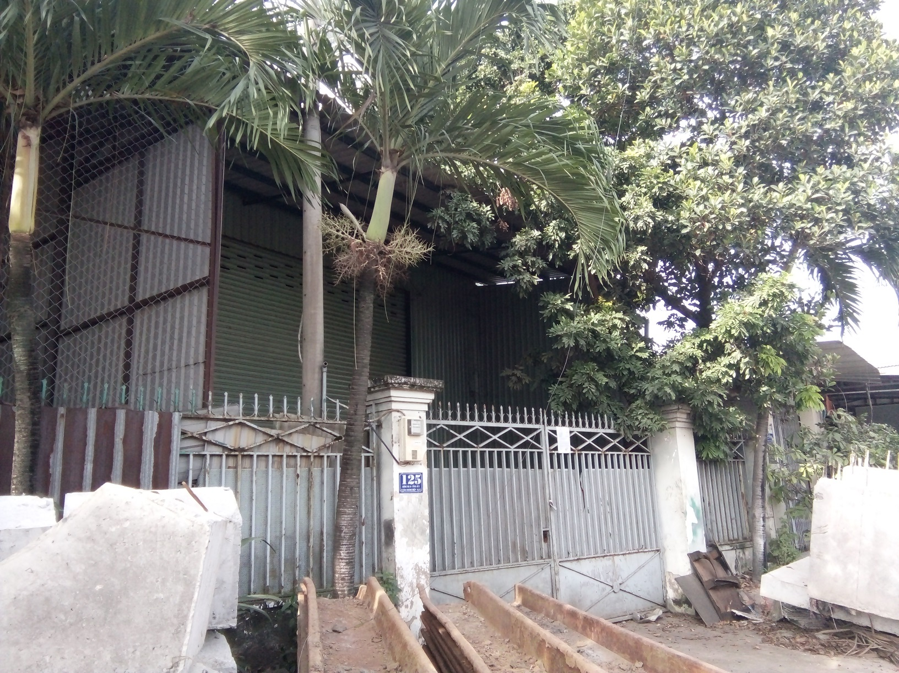
Effort has been made by the IUH to minimize the need of land acquisition and resettlement. Where avoidance of land acquisition is not feasible, compensation will be made to the affected households for the assets that are lost/affected, including their loss of income as a result of land acquisition. The compensation payment will be made on the basis of the principles set forth in the RAP. In addition to compensation, households who are severely affected will be provided with additional financial support for resettlement. They are also eligible for participating in the Livelihood Restoration Program that was designed based on their needs to assist them in promptly restoring their livelihood as a result of loss of land/business/crops, or as a result of physical relocation. In addition to the compensation and support, other measures will be taken to mitigate the potential adverse impact, including early notification of land acquisition (i.e. before 90 days for agricultural land and 180 days for residential land), resettlement site is close to the existing households. During resettlement process, consultation will be conducted regularly to ensure feedback on affected households is considered to avoid/mitigate the resettlement impact. Temporary impact on existing living and business activities will be mitigated by allowing the households to continue using their existing houses and running their current business until their new houses are ready to move in.
One out of 82 houses to be displaced
Mitigation measure for impact on livelihood
All households who are severely affected and who are vulnerable will be eligible to participate in the Livelihood Restoration Program (LRP), which include trainings on agricultural extension, new job training, credit access and other measures as recommended and appropriate to support the livelihoods restoration of affected households to ensure their livelihood is restored to the pre-project level, or even improve. The LRP will be developed in consultation with affected households after the Resettlement Action Plan (as approved by HCMC PC and the World Bank) are disclosed fully to the affected households to ensure the consultation on measures to restore livelihoods for severely affected households meaningful and realistic. Costs related to implementing LRP will be borne by the Project Owner.
Mitigation measure for temporary impact on land/local business
Temporarily affected land, including assets associated with affected land, will be compensated for - as agreed with the land owner. Upon return of affected land to local people, the affected land must be restored to its original condition – as agreed with the affected households.
In case the construction affect temporarily the business activities of local households outside the project area, resulting in loss of income that derive from such business, loss of income should be compensated for the entire period of impact – as agreed with the affected households.
Mitigation measure for impact on crops and trees
For annual and perennial trees, standing crops, compensation in cash will be paid at full replacement cost, irrespective of the legal status of the land, and are in line with Article 90 of the Land Law 2013.
Movable crops such as orchard trees will not be compensated but transportation of the trees to new location is supported as specified by District Board for Compensation and Land Acquisition. If replanting of trees in new location incurs costs, such full costs will be compensated for.
Mitigation measure for impact on business
For economic loss resulting from contract termination: For households/individual who rent government- or private-owned land for non-farm business, and the land rental is made on renewable contract basis. By the time when the affected land must be returned to government but the land lease contract is still valid, compensation will be paid – as agreed upon in the land lease contract, if any.
For loss of income incurred by business owner, the mechanism for compensation is as follows:
- For registered businesses, compensation will be paid in cash for the loss of net business income, equivalent to 50% of the annual average net income - as declared with the tax agency during the recent three years (This amount is equivalent to 100% of monthly net income for 6 months).
- For non-registered businesses, whose operations are recognized by local authority and whose net income for non-registered businesses are affected, compensation will be paid in cash for the income losses for at least three months.
- For households who do retailed business. They do not have business license and do not pay tax, including also squatter whose business are located on the right of the way, compensation will be a one-time allowance of 3 million VND per household.
For loss of income incurred by business employees:
- Employees who permanently lose their existing job due to acquisition of land on which the business are located will receive an unemployment allowance at the basic wage level for up to 6 months. Cash assistance for vocational training will be provided to the affected employee. HCMC PC will decide on the assistance level for vocational training.
- If they lose their income only temporarily during the business transition period, they will be supported with an allowance as specified by District PC.
Mitigation measure for UXO clearance
UXO clearnce shall be implemented prior to land acquisition. This work will be carried out by specialized demining units of the Army as Military Zone 7 based in HCMC. The subproject owner and specialized demining units will have to inform the local residents at least one month prior to the clearance and must use protective barriers and warning signs in order to reduce risk for people and livestock. The demining unit and the universit will appoint staff responsible for guiding to local people not entering the UXO clearance area. UXO clearance will comply with Circular 146/2007/TT-MOD of Ministry of Defence of the Government of Vietnam.
Mitigation measure for grave relocation
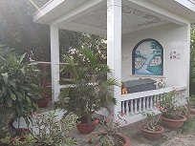
There are 31 household graves which will need to be relocated for construction of the university. The relocation of graves will be done on the basis of full consultation with the affected households to meet their customs and habits regarding to relocation of graves. Compensation payment for affected graves includes full costs associated with a) land for re-burial, b) excavation, c) relocation, d) reburial, e) construction of new tombs, and f) other reasonable related costs which are necessary to meet local customs and habits.
One out of 31 graves to be relocated
Land for relocation of all affected graves will be provided to the affected households - at a graveyard as designated by the District PC. Affected households will be informed of the location of this graveyard so that they can decide where to relocate the affected graves – to the designated graveyard, or to somewhere else in accordance with their customs and habits. If the affected households decide to relocate the affected graves to the graveyard – as designated by the District PC, the land will be provided to all the affected graves at no costs to them. If they decide to relocate the affected graves on their own, the replacement cost for buying land will be compensated for.
In case owner of the affected graves could not be identified, public announcement have to be made (on TV, popular newspaper) for a number of times to look for the grave owners. Within a reasonable time, if grave owners could not show up, the relocation of graves should be done by a specialized unit in consultation with the District Department of Health. The geographical location and status of the graves (with photos taken in details), the procedure of grave relocation, and the new location of the graves have to be documented carefully for the owner’s use at a later time. During implementation the Subproject Owner will make early announce to the households whose graves are affected so that they can arrange their embodiment in consistence with the spiritual practices of the people and compensate to the affected household as required in the subproject RAP and ESMP.

Mitigation measures for site-specific impacts during construction.
Mitigation measures for site-specific impacts during construction are below.
Mitigation measures for fall risk due to working at heights
Fall prevention and protection measures should be implemented whenever a worker is exposed to the hazard of falling more than two meters; into operating machinery; into water or other liquid; into hazardous substances; or through an opening in a work surface. Fall prevention / protection measures may also be warranted on a case-specific basis when there are risks of falling from lesser heights. Fall prevention may include:
- Installation of guardrails with mid-rails and toe boards at the edge of any fall hazard area;
- Proper use of ladders and scaffolds by trained employees;
- Use of fall prevention devices, including safety belt and lanyard travel limiting devices to prevent access to fall hazard area, or fall protection devices such as full body harnesses used in conjunction with shock absorbing lanyards or self-retracting inertial fall arrest devices attached to fixed anchor point or horizontal life-lines;
- Appropriate training in use, serviceability, and integrity of the necessary PPE; and
- Inclusion of rescue and/or recovery plans, and equipment to respond to workers after an arrested fall.
If work at heights cannot be avoided, a risk assessment should be carried out before any work at height is undertaken. The assessment should highlight the measures that must be taken to ensure people are not at risk of falling from height. The risks associated with working at height must be assessed. Below is good practice that should be taken into account during construction with working at heights.
- Ladders: Ladders are acceptable only for access or work of short duration.
- erected at correct angle (4 up to 1 out)
- secured (preferably at top) or footed
- positioned close to the work to avoid over-reaching
- sufficiently protected at the base of any ladder or access equipment to prevent pedestrians or vehicles bumping into them.
- Stepladders: When using stepladders the following precautions should be taken.
- always spread them to their full extent and lock them off
- do not work on the top platform
- do not use the top tread, tool shelf or rear part of the steps as a foot support
- only one person should be on the ladder at any one time
- the ladder must be appropriate and of the correct grade for the intended use.
- Access equipment:
- any hired equipment must be fit for the purpose. Hire contractors must provide information about the risks involved.
- all access equipment must be properly maintained and regularly inspected
- those erecting and using access equipment must be competent to do so, and training should be provided where necessary
- precautions must be taken to prevent the fall of objects or persons
- do not increase reach by placing ladders on access equipment.
- Mobile elevated platforms:
- use the platform only on level, firm ground
- only use the equipment with outriggers and stabilisers
- work with a trained operator at ground level
- safety harnesses must be worn while on the platform
- keep the platform within safe working limits and radius, taking account of wind speeds.
- Scaffold towers:
- be erected by a competent person
- have a height to base dimension ratio not exceeding 3 to 1 indoors, or 2.5 to 1 outdoors
- have stabilisers deployed as necessary to meet the correct height to base ratio
- use outriggers or stabilisers if above 2.5 m high
- have all casters firmly locked before use
- have ladder access to the working platform
- never be moved while the tower is occupied
- be regularly inspected and maintained.
- Safety lines, harnesses and nets:
- Fall restraint and arrest equipment such as nets, airbags and harnesses, etc. should only be considered as a last resort when no other means are reasonably practicable.
- They should only be used and erected by trained operatives and tested and inspected regularly.

Table 11. Mitigation measures for site-specific impacts on sensitive receptors
No | Sensitive receptors and their relation to subproject activity | Site-specific impacts | Specific mitigation measures | Responsibility
 |  |  |  | Implementation | Supervision
1 | Transmission Line 110 kV across construction site | Construction activities may pose damage to the transmission line due to short-circuit by operation of cranes and concrete-ready pump trucks close to the transmission line i.e. within safety corridor of the transmission line and other worker’s activities.  Overhead wires can be struck by metal devices, such as poles or ladders, and by vehicles with metal booms. Vehicles or grounded metal objects brought into close proximity with overhead wires can result in arcing between the wires and the object, without actual contact.  Workers work within safety corridor may be affected by magnetic field or electric shock, i.e. at a distance less than 3 meters from the transmission line | - Establishing “no approach” zones around or under the transmission line with a minimum distance of 7 meters.  - No carrying out construction activities within 20 m of transmission line during rainy days  - Providing workers with personal protective equipment and enforce them to use.  - Appointing qualified technical staff to supervise construction activities near the power towers and lines.  - Setting up lighting system at night.  - No constructing any works within safety corridor of 17 m (8.5 m each side) of the transmission line.  - Prohibiting the following activities (as per Decree 14/2014/ND-CP on Electricity Safety):  - Using of pylon for constructing tent;  - Using the transmission line for other purposes without approval of management unit;  - Using construction equipment that may cause vibration or damage to the transmission line;  - Stockpiling of soil, construction material, equipment or wastes within safety corridor;  - Stockpiling of explosive, inflammable material and chemicals which may cause corrosion or damage to the transmission line;  - Excavating to cause land subsidence for pylon;  - Stealing of items of transmission line | Contractor | PMU, CSC
2 | Tan Chanh Hiep 10 road with 8 meters wide – main access road to construction site | Transportation of construction material and construction wastes would cause (i) damage of the road, (ii) dust, exhaust emission, noise and vibration impacts on residents living along both sides of the road, and (iii) traffic accident risks and congestion | - Prohibit transportation at rush hours (6-8 a.m and 4-6 p.m).  - Using proper trucks (total laden weight less than 20 tons).  - Coordinating with local traffic police to regulate the fleet as necessary.  - Limiting the vehicle speed at 20 km/h.  - Limiting use of horn.  - Using registered vehicle trucks and maintaining vehicle trucks regularly, i.e. once every six months.  - Covering materials and wastes during transportation.  - Washing vehicle trucks before moving out of construction sites.  - Repairing road damages immediately if any | Contractor | PMU, CSC
3 | The local existing drainage canal in the subproject area, 70 m far from construction site, will be used for draining wastewater from construction site | Construction activities may cause blocking of water flows due to sedimentation and disposal of garbage  Worker’s health might be affected by unpleasant odor and mosquitoes from the canal if worker’s camps located near to the canal, i.e. less than 10 meters far from the canal bank | - Excavated soil and construction materials such as sand, stone and gravel will be stockpiled at least 50 meters far from the canal bank.  - Worker’s camps should be located at least 50 meters far from the canal bank.  - Construction wastewater with high sediment will collected into sediment trap ponds on site before discharged into the canal.  - Disposal of garbage into the canal is prohibited.  - Contractors should cooperate with local authority and people to regularly check and clean up the canal bed to ensure no blocking and stagnation throughout construction period. | Contractor | PMU, CSC
4 | One of family restaurants on Tan Chanh Hiep road, 100 meters far from construction site | Food will be contaminated by dust due to transportation of construction wastes and materials  Client’s and the restaurant owner’s health will be affected by dust, exhaust emission and noise  Business will be temporarily affected due to reduction in the number of clients  Income will be lost due to loss of regular clients | - Inform the household of the construction schedule, activities, and associated impacts at least one month before start of the construction.  - Dust suppression will be done through covering construction and waste during transportation and spraying water on road surface at least three times per day (morning, noon, and afternoon).  - Vehicle truck speed should be limited at 20 km/h.  - Horn is limited.  - Transportation schedule should be properly arranged to reduce impact on business, i.e. avoiding transportation activities during morning time.  - Loss of income should be compensated for the entire period of impact – as agreed with the affected households.  - For registered businesses (9 households), compensation will be paid in cash for the loss of net business income, equivalent to 50% of the annual average net income - as declared with the tax agency during the recent three years (this amount is equivalent to 100% of monthly net income for 6 months). | Contractor | PMU, CSC

Mitigation Measures for Environmental Impacts during Operation Phase
Below are a set of mitigation measures which will be applied to avoid, prevent, mitigate and offset environmental and social impacts during operation.
Mitigation measure for gases and noise emission from standby generator
Gases emission mitigation: The University will select the type of generator that is produced in accordance with safety and environmental friendly standards and has low waste gases and noise emission levels. Use of diesel with low sulfur content of 0.05S or bio-fuels will be taken into account. Check and maintenance work will be done regularly, i.e. once every six months. In addition, the university will plant green tree belts around the university and along the internal passages to create a cool and fresh atmosphere, minimizing the impact of the university on the residential areas.
Noise mitigation: Generator’s room is located in a suitable area, away from working area with a distance ≥ 20 m. To minimize the noise effect, the operation workers should set it automatic restarting when power outage. Worker shall be provided with ear cap when they operate the generator. When locating generator sets outdoors, the use of enclosures – particularly sound-attenuating enclosures – combines all of these strategies into a convenient package that provides weather protection as well as sound attenuation. The following figure shows measures to be applied to reduce noise level.
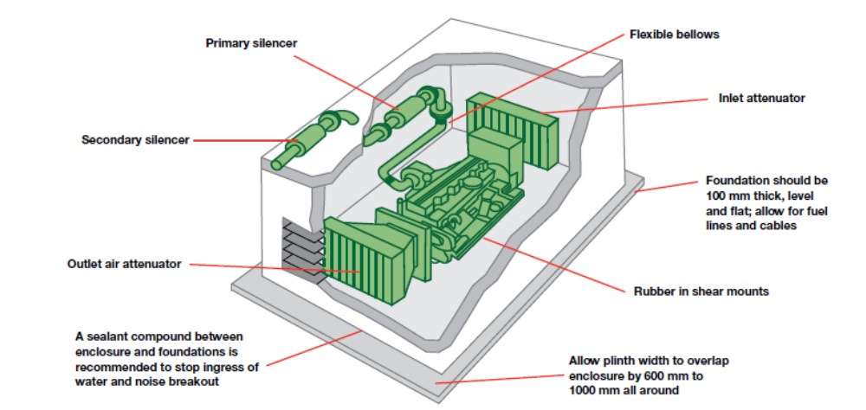
Figure 7: Typical genset installation showing noise control measures
Mitigation measures for domestic wastewater and sludge
Domestic sanitary sewage with generation rate of 254.9 m³/day will be preliminarily treated by 3-compartment septic system to remove pollutants by approximately 50- 60% before discharged into the local sewerage system. The construction of septic system will follow the following good practices:
- Properly designed and installed in accordance with local regulations and guidance to prevent any hazard to public health or contamination of land, surface or groundwater.
- Well maintained to allow effective operation;
- Installed in areas with sufficient soil percolation for the design wastewater loading rate; and
- Installed in areas of stable soils that are nearly level, well drained, and permeable, with enough separation between the drain field and the groundwater table or other receiving waters.
Sludge in manholes and septic tanks will be removed regularly once every 2-3 years by the URENCO and transported to the Da Phuoc Landfill for treatment to ensure the environmental sanitation and safety.
Mitigation measure for social issues
Students must comply with the requirements of registration with local authority for temporary residence. Students are prohibited from abuse of acohol or drug, and gambling.
The univeristy will strengthen communication for students on learning spirit and sound behavior with teachers, between students and with local people.
The univeristy will provide students with library, learning hall, and sport area with the aim of helping students avoiding social evils.
The university will regularly organize sport and performance activities at the weekend or holidays so as to attact of student’s participation.
The university will coordinate with responsible units of Tan Chanh Hiep ward and District 12 in management of shops, restaurants, services and guest-houses around the university with the aim of ensuring stable prices and food safety as well as preventing social evils.
Tan Chanh Hiep ward and District 12 will take account of planning issues to ensure that the local existing infrastructures meet development of the university.
Mitigation measure for solid wastes
Tan Chanh Hiep ward and Disctrict 12 will coordinate local environmental units to collect and treat domestic wastes generated from local people’s activities in the region, including service activities to serve the student’s needs.
The univerisity will provide the trash bins with volume of 120 – 140 liters to collect domestic solid waste. The univeristy would contract with Public Service Company of District 12 to transport domestic waste daily (6.373 tons/day) to Da Phuoc landfill. In addition, the university aslo arranges the sanitation unit to clean up the university everyday and strenghthen communication on environmental protection for all students and staff. Local authority will strengthen collection and treatment of solid wastes generated from service activities serving the student’s needs in the areas around the university to ensure local environmental hygiene.
Hazardous watses will be segregated from non-nazardous wastes and treated in accordance with Circular 36/2015/TT-BTNMT on hazardous waste management. The subproject will also apply good practices on storage and transportation of hazardous watses, as follows:
- Hazardous waste is stored in a manner that prevents the commingling or contact between incompatible wastes, and allows for inspection between containers to monitor leaks or spills. Examples include sufficient space between incompatibles or physical separation such as walls or containment curbs;
- Store in closed containers away from direct sunlight, wind and rain;
- Secondary containment systems should be constructed with materials appropriate for the wastes being contained and adequate to prevent loss to the environment;
- Secondary containment is included wherever liquid wastes are stored in volumes greater than 220 liters. The available volume of secondary containment should be at least 110 percent of the largest storage container, or 25 percent of the total storage capacity (whichever is greater), in that specific location;
- Provide adequate ventilation where volatile wastes are stored; and
- On-site and Off-site transportation of waste should be conducted so as to prevent or minimize spills, releases, and exposures to employees and the public. All waste containers designated for off-site shipment should be secured and labeled with the contents and associated hazards, be properly loaded on the transport vehicles before leaving the site, and be accompanied by a shipping paper (i.e. manifest) that describes the load and its associated hazards.
Mitigation measure for traffic disturbance and accident
The university is constructed at planned location, situated on the outskirts of the city, close to major roads such as national road #1A and #22 so traffic is convenient. Design and construction of internal roads around the university with many entrances, many parking areas is to disperse the vehicles and reduce traffic jam on Tan Chanh Hiep 10 and Tan Chanh Hipe 10B routes. Also, in order to limit personal means of transport the university contacts Center for Public Passenger Transport Management and Execution to organize schoolbuses with university bus stations. The university will also strenghthen regular communication on traffic safety for students and staff.
Mitigation measure for fire, explosion and short-circuit
The electrical system is designed and installed of with full electrical safety devices such as fire-resistant materials, automatic circuit breaker overload protection & short-circuit, leakage protection. Design and arrange the items in compliance with fire regulations. The subproject profile of the fire-fighting must be approved by the authorized agency.
A Life and Fire Safety Master Plan identifying major fire risks, applicable codes, standards and regulations, and mitigation measures should be prepared before operation of buildings. The Master Plan should be prepared by a suitably qualified professional, and adequately cover, but not be limited to, the issues addressed briefly in the following points. The suitably qualified professional selected to prepare the Master Plan is responsible for a detailed treatment of the following illustrative, and all other required, issues.
Fire prevention: Fire prevention addresses the identification of fire risks and ignition sources, and measures needed to limit fast fire and smoke development. These issues include: (i) fuel load and control of combustibles, (ii) ignition sources, (iii) interior finish flame spread characteristics, (iv) interior finish smoke production characteristics, and (v) human acts, and housekeeping and maintenance.
Means of Egress: Means of Egress includes all design measures that facilitate a safe evacuation by residents and/or occupants in case of fire or other emergency, such as (i) clear, unimpeded escape routes, (ii) accessibility to the impaired/handicapped, (iii) marking and signing, and (iv) emergency lighting.
Detection and Alarm Systems: These systems encompass all measures, including communication and public address systems needed to detect a fire and alert: (i) building staff , (ii) emergency response teams, (iii) occupants, (iv) civil defense.
Compartmentation: Compartmentation involves all measures to prevent or slow the spread of fire and smoke, including: (i) separations, (ii) fire walls, (iii) floors, (iv) doors, (v) dampers, and (vi) smoke control systems.
Fire Suppression and Control: Fire suppression and control includes all automatic and manual fire protection installations, such as: (i) automatic sprinkler systems, (ii) manual portable extinguishers, and (iii) fire hose reels.
Emergency Response Plan: An Emergency Response Plan is a set of scenario–based procedures to assist staff and emergency response teams during real life emergency and training exercises.
Operation and Maintenance: Operation and Maintenance involves preparing schedules for mandatory regular maintenance and testing of life and fire safety features to ensure that mechanical, electrical, and civil structures and systems are at all times in conformance with life and fire safety design criteria and required operational readiness.
The following fire precautions should be taken into account, including:
- Equipping facilities with fire detectors, alarm systems, and fire-fighting equipment. The equipment should be maintained in good working order and be readily accessible. It should be adequate for the dimensions and use of the premises, equipment installed, physical and chemical properties of substances present, and the maximum number of people present.
- Provision of manual firefighting equipment that is easily accessible and simple to use
- Fire and emergency alarm systems that are both audible and visible
The following measures will be applied to mitigate fire and explosion:
- Storing flammables away from ignition sources and oxidizing materials. Further, flammables storage area should be:
- Remote from entry and exit points into buildings
- Away from facility ventilation intakes or vents
- Have natural or passive floor and ceiling level ventilation and explosion venting
- Use spark-proof fixtures
- Be equipped with fire extinguishing devices and self-closing doors, and constructed of materials made to withstand flame impingement for a moderate period of time
- Providing bonding and grounding of, and between, containers and additional mechanical floor level ventilation if materials are being, or could be, dispensed in the storage area
- Where the flammable material is mainly comprised of dust, providing electrical grounding, spark detection, and, if needed, quenching systems
- Defining and labeling fire hazards areas to warn of special rules (e.g. prohibition in use of smoking materials, cellular phones, or other potential spark generating equipment)
Students in the dormitory will only use gas and electricity for cooking in specified areas and striclty comply with safety rules of gas and electiricy use. Given that the 110 kV transmission line across the university, the following activities will be strictly prohibited:
- Flying a kite close to the transmission line
- Planting or allowing trees approaching the 6-m safety zone of the transmission line
- Installing antenna, clothes-lines and other devices in locations which may touch the electric wires in case of collapsing or falling
- Throwing any objects on the transmission line
The following measures should be taken into account to esnure electrical safety:
- Marking all energized electrical devices and lines with warning signs
- Locking out (de-charging and leaving open with a controlled locking device) and tagging-out (warning sign placed on the lock) devices during service or maintenance
- Checking all electrical cords, cables, and hand power tools for frayed or exposed cords and following manufacturer recommendations for maximum permitted operating voltage of the portable hand tools
- Double insulating / grounding all electrical equipment used in environments that are, or may become, wet; using equipment with ground fault interrupter (GFI) protected circuits
- Protecting power cords and extension cords against damage from traffic by shielding or suspending above traffic areas
- Appropriate labeling of service rooms housing high voltage equipment (‘electrical hazard’) and where entry is controlled or prohibited
- Conducting detailed identification and marking of all buried electrical wiring prior to any excavation work
The univeristy will regularly strengthen communication on safety rules and provide annual training in preventing and fighting fire to students and staff.
Management of laboratory wastes
Laboratory waste gases: Natural ventilation for laboratories is the first priority. Besides, the subproject will be designed and equipped with fan to fan fresh air from outside into the room and fume hoods to ensure the health of staff who work in the laboratories.
Collection and treatment of chemical vapors in the laboratory: Laboratory is properly provided with specialized equipment and work areas. Experiment zones with volatile chemicals is located in a separate area, and installed with a dedicated fume hood with suitable capacity, ensure that all gases and chemical vapors must be sucked.
Operation principle of the fume hood: the air contains chemical vapor arising from the laboratory is collected and sucked into the device, then follows PVC pipe into two major parts of the system, namely: Adsorption - filtration device and absorption - filtering equipment. Spray water from the top down, bottom-up gas, the water-soluble gas as acidic vapor, soluble organic solvent will be absorbed into water and retained, the water-soluble gases will not escape and will be absorbed by the device with activated carbon filter. Filtered air through the device meets the requirements of the QCVN 05:2013/BTNMT and QCVN 06:2009/BTNMT.
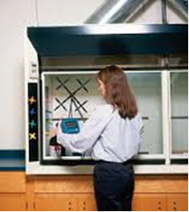 | 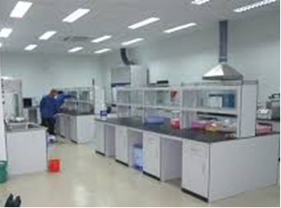

Figure 8. Laboratory fume hoods
Laboratory wastewater with generation rate of 2.6 m³/day is collected separately and treated by physio-chemical methods before discharged into the local wastewater drainage system. Process of laboratory wastewater treatment is as follows:
Laboratory wastewater → Collection tank → Wastewater pump → Physical-chemical reactor (add ozone, pH adjustment chemical, coagulant) → Sediment tank → General sewerage system.
Laboratory solid wastes shall be collected, classified and treated in compliance with Circular 36/2015/TT-BTNMT on hazardous waste management as well as the prudent practices in the laboratory: Handling and Management of Chemical Hazards. The best practices on laboratory waste management is given in Appendix 1. The task for laboratory waste handling is shown in Table 14.
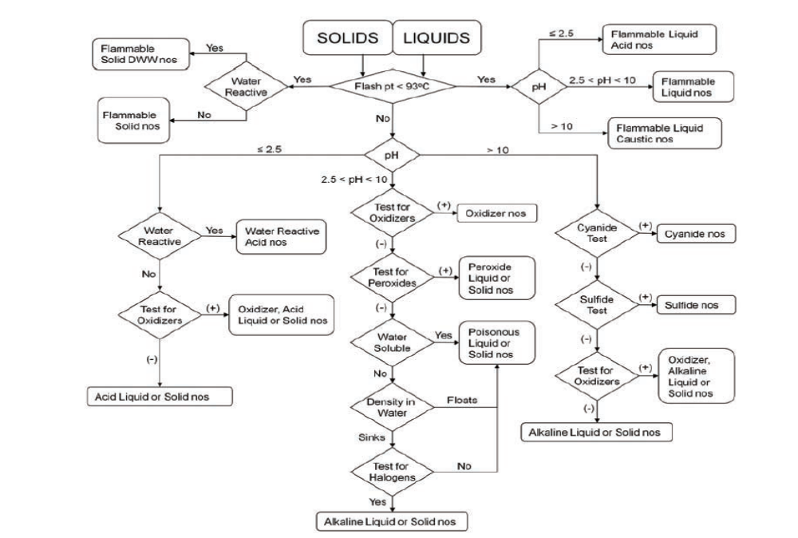
Figure 9: Flowchart for categorizing unknown chemicals for waste disposal

Table 12. Assignment of Tasks for Laboratory Waste Handling
Task | Who Should Perform | Why?
Determine if waste is regulated as hazardous | Staff | Knowledge of the waste, liability considerations, and economics
Segregate according to hazard class | Staff | Economics and safety in storage
Determine if the material will be recycled or reused | Staff | Economics, knowledge of in-house requirements and capabilities
Commingling if appropriate | Staff | Economics, safety, liability, storage space; waste disposal firm could be consulted for advice
Determine appropriate disposal method | Staff and employees of the waste disposal firm | Waste disposal firm is aware of options for specific waste streams; staff should be involved because of liability and cost
Determine packing protocol for labpacks | Waste disposal firm | The waste disposal firm is aware of what is required by the treatment, storage, and disposal facility
Labpacking | Waste disposal firm | The waste disposal firm is generally required to do labpacking
Manifest preparation | Waste disposal firm; review by Staff | The waste disposal firm typically has more experience and will prepare the manifest; staff should be properly trained in how to review a manifest because of liability and cost considerations

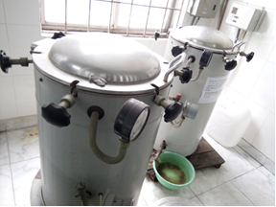

Figure 10. Autoclave in IUH for sterilizing
Ways to help achieve the goal of reducing the volume of chemical waste generated from laboratory includes but is not limited to:
- Practice the concept of Source Reduction by simply ordering the smallest quantity of chemical materials required for researches.
- Keep an inventory of chemicals on hand.
- Share surplus chemical with other labs.
- Purchase mercury-free instruments.
- Substitute hazardous chemicals with non-hazardous chemicals whenever possible.
- Reduce the scale of laboratory experiments to reduce the volume of waste being produced whenever possible.
Laboratory risk mitigation
Laboratories will be constructed towards achieving ISO/IEC 17025:2005. Laboratory operation should follow “Prudent Practices in the Laboratory: Handling and Management of Chemical Hazards. The international best-practices in the laboratory safety is given in Appendix 1.
Training plays an important role in minimizing laboratory risk. Thus, one important source of information for laboratory personnel is training sessions, and the critical place it holds in creating a safe environment should not be underestimated. Facts are only as useful as one’s ability to interpret and apply them to a given problem, and training provides context for their use. Hands-on, scenario-based training is ideal because it provides the participants with the chance to practice activities and behaviors in a safe way. Such training is especially useful for learning emergency response procedures. Another effective tool, particularly when trying to build awareness of a given safety concern, is case studies. Prior to beginning any laboratory activity, it is important to ensure that personnel have enough training to safely perform required tasks. If new equipment, materials, or techniques are to be used, a risk assessment should be performed, and any knowledge gaps should be filled before beginning work.
Safety rules and regulations: Safety rules and regulations are created to protect laboratory personnel from unsafe work practices and exposure to hazardous materials. Consistently following and enforcing the safety rules in order to create a safe and healthful laboratory environment in which to work will help encourage a culture of safety within the workplace. What follows is a description of laboratory safety rules, but these will not cover every contingency. Part of the culture of safety is communication and discussion about safety hazards within the laboratory, so that new concerns can be addressed as quickly as possible.
General safety rules: Below are some basic guidelines for maintaining a safe laboratory environment.
- To ensure that help is available if needed, do not work alone if using hazardous materials or performing hazardous procedures.
- To ensure that help is available in case of emergencies, laboratory personnel should not deviate from the assigned work schedule without prior authorization from the laboratory supervisor.
- Do not perform unauthorized experiments.
- Plan appropriate protective procedures and the positioning of all equipment before beginning any operation. Follow the appropriate standard operating procedures at all times in the laboratory.
- Always read the material safety data sheet (MSDS) and the label before using a chemical in the laboratory.
- Wear appropriate PPE, including a laboratory apron or coat, at all times in the laboratory. Everyone, including visitors, must wear appropriate eye protection in areas where laboratory chemicals are used or stored.
- Wear appropriate gloves when handling hazardous materials. Inspect all gloves for holes and defects before using.
- Use appropriate ventilation such as laboratory chemical hoods when working with hazardous chemicals.
- Contact the Chemical Hygiene Officer (CHO) or the environmental health and safety (EHS) office if have questions about the adequacy of the safety equipment available or chemical handling procedures.
- Know the location and proper use of the safety equipment (i.e., eyewash unit, safety shower, fire extinguisher, first-aid kit, fire blanket, emergency telephone, and fire alarm pulls).
- Maintain situational awareness. Be aware of the hazards posed by the work of others in the laboratory and any additional hazards that may result from contact between materials and chemicals from different work areas.
- Make others in the laboratory aware of any special hazards associated with your work.
- Notify supervisors of any chemical sensitivities or allergies.
- Report all injuries, accidents, incidents, and near misses as directed by the organization’s policy.
- For liability, safety, and security reasons, do not allow unauthorized persons in the laboratory.
- Report any unsafe conditions to the laboratory supervisor or CHO.
- Properly dispose of all chemical wastes. Follow organizational policies for drain and trash disposal of chemicals.
The quick guide for toxicity risk assessment of chemicals is as follows:
- Identify chemicals to be used and circumstances of use. Identify the chemicals involved in the proposed experiment and determine the amounts that will be used. Is the experiment to be done once, or will the chemicals be handled repeatedly? Will the experiment be conducted in an open laboratory, in an enclosed apparatus, or in a chemical fume hood? Is it possible that new or unknown substances will be generated in the experiment? Are any of the trained laboratory personnel involved in the experiment pregnant or likely to become pregnant? Do they have any known sensitivities to specific chemicals?
- Consult sources of information. Consult an up-to-date LCSS for each chemical involved in the planned experiment or examine an up-to-date material safety data sheet (MSDS) if a laboratory chemical safety summary (LCSS) is not available. Depending on the laboratory personnel’s level of experience and the degree of potential hazard associated with the proposed experiment, obtain the assistance of supervisors and safety professionals before proceeding with risk assessment.
- Evaluate type of toxicity. Use the above sources of information to determine the type of toxicity associated with each chemical involved in the proposed experiment. Are any of the chemicals to be used acutely toxic or corrosive? Are any of the chemicals to be used irritants or sensitizers? Will any select carcinogens or possibly carcinogenic substances be encountered? Are any chemicals involved in the proposed experiment suspected to be reproductive or developmental toxins or neurotoxins?
- Consider possible routes of exposure. Determine the potential routes of exposure for each chemical. Are the chemicals gases, or are they volatile enough to present a significant risk of exposure through inhalation? If liquid, can the substances be absorbed through the skin? Is it possible that dusts or aerosols will be formed in the experiment? Does the experiment involve a significant risk of inadvertent ingestion or injection of chemicals?
- Evaluate quantitative information on toxicity. Consult the information sources to determine the Lethal Dose 50 (LD50), for each chemical via the relevant routes of exposure. Determine the acute toxicity hazard level for each substance, classifying each chemical as highly toxic, moderately toxic, slightly toxic, and so forth. For substances that pose inhalation hazards, take note of the threshold limit value–time weighted average (TLV-TWA), short-term exposure limit, and permissible exposure limit values.
- Select appropriate procedures to minimize exposure. Use the basic prudent practices for handling chemicals, for all work with chemicals in the laboratory. In addition, determine whether any of the chemicals to be handled in the planned experiment meet the definition of a particularly hazardous substance due to high acute toxicity, carcinogenicity, and/or reproductive toxicity. If so, consider the total amount of the substance that will be used, the expected frequency of use, the chemical’s routes of exposure, and the circumstances of its use in the proposed experiment. As discussed in this chapter, use this information to determine whether it is appropriate to apply the additional procedures for work with highly toxic substances and whether additional consultation with safety professionals is warranted.
- Prepare for contingencies. Note the signs and symptoms of exposure to the chemicals to be used in the proposed experiment. Note appropriate measures to be taken in the event of exposure or accidental release of any of the chemicals, including first aid or containment actions.
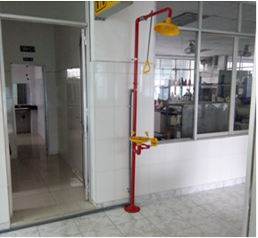
Figure 11. Safety shower available in the area where chemicals are handled in IUH

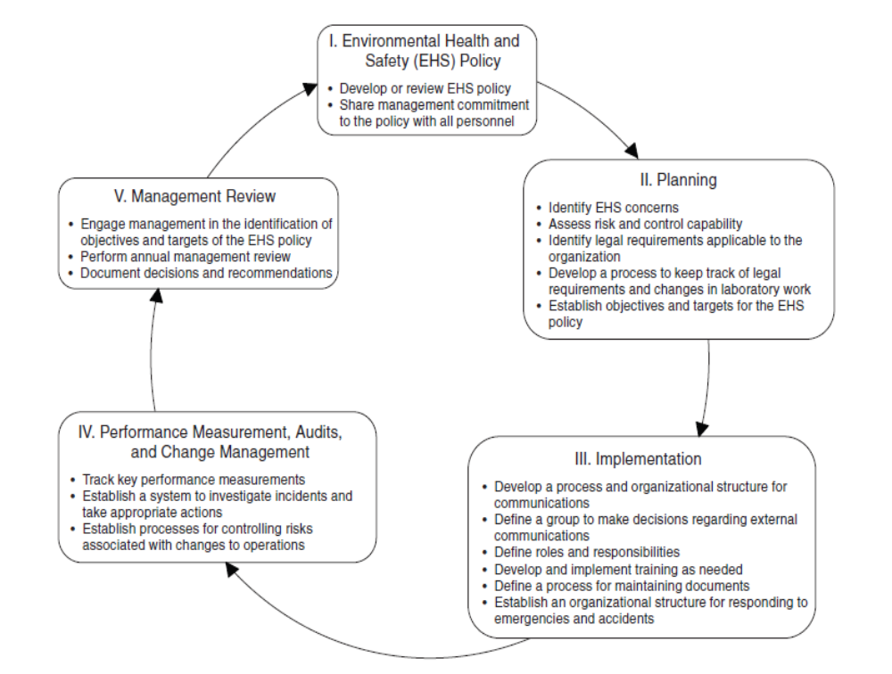
Figure 12. Overview of Laboratory Environmental, Health and Safety Management System

INSTITUTIONAL ARRANGEMENTS
  - Implementation Arrangements
The tables and figures below summarize the roles and responsibilities of the key parties and their relationships regarding the implementation of the ESMP.
- Contractors will beresponsible for implementing mitigation measures. These measures will be included in bidding documents and their costs are to be included in construction bid packages;
- CSC will be responsible for monitoring the day-to-day implementation of mitigation measures. Related costsare included in the CSC service contract;
City Sub-DONRE

PMU’s Environmental and social Staff(s)

CSC
Contractor

Communities

WB

DONRE

PMU
Figure 13. Organization chart for ESMP Implementation
Table 13. Roles and responsibilities of key parties
Community/  Agencies | Responsibilities
PMU | - PMU will be responsible for monitoring the overall subproject implementation, including environmental compliance of the subproject. PMU will have the final responsibility for ESMP implementation and environmental performance of the subproject during the construction and operational phases.  - Specifically the PMU will: (i) closely coordinate with local authorities in the participation of the community during subproject preparation and implementation; (ii) monitor and supervise ESMP implementation including incorporation of ESMP into the detailed technical designs and bidding and contractual documents; (iii) ensure that an environmental management system is set up and functions properly; (iv) be in charge of reporting on ESMP implementation to the DONRE and the World Bank.  - In order to be effective in the implementation process, PMU will assign Environmental Staff(s) (ES) to help with the environmental aspects of the subproject.
PMU Environmental and Social Staff(s) (ES) | - The ES is responsible for monitoring the implementation of the World Bank’s environmental and social safeguard policies in all phases and process of the subproject. Specifically, ES will be responsible for: (i) helping PMU incorporate ESMP into the detailed technical designs and civil works bidding and contractual documents; (ii) helping PMU incorporate responsibilities for ESMP and RAP monitoring and supervision into the TORs, bidding and contractual documents for the Construction Supervision Consultant (CSC) as needed; iii) providing relevant inputs to the consultant selection process; (iv) reviewing reports submitted by the CSC and safeguard consultants; (v) conducting periodic site checks; (vi) helping the PMU on solutions to handle social and resettlement issues of the subproject; and vii) preparing environmental and social performance section on the progress and review reports to be submitted to the DONRE and the World Bank.
Construction Supervision  Consultant (CSC) | - The CSC will assign Environmental and Social Staff(s) and will be responsible for routine supervising and monitoring all construction activities and for ensuring that Contractors comply with the requirements of the contracts and the ECOP. The CSC will engage sufficient number of qualified staff (e.g. Environmental Engineers) with adequate knowledge on environmental protection and construction subproject management to perform the required duties and to supervise the Contractor’s performance.  - The CSC will also assist the PMU in (i) reporting and maintaining close coordination with the local community, and (ii) strengthening safeguard capacity for civil contractors.
Contractor | - The contractor will assign Environmental and Social Staff(s) to carry out Environmental and Social mitigation measures proposed in the ESMP.  - Based on the approved environmental specifications (ECOP) in the bidding and contractual documents, the Contractor is responsible for establishing a Contractor ESMP (CESMP) for each construction site area, submit the plan to PMU and CSC for review and approval before commencement of construction. In addition, it is required that the Contractor get all permissions for construction (traffic control and diversion, excavation, labor safety, etc. before civil works) following current regulations.  - The Contractor is required to appoint a competent individual as the contractor‘s on-site Safety and Environment Officer (SEO) who will be responsible for monitoring the contractor‘s compliance with health and safety requirements, the CESMP requirements, and the environmental specifications (ECOP).  - Take actions to mitigate all potential negative impacts in line with the objective described in the CESMP.  - Actively communicate with local residents and take actions to prevent disturbance during construction.  - Ensure that all staff and workers understand the procedure and their tasks in the environmental management program.  - Report to the PMU and CSC on any difficulties and their solutions.  - Report to local authority and PMU and CSC if environmental accidents occur and coordinate with agencies and keys stakeholders to resolve these issues.
Local community | - Community: According to Vietnamese practice, the community has the right and responsibility to routinely monitor environmental performance during construction to ensure that their rights and safety are adequately protected and that the mitigation measures are effectively implemented by contractors and the PMU. If unexpected problems occur, they will report to the CSC and PMU.
Province and City  People’s Committees (PPCs/DPCs), Provincial DONRE | - Oversee implementation of subprojects under recommendations of DONRE and PMU to ensure compliance of Government policy and regulations. DONRE is responsible for monitoring the compliance with the Government environmental requirements.
  - Environmental Compliance Framework
(i) Environmental Duties of the Contractor
The contractor firstly shall adhere to minimize the impact that may be result of the subproject construction activities and secondly, apply the mitigation measures under ESMP to prevent harm and nuisances on local communities and environment caused by the impacts in construction and operation phases.
Remedial actions that cannot be effectively carried out during construction should be carried out on completion of the works (and before issuance of the acceptance of completion of works)
The duties of the Contractor include but not limiting to:
- Compliance with relevant legislative requirements governing the environment, public health and safety;
- Work within the scope of contractual requirements and other tender conditions;
- Organize representatives of the construction team to participate in the joint site inspections undertaken by the Environmental Staff of the CSC;
- Carry out any corrective actions instructed by the Environmental Staff of the PMU and CSC;
- In case of non-compliances/discrepancies, carry out investigation and submit proposals on mitigation measures, and implement remedial measures to reduce environmental impact;
- Stop construction activities, which generate adverse impacts upon receiving instructions from the Environmental Staff of PMU and CSC. Propose and carry out corrective actions and implement alternative construction method, if required, in order to minimize the environmental impacts; Non-compliance by the Contractor will be cause for suspension of works and other penalties until the non-compliance has been resolved to the satisfaction of the ES of PMU and CSC.
(ii) Contractor’s Safety, Social and Environmental Officer (SEO)
The contractor shall be required to appoint competent staff(s) as the Contractor’s on-site safety, Social and environmental officer (SEO). The SEO must be appropriately trained in environmental management and must possess the skills necessary to transfer environmental management knowledge to all personnel involved in the contract. The SEO will be responsible for monitoring the contractor‘s compliance with the ESMP requirements and the environmental specifications. The duties of the SEO shall include but not be limited to the following:
- Carry out environmental site inspections to assess and audit the contractors' site practice, equipment and work methodologies with respect to pollution control and adequacy of environmental mitigation measures implemented;
- Monitor compliance with environmental protection measures, pollution prevention and control measures and contractual requirements;
- Monitor the implementation of environmental mitigation measures;
- Prepare audit reports for the site environmental conditions;
- Investigate complaints and recommend any required corrective measures;
- Advise the contractor on environment improvement, awareness and proactive pollution prevention measures;
- Recommend suitable mitigation measures to the contractor in the case of non-compliance. Carry out additional monitoring of noncompliance instructed by the ES of PMU and CSC
- Inform the contractor and ES (of PMU and CSC) of environmental issues, submit contractor’s ESMP Implementation Plan to the ES of PMU and CSC, and relevant authorities, if required;
- Keep detailed records of all site activities that may relate to the environment.
(iii) Environmental and Social Supervision during Construction (CSC)
During construction phase, a qualified CSC reporting to the PMU shall carry out the environmental supervision. The CSC will assign environmental and social staff(s), will be responsible for inspecting, and supervising all construction activities to ensure that mitigation measures adopted in the ESMP are properly implemented, and that the negative environmental impacts of the subproject are minimized. The CSC shall engage sufficient number of Environmental Supervision Engineers with adequate knowledge on environmental protection and construction subproject management to perform the required duties and to supervise the Contractor’s performance. Specifically ES of CSC will:
- Review and assess on behalf of the PMU whether the construction design meets the requirements of the mitigation and management measures of the ESMP,
- Supervise site environmental management system of contractors including their performance, experience and handling of site environmental issues, and provide corrective instructions;
- Review the ESMP implementation by the contractors, verify and confirm environmental supervision procedures, parameters, monitoring locations, equipment and results;
- Report ESMP implementation status to PMU and prepare the environmental supervision statement during the construction phase; and
(iv) Compliance with Legal and Contractual Requirements
The constructions activities shall comply not only with contractual environmental protection and pollution control requirements but also with environmental protection and pollution control laws of the Socialist Republic of Viet Nam.
All the works method statements submitted by the Contractor to the CSC and PMU for approval to see whether sufficient environmental protection and pollution control measures have been included.
The CSC and PMU shall also review the progress and program of the works to check that relevant environmental laws have not been violated, and that any potential for violating the laws can be prevented.
The Contractor shall copy relevant documents to the SEO and the ES of CSC and PMU. The document shall at least include the updated work progress report, the updated work measure, and the application letters for different license/permits under the environmental protection laws, and all the valid license/permit. The SEO and the ES shall also have access, upon request, to the Site Log-Book.
After reviewing the documents, the SEO or the ES shall advise the PMU and the contractor of any non-compliance with the contractual and legislative requirements on environmental protection and pollution control for them to take follow-up actions. If the SEO or the ES concludes that the status on license/permit application and any environmental protection and pollution control preparation works may not comply with the work measure or may result in potential violation of environmental protection and pollution control requirements, they shall advise the Contractor and the PMU accordingly.
(v) Environmental Claims and Penalty System
In the compliance framework, if non-compliance with environmental regulations are discovered by CSC/ES/IEMC/PMU during the site supervision, 2% values of interim payment of the contractor of this month will be held back. The Contractor will be given a grace period (determined by CSC/PMU) to repair the violation. If the Contractor performs the repairs within the grace period (confirmed by CSC/PMU), no penalty is incurred and keeping money will be pay. However, if the Contractor fails to successfully make the necessary repairs within the grace period, the Contractor will pay the cost for a third party to repair the damages (deduction from keeping money).
In case of IEMC/CSC/PMU not detected of non-compliance with environmental regulations of the contractor, they will be responsibility payment to repair the violation.
(vii) Reporting Arrangements
ESMP monitoring and reporting requirements are summarized in Table 71 below.
Table 14. Regular Reporting Requirements
No. | Report Prepared by | Submitted to | Frequency of Reporting
1 | Contractor to the Employer | PMU | Once before construction commences and monthly thereafter
2 | Construction Supervision consultant (CSC) | PMU | Weekly and monthly
4 | Community Monitoring | PMU | When the community has any complaint about the subproject safeguards implementation
5 | PMU | DONRE | Every three-month
6 | PMU | WB | Every six-month
  - Grievance Redress Mechanism (GRM)
Complaints relating to any subproject's problems will be solved through negotiations to achieve the consensus. A complaint will go through three Stages before it can be transferred to the court. The enforcement unit will pay all administrative and legal fees relating to the acceptance of complaints. This cost is included in the subproject budget.
Complaint procedures and resolution will be performed as follows:
The first level People’s Committee of ward / commune. An affected household is to take his/her complaint to any member of the People's Committee of the ward / commune, through the village head or directly to People’s Committee of the commune / ward, in written or oral form. The said member(s) of the People’s Committee or the village head will inform the People’s Committee of the ward/commune on the complaint. The People's Committee of Ward/Commune will work directly in person with the said affected household and will decide on the settlement of the complaint 5 days after receiving such complaint (this may take 15 days in mountainous or remote areas). The Secretariat of the People’s Committee of the relevant commune/ward is responsible for documenting and recording all the complaints that it is handling.
After the Ward/Commune People's Committee issues its decision, the relevant household can make an appeal within 30 days. In case a second decision has been issued but the said household is still not satisfied with such decision, such household can appeal to the municipal (city) People’s Committee (CPC).
The second level The CPC. Upon receiving a complaint from a household, the CPC will have 15 days (or 30 days in case of remote and mountainous areas) after receiving the complaint to resolve the case. The CPC is responsible for filing and storing documents on all complaints that it handles.
When the CPC has issued a decision, the household can make an appeal within 30 days. In case a second decision has been issued and the household is still not satisfied with such a decision, they can appeal to the Provincial People’s Committee (PPC).
The third level The PPC. Upon receiving a complaint from the household, the PPC will have 30 days (or 45 days in case of remote and mountainous areas) after receiving the complaint to resolve the case. The PPC is responsible for filing and storing documents for all complaints to be submitted.
After the PPC has issued a decision, the household can appeal within 45 days. In case a second decision has been issued and the household is still not satisfied with such decision, they can appeal to the court within 45 days. The PPC will then have to pay the compensation into an account.
The Forth level Provincial Court. In case a complainant brings his/her case to a provincial court and the court rules in favor of the complainant, the provincial authorities will have to increase the compensation up to such a rate as may be ruled by the court. In case the court’s ruling is in favor of the PPC, the complainant will be refunded the amount of money that has been paid to the court.
The decision ruling the settlement of complaints will have to be sent to complainants and concerned parties, and shall be publicly posted at the headquarters of the People's Committee of the relevant level. The complainant will receive such ruling three days after the result of complaint resolution at the ward / commune / town level has been decided upon and 7 days at the district or provincial level.
To minimize the number of complaints at provincial level, the PMU will coordinate with the District Compensation Committee to participate and provide consultation in solving complaints and respond to complainants. Its role and capacity is to carry out the compensation, support and arrange resettlement for affected households and displaced persons.
Personnel: The environment and resettlement staff chosen by the PMU will design and maintain a database of the subproject-related complaints from affected households, including information such as: the nature of the complaint, the source and date of receipt of the complaint, the name and address of the complainant, action plan, and current status.
For oral complaints, the receiving / mediator board will record these requests in a complaint form at the first meeting with the affected person.
Contractor and Construction Supervision Consultant:
During construction, the GRM will also be managed by the contractors under supervision of the CSC. The contractors will inform the affected communities and communes about the GRM availability to handle complaints and concerns about the subproject. This will be done via the community consultation and information disclosure process under which the contractors will communicate with the affected communities and interested authorities on a regular basis. Meetings will be held at least quarterly, monthly information brochures will be published, announcements will be placed in local media, and notices of upcoming planned activities will be posted, etc.
All complaints and corresponding actions undertaken by the contractors will be recorded in subproject safeguard monitoring reports. Complaints and claims for damages could be lodged as follows:
- Verbally: direct to the CSC and/ or the contractors’ safeguard staff or representatives at the site offices.
- In writing: by hand-delivering or posting a written complaint to specified addresses.
- By telephone, fax, e-mails: to the CSC, the contractors’ safeguard staff or representatives.
Upon receipt of a complaint, the CSC, the contractors’ safeguard staff or representatives will register the complaint in a complaint file and maintain a log of events pertaining to it thereafter, until it is resolved. Immediately after receipt, four copies of the complaint will be prepared. The original will be kept in the file, one copy will be used by the contractor’s safeguard staff, one copy will be forwarded to the CSC, and the fourth copy to the PMU within 24 hours since receipt of the complaint.
Information to be recorded in the complaint log will consist of:
- The date and time of the complaint.
- The name, address and contact details of the complainant.
- A short description of the complaint.
- Actions taken to address the complaint, including contact persons and findings at each step in the complaint redress process.
- The dates and times when the complainant is contacted during the redress process.
- The final resolution of the complaint.
- The date, time and manner in which the complainant was informed thereof.
- The complainant’s signature when resolution has been obtained.
Minor complaints will be dealt with within one week. Within two weeks (and weekly thereafter), a written reply will be delivered to the complainant (by hand, post, fax, e-mails) indicating the procedures taken and progress to date.
The main objective will be to resolve an issue as quickly as possible by the simplest means, involving as few people as possible, and at the lowest possible level. Only when an issue cannot be resolved at the simplest level and/ or within 15 days, will other authorities be involved. Such a situation may arise, for example, when damages are claimed, the to-be-paid amount cannot be resolved, or damage causes are determined.
World Bank Grievance Redress Mechanism: Communities and individuals who believe that they are adversely affected by a World Bank (WB) supported subproject may submit complaints to existing subproject-level grievance redress mechanism or the WB’s Grievance Redress Service (GRS). The GRS ensures that complaints received are promptly reviewed in order to address subproject-related concerns. Subproject affected communities and individuals may submit their complaints to the WB’s independent Inspection Panel which determines whether harms occurred, or could occur, as a result of WB non-compliance with its policies and procedures. Complaints may be submitted at any time after concerns have been brought directly to the WB’s attention, and Bank Management has been given an opportunity to respond. For information on how to submit complaints to the World Bank’s corporate Grievance Redress Service (GRS), please visit www.worldbank.org/grs. For information on how to submit complaints to the World Bank Inspection Panel, please visit www.inspectionpanel.org.
  - ESMP implementation plan
ESMP implementation plan of the Contractor
Shortly after the contract is signed, based on the approved subproject ESMP and construction methods, construction plan approved by CSC and PMU, the Contractor prepares detailed ESMP of the package and submits to the CSC for review and approval.
After the package ESMP is approved by CSC, the contractor carries out the environmental and social impact mitigation measures on site.
The package ESMP will be disclosed at worker’s camp and site office to disseminate the information of mitigation measures to workers.
Making the public information panel at entrances of construction site, address, representative, phone number of stakeholders for supervision by local community and contact as necessary.
Assigning staff in charge of environment and safety, training, providing PPE, regular health examination for workers.
Surveying, examination of environmental status on site, reporting to the CSC if there are significant differences compared to the environmental background.
Contracting with the authorized units for treatment of domestic wastes, hazardous wastes,… and clean water supply.
Managing the workers and construction equipment and providing new certificate in case of expiration.
Implementing ESMP and updating, and submitting to the CSC for approval if there are changes before application.
Cooperating with the PMU and CSC to deal with the complaint of local people about the environmental and safety problem of the package in a timely manner.
Reporting on the package ESMP implementation monthly.
Start of the subproject and personnel
The staff in charge of environmental safeguards of the contractor must be environmental engineer or have relevant disciplines and must have a certificate of occupational health and safety and work fulltime on site.
Providing training in occupational health and safety for workers and regular conducting examination of worker’s health.
  - Capacity development and training
Given that IUH has not yet implemented the Bank-financed projects, it is not familiar with the World Bank safeguard policy requirements. Thus, capacity development and training is necessary to help the IUH to conduct effectively monitoring of ESMP implementation. A two-day training course will be organized by the World Bank safeguard specialists for the IUH staff who will be responsible for subproject environmental safeguard issues to provide them with requirements of the operational policies of the World Bank related to the subproject implementation including OP4.01 (Environmental Assessment), IFC General EHS Guidelines, OP4.11 (Physical Cultural Resources) and OP4.12 (Involuntary Resettlement). Such training should be provided to Construction Supervision Consultant (CSC) and contractor’s EHS officer and repeated annually to refresh their knowledge.
The PMU established by the IUH to assist in subproject implementation will be responsible for coordinating with CSC and Construction Contractors to provide one-day OHS orientation training (as per IFC EHS Guidelines) to all new employees, visitors, and workers to ensure they are apprised of the basic site rules of work at / on the site and of personal protection and preventing injury to fellow employees. One-day basic OHS training should generally be provided to management, supervisors, workers, and occasional visitors to areas of risks and hazards. Such training should be organized before commencement of construction and reiterated annually.

ENVIRONMENTAL MONITORING PLAN

Monitoring of compliance with mitigation measures
Compliance monitoring will be done regularly by PMU and its construction supervision consultant (CSC). PMU and its CSC will be responsible for daily monitoring contrator’s compliance with agreed mitigation measures. Results will be reflected in the monthly progress reports.
Local authority and community will be undertaking the monitoring task in accordance with the GoV’s regulations, i.e. Decree 80/2005/ND-CP - Regulation on community’s investment monitoring.
In addition, contractors’ ES officer will be responsible for daily monitoring labour safety and environmental hygiene on site and reporting to PMU and CSC.
Detailed monitoring plan will be prepared during detailed design phase. The cost estimates for monitoring shall be included in the ESMP implementation cost.

Ambient Environmental Quality Monitoring
Environmental quality monitoring is the most important task of environmental management. Environmental monitoring requires scientific methods, techniques, technologies, and organizations to aim at closely/systematically controlling and monitoring of changes in environmental quality. The ambient environmental quality monitoring will be carried out by the project owner/PMU. Details are shown in the table below.
Table 15. Environmental Monitoring Plan during construction phase
Environment | Location | Frequency | Parameters to be monitored | Applicable National Technical Regulations
Air quality | 4 locations at 4 conners of project’s fence, including 3 points near the resident areas | Every three-month | Table 1 of QCVN 05:2013/BTNMT: SO₂, CO, NO₂, TSP, PM₁₀, Pb. | QCVN 05:2013/BTNMT
Noise | Similar to air sampling locations | Every three-month | Equivalent noise (dBA) | QCVN 26:2010/BTNMT
Excavated soil | 2 locations within 5.98 hectares | Once | As, Cd, Cu, Pb, Zn | QCVN 03-MT:2015/BTNMT
Proposed construction period: 3 years
Table 16. Environmental Monitoring Plan during operation phase
Environment | Location | Frequence | Parameters to be monitored | Applicable National Technical Regulations
Wastewater quality after treatment | 01 point at outlet | Every six-month | Table 1 of QCVN 14:2008/BTNMT: pH, BOD₅ (20°C), TSS, dissolved solid, Sulfur (by H₂S), Ammonium (by N), Nitrate (NO³⁻) (by N), animal, vegetable oil, total surfactant, Phosphate (PO₄³⁻) (by P), total Coliforms; wastewater volume. | QCVN 14:2008/BTNMT - column A; K = 1.
Emission | Laboratory | Every six-month in first 2 years | Acid vapour, VOCs | Decision 3733/2002/QĐ-BYT

COST ESTIMATES

Table 17. Cost estimates for ESMP implementation
No | Content of work | Unit | Quantity | Price (thousand, VND) | Total (thousand, VND) | Source
I | Pre-construction phase |  |  |  | 2,784,500
 | Corrugated fences, canvas | Package | 1 | 50,000 | 50,000 | Site clearing cost
 | Solid waste collection and transportation | House | 84 | 5,000 | 420,000 | Site clearing cost
 | Mobile septic tank, trash bin | Package | 1 | 16,500 | 16,500 | Site clearing cost
 | Collection and transportation wastes from clearing process | Package | 1 | 200,000 | 200,000 | Site clearing cost
 | Capacity development and training | Package | 1 | 20,000 | 20,000 | Investment preparation cost (PMU)
II | Construction phase |  |  |  | 28,555,950
 | Capacity development and training | Package | 1 | 100,000 | 100,000 | subroject cost
 | Subproject public information panel installation | Package | 2 | 3,000 | 6,000 | Construction cost
 | Construction equipment appraisal | Package | 1 | 150,000 | 150,000 | Construction cost
 | 120-L trash bin | Piece | 14 | 1,500 | 21,000 | Construction cost
 | Domestic waste collection fee | Month | 33 | 350 | 11,550 | Construction cost
 | Collection of waste from mobile toilets | Month | 33 | 50,000 | 1,650,000 | Construction cost
 | Washing ground, sediment traps, drainage pipes | Package | 1 | 150,000 | 150,000 | Construction cost
 | Corrugated fences, canvas | Package | 1 | 500,000 | 500,000 | Construction cost
 | Water sprinkle | Package | 1 | 250,000 | 250,000 | Construction cost
 | Tire washing | Package | 1 | 10,000 | 10,000 | Construction cost
 | PPE | Set | 377 | 1,200 | 452,400 | Construction cost
 | Traffic management | Package | 1 | 150,000 | 150,000 | Construction cost
 | Construction waste collection, transportation and treatment | Package | 1 | 200,000 | 200,000 | Construction cost
 | Septic tank | Tank | 7 | 40,000 | 280,000 | Construction cost
 | Wastewater drainage pipes | Package | 1 | 200,000 | 200,000 | Construction cost
 | Toilets | Room | 70 | 50,000 | 3,500,000 | Construction cost
 | Laboratory fume hoods, ventilation and air handling | Package | 1 | 3,000,000 | 3,000,000 | Construction cost
 | Green trees planting | Package | 1 | 750,000 | 750,000 | Construction cost
 | Other construction items include environmental and social impact mitigation measures | Package | 1 | 15,000,000 | 15,000,000 | Construction cost
 | Environmental Supervision and Monitoring | System | 1 | 2,145,000 | 2,145,000 | Construction cost
III | Operation phase (account for 1 year) |  |  |  | 1,107,320
 | PPE for worker | Set | 5 | 1,200 | 6,000 | O&M cost
 | Equipment appraisal and maintenance | Package | 1 | 50,000 | 50,000 | O&M cost
 | Operating laboratory air treatment systems | Package | 1 | 300,000 | 300,000 | O&M cost
 | Dredging and drainage maintenance | Package | 1 | 100,000 | 100,000 | O&M cost
 | Domestic waste collection fee | Month | 12 | 110 | 1,320 | O&M cost
 | Environmental Monitoring | Package | 1 | 150,000 | 150,000 | O&M cost
 | Other costs for environment and safety | Package | 1 | 500,000 | 500,000 | O&M cost

PUBLIC CONSULTANT AND INFORMATION DISCLOSURE

Public Consultation
The objective of the public consultation is to provide a summary of the proposed subproject's objectives, description, and potential impacts and proposed mitigation measures to subproject-affected groups including locally-affected people, local authority and NGOs and take their views into account during engineering design and implementation. It aslo aims to promote two-way communication between the project owner and project stakeholders, including affected people to ensure generally the public, and particularly the affected group, understand the subproject purpose, subproject design, potential positive and negative environmental impacts of the subproject, and subproject policy on involuntary resettlement. It creates opportunity for affected people to participate in all stages of project implementation. Meaningful feedback from consultations will be considered and integrated in the subproject design and mitigation measures. Consutlations with such groups will be carried out during implementation as neccesary to address environmental issues that affect them.
The following stakeholders were informed of the subproject purpose and subproject’s potential impacts:
- Representatives of affected households;
- Representatives of non-affected households who live adjacent to the project area;
- Representatives of Tan Chanh Hiep Ward’s Peoples’ Committee;
- Representatives of District’s Peoples’ Committee No. 12;
- Representatives of Ho Chi Minh City Peoples’ Committee;
- Representatives of Industrial University of Ho Chi Minh City;
- Representatives of Mass organizations, i.e. Women’s Union, Farmers’ Associations, etc.
Various methods and techniques have been used to conduct public consultation and information disclosure, consultation with and participation of affected peoples, including a) community meetings, b) household survey, c) focus group discussion, field observation and key informant interview. Using various methods and techniques aims to enhance the reliability and validity of the feedback from the subproject stakeholders, particularly the locally-affected people and to ensure that (i) affected people receive fully subproject information; and (ii) all affected people are involved in process of free, prior and informed consultation during preparation and implementation. Consultation meetings and direct interviews took place on the days 30 October 2016, 13 November 2016, and 18 November 2016, with the participation of 27 to 34 affected people at each meeting.
From the structured consultation (socioeconomic survey), the feedback from representative of affected households, in general, as follows:
- In terms of the level of project implementation support, 65% of respondent (103 HHs) said they supported the project. 31% (20 HHs) said they support the project provided they the compensation and support are adequate. The remaining 15% (24 HHs) don’t know by the time of the survey (which will be followed) during consultation in the future.
- In terms of impact on Income, 35% of respondent (47 HHs) indicated that their key income source would be affected as a result of the land acquisition. The remaining 65% (88 HHs) said their key income sources would not be affected since they are not using their agricultural for income generation (they have paid job and other non-land based businesses.
- With regards to preferred mode of compensation, 39% of respondent having residential land affected said they preferred land for land whereas 54% prefers compensation in cash. For affected residential land, 42% preferred land for land while 37% prefers cash compensation. Only 9% preferred relocation to the project’s resettlement site, suggesting that people have not known clearly the resettlement site (location, technical specification, economic opportunities). These questions were also raised in public meetings and focus group discussion.
- Regarding planned use of compensation money, 32% of respondent plan to use their compensation to build new houses. 8% repair their houses. 20% will buy new land, and 14% will use the compensation to invest in their businesses. A small fraction (5%) plan to use compensation money to pay their debt.
Regarding enviornmental aspect, local people support the subproject implementation and hope that the subproject will be soon completed and effectively operate. The locally-affected people wanted that construction activities need to ensure environmental hygiene, especially dust mitigation, mitigation of road damage and soon completing construction to restore inital environment conditions; during operation traffic congestion needs to be mitigated and ensure security and order in the context of crowded students.

Table 18. Summary of public consultant results
Comments raised by local people | Feedback
To want that the project owner complies with planning and conduct construction in line with approved construction schedule to avoid frozen planning | The subproject is funded by the World Bank so it should be carried out in accordance with the approved schedule and ensure fair compensation for affected households.
To want that specific compensation rates must be publicized | Specific compensation rates will be publicized to locally-affected people shortly after approved by the City PC.
To need to know the detailed engineering design of the university, particularly the detailed design of the resettlement site and access road connecting the resettlement site and the other part of the ward, and the readiness of other facilities such as water, electricity, and width of the road.  Households who currently have active business on Tan Chanh Hiep 10 Street need to know the specific location of the land plot as well as the land area for each households in the resettlement site to assess their viability of their business once they move into the resettlement area.  To want the resettlement site be ready constructed in terms of infrastructure before people actually move in. They expect the project be carried out as soon as possible because the projects using these land area has been pending for so long.  People also express their appreciation of the University being here as this may promote the new business environment.  To expect the compensation rates be at the market rates, and appropriate to support them in resettlement and restoration of their income/livelihoods.  Compensation rates should be fair and applied consistently to avoid disagreement among affected households.  Residential land should be compensated for the actual areas, not the quota for residential land. | Detailed engineering design: The detailed design for the entire new campus of the IUH in Tan Chanh Hiep Ward is under development. Once completed, the design will be reviewed for technical aspects by HCMC Department of Architecture and approval of HCMC People’s Committee for implementation. Once approved, the detailed design will be disclosed to the affected households – through public meeting to facilitate questions and answers. Detailed design will provide technical specification of roads (within resettlement site), location of dormitory (for students), and functional departments of the University.  Compensation policies (with detailed on eligibility criteria, compensation rates, supports, resettlement options, compensation mode and implementation schedule) will be disclosed – through similar public meetings to allow questions and comments from affected people. Additional consultation meetings to discuss on these issues – with more details, will be done once the compensation policies for the project has been agreed between the World Bank and Ho Chi Minh City’s Peoples Committee.
To be concerned about environmental sanitation, sepcially dust, exhaust emission, road damage, traffic congestion. | The safeguard policies of the World Bank and the environmental protection law of the Government of Vietnam take into account environemntal and human health protection for the Bank-financed projects. Thus, potential impacts will be fully mitigated thorugh ESMP and closely monitored by PMU/its construction supervision consultants and locally-affetced people themselves to ensure that environment and human health is protected.
To be concerned about security and order problems in the context of crowded students and traffic congestion | The university will actively strengthen communication to student on security and order compliance. The student will have to register temporary residence. The university shall build the dormitory for student and coordinate with the city to arrange the bus route with bus-stop at the univeristy to serve traveling of students and limit traffic congestion.

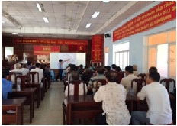 | 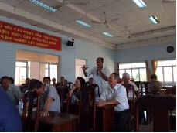
Figure 14. The project owner’s presentation | Figure 15. Local people present their views

Information disclosure
The subproject complies with the policy on access to information of the World Bank and the GoV’s regulations. Namely, the subproject information is widely published across all media, as follows:
On June 20, 2014, HCMC Education online press on www.giaoduc.edu.vn published: IUH: Building the national key university including information about the subproject construction in district 12.
On October 7, 2016, on web of IUH www.iuh.edu.vn published: IUH meets the WB mission in cooperation framework to implement the IUH construction subproject in District 12.
The final RAP is published on information board of Tan Chanh Hiep CPC and District 12 DPC.
When available, the final ESMP shall be disclosed locally in Vietnamese language and through the Bank Operations Portal prior to project appraisal.
Table 19. Information disclosure
Disclosure content | Disclosure through | Location | Estimated Time
Subproject information | Official website | www.giaoduc.edu.vn  www.iuh.edu.vn | 20 Jun 2014  18 Nov 2016
Subproject information | Information board | Construction site | Starting work
Draft final ESMP | (a) Information board  (b) Official website  (c) PMU Office and Website  (d) PMU office and Website  (e) DONRE Office | (a) Tan Chanh Hiep Ward PC  (b) The Bank’s external website and operation portal  (c) Industrial University of HCMC  (d) Ministry of Education and Training  (e) DONRE of HCMC | (a) 7 Jan 2017  (b) 10Jan 2017  (c) 7 Jan 2017  (d) 7 Jan 2017  (e) 7 Jan 2017

REFERENCES
Alexander P. Economopoulus, 1993. Assessment of Sources of Air, Water and Land Pollution -Part One: Rapid Inventory Techniques in Environmental Pollution. World Health Organization (WHO), Geneva, 1993
California Department of Transportation. Transportation and Construction Vibration. Guidance Manual, September 2013.
Dannis Aaberg, 2007. Generator Set Noise Solutions: Controlling unwanted noise from on-site power systems. Power topic #7015.
Environmental, Health, and Safety Guidelines. (www.ifc.org/ehsguidelines)
Government of Uganda, 2005. Environmental and Social Management Framework for Millennium Science Initiative Project. The World Bank Uganda Office.
Ho Chi Minh City Statistical Yearbook 2015.
Laboratory Waste Management Guide. Final report, SQG-LABS-1, December 2015. Local Hazardous Waste Management Program in King County, Washington.
Nguyen Khac Cuong. Environment in Construction Activities, Handbook.
Nguyen Phuoc Dan, 2004. Wastewater Treatment. Department of Environment, Ho Chi Minh City University of Technology, 2004.
Pham Duc Nguyen. Architectural Acoustics, Theoretical Basis and Application Solutions. Science and Technics Publishing House.
Pham Ngoc Dang, and Mackenzie, L.da, 1985. Air Environment. Science and Technics Publishing House, 2000.
Research of Regeneration of Waste Oil to Liquid Fuel. Ministry of Science - Technology - Environment 2002.
Resettlement Action Plan (RAP) for IUH Subproject. 8 December 2016.
The Center for Environmental Technology and Management (CENTEMA), 2002. Research of solid waste from school.
The Committee on Prudent Practice in the Laboratory, 2011. Prudent Practices in the Laboratory. The National Academic Press, ISBN 978-0-309-13864-2|DOI 10.17226/12654, Washington, D.C.
University of Pennsylvania, 2011. Laboratory Chemical Waste Management Guidelines. Revision 2011.
US Green Building Council, 2013. Reference Guide for Building Design and Construction. Leadership in Energy and Environmental Design.
WBDG Sustainable Committee, 2016. Whole Building Design Guide. Updated: 10-27-2016.
World Health Organization (WHO), 2011. Laboratory Quality Standards and Their Implementation. ISBN 978 92 9022 397 9.

APPENDIX 1. INTERNATIONAL BEST-PRACTICES IN THE LABORATORY SAFETY

Procurement / Transport
- Minimize acquisition / quantity of hazardous materials, minimize storage time needed
- Identify mechanism of waste disposal before acquisition
- For chemicals, have Material Safety Data Sheets (MSDSs) accessible/confine deliveries to areas that are equipped to handle them (and train relevant personnel)
- Ensure container is intact and appropriately labeled (US regulations detail how hazardous materials have to be identified, packaged, marked, labeled, documented and placarded)
- Transport in appropriate (secondary) containers
- Use triple packaging system for infectious and potentially infectious substances
- Adhere to international air transport regulations
Storage / Management
- Inventory should have name as printed on the container
- For chemicals: include molecular formula for further identification and to provide a simple means of searching chemicals; include CAS (Chemical Abstract Service) registry number for unambiguous identification of chemicals despite the use of different naming conventions
- Source
- Size of container
- Hazard classification, as a guide to safe storage, handling, and disposal
- Date of acquisition, to ensure that unstable chemicals are not stored beyond their useful life, and Storage location
Procedures
- Dispose of materials anticipated to not be needed within a reasonable time frame
- Use approved containers; make sure storage containers remain intact and sealed
- Dispose of chemicals prior to expiration date, monitor reactive chemicals
- Replace deteriorating labels before information is obscured or lost
- Follow regulations for safe storage in stockroom or lab
- Avoid storing chemicals on bench tops or lab hoods
- Store volatile chemicals in ventilated cabinet (near hood)
- If ventilation is not required, store in closable cabinet or on shelf with lip to prevent sliding
- Do not expose stored chemicals to heat or direct sunlight
- Observe all precautions regarding the storage of incompatible chemicals
- Provide vented cabinets beneath hoods for storing hazardous materials
- Use chemical storage refrigerators for storing chemicals
- Have fire protection system (sprinklers)
- Follow storage limits for flammable and combustible liquids
- Restrict access to storage facility
Protocols / Facilities for Use in Research
- Wear and use appropriate personal protection materials to minimize exposure
- Wash hands
- Reduce the possibility of creating splashes or aerosols
- Contain in biological safety cabinets operations that generate aerosols
- Use good housekeeping
- Use mechanical pipetting devices
- Promptly decontaminate work surfaces
- Never eat, ring, smoke, handle contact lenses, apply cosmetics, or take medicine in the lab
- Take special care when using sharps
- Keep lab doors closed when experiments are in progress
- Use secondary leak-proof containers to move or transfer cultures
- Decontaminate infectious waste before disposal
- Post appropriate warning signs
- Mark emergency equipment, maintain it, inspect it; list telephone numbers to call in case of accident
- Control access
For Radioisotopes
- Use only in designated areas
- Allow the presence of essential staff only
- Use personal protective equipment
- Monitor personal radiation exposures
- Use spill trays lined with disposable absorbent materials
- Limit radionuclide quantities
- Shield radiation sources
- Mark radiation containers with the radiation symbol, including radionuclide identity, activity, and assay date
- Use radiation meters to monitor working areas, protective clothing, and hands after completion of work
- Use appropriately shielded transport containers
- Remove radioactive waste frequently from the working area
- Maintain accurate records of use and disposal of radioactive materials
- Screen dosimetry records for materials exceeding the dose limits
- Establish and regularly exercise emergency response plans
- In emergencies, assist injured persons first
- Clean contaminated areas thoroughly
Write and keep incident reports
For Animal laboratories
- Require good microbiological techniques
- Establish policies and protocols for all operations and for access to vivarium
- Establish appropriate medical surveillance program and supervision for staff
- Prepare and adopt safety or operations manual
- Post warning signs
- Decontaminate work surfaces after use
- Use appropriate biological safety cabinets or isolator cages; handle and decontaminate animal bedding and waste materials appropriately
- Transport material for autoclaving or incineration safely, in closed containers
Treat, report, and record injuries
Training of Personnel
Employer develops Chemical Hygiene Plan containing (models available from U.S. government and from some professional societies):
- Employee information and training about the hazards of chemicals in the work area:
  - How to detect their presence or release
  - Work practices and how to use protective equipment
  - Emergency response procedures
- Circumstances under which a lab operation requires prior approval from the institution
- Standard operating procedures for work with hazardous chemicals
- Criteria for use of control measures
- Measures to ensure proper operation of fume hoods and other protective equipment
- Provisions for additional employee protection for work with select carcinogens and toxins
- Provisions for medical consultations and examinations for employees
- Labs should establish their own safety groups at the department level (include students and support staff)
- Labs should provide training in safety and waste management for all lab workers, including students in laboratory classes
- Labs should incorporate institutionally supported lab and equipment inspection programs into their overall health and safety programs
- Review exit / evacuation routes
- Know how to report fire, injury, chemical spill, or summon emergency response
- Know first aid
- Know location and use of emergency equipment such as safety showers and eyewashes
- Know location and use of fire extinguishers and spill control equipment (have appropriate kits readily available)
- Lab personnel should establish ongoing relationships and clear lines of communication with emergency response teams
- Include information on safe methods for highly hazardous procedures commonly encountered by lab personnel that involve:
  - Inhalation risks o Ingestion risks O Risks of percutaneous exposures o Bites and scratches when handling animals
  - Handling of blood and other potentially hazardous pathological materials
  - Decontamination and disposal of infectious material
Segregation / Triage of Waste
Multi hazardous waste - goal is reduction of waste to a waste that presents a single hazard.
- Consider frequency and amount of waste generated; assess risk
- Identify / characterize waste:
  - Physical description
  - Water reactivity
  - Water solubility
  - pH and possibly neutralization information
  - ignitability / flammability
  - presence of oxidizer
  - presence of sulfides / cyanides o presence of halogens
  - presence of radioactive materials
  - presence of biohazardous materials
  - presence of toxic constituents
- Minimize waste’s hazards
- Determine options for management of hazards
- If appropriate, take steps to neutralize waste or render it non-hazardous
- When possible, select a single management option
- Establish procedures for dealing with unstable waste, or waste that requires special storage or handling
- Store safely:
  - Designated room or facility modified to contain the waste (with ventilation and effluent trapping)
  - Protect workers
  - Minimize risk of fire or spill
  - Minimize radiation levels outside of area
  - Consider compatibility of materials being accumulated (e.g., aqueous and non-aqueous waste should be separated)
- Give particular attention to the handling or cleaning of radioactive laboratory ware, and to the proper disposal of sharps.
  - Non-contaminated (non-infectious) waste can be reused or recycled or disposed of as general waste
  - Contaminated (infectious) sharps - collect in puncture-proof containers fitted with covers and treated as infectious; autoclave if appropriate
  - Contaminated material for decontamination by autoclaving and thereafter washing and reuse or recycling
  - Contaminated material for direct incineration
Disposal
No activity should begin unless a plan for the disposal of hazardous waste has been formulated
- Use appropriate disposal method for each category of waste
- Use appropriate containers
- Label and securely close waste containers
- Separate wastes as appropriate
For low level radioactive waste, options include
- Storage time for decay and indefinite on site storage,
- Burial at a low-level radioactive waste site,
- Incineration, or
- Sanitary sewer disposal
For biological waste, options include
- Disinfection
- Autoclaving
- For liquids, disposal in sanitary sewer; putrescible waste disposed of by incineration; needles and sharps require destruction, typically by incineration or grinding
Collection and storage of waste
- At satellite area near lab:
- should be clearly identified, ventilated if necessary o determine whether to recycle, reuse, or dispose
- hold here for less than one year; when containment volume limits reached, move to central accumulation area - package appropriately
- At central accumulation area:
- separate according to compatibility, commingle solvents when appropriate o label clearly, store in appropriate containers O limit storage time to 90 days
- (ensure that employees are trained to handle waste materials as well as contingency planning for emergencies)
- When transporting, make provisions for spill control in case of accident; have internal tracking system to follow movement of waste
- Ensure that all necessary records have been generated (Quantities and identification of waste generated and shipped; Documentation and analyses of unknown materials; Manifests for waste shipping as well as verification of waste disposal; Any other information required to ensure compliance and safety from long-term liability)
- Disposal options:
- Incineration - is method of choice for most wastes, but is most expensive
- Normal trash - only where appropriate, must be clearly identified and appropriately labeled
- Sanitary sewer - not commonly used; solutions must be aqueous and biodegradable, or low toxicity inorganics - make sure sewer doesn’t drain into water supply inappropriate for waste disposal, and make sure waste is highly diluted
- Release to the atmosphere - not acceptable; fume hoods must have trapping devices to prevent discharge to atmosphere
- If hazardous and non-hazardous wastes are mixed, entire waste volume must be treated as hazardous
- Preparation for transport to a treatment, storage, and disposal facility (TSDF)
- Waste generator must obtain assurance (in terms of documentation, permits, records) that provider is reliable
For infectious material
- Decontaminate, autoclave, or incinerate in lab
- Package appropriately (for incineration or for transfer to another facility for incineration)
- Protect against hazards to others to those who might come in contact with discarded items

APPENDIX 2. SUSTAINABLE DESIGN GUIDE

Optimize Site Potential
Sustainable site planning should consist of a whole system approach that seeks to:
- Minimize development of open space through the selection of disturbed land, re-use of brown-field sites, and retrofitting existing, buildings;
- Provide wildlife corridors if possible on a base, campus or facility-wide scale. Link natural areas to the greatest extent possible so that contiguous areas allow for undisturbed wildlife movement;
- Consider energy implications and carbon emissions in site selection and building orientation;
- Control erosion through improved grading and landscaping practices;
- Use native plants and remove existing invasive plants;
- Reduce heat islands through building design methods, minimizing impervious surfaces, and using landscaping;
- Minimize habitat disturbance;
- Reduce, control, and treat surface runoff;
- Restore the health of degraded sites by improving habitat for indigenous species through appropriate native plants, climate-adapted plants, and closed-loop water systems;
- Locate the building in walkable distance to a range of stores and services, particularly grocery stores;
- Incorporate transportation solutions along with site plans that acknowledge the need for bicycle parking, carpool staging, and proximity to mass transit. Encourage alternatives to traditional commuting;
- Consider site security concurrently with sustainable site issues. Location of access roads, parking, vehicle barriers, and perimeter lighting, among others are key issues that must be addressed; and
- Work closely with lighting designer to reduce security lighting and its associated light pollution. With overly bright security lighting, often the "bad guys" can safely stage operations just out of range, invisible to the security personnel whose eyes are adjusted to the overly bright immediate environment.
Optimize Energy Use
During the facility design and development process, building project must have a comprehensive, integrated perspective that seeks to:
- Reduce heating, cooling, and lighting loads through climate-responsive design and conservation practices;
- Employ renewable energy sources such as day-lighting, passive solar heating, photovoltaic, geothermal, and groundwater cooling;
- Specify efficient heating, ventilating, and air-conditioning (HVAC) and lighting systems that consider part-load conditions and utility interface requirements;
- Optimize building performance by employing energy modeling programs and optimize system control strategies by using occupancy sensors CO₂ sensors and other air quality alarms;
- Monitor project performance through a policy of commissioning, metering, annual reporting, and periodic re-commissioning; and
- Integrate water saving technologies to reduce the energy burden of providing potable water.
Protect and Conserve Water
The protection and conservation of water must be considered throughout the life of the building. Facility owners and developers must seek to:
- Use water efficiently through high efficiency fixtures, elimination of leaks, water conserving cooling towers, and other actions;
- Balance the energy and water conservation strategies in cooling tower through water and air side economizers and the use of off-peak cooling as appropriate;
- Improve water quality. For example, storm water settling ponds, kitchen grease-traps, eliminate garbage disposals, and lead-bearing products in potable water;
- Recover non-sewage and gray-water for on-site use (such as toilet flushing and landscape irrigation, and more generally, consider the water quality requirements of each water use);
- Establish waste treatment and recycling centers;
- Apply the Best Management Practices for Water Conservation;
- Follow Environmental Protection Agency (EPA) Technical Guidance on Implementing the Storm water Runoff Requirements for Federal Projects under Section 438 of the Energy Independence and Security Act hydrology requirements to maintain or restore predevelopment hydrology of the property with regard to the temperature, rate, volume and duration of flow.
Optimize Building Space and Material Use
As early as during conceptual design and design-development stages, the project must have a comprehensive, integrated perspective that seeks to:
- Salvage and utilize existing facilities, products, and equipment whenever possible, such as historic structures, previous brown-field or grey-field sites, and reconditioned fixtures and furnishings;
- Design facilities adaptable for different uses during their life cycle incorporating building components that can be disassembled, and reused or recycled;
- Reduce overall material use through optimizing building size and module;
- Evaluate the environmental preferability of products using lifecycle thinking and lifecycle assessment (LCA)
- When new materials are used, maximize their recycled content, especially from a post-consumer perspective;
- Specify materials harvested on a sustained yield basis such as lumber from third-party certified forests;
- Limit the generation of construction and demolition (C&D) materials, encourage the separation of waste streams, and ensure that reuse and recycling is done in an environmentally acceptable manner during the construction, renovation, and demolition processes;
- Eliminate the use of materials that pollute or are toxic during their manufacture, use, or reuse;
- Give preference to locally produced products and other products with low embodied energy content; and
- Encourage success of operational-waste recycling through planning in the design-development phase.
Enhance Indoor Environmental Quality (IEQ)
During the facility/renovation design and development process, the project must have a comprehensive, integrated perspective that seeks to:
- Facilitate quality IEQ through good design, construction, commissioning, and operating and maintenance practices;
- Value aesthetic decisions, such as the importance of views and the integration of natural and man-made elements;
- Provide thermal comfort with a maximum degree of personal control over temperature and airflow;
- Supply adequate levels and quality of ventilation and outside air for acceptable indoor air quality;
- Prevent airborne bacteria, mold, and other fungi, as well as radon, through building envelope design that properly manages moisture sources from outside and inside the building, and with heating, ventilating, air-conditioning (HVAC) system designs that are effective at controlling indoor humidity;
- Use materials that do not emit pollutants or are low-emitting;
- Assure acoustic privacy and comfort through the use of sound absorbing material and equipment isolation;
- Control disturbing odors through contaminant isolation and removal, and by careful selection of cleaning products. Pursue energy efficient strategies to remove harmful odors while recovering the energy used in conditioning the interior environment;
- Create a high-performance luminous environment through the careful integration of natural and artificial light sources; and
- Provide quality water.
Optimize Operations and Maintenance Practices
Throughout the building's life cycle, operations and maintenance should seek to:
- Train building occupants, facilities managers, and maintenance staff in sustainable design principles and methods that will minimize system failures;
- Purchase cleaning products and supplies that are resource-efficient, bio-degradable and safer for both janitorial staff and building occupants, and thereby improving indoor air quality;
- Test sensor control points on a regular basis to ensure energy efficiency is not compromised;
- Use automated monitors and controls for energy, water, waste, temperature, moisture, and ventilation;
- Reduce waste through source reduction and recycling to eliminate off-site disposal;
- Minimize travel by supporting telecommuting programs and enabling a mobile work environment;
- Perform scheduled energy audits and re-commissioning of systems; and
- When updating a facility or its systems, choose higher efficiency equipment, durable materials that will withstand storms and other natural events, and improve the tightness of the building envelope if feasible.

The EHS Guidelines can be consulted at www.ifc.org/ifcext/enviro.nsf/Content/EnvironmentalGuidelines.
Basic construction area has the measurement as LxB = 402.5x131.1m
A plot of vacant agricultural land of 4,090.8m² from local people was rented out to the company for storehouse. However, the company already left in November 2011 and this land area was returned to land owners.

