Romania
Systematic Country Diagnostic
Background Note
Migration

June 2018

Acknowledgments
This note was prepared by Andrei Dospinescu and Giuseppe Russo.

Contents
Executive Summary 4
Theoretical Background 5
Emigration from Romania: Challenges, Risks and Opportunities. 7
Is emigration negatively affecting potential growth? 8
Social impact of emigration. Is there a generation left-behind? 14
Conclusions 17
Annex 1. Key Romanian emigration trends and patterns between 1990 and 2017 18
References 19

Boxes
Box 1. High-skilled migration: The case of Romanian physicians 10
Box 2. What motivates the return of high-skilled labor force? 12

Figures
Figure 1. Top countries of destination (2017) 7
Figure 2. Romanian population decline vs Migration outflows (2000 vs 2017) 7
Figure 3. Romanian migration to Europe 8
Figure 4. Top ten bilateral migration corridors of international migration 2000–2010 8
Figure 5. The sources of growth in Romania have shifted 9
Figure 6. Contributions of outward migration to working-age population growth 9
Figure 7. Emigration and real labor productivity growth 9
Figure 8. Emigration and real GDP growth…………………………………………………………………………………………………………………….13
Figure 9. Emigration and per capita income in purchasing power standard…………………………………………………………………..13
Figure 10. Inflows of remittances in Romania………………………………………………………………………………………………………………..16
Figure 11. Remittances and poverty in Romania……………………………………………………………………………………………………………16
Figure B1.1. Number of Romanian physicians working in Romania and abroad 10
Figure B1.2. Increased percentage of Romanian physicians working abroad 10
Figure B1.3 Number of Romanian physicians working in EU countries vs Non-EU countries 11
Figure B1.4 Percentage of Romanian physicians working in EU countries vs Non-EU countries 11
Figure B1.5. Age structure of Romanian physicians working abroad 11
Figure B1.6. Applications submitted to Cluj Medical Association by physicians wanting to work abroad 11

Figure B2.1. Romanian students abroad and at home 12
Figure B2.2. Romanian students abroad by country of destination (2016) 12

Table
Table 1. Participation in education of children with migrant parents (percent) 16

Executive Summary
Romania experienced the highest increase in emigration among the EU countries since 1990. Between 1990 and 2017, Romania registered the highest increase in the migration stock, at 287 percent. However, in terms of the share of emigrants in population, Romania is only the seventh in the EU, at 18.2 percent. Compared with regional peers, Romania ranked second, after Croatia, which recorded a 22.1 percent emigration rate. The impact of the high number of emigrants from the Eastern European countries was emphasized in numerous studies (OECD 2013, European Commission 2014, IMF 2016). These studies point to a less than clear-cut impact of emigration on the labor market, social and human capital development, and economic growth.
This high emigration dynamic affected both high-skilled and low-skilled migration. The structure of emigration by skill level reflects the prevalence of two types of emigration. The highest emigration rate is registered for high-skilled emigrants at 26.6 percent, followed by low-skilled emigrants at 20 percent. The lowest emigration rate is recorded for medium-skilled emigrants at 15.7 percent. The structure has important consequences for the contribution of labor to growth and for the Romanian labor market (Mereuta 2012, European Commission 2014, IMF 2016). For example, the number of physicians working abroad exceeded 14 thousand as of 2013, representing more than 26 percent of the total number of Romanian physicians.
Migration had a negative impact on the labor market. Working-age emigrants exceed 2.65 million persons, accounting for about 20.6 percent of the Romanian working population. This high outflow had a negative impact on the working-age population growth. The average annual working-age population growth in Romania, for example, would have been around 0.9 percentage points higher in the absence of emigration (IMF 2016). Real labor productivity growth was also affected, especially by the high emigration rate of skilled emigrants (IMF 2016). This large outflow of labor led to significant supply shortages, mainly for the high-skilled workers and the skilled manual workers. ICT, health and education, science and engineering professionals, and technicians were mainly affected (European Commission 2014).
The impact of migration on economic growth has been mixed. Labor productivity was positively affected by the returning Romanian migrants (Léon-Ledesma and Piracha 2004, Radu and Epstein 2007, Mereuta 2012) while remittances boosted investment (Léon-Ledesma and Piracha 2004, Radu and Epstein 2007, Mereuta 2012). On the negative side, cumulative real GDP growth would have been about 10 percentage points higher on average in Romania in the absence of emigration. High-skilled emigration was the main cause, accounting for more than 95 percent of the negative impact on growth (IMF 2016).
Remittances had a positive impact on poverty and income inequality reduction. Various panel data analyses (UNCAD 2011, Ciupureanu and Roman 2016, Pekovic 2017), which included Romania in the sample of countries, found that a 10 percent increase in remittances reduced the poverty headcount by as high as 5.3 percent and as low as 3.1 percent. Remittances also led to a reduction of inequality within localities and between the urban and rural areas (Zamfir et al 2010).
The increased vulnerability of the low-skilled emigrants and the disruptive effects of migration on the family structure partially offset the benefits from remittances. Migrant parents are vulnerable because high percentages are low-skilled. When they return to Romania, they have lesser capacity to integrate into the Romanian labor market because of lack of jobs on the local labor market and low wages (Vasile 2014, Eurofound 2012). Children whose parents are working abroad are more exposed to vulnerability, marginalization, and exclusion (UNICEF 2008). Spatially, risks associated with migration—with the highest number of children with one or both parents working abroad – was recorded in the North-East region. This is also the region with the highest risk of poverty or social exclusion (AROPE) rate (Sanduleasa and Matei 2015).

Theoretical Background
    - International migration is becoming an increasingly important topic in the government’s agenda. The number of international migrants increased by 49.1 percent between 2000 and 2017, compared with a growth of only 13.2 percent in the previous decade (UN 2017). Migration has different determinants and characteristics depending on the geographic origin and destination of flows. Added to this, the variety of migration patterns—permanent migration, temporary migration, repeat migration, seasonal migration, and circular migration—and the challenges stemming from the availability and reliability of different data sources makes international migration “the most difficult of demographic phenomena to define and measure correctly” (UN 1991, p. 99).
    - Complex political, economic, and social events are shaping the migration phenomenon in Europe and Eastern Europe. Europe went through several migration periods following World War II (Zimmermann 1995). The war caused major population displacements, which however were determined by the conflict, rather than economic opportunities. Later, the collapse of the Soviet Union and the related economic strain reintroduced a large share of the world population into the world labor market. After the dramatic years following 1989, the transition to a market economy, and the increasing integration with the EU have favored a more regular mobility. The increased integration is also a trademark of the European migration characterized by a higher weight of temporary migration compared with the North American migration (Bohning 1987, Glytsos 1988). This phenomenon is more visible in the case of migration from transitional countries, with more than 80 percent of the migrants choosing to return home within a few years of departure, according to the International Organization for Migration (1998).
    - Romania went through several migration waves following the political regime change in 1989. Between 1990 and 1993 there was a large compensation movement, constituted mainly of citizens of German origin, who couldn’t leave before 1989. This was followed by a decline in migration until the early 2000s. The subsequent integration in the EU led to an increasing number of Romanian emigrants in the EU countries, especially in Italy and Spain (Sandu 2010). Until early 2000, migration was highly selective, in majority male, with urban migration higher than rural (Sandu 2006). There were also significant regional differences, with migrants coming mainly from the East and the West of the country and less from the South (Sandu 2005). Following the EU integration, migration became less selective in terms of urban versus rural, male versus female, and in terms of regional distribution (Sandu 2010). Romania’s EU accession in 2007 had also a high impact, leading to an increased weight of high-skilled migration—of physicians for example—but also of the unskilled labor force (Sandu 2010, Suciu 2010).
    - Economic theory suggests that the gains from labor mobility are large. Workers move where their productivity is higher, and this movement increases production and enhances efficiency at the global level. Remittances flow toward the sending countries, where they alleviate poverty. The relative scarcity of workers can also support wages in the source countries. Historical experience proves that migration flows change promptly following economic opportunities (Chiswick and Hatton, 2003; Venturini, 2004; Faini and Venturini; 2010) and that they not only benefit the destination country, but are also very effective in promoting the welfare of immigrants (Clemens, 2011; Rapoport, 2016). Returning migrants often benefit the origin country by importing skills, business, and social norms (Le, 2008; Rapoport, 2004; Clemens et al., 2014).
    - However, various kinds of externalities associated with migrations can reverse the positive impact. A traditional concern is that a brain drain may harm long-term growth prospects (see Commander et al., 2004, for a survey); the loss of the most productive young workers may harm local businesses, and the separation of households may leave entire generations of distressed children. These downsides are known in the literature (McKenzie and Rapoport, 2006; Hildebrandt and McKenzie, 2005), and are essentially linked to a one-way migration, where the outflow of human capital permanently impoverishes the sending country. Return migration or even circular migration seem more apt to promote the welfare of both sending and destination countries (Zimmermann, 2014). Other social costs linked to emigration concern the left-behind generations. Children whose parents are working abroad may be vulnerable to exclusion or marginalization (Giannelli and Mangiavacchi, 2010). There is insufficient evidence on this issue, mainly because of a lack of data. However, studies (Botezat and Pfeiffer, 2014) suggest that children of migrated parents tend to be more sick or depressed and register a lower participation rate in education (World Bank 2015).
    - The net effect of emigration should be assessed empirically to facilitate a well-informed governmental intervention. Available data suggest that in recent years more dynamic forms of migration—like return migration or circular migration—are indeed substituting older patterns of permanent migration. The freedom of movement within the EU in 2002, culminating with membership in the EU in 2007, played a major role in reshaping the behavior of the emigrants. On the one hand, it made migration easier and less costly, thus incentivizing mobility from the poorer regions. On the other hand, it stimulated returns and seasonal mobility. From a theoretical point of view, these developments suggest that migration may be evolving toward a model more favorable to Romania, since it reduces the risk of hampering potential growth through brain drain and labor shortage. However, brain drain is still a major concern in the health sector: the EU membership has remarkably facilitated the physicians’ emigration, because it assures full recognition of their qualifications. According to the official statistical data, as of 2013 more than 14 thousand physicians work abroad, representing more than 26 percent of the total number of Romanian physicians. Also, the number of Romanian students abroad more than doubled in the last 16 years, from about 12.5 thousand in 2000 to 33.4 thousand in 2016, a large majority of them preferring to remain abroad (LSRS, 2016).

Emigration from Romania: Challenges, Risks, and Opportunities.
12. Emigration has been one of the key issues in Romania since the early 1990s, being partially responsible for the demographic decline. Various estimates indicate that between 3–5 million Romanians currently live and work abroad. If we take the more optimistic figure of 3.58 million from the UN (2017), emigrants represent around 18.2 percent of the population. Moreover, the Romanian population has fallen from 22.8 million in 2000 to 19.6 million in 2017, with outward migration responsible for more than 75 percent of this decline. What are the consequences of this huge outflow for the Romanian economy? Does emigration make Romania worse off or better off? The answers to these questions can be crucial for the long-term development of Romania.
Figure 1. Top countries of destination (2017) | Figure 2. Romanian population decline versus migration outflows (2000 vs 2017)
Source: Eurostat, National Census data | Source: NIS, Eurostat, UN
13. Romanian emigration corridors to Italy and Spain ranked among the top ten international bilateral migration corridors between 2000 and 2010. Romania’s EU accession in 2007, and the increased integration into the EU labor market during the 2000s, reinforced the EU position as the main migration destination. Between 2000 and 2010 the Romanian migration abroad tripled, from about 1.1 million to about 3.4 million, showcasing not only the impact of EU accession but also the magnitude of the phenomenon, leading to social and economic implications. In the same vein, between 2006 and 2007 the number of Romanians residing in Italy and Spain doubled, from about 800 thousand in 2006 to about 1.75 million in 2007 (Suciu 2010). The magnitude and the short time span of the increase raised the risks of marginalization and exclusion for children with one or both parents working abroad (UNICEF 2008) and had negative implications for the labor market.
Figure 3. Romanian migration to Europe  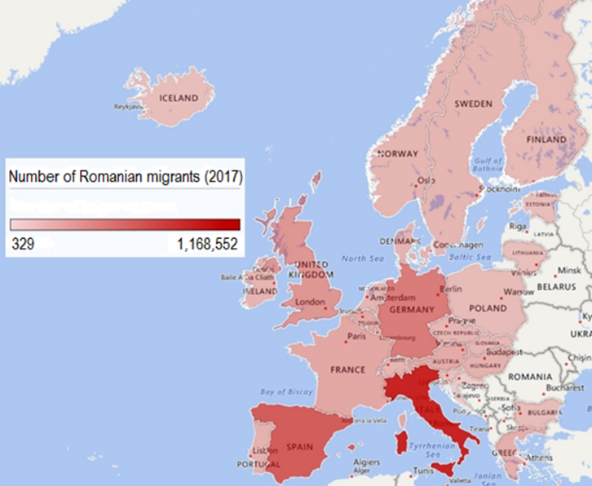 | Figure 4. Top ten bilateral migration corridors of international migration 2000-2010 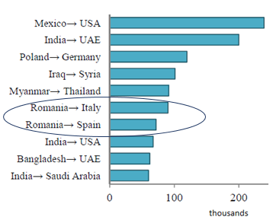
Source: Eurostat  Note: Romanian migrants in the respective countries (stock) for 2017. | Source: United Nations (2015)

14. Working age emigrants exceed 2.65 million persons, accounting for about 20.6 percent of the Romanian working population as of 2017. The magnitude of the migration outflow led to an increasing number of Romanians working and living abroad. The authors of this report estimate the total number of working age emigrants to just over 3 million, based on 2017 data from Eurostat and the latest national census data on the number of Romanian emigrants to the top non-European countries—United States, Canada, Israel, and Ukraine. This represents 23.3 percent of the Romanian working age population, showcasing the impact on the labor market.
15. The economic and social impact of emigration has been mixed. Among the benefits, remittances are perhaps the most tangible, accounting for 1.9 percent of GDP in 2016 from a peak of 4.5 percent in 2008. Remittances help households to escape poverty, and play an important role in the process of development. However, migration also has intangible consequences, which can be somewhat subtler, but not less important in the long run. For instance, there is evidence that returning migrants can benefit the source countries by importing skills and norms they have acquired abroad. Returning migrants are also likely to start new businesses. At the same time, emigration has a negative economic and social impact, affecting the labor market from the losses in the skilled labor force, and increasing the risk of marginalization and social exclusion.

Is emigration negatively affecting potential growth?
    - Labor had a negative contribution on growth, especially before 2009. The composition of Romania’s GDP growth has been gradually changing since 2000 (Figure 11). In 2000–2008 labor had a sizeable negative contribution of −22 percent, reflecting the negative impact of demographic trends, emigration, and low labor force participation. Growth was mainly driven by total factor productivity (TFP, 80 percent), indicating the efficiency gains from the gradual correction of resource misallocation during the transition to a market economy. Positive contributions were also made by physical (38 percent) and human capital (3 percent). Since 2009, the sources of growth have shifted, with a reduction of the TFP contribution to 50 percent, and an increase in the contribution of physical capital to 56 percent. The increased importance of physical capital accumulation for growth is probably a reflection of the public and private investment stimulated by EU accession. The diminished, albeit still sizeable TFP contribution, indicates that the efficiency gains from structural transformation, which had been propelling growth since the start of transition, are now gradually fading. In this context, the drivers are shifting toward capital, with labor still contributing negatively to growth.
Figure 5. The sources of growth in Romania have shifted

Source: Eurostat, World Bank calculations, based on a human capital adjusted Solow model
    - Labor supply and labor productivity were affected by emigration. The outflow migration of skilled labor resulted in labor shortages, skill gaps, and distorted wage demand (Mereuta 2012, European Commission 2014, IMF 2016). Real labor productivity was also negatively affected, mainly by skilled emigration. An IMF (2016) analysis indicated that real labor productivity growth in Romania would have been around 7.5 percentage points higher in the absence of emigration, for the analyzed period (see Figure 7).
Figure 6. Contributions of outward migration to working-age population growth (average compound annual growth rate, 1990–2012) | Figure 7. Emigration and real labor productivity growth (percentage points; additional cumulative real labor productivity growth, 1995–2012)
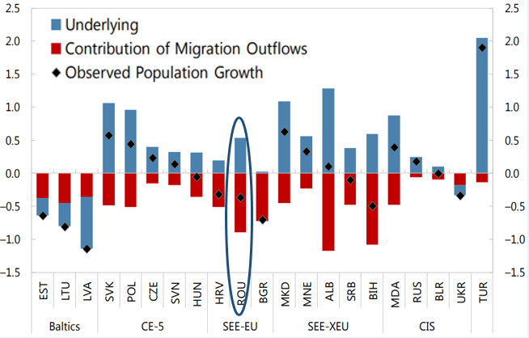 | 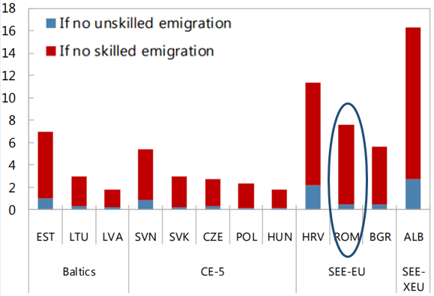
Source: IMF (2016)
    - Romania registered one of the largest increases of high-skilled emigration into the G20 countries in the 2000s. Romania is the tenth main country of origin in terms of migration flows in the G20, according to the OECD. In terms of high-skilled immigration into the G20 countries, Romania recorded the largest increase in the first decade of this century (about 492,000 persons in 2010–11). The number of highly educated female migrants more than doubled between 2000–01 and 2010–11, whereas the increase has been lower for men.
Box 1. High-skilled migration. The case of Romanian physicians
The number of physicians working abroad exceeded 14 thousand as of 2013, representing more than 26 percent of the total number of Romanian physicians. Between 1991 and 2013 the outflow of physicians increased nine times, the highest increased been registered after the 2000s. The figures reflect an increasing deficit of medical specialist which its more evident if we take into account that between 2000 and 2013 the number of physicians working in Romania increased by 18 percent while those working abroad increased by more than 650 percent.
Figure B1.1. Number of Romanian physicians working in Romania and abroad | Figure B1.2. Increased percentage of Romanian physicians working abroad
Source: National Institute of Statistics, OECD, Eurostat, WHO, Bharava et al (2010)

Migration outflows gradually shifted to EU countries after Romania’s accession to EU. Only about 30 percent of the Romanian physicians working abroad were based in EU countries in 2000. This increased greatly after Romania’s EU accession, to about 53 percent in 2007 and 72 percent in 2013. The absolute values also indicate the magnitude of the outflows, with the number of physicians working abroad in EU countries almost tripling in a span of 7 years, from 2007 to 2013.

Figure 8. Number of Romanian physicians working in EU countries vs Non-EU countries | Figure B1.4. Percentage of Romanian physicians working in EU countries vs Non-EU countries
Source: OECD, Eurostat, WHO.

More than 50 percent of Romanian physicians working abroad are younger than 40 years old, and a majority of applications submitted to the Romanian Medical Association are from resident physicians. Because of low wages, especially for resident physicians, working conditions, and the availability of equipment and supplies in the medical system—to name some of the main restrictions—Romanian physicians are reorienting to work abroad. At the same time, a growing number of young physicians are choosing to finish their residency abroad. This is reflected in the increased shortage of physicians in Romanian hospitals.
Figure B1.5. Age structure of Romanian physicians working abroad | Figure B1.6. Applications submitted to Cluj Medical Association by physicians wanting to work abroad
Source: National Institute of Statistics | Source: Cluj Medical Association

    - Supply shortage is highest for high-skilled workers and skilled manual workers. A high share of bottlenecks in Romania (European Commission 2014) have been registered for a number of occupational groups: Software and applications developers and analysts, generalist and specialist medical practitioners, electrical engineers, physical and engineering science technicians, machinery mechanics and repairers, cooks, car, van, and motorcycle drivers, and garment and related trades workers. The background causes of the labor shortage vary in importance, depending on the sector. In some cases, the main problem lies with specialized profiles that require specific vocational training or technical school education. In other cases, the non-attractive level of salaries is the main reason. In many sectors, labor mobility reflecting the migration of qualified members of the workforce is the main cause (European Commission 2014).
    - There is evidence that returning migrants have a positive economic and social impact. Migration of labor and entrepreneurship are positively correlated. As migrants accumulate human and financial capital they tend to invest in productive activities. Also, their work experience gained abroad is positively leveraged when developing a business (Radu and Epstein 2007, Roman and Voicu 2010). The highly educated that come back want to have a professional career in Romania, and to be involved in improving the political and socioeconomic environment (LSRS 2013, 2016).
Box 2. What motivates the return of a high-skilled labor force? The case of Romanian students abroad
The number of Romanian students abroad more than doubled in 16 years, from about 12.5 thousand in 2000 to about 33.4 thousand in 2016. In comparison, the number of students in Romania has decreased from as high as 900 thousand in 2009 to 405 thousand in 2016. Europe is the main destination, with the United States—the first non-EU country—occupying the 10th position in terms of the number of Romanian students as of 2016.
Figure B2.1. Romanian students abroad and at home | Figure B2.2. Romanian students abroad by country of destination (2016)
Source: UNESCO

Romanian students cite the attractiveness of the educational offer and becoming proficient in a foreign language as the main reasons for studying abroad. In a number of surveys organized by LSRS between 2010–2016 on a sample of more than 1000 students, the attractiveness of the educational offer was consistently indicated as being a key reason for studying abroad: about 50 percent of respondents considered it very important on a scale ranging from not important to very important. The labor market prospects were also perceived as being very satisfying by more than 50 percent of the students abroad. This is especially relevant, given the Romanian labor market’s structural rigidities, with youth unemployment at 20.6 percent—much higher than total unemployment at 5.9 percent as of 2016.
Internship and traineeship programs, job opportunities and proximity to the family are the most important factors that would motivate students to return and work in Romania. Apart from the proximity to the family, the other motivating factors reflect labor market requirements. When asked if they are interested in a job, internship, or traineeship in Romania or abroad, a large majority preferred the opportunities available abroad. This is consistent with the need to create labor market incentives for lifelong learning. Romania ranked last in 2016 in terms of adult participation in lifelong learning, with only 7 percent of the population ages 25 to 64 participating in education and training, compared with the EU28 average of 16.6 percent.
The political environment and full recognition of diplomas are among the most important obstacles to return and work in Romania. The obstacles reflect institutional requirements. Romania lags behind in several dimensions of governance compared with EU27 (World Governance Indicators 2016), mainly in terms of control of corruption and government effectiveness. This showcases the need for improving the institutional environment to make Romania more attractive for the high-skilled labor force studying and working abroad.

    - However, the overall impact of migration on economic growth was mixed. Returning Romanian migrants had a positive impact on labor productivity (Léon-Ledesma and Piracha 2004, Ambrosini et al. 2012), while remittances boosted investment (Léon-Ledesma and Piracha 2004, Radu and Epstein 2007, Mereuta 2012). Nonetheless, remittances also had a negative impact, representing a second form of welfare affecting recipients’ willingness to work (Mereuta 2012). Skilled emigration played a key role in slowing output growth and income convergence. An IMF (2016) study indicated that cumulative real GDP growth would have been around 10 percentage points higher on average in Romania in absence of emigration (see Figure 8). Also, the per capita income gap between Romania and the EU28 would have been reduced by about 6.5 percentage points in absence of emigration (Figure 9).
Figure 8. Emigration and real GDP growth (percentage points; additional cumulative real GDP growth, 1995–2012) | Figure 9. Emigration and per capita income in purchasing power standard (percentage points; additional reduction in per capita GDP gap with the EU28, 1995–2012)
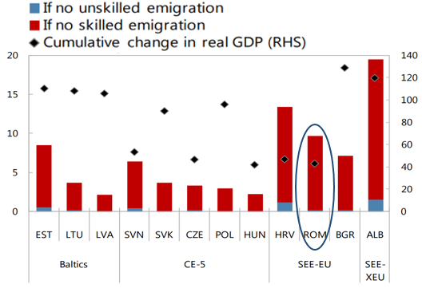 | 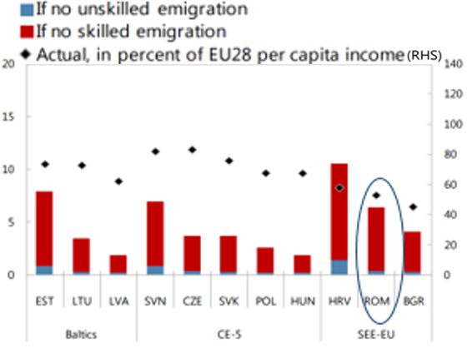
Source: IMF (2016) | Source: IMF (2016)

Social impact of emigration: Is there a generation left behind?

20. The spatial distribution of migration positively correlates with the distribution of social exclusion risks. The highest number of children with one or both parents working abroad was recorded in the North-East region. This is also the region with the highest risk of social exclusion in Romania in terms of the AROPE rate (Sanduleasa and Matei 2015). The areas most affected by external migration are the remote and densely populated ones, lacking a large and dynamic urban center as in the case of Subcarpathian Moldova (Suceava, Neamt, Bacau, Vrancea) as well as Satu-Mare, Maramures and Bistrita. These regions are predominantly rural, with small and medium size cities not having the economic capacity to absorb the excess labor force (World Bank 2017).
    - Migration had a positive impact on inter-household income inequality through remittances. Remittances led to a reduction of inequality both within and between urban and rural areas. The reduction of inequality between urban and rural areas also reduced the impact of inequality on the total level of inequality (Zamfir et al 2010). The impact was stronger after 2004, when a spike in remittance inflows occurred (Figure 10). Between 2004 and 2016 the average inflow was 3.5 billion euro, representing on average 2.8 percent of GDP. The peak level was registered in 2008, when the inflow was 6.4 billion, representing 4.5 percent of GDP, but declined to 3.2 billion euro in 2016, equal to 1.9 percent of the GDP.
Figure 10. Inflows of remittances in Romania
Source: World Bank

    - Remittances had a positive impact on poverty reduction. Various panel data analyses point toward a statistically significant impact of remittances on the poverty headcount. UNCAT (2011) used an ample panel of 77 developing countries, including Romania, and found that a 10 percent increase in remittances leads to a 3.1 percent reduction in the poverty headcount for a $1.25 a day poverty line. Using a smaller sample of countries (Poland, Romania, Ukraine, and Turkey), Ciupureanu and Romana (2016) found that a 10 percent increase in remittances leads to a 5.3 percent decline in the share of people living on less than $2 a day. The econometric results are also consistent with the historical evolution of remittances inflows and poverty in Romania (Figure 11).
Figure 11. Remittances and poverty in Romania
Source: World Bank

    - Disruptive effects on the family structure may offset the benefits from remittances. Parental migration when the child is left in the country of origin may have long-term implications for his development and future life. Children of migrant parents may be psychologically harmed, be less involved in school activities, and more involved in work tasks, especially in rural areas. There are several qualitative studies documenting these effects in the case of Romanian children (see UNICEF 2008 for details). Increased divorce rates and decreased birth rates are also associated with migration, especially for communities vulnerable to marginalization or exclusion (Sandu 2009).
    - Migrant parents are vulnerable because of the high percentage of low-skilled labor. This leads them to work in low paid jobs. It also decreases their capacity to integrate into the Romanian labor market when returning, because of the lack of jobs on the local labor market and low wages (Vasile 2014, Eurofound 2012). Moreover, their working conditions are in many cases below the standards of the destination country, especially in construction or agriculture (Vasile 2014), even if they are legal workers.
    - Lack of employment and low wages are the main causes behind parents’ migration. The remote and poor rural areas are most affected by migration (World Bank 2017). These are also the areas with a much lower economic capacity to absorb the labor force, and lower incomes. For example, in 2016, the average monthly income per household was about 26 percent lower in the rural areas compared with urban areas. Also, the rural areas have the highest proportion of children with one or both parents working abroad (UNICEF 2008).
    - The National Authority for Child Protection and Adoption estimates the total number of Romanian children with one or both parents working abroad at about 95 thousand. As of end 2016 there were 95,308 children with parents working abroad. About 34 percent have both parents working abroad, which makes them more vulnerable to marginalization and social exclusion. Out of the total number of children with parents working abroad, about 96 percent remain in the care of relatives, with no special protection measure in place.

    - Participation in education is lower for children with both parents working or living abroad. Age and having one or both parents working or living abroad are predictors of the participation rate in education (World Bank 2015). Children are more likely to leave school if they are in primary school or if they are older than 15, the minimum legal age for working (Table 1). The impact also varies, depending on the migration status. If one parent is working or living abroad while the other remains at home with the child, the participation rate marginally increases. If both parents work abroad, children, lacking parental guidance, are more likely to abandon school. In this case, the participation rate drops by an average of 15 percent, with the highest decrease registered for children older than 15.
Table 1. Participation in education of children with migrant parents (percent)
 | Percent of 6–9 year-olds in education | Percent of 10–14 year-olds in education | Percent of 15–17 year-olds in education
Children with both parents at home | 75.5 | 97.3 | 92.8
Children with one parent at home and the other having migrated | 77.1 | 97.9 | 91.3
Children with both parents migrated abroad | 60.3 | 87.0 | 73.3
Source: World Bank (2015)

Conclusions
Romania registered the highest increase in emigration among the EU countries after the fall of the communist regime. Between 1990 and 2017, Romania registered the highest increase in the migration stock, at 287 percent. Most of the increase was experienced after 2000, when more than 2.4 million persons migrated abroad. As Romania’s population fell from 22.8 million in 2000 to 19.6 million in 2017, outward migration was responsible for more than 75 percent of the decline.
The Romanian working population has been particularly affected by the large outflow. Working-age emigrants exceed 2.65 million persons. This is equivalent to a 20.6 percent emigration rate. Both the high-skilled and low-skilled labor forces were particularly affected. The highest emigration rate was registered for high-skilled emigrants at 26.6 percent, and low-skilled emigrants at 20 percent, leading to significant labor supply shortages (European Commission 2014).
The positive impact of remittances and return migration on economic growth was partially offset by the negative impact of skilled emigration. On one hand, labor productivity was positively affected by the returning Romanian migrants (Léon-Ledesma and Piracha 2004, Radu and Epstein 2007, Mereuta 2012) while remittances boosted investment (Léon-Ledesma and Piracha 2004, Radu and Epstein 2007, Mereuta 2012). On the other hand, skilled emigration played a key role in slowing output growth. Cumulative real GDP growth would have been around 10 percentage points higher on average in Romania in the absence of emigration (IMF 2016).
The social impact of emigration has been mixed. Remittances had a positive impact on poverty reduction (UNCAD 2011, Ciupureanu and Roman 2016, Pekovic 2017), and led to a reduction of inequality within localities and between the urban and rural areas (Zamfir et al 2010). The positive impact of remittances was partially offset by the disruptive effects of emigration on family structures. Children with parents working abroad were more exposed to vulnerability, marginalization, or exclusion (UNICEF 2008). The participation rate in education was also lower for children with both parents working abroad (World Bank 2015).

Annex 1. Key Romanian emigration trends and patterns between 1990 and 2017
 | 1990 | 1991 | 1992 | 1993 | 1994 | 1995 | 1996 | 1997 | 1998 | 1999 | 2000 | 2001 | 2002 | 2003
Permanent emigration | High number of emigrants, between 30 and 100 thousand per year |  |  | Medium number of emigrants, about 20 thousand per year on average |  |  |  |  |  | Low number of emigrants, about 11 thousand per year on average
 | High number of German emigration |  |  | Mainly German emigration |  |  |  |  |  | Prevalence of German, Italian and North America emigration
Temporary emigration | Low rate reflecting the low integration in the European labor market |  |  |  |  |  | High rate, partially legal, highest dispersion of emigration destination, high selectivity |  |  |  |  |  | Circulation in Schengen space, more than 70% in Italy and Spain
 | 2004 | 2005 | 2006 | 2007 | 2008 | 2009 | 2010 | 2011 | 2012 | 2013 | 2014 | 2015 | 2016 | 2017
Permanent emigration | Low number of emigrants, about 11 thousand per year |  |  | Low number of emigrants, about 9 thousand per year |  |  |  | Increased number of emigrants, about 17 thousand per year
 | Dispersed emigration (DE) |  |  |  |  |  |  | Prevalence of Spanish, Italian and German emigration, accounting for about 50 percent of total emigration on average
Temporary emigration | Circulation in Schengen space, more than 70% in Italy and Spain |  |  | Post EU accession, structural changes, more than 60% in Italy and Spain |  | Decreasing from about 300 thousand in 2008 to about 160 thousand in 2013 |  |  |  |  | Increasing to about 210 thousand in 2016; 2017 data indicate a slowdown in the migration outflow*
Source: National Institute of Statistics, adaptation from Sandu et al (2004) and Suciu (2010), Eurostat data for 2017
Note: * a distinction between permanent and temporary migration cannot be made based on available Eurostat data for 2017

References
- Anghel R.G., Piracha M., Randazzo T. (2015). “Migrant’s remittances: Channeling Globalization”, IZA DP No. 9516

- Ambrosini, J. W., K. Mayr, G. Peri and D. Radu (2012), The Selection of Migrants and Returnees in Romania: Evidence and Long-Run Implications, IZA Discussion Papers No. 6664, Bonn

- Atoyan, M.R., Christiansen, L.E., Dizioli, A., Ebeke, M.C., Ilahi, M.N., Ilyina, M.A. and Raei, M. F., (2016). Emigration and its economic impact on Eastern Europe. Washington: International Monetary Fund

- Barcevicus, E., Iglicka K., Repeckaite D., and Zvalionyte D. (2012), “Labour mobility within the EU: The impact of return migration”, Eurofound

- Beine M., Parsons C. (2015), “Climatic Factors as Determinants of International Migration”, Scandinavian Journal of Economics 117(2), 723-767

- Bhagwati J., Hamada K. (1974), “The Brain Drain, International Integration of Markets for Professionals and Unemployment: a Theoretical Analysis”, Journal of Development Economics 1(1), 19-42

- Bohning, W.R., (1987). Studies in International Migration, New York: St. Martin's Press.

- Botezat A., Pfeiffer F. (2014), “The Impact of Parents Migration on the Well-Being of Children Left Behind: Initial Evidence from Romania”, IZA DP 8225.

- Cattaneo C., Peri G., (2016), “The Migration Response to Increasing Temperatures”, Journal of Development Economics 122, 127-146.

- Chiswick B., Hatton T. (2003), “International Migration and the Integration of Labor Markets”, in Bordo M.D., Taylor A. M., Willliamson J.G. (eds.) Globalization in Historical Perspective, University of Chicago Press, 65-120

- Ciupureanu CA., Roman M.D. (2016) Do Remittances Reduce Poverty in Developing Countries?. In: Karasavvoglou A., Aranđelović Z., Marinković S., Polychronidou P. (eds) The First Decade of Living with the Global Crisis. Contributions to Economics. Springer, Cham

- Clemens M. (2011), “A Labor Mobility Agenda For Development”, in Birdasall N., Fukuyama F. (eds), New Ideas on Development after the Financial Crisis, Johns Hopkins University Press, 260-287.

- Clemens M. (2015), “Does Development Reduce Migration?”, in Lucas R. E. (ed.), International Handbook of Migration and Economic Development, Edward Elgar Publishing, 152-185.

- Clemens M., Ogden T.N. (2014), “Migration as a Strategy for Household Finance: A Research Agenda On Remittances, Payments and Development”, Center for Global Development WP # 354

- Clemens M. A.; Ozden C., Rapoport H. (2014), “Migration and Development Research is Moving Far Beyond Remittances”, World Development 64, 121-124.

- Commander S., Kangasniemi M, Winters L.A. (2004), “The Brain Drain: Curse or Boon? A Survey of the Literature”, in Baldwin L.E., Winters A.L. (eds), Challenges to Globalization: Analyzing the Economics, University of Chicago Press, 235-272

- Cristea, Marius; Mare, Codruța; Moldovan, Ciprian; China, Andreea-Mirela; Farole, Thomas; Vințan, Adina; Park, Jane; Garrett, Keith Patrick; Ionescu-Heroiu, Marcel. (2017). “Magnet cities : migration and commuting in Romania”, Washington, D.C. : World Bank Group

- Del Boca D. (2003), “Mothers, Fathers and Children After Divorce: The Role of Institutions”, Journal of Population Economics 16(3), 399-422

- European Commission (2014), “Mapping and Analysing Bottleneck Vacancies in EU Labour Markets”, Report

- Faini Riccardo, Venturini Alessandra (2010), Development and Migration: Lessons from Southern Europe, in Epstein G.S., Gang I., (eds) Frontiers of Economics and Globalization, vol. 8, Migration and Culture, 105-136, Emerald Publishing Group.

- Giannelli G. C., Mangiavacchi L. (2010), “Children’s Schooling and Parental Migration: Evidence on the “Left-Behind” Generation in Albania”, Labour (24), 76-92

- Glytsos, N.P. (1988), “Remittances and Temporary Migration: A Theoretical Model and its Testing with the Greek-German Experience," Weltwirtschaftliches Archiv, 124, 524-549.

- Hildebrandt N., McKenzie D.J. (2005), “The Effect of Migration on Child Health in Mexico”, The World Bank, Washington D.C., 35

- International Organization for Migration (1998), Migration Potential in Central and Eastern Europe. Technical Cooperation Centre for Europe and Central Asia, International Organization for Migration (IOM), Geneva.

- Kiros G.E., White M.J. (2004), “Migration, Community Context and Child Immunization in Ethiopia”, Social Science and Medicine (59)12, 2603-2616

- Le T. (2008), “Brain Drain or Brain Circulation: Evidence from OECD’s International Migration and R&D Spillovers”, Scottish Journal of Political Economy, 55(5), 618-636

- Léon-Ledesma, Miguel, and Matloob Piracha (2004). “International Migration and the Role of Remittances in Eastern Europe.” International Migration (42) 4: 65–83.

- Mereuta C. (2013), “Mobilizing migrants’ skills and resources in Romania”, In “Coping with Emigration in Baltic and Eastern European Countries”, OECD Publishing

- Mesnard A. (2004), “Temporary migration and capital market imperfections”, Oxford Economic Papers 56, 242-262

- McKenzie D.J., Rapoport H. (2006), “Can Migration Reduce Educational Attainment? Evidence from Mexico”, Journal of Population Economics 24(4), 1331-1358.

- OECD and UNDESA (2013), “World Migration in Figures”, Report

- OECD (2017), “G20 global displacement and migration trends report 2017”, Report

- Peković, D. (2017). The effects of remittances on poverty alleviation in transition countries. Journal of International Studies, 10(4), 37-46. doi:10.14254/2071-8330.2017/10-4/2

- Radu, D.C. and G. Epstein (2007), Returns to return migration and determinants of subsequent moves, EALE Conference Paper, EALE Annual Conference 20-22, September 2007, Oslo.

- Rapoport H. (2004), “Who’s Afraid of the Brain Drain? Human Capital and Growth in the Developing Countries”, Brussels Economic Review 47(1), 89-101

- Rapoport H. (2016), “Migration and Globalization: What’s in it for Developing Countries?”, International Journal of Manpower 37(7), 1209-1227

- Sandu, D ., (2005), „Emerging transnational migration from Romanian Villages” , în Cur. Sociology, vol. 53, nr. 4, pp. 555-582

- Sandu, D., (2006), Locuirea temporară în străinătate. Migraţia economică a românilor: 1990-2006, Bucureşti, Fundaţia pentru o Societate Deschisă.

- Sandu D., (2010), Lumile sociale ale migrației românești în străinătate, Polirom Publishing house

- Séchet R., Vasilcu D. (2015), “Physicians’ Migration from Romania to France: a Brain Drain into Europe?”, Cybergeo, European Journal of Geography, document 743, DOI : 10.4000/cybergeo.27249

- Stark O. (2004), “Rethinking the Brain Drain”, World Development 32(1), 15-22

- Suciu O.V. (2010), “Migration in Europe. Case Studies: Bulgaria and Romania”. CRCE 2010 Colloquium

- The National Authority for Child Protection and Adoption (2017), “The situation of children with parents working abroad”, Report

- Tesliuc, Emil Daniel; Grigoras, Vlad Alexandru; Stanculescu, Manuela Sofia. 2015. “Background study for the national strategy on social inclusion and poverty reduction: 2015-2020”, Washington, D.C. : World Bank Group

- UNCTAD. (2011). Impact of Remittances on Poverty in Developing Countries. United Nations Conference on Trade and Development, Geneva

- UNICEF (2008), “National analysis of the phenomenon of children left home by their parents who migrate abroad for employment”, Report

- United Nations (2017), “International Migration Report 2017”, Report

- Vasile, V. (2013), “Labour mobility impact on sending countries. Romania EU workers case study”, Procedia Economics and Finance 8, 737 – 746

- Venturini, A. (2004), Postwar Migration in Southern Europe 1950-2000, Cambridge University Press.

- Zamfir, Ana Maria, Mocanu Cristina, Militaru Eva and Speranta Parciog. 2010. “Impact of Remittances on Income Inequalities in Romania”, In Globalization and Transformation of Social Inequality, edited by U. Schuerkens, 58-75. Oxford:Taylor & Francis Publishing House

- Zimmermann K. (2014), “Circular Migration”, IZA World of Labor (1) doi: 10.15185/izawol.1

- Zimmermann, K.F., (1995), “Tackling the European Migration Problem”, Journal of Economic Perspectives

- http://www.un.org/en/development/desa/population/migration/data/estimates2/estimates15.shtml [Accessed on October 10th, 2017]

United Nations Population Division (UN 2017) estimated the total number of Romanian emigrants to 3.58 million as of 2017.
The emigration rate of a given origin country i in a given year is defined as the share of the native population of country i residing abroad at this time: mi = Mi/(Mi+Ni), where Mi is the emigrant population from country i living abroad, and Ni is the native non-migrant population of country i , https://www.oecd.org/migration/46561284.pdf
According to Eurostat and United Nations data as of 2017.
Regional comparators Bulgaria, Croatia, Czech Republic, Hungary, Poland, Slovakia, Slovenia.
High-skilled emigrants—emigrants with tertiary education attainment, Medium-skilled emigrants—emigrants with upper secondary and post-secondary non-tertiary education attainment, Low-skilled emigrants—emigrants with less than primary, primary and lower secondary education attainment, see also OECD (2013) and http://www.oecd.org/els /mig/ methodology-DIOC-2010-11.pdf
According to Eurostat data for 2017 in the case of EU destination countries, and the latest OECD data, 2011, for non-EU destination countries. Migration to EU accounts for around 88 percent of the Romanian emigration stock.
Poverty headcount represents the proportion of a population that exists, or lives, below the poverty line.
United Nations Population Division estimated the total number of emigrants to 3.58 million as of 2017, the authors of this report estimate a higher figure of just above 4 million. The calculation is based on Eurostat and national census data of the top Non-European countries in terms of the number of Romanian migrants, namely United States, Canada, Israel and Ukraine.
According to UN (2017) the net migration outflow between 2000 and 2017 was around 2.44 million (calculated as the difference between the migration stock in 2017 and 2000).
https://www.oecd.org/g20/topics/employment-and-social-policy/G20-OECD-migration.pdf
The figures are based on the definition introduced in the Balance of Payments and International Investment Position Manual (BPM6) according to which personal remittances are the sum of two main components: compensation of employees and personal transfers. The data reflects heterogeneous sources, mainly the central banks of the destination countries. It should also be noted that there are shortcomings in the data, stemming from the difficulty of observing informal flows; and the official data most probably underestimate the true amount of remittances (Anghel et al., 2015).

