Options for Preparing a Sustainable Land Management (SLM) Program in Mali
69972
Consistent with TerrAfrica for World Bank Engagement at the Country Level

Introduction

1. Background and rationale:

1. One of the most environmentally vulnerable areas of the world is the drylands of sub-Saharan Africa, particularly the Sahel, the Horn of Africa and Southeast Africa. Mali, as with other dryland areas in this category, suffers from droughts approximately every 30 years. These droughts triple the number of people exposed to severe water scarcity at least once in every generation, leading to major food and health crisis. In general, dryland populations lag far behind the rest of the world in human well-being and development indicators. Similarly, the average infant mortality rate for dryland developing countries exceeds that for non-dryland countries by 23% or more. The human causes of degradation and desertification include direct factors such as land use (agricultural expansion in marginal areas, deforestation, overgrazing) and indirect factors (policy failures, population pressure, land tenure). The biophysical impacts of dessertification are regional and global climate change, impairment of carbon sequestation capacity, dust storms, siltation into rivers, downstream flooding, erosion gullies and dune formation. The social impacts are devestating- increasing poverty, decreased agricultural and silvicultural production and sometimes malnutrition and/or death.

2. There are clear links between land degradation and poverty. Poverty is both a cause and an effect of land degradation. Poverty drives populations to exploit their environment unsustainably because of limited resources, poorly defined property rights and limited access to credit, which prevents them from investing resources into environmental management. Estimates show that the incidence of poverty in Mali was 64% in 2006 and most of these poor live in drylands or areas of low soil suitability and subsist on agriculture and pastoral activities (Figures 1 and 2). This climatic reality, coupled with unsustainable agricultural or pastoral practices, results in high levels of land degradation. Land degradation also results in increased poverty. For example, the cotton sub-sector has the second largest export share after the gold sub-sector in Mali and yet, the incidence of poverty is particularly high in cotton production areas such as the region of Sikasso, where erosion of arable lands are prevalent and yields are declining (Figure 3).

3. Sustainable Land Management (SLM) strategies and investments can be used to as a key intervention measure, both at the national level and at the farmer-plot level, to control for and minimize land degradation. SLM can be defined as the use of land resources to meet changing needs while assuring the long-term productive potential of these resources and the maintenance of environmental functions. Evidence suggest that adopting sustainable land management technologies, within the right policy and institutional framework, can reduce land degradation and enhance productivity.

4. Why should Governments invest in SLM? Without SLM, desertification will continue unchecked in Mali and therefore investment in SLM is a pressing priority. The poverty impact of SLM is clear, as is the environmental impact. The economic argument is less obvious. Land degradation is expensive both at a) at the individual farmer/pastural level in terms of loss of productivity and income and b) at the national level in terms of its impact on agricultural Gross Development Product (GDP). This is because the agricultural sector in Mali is a major source of growth and contributes to 35.6% of GDP. Recent studies show annual losses as high as 6% of GDP due to soil erosion and 5.35% due to deforestation. Soil erosion losses alone were predicited to reach US$12.4 million in year 2005 and more in subsequent years. Therefore, land degradation has an significant impact on GDP and Mali’s ability to grow and prosper.

5. The Malian Government’s response to land degredation is articulated in their national strategies such as the PRSP (2007),’Rapport National sur l’Etat de l’Environnement 2005’, ‘Profil Environnemental du Mali’, ‘Cadre Stratégique de Lutte contre la Pauvrete’, ‘Plan d’Action pour la Gestion Integrée de la Fertilité des Sols’, ‘Programme Special pour la Securité Alimentaire’, ‘Schema Directeur du Développement Rural’ and ‘Projet d’appui à la Politique Environnementale’ (MEA, 2006; Atkins International, 2006; PAPE, 2005; MDRE, 2002; MDR, 2002; CSLP, 2003; PSSA, 2005). These strategies and action plans highlight internal solutions that would ensure that land management is prioritized and better addressed in Mali and include:

- Strategic investments to combat land degradation, desertification and sedimentation of the River Niger and its tributaries (2007 PRSP)
- An effective transfer of natural resources to decentralized communities
- Land tenure reviews that would encourage better managements by actual land users,
- Improved capacity of decentralized communities
- Well defined and common environmental policies
- An effective coordination of land management and environmental programs by the STP.

- Mali is well organized to engage communities on SLM issues because of its decentralization policy which, on some level, allows easy access to communities through government structures. Mali is organized into 8 administrative ‘Régions’ plus the District of Bamako. Each administrative region is subdivided into ‘Prefectures’ which in turn are made of ‘Sous-prefectures’. Each ‘Sous-prefecture’ is subdivided into ‘Communes’ which are made of several villages. The Communes are the ‘hearth’ of the decentralized process. Each Commune is required to make its own development plan. Although these plans, in most cases, have not yet been elaborated, the structures allow for an SLM prioritization to move quickly from the national level to the communes and communities. Between 1995 and 1998, full legal authority was given to local communities to manage natural resources and the environment in their communities. Although this transfer of authority was not fully effective (lack of plans, finances, land tenure etc), it sets up the legal framework for working on SLM issues with communities.

- In terms of investment, SLM interventions should depend on the specifics of the country context. Some strategies focus on technological solutions to degradation which may include: i) integrated land and water management technologies: these include rainfall capture, soil-water conservation techniques to improve groundwater recharge, improved tilling mechanisms; ii) soil protection through reafforestation techniques: these include improving soil cover by planting vegetation to improve topsoil and reduce wind erosion; iii) increased use of inorganic and organic fertilizers to maintain soil structure and fertility and iii) improving pastoral management strategies. Others strategies may be directed at changing policies that are detrimental to sustainable land management such as unclear land tenure policies or policies which encourage the growth of erosive crops. Some strategies may employ a combination of technical and policy interventions. A one fit all approach, however, will not work because of country specific factors (land tenure constraints, weak institutional and policy frameworks, lack of government commitment, interest and financial backing, capacity constraints) and it is therefore important to map out the specific country context and highlight options for SLM intervention within that context. This study assesses how to initiate an SLM country level strategy in Mali that is relevant to the articulated priorities and the specific Malian country context. The study details the extent and cause of land degradation (Chapter 1), the costs associated with land degradation (Chapter 2), the policy and institutional framework for land management (Chapter 3), best practice in SLM and other technological options (Chapter 4), the way forward and final recommendations (Chapter 5). Instead of broadly focusing on the whole of Mali, this paper pays special attention to 3 geographic belts: the northern pastoral belt, the cotton areas and the rice areas as well as some identified land degradation hotspots.

- This analysis was based on a) a desk review of available Malian literature and key policy documents; b) discussions with various institutions, donors, Government officials and other stakeholders in Mali and c) a data collection exercise in Mali that focused on obtaining information that could not be found in the general literature such as information on public expenditure, key maps and detailed information on institutional structures in Mali.

Figure 1 Productive Land in Mali

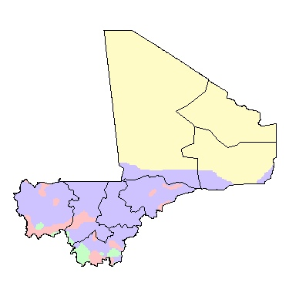
Administration
Environmental Constraints |  | Dry areas with low production potential
 |  | Low soil suitability
 |  | Erratic rainfall and dry stress risk
 |  | Low to medium climatic production potential
Source: Environmental constraints:

Figure 2. Poverty Incidence
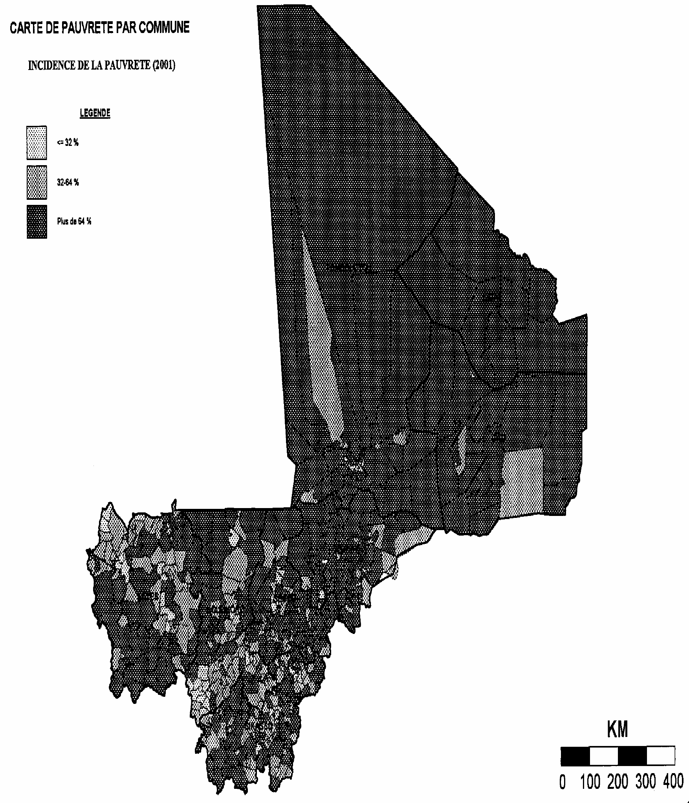

Figure 3 Evolution of Cotton Harvests in Mali 1960-2004

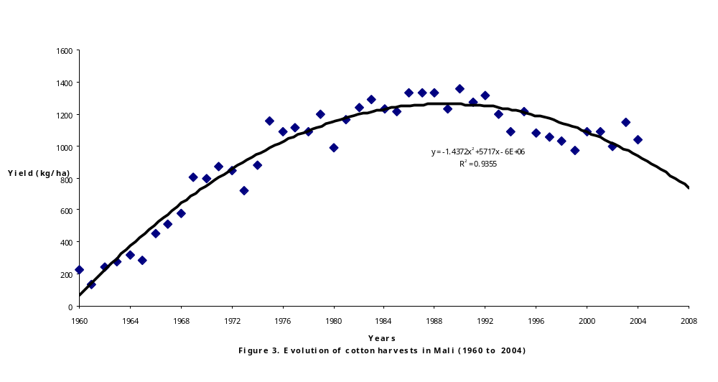
CHAPTER 1: THE EXTENT AND CAUSE OF LAND DEGRADATION IN MALI

1. The Scope of the Environmental Problem: Land Degradation Analysis

General Human-Induced Land Degradation in Mali

9. SLM can be approached by looking for symptoms of unsustainability, such as soil degradation, deforestation, and biodiversity loss. Figure 4 shows the distribution of human induced soil degradation in Mali. The most severe degradation occurs in the northern semi-arid belt between Gao and Mopti (encompasing all of the Seno zone and parts of the Gourma and Office de Niger Zone). Transects taken from 1950 to 1990 show that degradation rates in this semi-arid are high, with a 10% increase in the percentage of barren soil over the 40 year period (FAO). This is in contrast to the arid zone in the extreme north where land is highly degraded but unchanged over the same 40 year period. Areas to the south which have higher rainfall (>600mm) are moderately degraded and areas along the Niger River are only mildly degraded. To the south, small patches of very severe degradation occur around the major cities.

Figure 4: Severity of Human Induced Soil Degradation in Mali
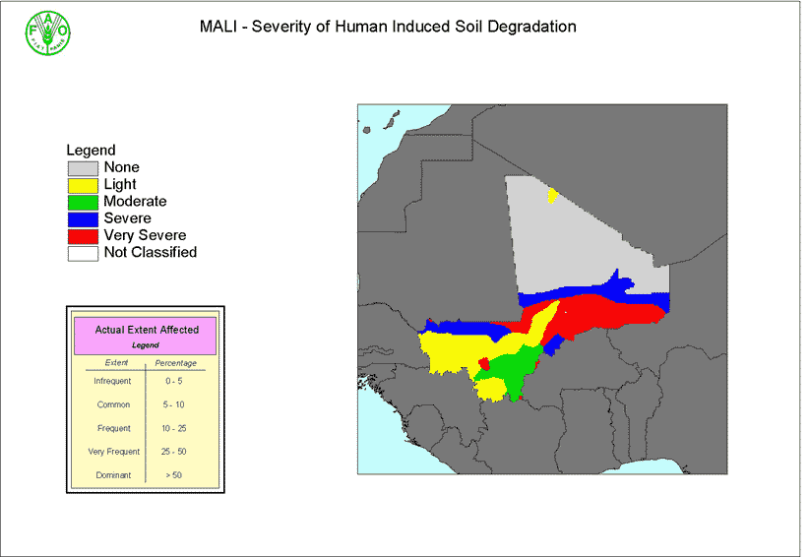

- The physical manifestation of land degradation takes various forms. Given that Mali is so large, the study will focus particularly on the cotton and rice growing belts , the semi-arid north and some identified hotspots. In these areas, land degradation includes:

- Loss of soil fertility in key productive areas (all areas)
- Reduced topsoil depth resulting in reduced water and nutrient retention capacity (all areas)
- Salinisation and alkalinity (rice zone)
- Deforestation (all areas)
- Soil compaction by animals and other factors (northern zone)
- Loss of soil structure resulting in wind erosion and sand dune creation (northern zone)
- Siltation into river beds, endangering key ecosystems (all areas)
- Dry season water scarcity (cotton and northern zones)
- Removal of crop residues (cotton and northern zones)
- Rising water table (rice zone)
- Desertification, if these degradation effects are not adequately addressed or controlled for

Hotspots of Human-Induced Land Degradation

- Figure 5 shows hotspots of severly degraded areas around the major cities in Mali. Degradation around the cities is caused by increasing demand for firewood- approximately 600,000 tons of wood is transported to Bamako yearly. Much of this wood is supplied from a radius of 200km around the major cities. The size of the supplying belt is directly related to the population of the city and since 90% of Malians obtain their cooking energy from firewood, the result is degradation and deforestation (Atkins, 2006).In these urban areas, the deforestation rate is approximately 100 000 ha per year (DNE, 2002). In addition to firewood, these supply belts play a key role in supplying pasture needs for urban and periurban cattle husbandries.

- There are now ongoing activities under the umbrella of the DNCN (Forestry service) to regenerate supply belts within a 200km radius around Bamako. ‘Marchés Ruraux’ and ‘s’équiper en reboisant’ are examples of these efforts. However, firewood consumption is increasing over time, particularly since the population of major cities such as Bamako continues to increase significantly from rural-urban migration.

Figure 5. Degradation hotspots around the major cities of Mali. Source: AMADER

(PANA - Programme d’Action National d’Adaptation aux Changements Climatiques. 2006. pp. 44.)

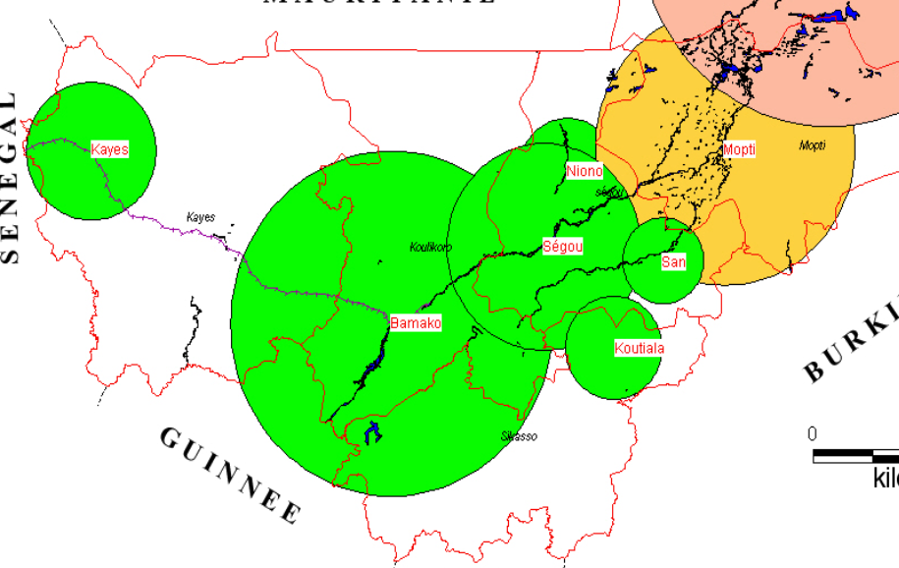

- Image 1 below shows another hotspot in Mali- the forest of Farmaké- which are located around Mopti . This degradation hotspot is caused by extreme deforestation. Here, woody plants in these degraded forests have been replaced by opportunistic shrubs (such as Guiera senegalensis and Piliostigma reticulate), dead wood or by sand dunes.

Image 1 ‘Hotspots’ of land degradation in the forest of Farmaké.

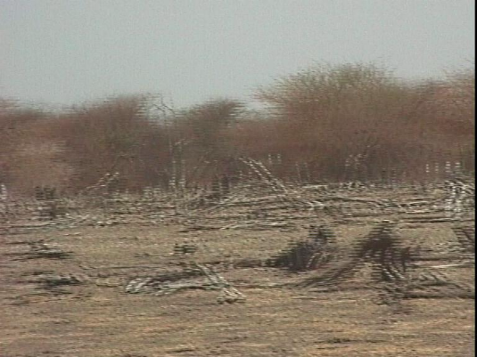
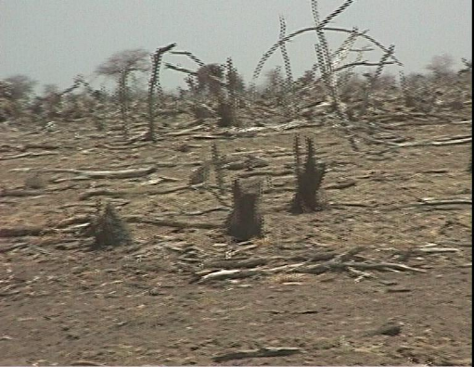

- Another hotspot of degradation in Mali is the Inland Delta of the Niger River (Image 2). In 1963, this area was regularly flooded, providing a unique ecosystem to fish, acquatic birds and vegetation. Devastating droughts between the late 1960s and early 1990s disrupted the equilibrium of this fragile ecosystem (MMEE, 2004). The image shows reduced volumes of both river and lake water (shown as dark patches). In addition, sand dunes, shown as bands in the plains, have become the norm.

Image 2. NOAA images of Inland Delta of the Niger river showing critical changes from Octobre 29, 1963 to October 2, 1987.

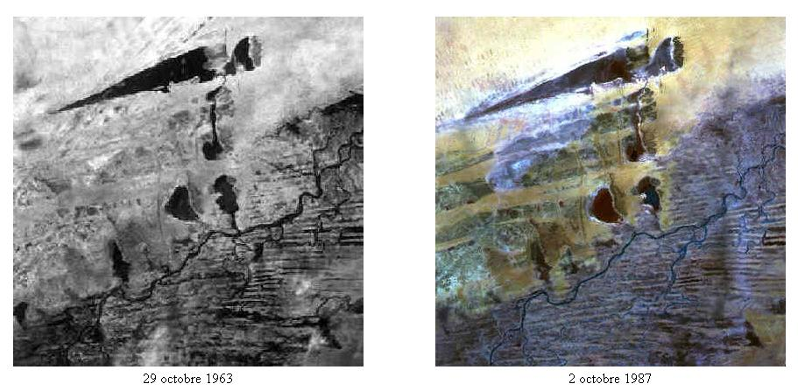

2. Climatic and Human Causes of Land Degradation

- In Mali, the major causes of land degradation stem from a) climatic conditions, which include an arid environment and low and irregular rainfall patterns; b) climatic processes such as wind and water erosion; and c) human activities, as identified in the previous chapter. To counter the problems that cause land degradation, it is important to distinguish between those resulting from a) the natural conditions of dryland ecosystems; b) human activities and c) those caused by unsustainable land management policies (FAO, 2005).

A. Climate Aridity and Land Degradation

- The Malian climate is characterized by the alternation of a long dry season and a rainy season of 2 months in the North and to 5-6 months in the South. The irregular rainfall in space and time varies from less than 100 mm in the North with 1,200 mm in the South (Figure 6). In general therefore, the climate in Mali is classified as arid (Table 1). Aridity can be defined in several different ways, but most simply it is a moisture deficit. In this analysis, moisture deficit, or an aridity index, is determined by the ratio of mean annual precipitation (total moisture) to the mean annual potential evapotranspiration (moisture loss). This index is then reclassified into six aridity zones according to the ranges defined by UNESCO (1977) and described in Table 1. According to this index, more than 90% of Mali is classified as Arid and, more precisely, 47% of the land in Mali lies in the hyper-arid zone. This aridity is becoming more pronounced due to a reduction in the mean annual rainfall (Figure 6).Comparisons of the periods of 1950/1970 to 1971/2000 show a downward shift of rainfall isohyets to the south (PANA, 2005). In addition, the isohyet for the annual mean rainfall of 1400 mm no longer exists in Mali.

Figure 6. Evolution of mean annual rainfalls from the period going from 1950 to 2000 (Source PANA, 2005).
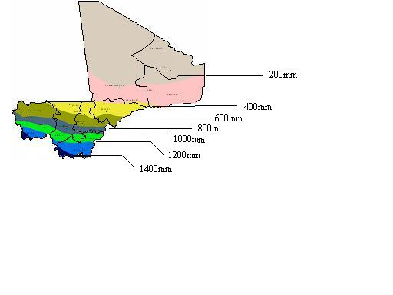
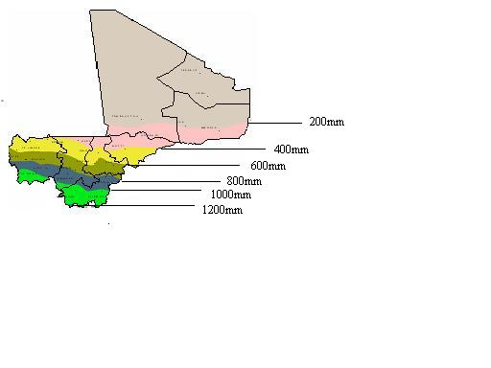

Mean annual rainfall during the period of 1950 - 1970
Mean annual rainfall during the period of 1971 - 2000

- Arid areas are more easily degraded than humid areas simply because there is less vegetation cover. Removal of this fragile protection exposes the soil to wind and water erosion, which in turn speeds up the deterioration of the soil compounds. When the soil itself is structurally fragile, this process occurs that much quicker. In Mali, the principal types of soil, which comprise a dozen classes, can be divided into 5 main categories of the followings: 1) slight ferrallitic soils, 2) tropical ferruginous soils, 3) subarid soils, and 4) hydromorphic soil and the vertisols. From an agronomic point of view, the various soils found in Mali generally have several important constraints which limit the cultivable potential: low levels of fertility, deficiencies in phosphorus, potassium and sulphur, and strong sensitivity to wind and/or water erosion. Thus, climatic factors greatly influence the soil’s fragility or susceptibility to degradation. A comparison of Figure 4 with Figure 7 shows that most of the degradation in mali (Gao to Mopti) occurs in the semi-arid, or sahelian zone.

Figure 7: Bio-climatic Zone and Rainfall in Mali (2000)

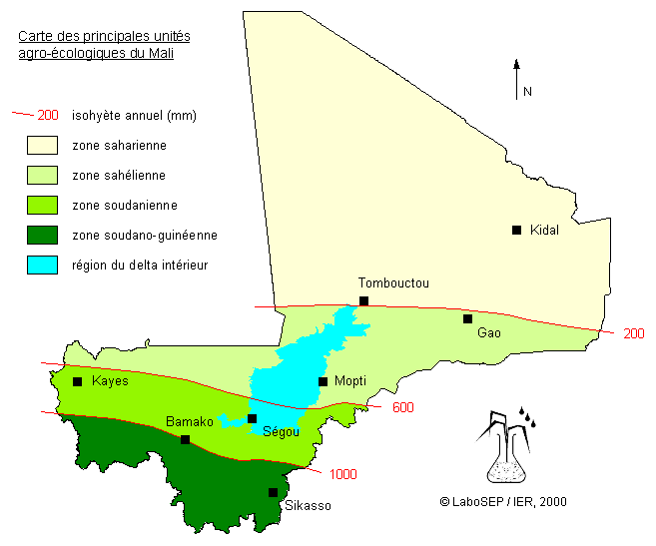
Source: Schéma Directeur du Secteur du Développement Rural, Actualisation 2000 -2010, Ministère du Développement Rural, VOLUME I

Table 1 Aridity Zone and Aridity Index (UNESCO, 1977) (REFERENCE?)
Aridity Zone | Aridity Index | Length of Growing Period  (days) | Typical Crops
Hyper-arid | <0.05 | 0 | No crops, no pasture
Arid | 0.05-0.20 | 1-59 | No crops, marginal pasture
Semi-arid | 0.20-0.50 | 60-119 | Bulrush millet, sorghum, sesame
Dry sub-humid | 0.5-0.65 | 120-179 | Maize, bean, groundnut, peas, barley, wheat, teff
Moist sub-humid | 0.5-0.65 | 180-269 | Maize, cotton, sweet potato, finger millet
Humid | >1 | >270 | Cassava, coffee, banana, enset, tea, sugar cane

B) Agricultural and Pastoral Activities in Marginal Areas

- Agricultural expansion into marginal areas, fuelwood collection and overgrazing are the interlocking factors causing land degradation in the semi-arid zones. Seventy-percent of the 10.7 million peopld living in Mali live in hyper-arid and semi-arid zones, where agriculture is limited and only 4% live in the moist sub-humid areas where agriculture is truly viable (Table 2) Yet, despite this, over 70% of Malians today describe themselves as farmers who practice agriculture. The impact of human activities- agriculture on marginal soils, deforestation and over-grazing -has resulted in large scale soil erosion and desertification in many areas of Mali. Overgrazing is the most notable factor causing decreases in above ground biomass and resulting degradation in arid climates (Kigomo, 2003).

Table 2 Population per Aridity Zone in CILSS (number in thousand)
Name | Humid | Moist Sub-Humid | Dry Sub-Humid | Semi-Arid | Arid | Hyper-Arid | Total
Burkina Faso | 0 | 226 | 2,128 | 7,957 | 162 | 0 | 10,472
Cape Verde | 0 | 0 | 0 | 0 | 374 | 12 | 386
Chad | 0 | 893 | 1,873 | 2,188 | 1,369 | 0 | 6,323
The Gambia | 0 | 0 | 940 | 170 | 0 | 0 | 1,110
Guinea-Bissau | 635 | 432 | 0 | 0 | 0 | 0 | 1,067
Mali | 0 | 380 | 1,205 | 7,501 | 1,615 | 77 | 10,778
Mauritania | 0 | 0 | 0 | 216 | 1,512 | 534 | 2,262
Niger | 0 | 0 | 0 | 4,070 | 4,905 | 164 | 9,139
Senegal | 0 | 796 | 432 | 6,424 | 657 | 0 | 8,308
Source: DRYLANDS POPULATION ASSESSMENT II (Draft), World Resources Institute and UNDP, November, 1999

- Agricultural expansion into new areas is approximately 3 to 3.5 million ha per year and while some of this is on arable land, there has been an increased use of marginal lands, particularly in the northern parts of the country. Various studies have shown that land degradation is not limited to these northern areas alone. The annual average of arable land losses due to erosion is approximately 6.5 tons/ha/yr, varying from 1 ton in the north, which has few arable lands, to more than 10 tons in the South. A figure of 31 tons was recorded near Sikasso, a cotton producing area.

C) Deforestation

- Deforestation is also a major contributant to vegetation loss, because it is quickly followed by soil erosion. The overall volume of biomass (forest and savanna shrub) in Mali is estimated at 520 million m3 with strong variation from North to South and by eco-climatic zone. More than 100,000 ha of this dissappears each year largely due to human activities- agricultural expansion, firewood, overgrazing and bushfires. The volume of wood lost to firewood and charcoal production is estimated at 5 million tons/year which corresponds to approximately 400,000 ha/yr.

D) Over-Grazing

- In the north, fragile soils, scant vegetation and an arid climate leads quickly to degradation as livestock populations increase and overgrazing removes much of the ground cover. In recent years, the livestock population has increased, putting pressure on scarce resources. In areas where dessertification is occuring and where wind erosion has caused massive siltation of rivers and watering holes, obtaining water for livestock is becoming increasingly difficult. This has led to an increased concentration of livestock around permanent water points, as well as the displacement of herders to the Niger Delta and further south. The former has caused large scale degradation, particularly around these water points and the latter has increased the conflict between agriculturalists and pastoralists and put increasing pressure on land. During the dry season, these problems are compounded by pastoralists from Burkina Faso who practice transhumance during the dry season and move into Mali to enable their livestock to access pasture and water.

E) Land Tenure Policies

- Land tenure is an important contributant to land degradation because farmers who do not have adequate tenure security are less likely to invest in technologies that may improve their land, particularly if these technologies are costly or do not yield a short-term benefit. Most local communities do not own their land (MEA-FAO, 2005). This limits both the technology that can be adopted and the degree to which it is adopted. If land tenure cannot be modified in the short to medium term to give greater tenure security to farmers, it is important that the sustainable land management technologies supported by the government or any project are a) viable options that would allow farmers to pick which investment is most suited to his/her financial and tenure situation and; b) not very costly and yet sustainable. Table 3 gives an overview of the land tenure situation in the different parts of Mali.

Table 3: Characteristics of land tenure system by region
Region | Issues
Kayes | No delimitation of borders with neighbor countries  No delimitation of the borders between communes / villages  No legal texts governing the use of rural lands
Koulikoro | Insufficient harmonization of legislative texts for rural and urban land management ;  Insufficiency harmonization between national land law and customary land law;  land acquisition by women is problematic;  The illicit sale of the lands by certain customary and communal chiefs is prevalent;
Sikasso | - Land insecurity – particularly for women  - Difficult coexistence between customary and national land laws  - Non-existence of cadastres in rural space  - No respect and ignorance of transhumance rules (formal and informal)  - Conflicts between communities and mine exploiters
Ségou | Weakness or absence of land development in the rural communes ;  Agricultural land is expanding, unchecked, into pastoral zones ;  Deterioration of the relationship between the various land users (farmers, stockbreeders, foresters, villages, local authorities, etc).
Mopti | - population increases puts pressure on customary land tenure regimes  - The precariousness of loaning lands increases land insecurity since the lender can reclaim his land at any time.  - borrowers will not invest completely on borrowed land;  - Difficult to make reconcile the legislative texts (domanial and land code, fishing code, forest code, pastoral charter, code local authorities…) with realities and practicalities on rural lands
Gao | - Antagonism between the custom law and the collective  - Problem with the delimitation of communes  - Permanent conflicts surrounding of the water points by animals and human  - Land speculation (land selling), Falsification of the land register, Illegal land occupation  - Unclear farm boundaries
Tombouctou | Land speculation (sell, loan, location);  - System of tenancy (no land valorization, land access to certain disadvantaged social categories is difficult,)  - High levels of land litigation;  - Land insecurity
Kidal | - Insufficient pastures, non respect of the rules, bushfires  - Insufficient water is source of a lot of litigation  - No delimitation of the communes  - Inadequacy legislation for customary tenure  - Uncontrolled pastoral space – open access
Source: Le Foncier Rural au Mali, Actes de l’Atelier National de Concertation, CEDREF- Sarl, 2001

2. Cause of Land Degradation By Zone

- It is useful to examine land degradation by zone because it assesses the most important land degradation problems in each zone, thereby allowing a more tailored technological solution to the identified problem. As with most countries that span a number of climatic zones, the specific forms of land degradation found in Mali vary across the country. Taking into account the climatic, geographic and land degradation conditions, Mali can be divided into 8 zones: Sahara (arid), Gourma (semi-arid), Seno, Office du Niger (ON), Office de Haute Vallée du Niger (OHVN), CMDT, KAARTA and West. The most severely degraded areas, between the cities of Gao and Mopti, include the Gourma, Seno and Office Niger Areas. The partition of these zones is shown as Figure 9.

Figure 9 land degradation zones
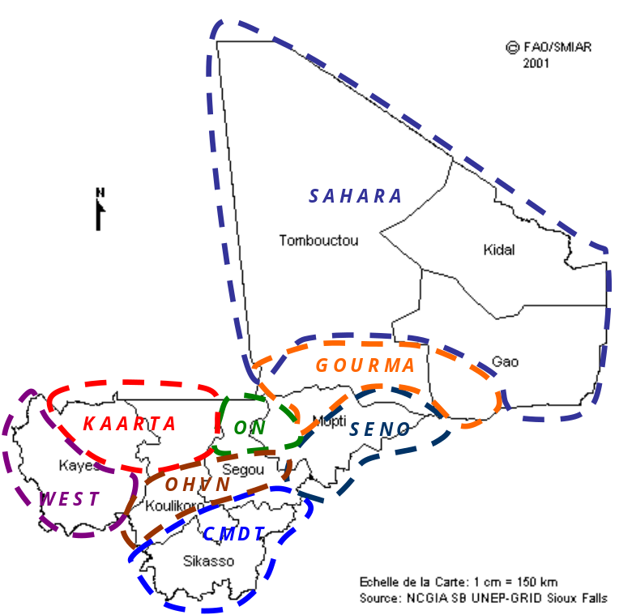

A) The Sahara zone

- The Sahara zone is highly degraded as a result of climatic factors. However, the rate of degradation remains stable and unchanged over the past 40 years. The zone comprises the Kidal region, most of Tombouctou and the upper Gao region. This hyper-arid zone, which receives less than 200mm/yr of rainfall, is situated in the Northern part and covers approximately 57% of Mali. The biggest problem in this zone is the southward movement of the Saharan desert, which has expanded expanded 350 km southward in the past 25 years (MEA, 2006). This is a result of moving sand dunes by wind erosion and accompanying sand storms which threatens lands and causes sedimentation (ensablement) of the Niger river bed. This is a key concern of Government. Other general degradation problems in this area include over-grazing by transhumant cattle, both national and international, and the removal of the scarce woody vegetation for firewood (Figure 10).

Figure 10 Cause of land degradation in the Sahara zone
Land Degradation
Sandbank
Development
Pasture degradation
Deforestation
Demand increase of
firewood and charcoal
Livestock of settled occupants
density increase
Soil fertility decrease
Water and wind
erosion
Population
increase
Low Rainfall
Over cultivation
Forage resource reduction
Climate change
Harmattan
Poverty
Crop yield reduction
Inadequate soil
and water
management
Demographic
pressure
Over grazing
Traditional land tenure
system
Soil degradation
Key factor

B) The Gourma zone

- In this zone, degradation is largely a result of water and wind erosion and desertification due to human and animal factors such as overgrazing, soil degradation by acidification and removal of woody vegetation for firewood. In addition, demographic pressures have led to over-cultivation in marginal areas, resulting in loss of soil fertility and erosion. Livestock rearing is also important in this area and transhumance with Burkina Faso is cited by the population as one of the causes of further degradation in the area, particularly around ponds (Figure 11).The Gourma zone is situated in the southern part of the Tombouctou and Gao region along the Niger River. The valley of Telemsi, situated in the east of this zone near Gao, has many siltated ponds and sand dunes which are a result of harmattan winds which bring dust and sand from the encroaching Sahara. Rainfall is approximately 200-400mm.

Figure 11 Cause of land degradation in the Gourma zone
Land Degradation
Sandbank
development
Pasture degradation
Deforestation
Demand increase of
firewood and charcoal
Demand increase of timber
Livestock of settled
occupants density increase
Mass transhumance
passage from Burkina Faso
Soil fertility decrease
Cultivable surface
reduction
Water and wind
erosion
Fallow period
shortening
Population
increase
Low Rainfall
Over cultivation
Forage resource reduction
Climate change
Harmattan
Poverty
Crop yield reduction
Inadequate
irrigation
Demographic
pressure
Over grazing
Lake water
decrease
Key factor
Traditional land tenure
system

C) The Seno Zone

- This zone, which is situated in the Sahelian ecological belt, is now the most degraded in Mali (see Figure 1) as a result of cultivation on marginal soils, overgrazing and the removal of crop residues. Degradation is manifested by a marked decrease in fertility, a reduction in vegetation cover and a reduction of viable agricultural and grazing land. In the Dogon Plateau, for example, where land is continously cultivated by millet cowpea intercropping in agroforestry parklands, specific problems include declining soil fertility due to short fallows, cultivation of marginal lands, soil acidification, soil mining, water and wind erosion, overgrazing and removal of crop residues. One of the degradation hotspots-the forest of Farimaké, outlined earlier in the chapter, is in this zone. In the surviving forests, the mass scale deforestation of the ligneous family, which is exploited for various uses, including firewood and timber, has resulted in large scale degradation. The harvest of the bourgou (seedlings raised after the first rains) is now practiced on a large scale to satisfy the increasing fodder needs in the urban towns. This practice has led to the irreversible destruction of ponds with bourgou. The zone comprises the Mopti region and is situated in the east of the region, bordering on Burkina Faso. Rainfall is approximately 400-600mm/year. This zone is suitable for primarily agro-pastoral activity (agriculture, livestock rearing) and early 60 % of the cultivable land in the Mopti region is located in this zone. These areas include the dry grounds of Méma, the Dogon Plate, and the plain of Séno.

Figure 8 Cause of land degradation in Seno zone
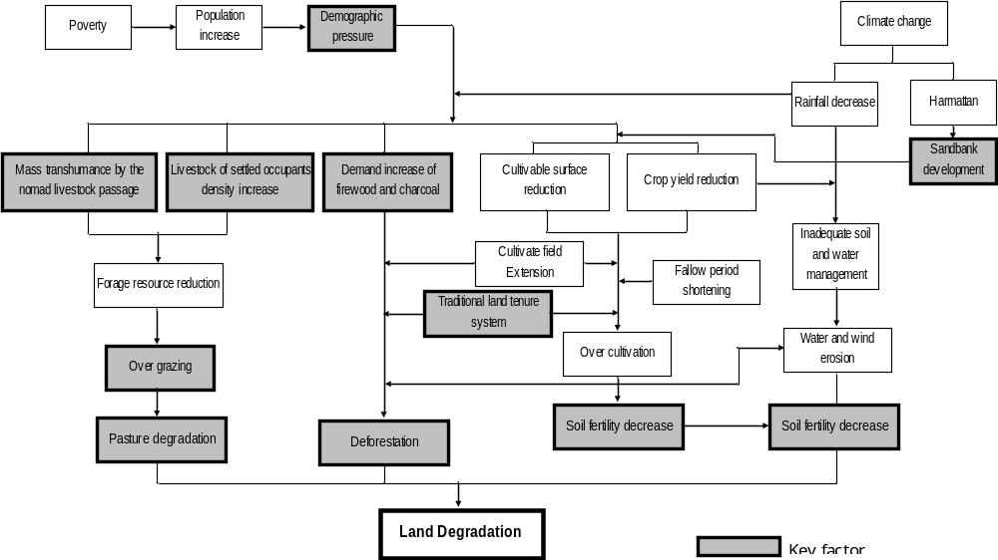

D) Office de Niger Zone

- Degradation in upper part of the Ségou region, also known as the rice cultivation area, is characterized by alkalinization and salinization of irrigated lands and a reduction of land fertility as a result of high demographic pressures (25 persons/km² ) on the land (Figure 9). Salinization occurs where the groundwater table has risen or where inappropriate irrigation practices have been conducted. In Mali, the ground water table has risen increased significantly from 1m in 1947 to 47 in 2001. The Terrastat database shows that approximately 20,000 hectares of irrigated land in Mali (particularly in the rice producing areas) have been affected by salinization. Removal of crop residues also contributes to degradation through soil exposure and erosion agents. The zone has a 4 month-long rainy season and a dry season which lasts the rest of the year. The Ségou region is traversed by the Niger River. The climate is classified as Sudanian and rainfall is approximately 400-600mm/year.

Figure 9 Cause of land degradation in ON zone
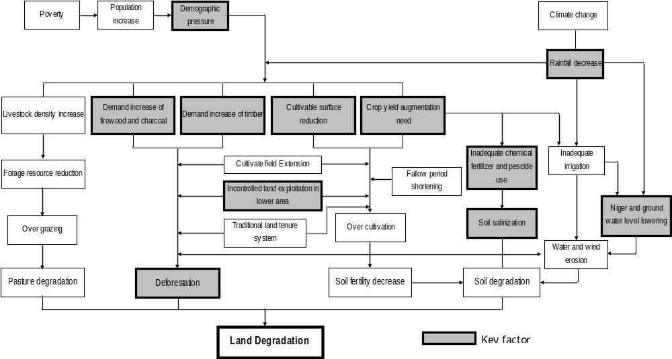

E) OHVN zone

- The proximity of the capital to this zone results in a large consumption of particular sylvi-agro-pastoral products and, as a result, there is an over-concentration of livestock in this region. In addition, population centers with a high demand for wood products and firewood has meant that deforestation around the cities are at a peak (Figure 10). This zone is located in the southern part of the Koulikoro and Ségou region and includes the Bamako district. The climate is in Sudan-Guinean, and rainfall is 600-1,000 mm. Despite the higher average rainfall in this area, droughts over the last few years have decreased the flow rate of the Niger River and lowered the water table.

Figure 10 Cause of land degradation in OHVN zone
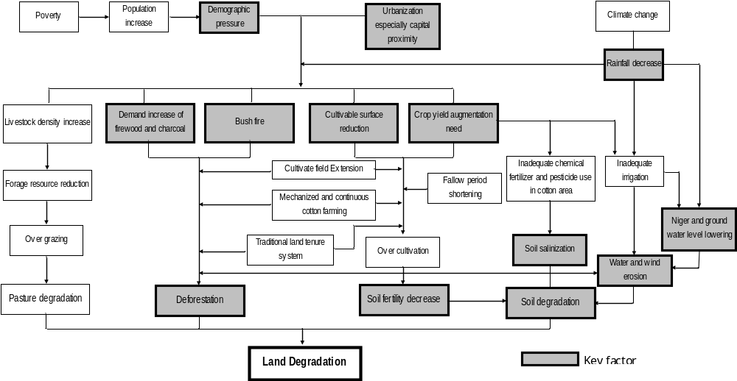

F) CMDT zone

- The most important cause of land degradation in this main cotton producing area is over-cultivation as a result of a) shorter fallows and b) land scarcity as a result of in-migrations into the region to grow cotton, particularly when cotton prices are high (Figure 11). Other problems contributing to land degradation include declining soil fertility due to soil mining, overgrazing, removal of crop residues, removal of woody vegetation for firewood, soil degradation by acidification and low level barnyard manure production by cattle.The zone is located in the southern part of the country and covers a surface of 71,790 km², approximately 5.8% of the national surface. Rainfall is 1,000-1,400 mm. Hydrography is characterized by 4 large rivers: the Sankarani, Bagoé, Baoulé and Bafing. In 1996, the population was estimated at 1,599,438 inhabitants, with 18.8% in the urban area and 81.2% in the rural area.

Figure 11 Cause of land degradation in CMDT zone
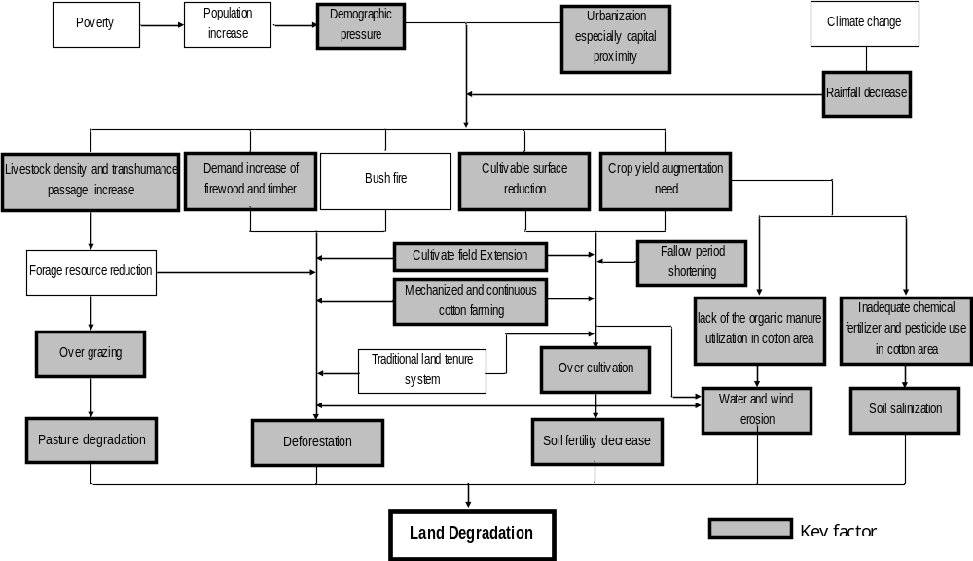

G) KAARTA zone

- Land degradation in this zone is largely a result of agricultural expansion and shorter fallows. Agricultural expansion has increased 233% in this zone from 150,000 ha in 1990 to 350,000 ha in 1996 with a continuing trend. In addition, deforestation is very rapid in this area and studies estimate that firewood removal rates increased more than 200% in 15 years from 747,000 tons in 1987 to 1.7 million tons in 2002 to meet the needs of cities such as Bamako. The exploitation of pasture by livestock is compounded by internal and external transhumance which brings livestock from Mauritania and Senegal during the dry season. The degradation of these pastures is caused by overexploitation of graminaceous and other herbaceous plants, excessive soil compaction, surface runoff and water and wind erosion (Figure 12). This zone covers the north-western part of the Koulikoro region and the north-east part of the Kayes region. The climate is North Sudanian and the annual precipitation is approximately 400-800 mm per year. The principal economic activities are livestock rearing and agriculture. Forestry is also relatively important because 6% of the surface area is classified as forested.

Figure 12 Cause of land degradation in KAARTA zone

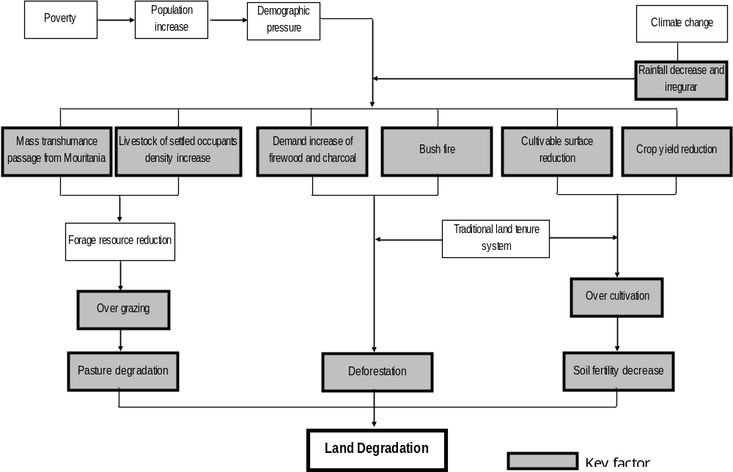

H) Western zone

- The demographic trends and the years of dryness, followed by an expansion of agriculture and exploitation on marginal lands (slopes, poor soils, etc), have increased degradation trends in the west. The 1995 regional plan for this area indicates that the ratio of cultivated area per capita decreased from 11 ha per person to 0.08 over the last 15 years as a result of erosion, soil marginality and other factors. Cultivated surfaces, however increased from 5 to 18% whereas zones in fallow decreased from 24% to 8% of the land area. A key problem in this area is the restoration of arable land.This zone is located in the west of the country and borders on Mauritania, Senegal and Guinea. Rainfall here varies from 800 mm to 1,400 mm. The main economic activities of the area include mining, agriculture and livestock rearing. Gold mining is prosperous but has resulted in much land degradation as a result of surface and sub-surface excarvation.

Figure 13 Cause of land degradation in the Western zone
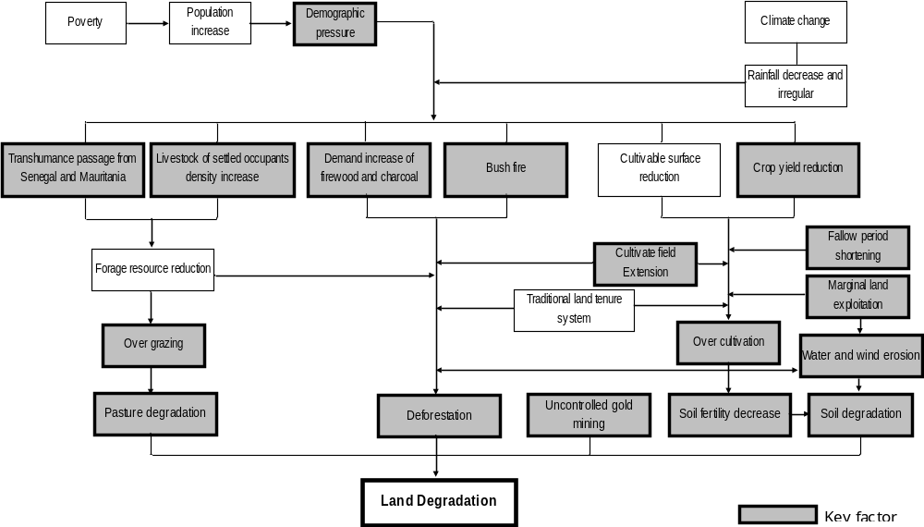
CHAPTER 2: SETTING UP THE FINANCIAL INCENTIVE FRAMEWORK: THE COST OF LAND DEGRADATION IN MALI

1. Assessing the Cost of Land Degradation

Costs of Degradation at the National Level

- It is important to assess the cost of degradation in Mali to ensure that proposed SLM strategies to combat the degradation are both cost-effective and beneficial in terms of their impact. However, there is no empirical data available to estimate this for Mali. We can attempt to reach a simplistic and rough estimate if we use the cost of certain types of land degradation found in the literature. In general, soil lost to degradation has been estimated to cost approximately US$1.84 million per year, which amounts to 0.6% of the total 1988 Malian GNP (Bishop et Allen, 1989). Other, more recent studies (Annex 2) estimate annual losses of 0.4 to as high as 6% of GDP (US$321 million annually) due to soil erosion and 5.35% (US$285 million) due to deforestation. This amounts to a loss of US$607 million annually to deforestation and soil erosion. If we were to include other types of land degradation, this figure increases significantly.

Costs of Degradation for the Individual Rural Farmer

- Costs of degradation assumed by the individual farmer can also be assessed by examining the cost of restoring that piece of land to reasonable fertility. The cost of improving soil fertility for each individual farmer is expensive. Scientists for the International Crops Research Institute for the Semi-Arid Tropics (ICRISAT) under the Desert Margins Program (DMP) in the Sahelian region found that improving the productivity of pearl millet and sorghum required at least 100 kg of Compound Nitrogen-Phosphorus-Potassium (NPK) fertilizer per hectare. Under the DMP, the poor farmers in Niger, Mali and Burkina Faso would need to spend approximately US$40 per hectare to follow the recommended NPK use. Since the average cereal land per agricultural labor force is about 1ha, an average farmer in the program would need to spend US$ 40 annually or between 12% to 32% of their income per year for fertilizer inputs. The expenditure is therefore justified only if the farmers can sell their produce for enough money to justify the cost of those inputs.

2. Assessing the Benefits of SLM investments

- SLM investments, particularly when they are combined with awareness creation at the farm level, have the potential to provide a stream of economic benefits. A study (Kergna) examined the economic benefit of various SLM and non-SLM policies in the agricultural sector. The policy changes focused on: (i) reducing soil productivity loss; (ii) introducing heat resistant varieties of crops; (iii) changing cropping patterns; (iv) technology adoption; (iv) cropland expansion; and (v) free trade. When all policies are considered as a package, results show an annual gain of $252 million in economic benefits as opposed to $161 million loss without policy adjustment. Simultaneously, undernourishment was reduced to 17 percent compared with 64 percent without policy adjustment. Interestingly enough, implementing the policy to improve soil productivity (without any other policies) had the most impact compared with no policy at all and reduced the malnourishment rate to 47 percent- the lowest among the single policy implementation scenarios (Table 4). Implementation of all policies except the soil related policy resulted in an economic benefit of US$ 134 million. This implies the crucial role of SLM techniques for the economy and food security. However, it also indicates the importance of combining relevant policy interventions to maximize impact.

Table 4. Changes in Undernourishment and Economic Benefits under Alternative Policy Options
 | Policy in Isolation |  |  | All policies but the identified one
Scenario | Malnourish (%) | Economic Benefits (Million US$) |  | Malnourish (%) | Economic Benefits (Million US$)
No policy | 64 | -161 |  | 17 | 252
Cropping patterns | 54 | -134 |  | 17 | 252
Trade | 47 | -93 |  | 21 | 229
Soil productivity loss | 47 | -54 |  | 27 | 134
Heat resistant varieties | 53 | -124 |  | 26 | 199
Technology adoption | 50 | -85 |  | 23 | 208
Cropland expansion | 55 | -77 |  | 21 | 186
Malnourish- Shows the percentage of population that is malnourished due to inadequate availability of food
Changes in Economic Benefits show changes in benefits from the base level in the absence of climate change.
Source: Policies for Reducing Agricultural Sector Vulnerability to Climate Change in Mali, Tanveer A. Butt^{1*}, Bruce A. McCarl¹, and Alpha O. Kergna, mimeo, undated

2. Assessment of Mali’s Financial Priorities in the Public Expenditure Reviews and Medium-Term Budget Framework

Are SLM Issues a Priority for Mali?

- Are SLM issues a priority for Mali given the high costs associated with land degradation? SLM is highlighted in a number of key documents. The Government’s National Environmental Strategy is detailed in several policy documents and initiatives that were drawn up in 1996 and 1998: (i) the Draft National Land Use Plan ( L’Esquisse du Schéma National d’Aménagement du Territoire (ESAT); (ii) the preliminary drafts of the regional land-use and development plans (ASPRAD, 1996) and (iii) the National Environmental Protection Policy (Politique Nationale de Protection de l’Environnement). In addition, a new forest policy was formulated in 1996. The National Strategy for the Protection of the Environment (PNPE) was prepared in 1998 as a follow on activity to Mali’s ratification of Agenda 21 and the UN Convention to Combat Desertification (UNCCD). The PNPE has a two-fold objective: (i) to ensure a healthy environment and sustainable development by making all actors accountable; and (ii) to help combat desertification, ensure security and combat pollution and poverty. Currently, nine National Action Programs have been identified. Under regional action plans, most of the budget has been allocated to the development of water resources and impovement of hydraulic infrastructure.

- Examining the Government’s recent budgetary framework, (The medium budget framework for 2006-2008) shows that SLM initiatives are important. For example, specific objectives for the 2 year period include: (i) the development of 10,000 of land of which 5,000 ha will be planted with crops resistant to seasonal climate changes; (ii) a 25 % increase in organic fertilizer production by women; (iii) the promotion of major agricultural inputs to improve soil fertility; (iv) the development and restoration of forests and natural habitats; (v) the fixation of dunes around the water points; (vi) the creation and revitalization of 500 associations to combat land degradation; (vii) the provision of improved stoves to 50,000 women to reduce firewood dependence; (viii)the training of women on techniques on water and soil conservation; and (ix) the promotion of ecological environments and renewable energy. In addition, the draft 2007 PRSP includes key SLM priorities which include: a) restoration of degraded areas; b) desertification and c) sedimentation of the River Niger. However, despite these targets, examining the sectoral ministeries budgets for 2004 (figures published in 2006), and for 2006-2008 show that there is a large discrepancy between a) what is planned (in strategies, action planning exercises) and what is budgeted for and b) what is budgeted for and what is actually executed.

How are Financial Resources Allocated to the SLM Agenda in the Ministry of Environment and Sanitation?

- Table 5 shows how the budget of Ministry of Environment and Sanitation (MES) was allocated and realised in 2004 (figures published in 2006- Table 5). MES had 4 programs: (i) General administration-Program 1; (ii) Improvement of living conditions-Program 2; (iii) Maintenance and integrated management of Niger River basin resources-Program 3; and (iv) Protection and conservation of nature-Program 4. Each program had specific objectives and results. Most of the programs in 2004 addressed general environmental concerns but not specifically the SLM agenda except for elements of Program 3. Program 3 mostly focused on the Niger River. Specifically, its three objectives focused on(i) strengthening the capacity of resource management of streams and river basins; (ii) promoting rationalization and improvement of water resource management among various users; and (iii) prevention of risks (SLM related topics of flooding, erosion, and droughts), combating invasive aquatic plants and maintaining the navigability of the river.. Achievements under these objectives include: (i) realization of television programs on river problems and information management trainings for 7 agents; (ii) finalization of river bank studies on Diafarabe, Segou and Gao, iii) completion of a study on water hyacinths; and (iv) clean up of water hyacinths in the district of Bamako and Beguineda. There were no concrete achievements mentioned for the prevention of risks category which includes the SLM related initiatives.

- Program 4 comprised the largest share of the MES budget (61%) and in terms of what was actually achieved, there were a few SLM related investments. For example, 22 ha of dunes were stabilized in Gao and 3,961 ha were reforested, 5,220 meters of live hedge and windbreak were created, 10 village forests were created for the population of Kita and 3,866,910 plants were planted. Despite these achievements, the budget execution rate of the Program 4 was the lowest (57%) among the total four programs and its investment execution rate was only 43% (Table 5).

Table 5. Budget of Ministry of Environment and Sanitation in 2004(in FCFA)

Programs for 2004 | Personnel |  | Operation |  | Investment |  | Total allocation | Total execution | Execution rate (%)
 | allocation | execution | allocation | execution | allocation | execution
General administration | 156,237,000 | 148,795,658 | 484,136,000 | 472,956,399 | 10,000,000 | 9,998,320 | 650,373,000 | 631,750,377 | 97%
Improvement of living environment | 171,308,000 | 167,193,826 | 225,062,000 | 222,999,824 | 1,096,000,000 | 689,183,170 | 1,492,370,000 | 1,079,376,820 | 72%
Maintenance and Management of Resources of Niger River Basin | 129,781,000 | 127,616,897 | 179,060,000 | 176,060,878 | 661,000,000 | 278,330,486 | 969,841,000 | 582,008,261 | 60%
Protection and conservation of nature | 1,027,973,000 | 1,038,526,579 | 196,212,000 | 196,106,943 | 3,609,000,000 | 1,534,990,955 | 4,833,185,000 | 2,769,624,477 | 57%
Total | 1,485,299,000 | 1,482,132,960 | 1,084,470,000 | 1,068,124,044 | 5,376,000,000 | 2,512,502,931 | 7,945,769,000 | 5,062,759,935 | 64%

- Table 6 shows the MES’s new budget for 2006-2008. The GRM funds allocated to the MEA grew from 1.7 billions (2003) to 3.2 billions F CFA in 2005 (MEA, 2006). An assessment of the programs suggests the continuing importance of natural resource protection and conservation and a small budget related to SLM initiatives related to the restoration of degraded and threatened zones. By the end of 2008, expected results include: (i) rational utilization of forestry and wildlife; (ii) resoration of degraded and/or threatened zones; (iii) improved knowledge of biodiversity; (iv) improved natural habitat conditions; (v) increased eco-tourism; (vi) strengthening of levels of management and surveillance; (vii) progressive transfer of competences to territorial collectives ensured; and (viii) riverside communities involved in natural resource management. The programs are not yet complete and therefore expenditure information is not yet available.

Table 6. Budget of Ministry of Environment and Sanitation for 2006-2008 (in FCFA)

Programs | Allocation for 2006 |  |  | Total allocation
 | Personnel | Operation | Investment | 2006 | 2007 | 2008
General administration | 204,328,000 | 803,213,000 | 210,000,000 | 1,217,541,000 | 1,263,715,000 | 1,387,497,000
Improvement of living environment | 207,340,000 | 277,789,000 | 2,223,000,000 | 2,708,129,000 | 3,413,785,000 | 3,577,162,000
Maintenance and Management of Resources of Niger River Basin | 136,189,000 | 152,082,000 | 225,000,000 | 513,271,000 | 525,340,000 | 563,682,000
Protection and conservation of nature | 1,152,836,000 | 388,016,000 | 7,882,700,000 | 9,423,552,000 | 10,267,176,000 | 10,698,250,000
Total | 1,700,693,000 | 1,621,100,000 | 10,540,700,000 | 13,862,493,000 | 15,470,016,000 | 16,226,591,000
Source: Source: Budget Programs 2006 Volume I Prevision, Ministry of Economy and Finance*Exchange rate of July 10 2006: 1 XOF = 0.00194161 USD or 1 USD = 515.036 XOF.

How are Budgetary resources allocated to SLM in the Ministry of Agriculture?

- Table 7 shows the budget allocation for the Ministry of Agriculture in 2004. The Ministry of Agriculture had 4 Programs: (i) General administration- Program 1; (ii) Support to rural people-Program 2; (iii) Development – Rural Equipment-Program 3; and (vi) Research and training-Program 4. Within this program, there were only indirect references to SLM. The most relevant to sustainable land management was Program 3, Development & Rural Equipment. Program 3 had three objectives: (i) evaluation of agriculture, pasture and water resources for development; (ii) study and monitoring of current investment projects on hydro-agricultural, pastoral, and fishery development; and (iii) improvement of sustainable management of agricultural, pastoral and fishery resources. The execution rate for this program was only 59%. In terms of what was actually achieved by the 2004 program: (i) a base-data on potential hydro-agricultural, pastoral and fishery resources were created for each region and the country; (ii) a cartography of potential pastoral species that could be developed were outlined for the Mopti and Sikasso regions; (iii) a national strategy on irrigation development was elaborated; (iv) a study was completed on financial mechanisms of irrigation; and (v) donor database for resource management on hydro-agriculture, patralism, and fishery were established in the total areas of Mali as well as each region. Therefore, in terms of actual achievements, none of the SLM related goals of pasture development and sustainable management of pastoral and agricultural resources was listed as achieved.

Table 7. Budget of Ministry of Agriculture in 2004 (in FCFA)

2004 | Personnel |  | Operation |  | Investment |  | Total allocation | Total execution | Execution rate (%)
 | allocation | execution | allocation | execution | allocation | execution
General administration | 596,725,000 | 577,696,178 | 1,256,254,000 | 1,250,726,035 | 28,000,000 | 27,975,392 | 1,880,979,000 | 1,856,397,605 | 99%
Support to rural people | 2,812,450,000 | 2,979,112,636 | 504,942,000 | 504,126,227 | 40,751,000,000 | 23,008,147,370 | 44,068,392,000 | 26,491,386,233 | 60%
Development - Rural equipment | 860,754,000 | 926,305,743 | 1,783,837,000 | 1,772,464,188 | 47,091,377,000 | 26,712,833,938 | 49,735,968,000 | 29,411,603,869 | 59%
Regulation and control | 1,392,010,000 | 1,428,033,059 | 2,337,208,000 | 2,330,834,619 | 1,822,000,000 | 1,494,545,738 | 5,551,218,000 | 5,253,413,416 | 95%
Total | 5,661,939,000 | 5,911,147,616 | 5,882,241,000 | 5,858,151,069 | 89,692,377,000 | 51,243,502,438 | 101,236,557,000 | 63,012,801,123 | 62%
Source: Budget Programs 2006 Volume II Realization, Ministry of Economy and Finance* Exchange rate of July 10 2006: 1 XOF = 0.00194161 USD or 1 USD = 515.036 XOF.

- Table 8 presents the Ministry’s budget for 2006-2008. The importance of this sector to the government is clear: The GRM funds allocated to the MEA has grown from 1.7 billions (2003) to 3.2 billions F CFA in 2005 (MEA, 2006). Similar to 2004, most of the investment occurs in Programs 3 and 4, of which the Program 3 is the largest. While most of the specific objectives for 2006-2008 remain the same as in 2004, there are some additional objectives, such as improvement on phytosanitary of agricultural products, as well as improved employment of rural youth and contribution to reduced HIV/AIDS infection in rural areas.

Table 8. Budget of Ministry of Agriculture for 2006-2008 (in FCFA)

 | Allocation for 2006 |  |  | Total allocation
 | Personnel | Operation | Investment | 2006 | 2007 | 2008
General administration | 475,833,000 | 1,530,051,000 | 1,502,000,000 | 3,507,884,000 | 3,818,986,000 | 4,103,973,000
Support to rural people | 3,525,160,000 | 3,791,332,000 | 26,527,000,000 | 33,843,492,000 | 38,424,689,000 | 39,956,304,000
Development - Rural equipment | 832,684,000 | 1,673,159,000 | 47,015,000,000 | 49,520,843,000 | 50,279,357,000 | 52,142,221,000
Research and training | 131,355,000 | 396,591,000 | 680,000,000 | 1,207,946,000 | 1,169,742,000 | 1,213,929,000
Total | 4,965,032,000 | 7,391,133,000 | 75,724,000,000 | 88,080,165,000 | 93,692,774,000 | 97,416,427,000

How are Budgetary resources allocated to SLM in the Ministry of Agriculture?

- The Ministry of Livestock and Fisheries was within the Ministry of Agriculture prior to 2004 and therefore their budget, objectives and results prior to this time are included in Tables 7 and 8. Table 9 represents the budget for 2006 – 2008 for the newly created Ministry of Livestock and Fishery. The Ministry has 4 Programs: (i) General administration-Program 1; (ii) Production and transformation of animal production-Program 2; (iii) Fishery production development-Program 3; and (iv)Veterinary sanitary protection and public health-Program 4. Program 2 is most relevant to sustainable land management though the precise budget allocated to SLM related activities is not known. Expected relevant results for this program for 2006 include: (i) the development of 100,000 ha of pastoral species and ponds and (ii) Ensure the monitoring of pastoral resources.

Table 9. Budget of Ministry of Livestock and Fishery for 2006-2008 (in FCFA)

 | Allocation for 2006 |  |  | Total allocation
 | Personnel | Operation | Investment | 2006 | 2007 | 2008
General administration | 137,192,000 | 729,419,000 | 50,000,000 | 916,611,000 | 700,958,000 | 774,263,000
Production and Transformation of animal production and industries | 445,709,000 | 65,966,000 | 5,683,000,000 | 6,194,675,000 | 5,969,659,000 | 6,209,890,000
Development of fish production | 172,391,000 | 55,364,000 | 334,000,000 | 561,755,000 | 611,935,000 | 628,270,000
Sanitary Protection and veterinary public health | 271,639,000 | 412,961,000 | 3,448,000,000 | 4,132,600,000 | 4,117,583,000 | 4,284,057,000
Total | 1,026,931,000 | 1,263,710,000 | 9,515,000,000 | 11,805,641,000 | 11,400,135,000 | 11,896,480,000
Source: Budget Programs 2006 Volume I Prevision, Ministry of Economy and Finance* Exchange rate of July 10 2006: 1 XOF = 0.00194161 USD or 1 USD = 515.036 XOF.

- This analysis shows that some elements of SLM related activities are included in the budgets of the different Ministeries. However, this budget is a) small, given that most SLM activities are within other environmental programs; b) often not even fully executed; c) does not seem to achieve significant measurable results. When we examine the expenditure to environment related activities, approximately US$ 130 million was budgeted for 2006-2008- this includes limited expenditures on SLM. If we examine the entire environment related budget, given that the ministries only have a 50% or so efficiency rate in implementation, half of this amount might be actually spent, which is approximately US$ 65-128.5 million annually for a three year period. This allocated expenditure for the entire evironment budget is approximately 2.4- 4.8% of Gross Domestic Product (GDP) of Mali in 2005 and 1.2-2.4% of GDP for actual execution. This cost or expenditure can be compared to the estimated cost of just one type of degradation- soil erosion- which is estimated to cost Mali 6% of GDP per year in the most degraded areas. This suggests that more Government funds need to be spent on combating land degradation.

Donor Investments in SLM

- In contrast to the Government’s low level of public expenditure on SLM, donors contribute quite a lot. In terms of direct financial flows to SLM, Annex 3 lists current external projects and programs which specifically mention land degradation or sustainable land management related issues. There are approximately 21current projects/programs with a total budget of US$93,585,297 that directly relate to SLM. Many will close in late 2006 or in 2007 although a few are multi-year programs. Most of the projects that address sustainable land management issues do so through integrated water, land, tree, crop and pastoral management. The GRM has designated the German cooperation has the leader in charge of monitoring funding (both GRM and international collaboration/cooperation) of environment projects in Mali. However, this coordination has been slow to take off.

3. Summary of Problems related to Budgetary Allocations for SLM

A) Lack of Dedicated Public Funding for SLM as a Result of Competing Priorities

- Mali is a country greatly affected by land degradation and dessertification. Yet, the budgetary framework shows that this is not a national priority. On the list of financial priorities in a resource poor country, SLM practices come rather low, with adhoc interventions that do not have an impact on the land degradation problem. Despite this, Mali has clearly prioritized land degradation in its action planning (Mali has signed the UNCCD, taken a keen interest in TerrAfrica and has taken steps to outline a series of projects and programs that would combat dessertification). However, an examination of the extent to which these plans have been funded by the Government shows that apart from a few investments, SLM remains largely unfunded by the public sector. There is a need now for the budgetary allocations to match the prioritized actions in the different strategic plans for combatting dessertification and land degradation.

B) Public funding needs to continue after donor projects have ended to ensure a long-term sustainable approach to land management.

- Although SLM is largely unfunded by the public sector, to a large extent much of the work related to the environment, and specifically to land management, is funded by external donors (see Table 1). Most projects address land degradation through antidessertification programs, reafforestation and agroforestry programs, climate change alert systems and programs that target the community level. A relatively small number of projects address soil fertility issues. The problem with donor funding is that investments are sporadic and often related to the interests of donors. Generally, projects do not a) build on past achievements; b) use a consistent approach; c) monitor results after the project is complete; and d) provide a continuous stream of funds to improve land management. In short, a project approach to SLM is helpful but does not produce sustainable long-term impacts. A more programmatic approach, with Government buy-in and financial commitment over the long-term, is needed. Certainly, for SLM to work in Mali, a programmatic approach that assures long term commitment from both the public sector and private/donor agencies, with indicators to measure this commitment (financial, strategic, institutional) over time, is fundamental to getting results.

- Table 10 examines the problems related to funding SLM in Mali, particularly from the public sector and examines ways of ensuring long-term sustained funding.

Problem | Recommended Action | Time
There is no economic valuation to quantify the loss in GDP attributed to land degradation or the economic benefits of SLM initiatives. | Commission a cost/benefit study which will present  a cogent argument for SLM investment in Mali | Preparation
Public expenditure reports give data  on environmental budgets but not precise information on expenditures  on SLM | Carry out a PER but focus on also getting detailed information from each sector as far as expenditures
Public Funding exists for some environmental activities but these are not necessarily related to SLM and often, allocations are underutilized | Establish a dedicated source of public funding for SLM activities through related sector ministry budgets, and from underutilized budgets. This dedicated source should continue after the project ends. For example, in the case of donor funded projects, Government can make arrangements so that the donors fund the first 5 years till the project ends and Government commits to funding the next 3 years. | Preparation
Public Funding for SLM may be lacking due to competing priorities | The PRSP indicates that aspects of SLM (land degradation, River Niger Siltation) are of importance  to Mali. Public funds for these particular activities should be funded in part by the Government. | Throughout
Commune level activities often  remain unfunded | Ensure a dedicated funding source for SLM related activities in communes. Commune capacity should be reinforced to enable them to complete their commune level development plans and put together a persuasive and justifiable argument for accessing funds. | Preparation

CHAPTER THREE: ANALYSING THE INSTITUTIONAL AND POLICY FRAMEWORK FOR LAND MANAGEMENT

1. Institutions

- Mali is a country greatly affected by land degradation and dessertification and an analysis of the institutions show that there are a number of avenues for addressing this problem. However, the problem is not the structures, but rather the coordination between structures, the lack of a national program or concerted agenda, and the lack of the necessary budgetary support to invest in sustainable land management. Finally, even in addressing land management concerns, most of these institiutions tackle the problem differently, using their particular mandates and approaches, resulting in an ad hoc approach to sustainable land management. Unless funded by external sources, these institutions have ample vision but are essentially ineffective before donors come in and after donors have completed their projects. This chapter describes the differents institutions that are directly involved in land management in Mali and outlines the problems faced by the current instititional framework in terms of land management.

Government Institutions

- The Ministry of Environment and Sanitation is comprised of three key agencies, two of which, the DNCN and the STP/CIGQE, intervene directly in the land arena.

- The Secretariat Technique Permanent du Cadre Institutionnel de Gestion des Questions Environnementales (STP/CIGQE) is set at the national level (office in Bamako) and handles policy issues related to land and environmental management. The STP also manages an inter-departmental committee (‘Comité Interministeriel’) which is in charge of setting the agenda. The STP is also the Focal Point of the United Nations Convention on Combating Desertification (UNCCD), though its plans are carried out in other structures of MEA, MA, and MEP. Discussions with staff indicate that although an old plan to counter desertification exists with approximately 10 projects for implementation, this has not been funded, 5+ years later.

- The ‘Direction Nationale de la Conservation de la Nature’ (DNCN) is a national structure with regional representation. It is broadly in charge of sustainable management of natural resources. The DNCN has representatives ‘Direction Régionale’ (DRCN) in each of the 8 administrative regions of Mali. There are sub-regional offices (Service de Conservation de la Nature) in most of the 49 ‘Prefectures’ of Mali. Selected projects or programs are implemented in selected ‘Sous-prefectures’, ‘Communes’ and Villages of some of the Prefectures. The DNCN is the Focal Point of several conventions such as the Convention on Biological Diversity. The regional structures, termed SCNs, are responsible for directly working with communities. SCN offices are grossly underfunded and understaffed. Working with these structures via projects, often requires some capacity needs to be filled (e.g., additional staff, training for staff vehicles, motorbikes, etc).

- The Ministry of Agriculture (MA) is mainly in charge of improving production systems and developing agricultural research. The following key 6 structures of the MA are responsible for the agricultural program and aspects of land management are contained in their mandates through not necessarily budgeted for (Annex 6).

- The ‘Cellule de Planification et de Statistiques’ (CPS) is a service that carries out studies, collect data, makes plans, evaluate models and several other activities for the Ministry of Environment (MA), Ministry of Environment and Sanitation (MEA), and the Ministry of Economic Planning (MEP). Similar to the STP in the Ministry of Environment and Sanitation, it is set only at the national level (office in Bamako). This type of institution would be important in monitoring and evaluating different types of land degradation data.

- The ‘Comite National de la Recherche Agricole’ (CNRA) is under the umbrella of the Ministry of Agriculture, the CNRA coordinates agricultural research on fields managed by the MEA, MA, and MEP. The CNRA include, in addition to its core body of the ‘Institut d’Economie Rurale (IER), the colleges of the University of Mali, the ‘Laboratoire Central Veterinaire (LCV), and NGO’s. The Institut d’Economie Rurale has 6 regional centers, 17 research and 4 laboratories to conduct research, train and extend to stakeholder any type of agricultural, environmental, livestock, wildlife, and fishery aspects.

- The ‘Direction Nationale de l’Agriculture’ (DNA). This structure manages the agricultural production systems in areas not covered by major ‘Offices’ such as those indicated below. The DNA has the same regional and sub-regional structures as the DNCN. The DNA is the Focal Point of the Convention on Plant Protection. This structure also hosts the Convention on Migrating African Locusts.

- The ‘Office du Niger’ is totally in charge of all aspects (land management, production, trading, socio-economics, etc.) of irrigated rice cropping systems in the ‘dead delta’ of the Niger River in Mali. Water is diverted by a dam from the Niger River in Markala to irrigate 100 000 ha of a potential of 1 000000 ha (Dabin, 1951). There is strong integration of agriculture and livestock production. In addition, vegetables (mainly onions and tomatoes) are used in the cropping systems.

- The ‘Compagnie Malienne pour le Developpement des Textiles’ (CMDT) is in charge of all aspects (land management, production, trading, socio-economics, etc.) of cotton production systems in Mali. There is strong integration of agriculture and livestock production. In addition, cereals are involved in the cropping systems. The CMDT is undergoing changes to concentrate only on cotton production and trading. Plans are underway to make CMDT a private company.

- The ‘Office de la Haute Vallee du Niger’(OHVN) is in charge of land management and productions systems in most of the administrative region of Koulikoro. OHVN has long been supported by the local mission of USAID. Part of the OHVN area produces cotton under the umbrella of CMDT. Recent evaluations have indicated improvements in natural resource management in the OHVN areas.

- Ministère des Domaines de l’Etat et des Affaires Foncières (MDEAF). The ‘Direction Nationale des Domaines et du Cadastre’ (DNDC) of this department handles land tenure issues which constitute a key factor in sustainable land and environmental management. The link between sustainable land management and land tenure is obvious. Farmers with more secure land tenure are more likely to invest in SLM initiatives particularly if those investments are costly. Farmers with less secure tenure are only likely to invest in SLM initiatives if the benefit of the investment can be obtained in the short-term and if the cost is not prohibitive.

- Ministère de l’Administration Territoriale et des Collectivités Locales (MATCL)
Mali is organized into 8 administrative ‘Régions’ plus the District of Bamako. Each administrative region is subdivided into ‘Prefectures’ which in turn are made of ‘Sous-prefectures’. Each ‘Sous-prefecture’ is subdivided into ‘Communes’ which are made of several villages. The Communes are the ‘hearth’ of the decentralized process. Each Commune is required to make its own development plan. GRM and collaborative funds can be mobized to implement these communal development plans. This department manages local, decentralized communities: the end users of land and the environment. This institution is particularly important because projects targeting farmers and pastoralists within communes will need to involve this Ministry. In addition, MATCL is important if SLM objectives are to be integrated into communal development plans.

- Ministère de l’Equipement et des Transports (MET). This department hosts the ‘Direction Nationale de la Meteorologie’ (DNM). The DNM is the focal Point of the United Nations Convention on Climate Change (UNCCC). This structure is in charge of characterizing climate change in Mali. Issues related to both attenuation and adaptation to climate change are handled by affiliated structures of MEA, MA, and MEP.

- The ‘Direction Nationale de l’Energie (DNE). This office makes policies and regulates energy supply in Mali. Two key approaches of this department involve reducing fire wood consumption and introducing biological gasoline. Several types of improved stoves are being marketed and promise a 30% reduction in the average family need of firewood. Despite these initiatives, there is no reduction in land clearing. The approach of ‘Energy Domestic’ has been assisting local communities to plant selected trees in cleared areas. However, regeneration values are still very low (> 10%). Another initiative, ‘Wood for equipment’ provides farming equipment for successful regeneration efforts. Sites using this approach (Sikasso and Kita) have shown significant success (regeneration rates > 16%). An old practice in Mali, but using a new approach consists of planting and harvesting Jatropha curcas for biogasoline production. This biogas could provide 5% of the total energy requirements of Mali in the next 5 years and 25% within 10 years.

Non-Government Institutions (NGOs)

- Three major centers of the Consultative Group for International Agricultural Research (CGIAR) have bases and regional land and environmental programs in Mali. These are ICRISAT, ICRAF and IFDC. These centers collaborate with governmental departments, NGO’s, and local communities. Such research/development programs include the Desert Margin Program being implemented by ICRISAT. One of the key requirements of the relevance/acceptance of such programs by a governmental department is that they fit into one or more land and environmental actions plans such as the PNAE (a national plan for environmental rehabilitation) of the MEA or the Strategic Plan of Agricultural Research of the MA.

- Numerous international NGO’s have land and environmental management programs in Mali. CARE has been conducting effective programs since the 70’s. Other well-known international NGOs include Syngenta, Sasakawa Global 2000, Agro-Action Allemande, etc. As required by the CGIAR centers, these international organizations must align their program to departmental plans or conventions. Accordingly, CARE, Syngenta, Sasakawa Global 2000 and Syngenta have activities that deal not only with the PNAE, but also with the UNCCD (MEA) and poverty alleviation (‘Cadre Strategique de Lutte contre la Pauvreté (CSLP). International NGO’s often work on training, awareness, and extension aspects. After years of actions with governmental departments at the national level, they are now taking their programs straight to the decentralized, local communities.

- There are more than 1000 national and local NGO’s working on land and environmental management in Mali. For example, a national NGO, Deguesi Vert, works with local communities of Nara and Cinzana in planting/interplanting Acacia senegal for the purpose of not only producing Arabic gum, but also for sequestering carbon. Funding is derived from the BioCarbon Funds of the Word Bank. Another national NGO, AMAPROS (Association Malienne pour le Promotion du Sahel) works on activities such as ‘ecological farms’, ‘greening the Sahel’. Such activities are implemented at the village level of the ‘Communes’ of Macina where seedlings of high-value species of Moringa spp. and grafted Zizyphus mauritiana are being produced and planted in garden plots and degraded lands. Funding is provided by the Norwegian Dryland Coordination Group.

Donors and External Aid in Land Management

- In Mali, a number of external agencies, bilateral donors, international banks and agencies, are indirectly and directly involved in sustainable land management (SLM). Annex 4 lists these projects and notes whether they are directly or indirectly involved in SLM In terms of areas of intervention, many interventions are national but Mopti in particular is a region that has received a significant portion of external assistance. A relatively small number of projects addressed soil fertility issues. Most projects address land degradation through dessertification programs, reafforestation and agroforestry programs, climate change alert systems and programs that are directly involved at the community level with natural resource management for both agricultural and pastoral systems. Although the executing agencies vary from NGOs to ICRAF, when we examine government ministeries alone, MEA manages more external projects related to SLM than other ministeries such as MA.

2. Problems with the Current Institutional and Policy Framework for Land Management

- There are many problems associated with the institutional framework in Mali that deals with land management issues:

A) Lack of Coordination and Coherence in Intervention Methods between Government institutions

- Institutions dealing with natural resources management and land management are both numerous and diverse (PAPE, 2005). However, there is a lack of coherence in their interventions methods (MEA. 2006). In fact, the 3 major departments (MEA, MA, and MEP) that define and implement land management policies often have overlapping mandates, conflicting objectives, and diverse methods. This results in different and conflicting remedies for the same piece of land. For example, MEA is charged with protecting the environment. Yet, MA and MEP are in charge of defining and extending management techniques for the sustainable use of the environment. Often, there is competition, particularly for external resources, between the various ministries and MEA often points a finger at MA as the institutional body whose production agenda results in degradation that they have to try and fix. The ‘Comité Inter-ministeriel’ which should have resulted in some degree of coordination is ineffective. These translate into the following constraints (MEA, 2006; PAPE, 2005; Atkins International, 2006):
- Lack of a global, common, and national vision for land use/management and the environment
- Lack of communication and coordination among actors
- Extension of sometimes conflicting technical messages
- Multiple extension agents and approaches for conflicting uses of the same land
- Inefficient enforcement of existing regulatory laws or policies
- Inefficient use of limited funds and technical agents

B) Overlapping Mandates within Government Departments and Structures

- The above weak coordination among institutions is compounded by ever-changing governmental departments and their affiliated structures. A few years ago, the department of the ‘Ministère du Développement Rural et de l’Environnement’ was broken down into the current MEA, MA, and MEP. The overlapping mandates and conflicting agendas of these new departments translated into weakening of the national action plan for the environment, the PNAE, through multi-implementers which set their own environmental issues and guidelines. This added a level of complexity to the management of a fragile and degraded land (MEA, 2006). In addition, this change suggested that sustainable land management does not appear to be a key development priority of the main government policies and strategies, because specific objectives of the different structures of the MA and the MEP were more oriented towards intensive production systems. GTZ, has been trying to coordinate, in collaboration with STP, the funding of land and environmental management. Their primary lists of funded, ongoing projects, programs or activities showed several overlapping cases or duplications at the same sites.

C) Insufficient Public Resources for Land Management

- The budget overview (Section 3) shows that the various ministeries address land management issues in a piece-meal fashion without concerted action. A concerted approach to land degradation would require an inter-ministeral approach and a common objective and plan that cuts across all ministeries. With inefficiencies in budget expenditure (40% of most allocations are not used), this suggests that the objective of past programs may not have been fully attained and it is important to assess the reason for this inefficiecy. It is clear that any successful SLM strategy would require all the institutions that deal with land management to come together to work on one SLM strategy for Mali that would deal with the multifaceted aspects of land management (agriculture, pasture, environment). The strategy should be monitorable, and have well defined objectives and a clear sense of what will have the most profound impact in terms of results and impact.

D) Lack of Capacity for Land Management

- The individual, institutional, and organizational capacities at both national and decentralized levels are insufficient for sustainable land management (PAPE, 2005). In terms of technical agents, the MEA, MA, and MEP do not have the capacity to provide agents at the local, decentralized level where land use takes place. The following case of the Prefecture of Cinzana is typical of all 49 prefectures of Mali. The MEA, MA, and MEP each have between 1 and 3 agents at the Prefecture of Cinzana. This translates to 1-3 MEA agents for 6 Communes and 347 villages. These agents have very limited means of transportation and yet they have to cover wide areas that are assigned to them. Although a truck and mopeds are available, monthly provisions for gasoline and repairs only last a few days. Thus the technical know-how is not fully decentralized enough to ensure that many communities are reached and that outreach occurs effectively. Only with financial injections from external projects is staff able to be fully mobilized. There is a clear need to create a local technical committee for land and environmental management. In Cinzana, NGO’s provide some of the backstopping. 14 agents from 8 NGO’s that work on land and environmental issues are located at Cinzana. These 8 NGO’s have an additional 17 agents located at the lower levels of the Sous-prefectures. Although this helps, most agents are located at the ‘Prefecture’ level, leaving significant gaps at the Commune and village levels where there is a strong need for extension and technical backstopping.

- In addition to the limited number of staff, there is a concern that the average age of these agents is 50 years and about 80-90% of the staff of these 3 departments will retire within the next 10 years. The MFPRERI stopped recruiting for the MEA, MA, and MEP since the early 80’s. The level of training, despite strong efforts from GRM and international collaboration, is still somewhat limited, except at the research level where most scientists have a Master of Science degree.

- Organizational capacity is severely limited at the Commune and village level. Despite the relatively long experience of village associations in Mali, there is still a need to assist communes get organized for a common purpose. Today, most communes have not been been able to develop their ‘communal development plan’ for submission to the ANICT funds. The HCCT has the mandate to assist them in doing so, but many of the 703 Communes have yet to develop a plan. Including a concerted SLM approach into these plans, if funded, could have significant impact at the communal and community levels.

E) Lack of Coordination between Donors/External Financial Agencies

- Given that a significant portion of resources for environment/natural resources and SLM budget is funded by external agencies, coordination among donors is key. This does not generally occur and lack of coordination was a key complaint in interviews with donor agencies. Without coordination, some projects are duplicated, important lessons are buried with the donor institutions and, in terms of results very little is achieved by this fragmented approach. The Ministry of Environment and Sanitation, led by a coordinator from GTZ (Deutsche Gesellschaft für Technische Zusammenarbeit (GTZ)), organized an environmental coordinating group among various external agencies (ANNEX 2). They are supposed to meet regularly but according to the coordinator, not all members attend and the degree of their commitment varies. The Ministry of Agriculture attempted to form a similar group for the agricultural sector about 10 years ago. However, it did not function well and was discontinued because each agency had different objectives, policies, and procedures (e.g, bilateral grant agencies vs. international development banks). The Ministry of Agriculture, nevertheless, indicates that it is planning to form a similar group again in the near future.

Institutional capacity for land management is spread between different ministeries so the multisectoral nature of land degradation cannot be adequately addressed.

- Institutional capacity for land management is weak and scattered throughout several ministeries so that there is no larger multisectoral approach to land management. Within the Ministry of Environment and Sanitation (MES), the STP is very underfunded and remains more a think tank then an implementing body. In terms of on the ground activities, most natural resource related activities are implemented by the ‘Direction Nationale de la Conservation de la Nature’ (DNCN). This national structure is broadly in charge of sustainable management of natural resources (forestry, wildlife, etc) and it, unlike the STP, has SCN regional offices (Service de Conservation de la Nature) in most of the 49‘Prefectures’ of Mali. The SCN agents, who are largely underfunded and understaffed, work directly with communities. Within the Ministry of Agriculture (MA), land issues are only largely addressed though specific Offices that are only concerned with certain agricultural crops.

F) Lack of Clear Policies Directed at Enabling Sustainable Land Management

68. Mali lacks clear policies that would support and create the incentive system for SLM. One of these relates to land tenure. As indicated earlier, land tenure strongly restricts management by excluding short or long term investments such as application of fertilizers having residual effects, planting trees, digging wells, other ‘costly’ soil and water conservation techniques. The Government of Mali has recently been facilitating the change from ‘land use right’ to ‘property right’, but at a somewhat substantial cost. Since this system is not yet functional, most farmers/pastoralists only have use rights to land. There is a strong need to secure land for its actual users. This may be possible through: (i) overcoming the tension between formal land law and customary law, (ii) encouraging participative and integrated land management at the watershed scale, (iii) preventing land use conflicts by clearer definitions of land use rights at national and decentralized levels, and (iv) building the capacities of decentralized communities towards elaborating ‘communal land use plans’.

3. Recommendations to Improve the Institutional and Policy Framework

- Table 9 recommends ways of improving the institutional and policy framework for SLM initiatives in Mali

Table 9: Recommendations for Improving the Institutional and Policy Framework for SLM
Problem | Solution | Time-Frame
SLM is not a priority within institutions | Create a national strategy for SLM that draws reference from other existing strategies such as the UNCCD action plan, TerrAfrica, national development plans, PRSP, etc. | Immediate
Institutional Mandates overlapping | Carve out a space for SLM by defining what SLM is vis a vis other environmental programs. Use the National Plan to give clarity to roles, institutions affected, etc | Immediate
SLM requires a multisectoral approach but Mali institutions are very sectoral with weak coordination and some rivalries | Form a multisectoral unit that is either a) within an agreed sectoral ministry or b) outside of the sectoral ministeries, e.g, housed at the ministry of finance though comprising staff from different sectors. The unit should be funded through dedicated public funds and donor funds. This unit will a) direct the process for the establishment of a national SLM action plan; b) assist with SLM donor coordination; c) be the key contact for SLM issues in Mali and coordinate actions with other sectoral ministeries and research institutions. The head of this unit should be a champion for SLM issues and the group should comprise both technical staff and policy level staff. The TORs should be developed and agreed upon to fully define the role and functionality of this unit. | During Preparation
Institutions lack the capacity for SLM management except for one or two research institutions | Capacity needs should be detailed for affected institutions and only those which have some level of capacity should be used and their capacity reinforced. Technical capacity for SLM at the various institutions should be reinforced through targeted trainings. All training should have a clear set of results and be measureable in terms of its effectiveness. | Year 1
SLM is not prioritized in sector budgets | Requirement of long-term budget for SLM in order to access GEF grant funds to ensure sustainability of the program. | Years 1 to the end of the project and beyond…to year 10
Sector policies do not focus on creating incentives for adoption of SLM and other technologies | Accelerate land titling and registration, particularly in highly degraded landscapes. | Years 1-4
Environment and SLM priorities are generally lacking in local level development plans | Embed SLM in local development and sectoral frameworks such as the Programme de Développement et Economique (PDSEC). | Preparation
Some policy failures create market imperfections, poverty and degradation | Accelerate programs that remove price distortions; promote trade or secure access to resources | 1-10 years
Donors do not coordinate work programs | Work with GTZ, other donors and the Government to establish a protocol for vetting SLM project proposals and establishing ground rules for engagement | Immediate

CHAPTER FIVE: SUSTAINABLE LAND MANAGEMENT PRACTICES IN MALI

1. Brightspots of Sustainable Land Management

- As indicated earlier, sustainable land management practices in Mali have largely taken the form of a project, rather than a programmatic approach. External donors have been involved in the land arena for some years and, as a result of their work, some successes can be highlighted. This section examines the best practices and positive impact of land management projects in Mali and assesses what has contributed to that success.

- Despite the serious cases of degradation or desertification, there are some ‘brightspots’ that are ‘greening’ in Mali. In fact, satellite data from the NOAA AVHRR sensing system for the period 1982–1999, using the Normalized Difference Vegetation Index (NDVI), indicates more land cover (Olsson et al., 2005) in the southern regions of the countries over time from 1984 to 1998 (Image 3). Certainly increased rainfall in 1998 and less droughts in recent years is one reason. However, human intervention is also thought to contribute to this effect. For example, brightspots’ of land, soil and crop management are emerging in the cotton belt with adoption of technology of ridge-tillage along contour lines, also known as ‘ACNs’. ACN’s have proven very effective in reducing run off, increasing water infiltration, and increasing crop production (Gigou et al., 1997). This technology has been instrumental in the regeneration of trees and shrubs, increased access to drinking water, promoting gardening for women in rural areas, etc. (Doumbia et al., 2006). More than 20,000 ha are now managed under permanent ACN’s.

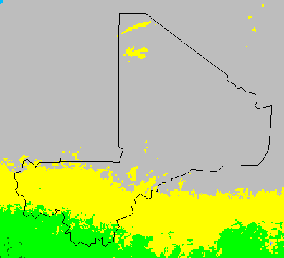
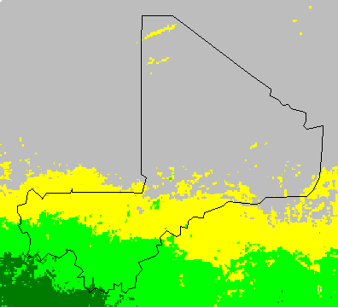

Mean NDVI in 1984 Mean NDVI in 1998

Image 3. ‘Brightspots’ of improved land cover greening in Southern regions of Mali (1984 - 1998).

2. Successful Sustainable Land Management Projects in Mali

Program for the Development of Agricultural Production in Mali (PRODEPAM)

- Some of the donor projects and programs in Mali have produced some success stories. For example, the Program for the Development of Agricultural Production in Mali (PRODEPAM) is a five year investment financed by the United States Agency for International Development (USAID). The objective of this program is to alleviate poverty by stimulating agricultural production in selected agricultural sectors. PRODEPAM started in April of 2004. The program components include: (i) Rehabilitation and expansion of irrigated agriculture, including infrastructural improvements, intensification, crop diversification and technologies; (ii) Development and strengthening of animal feed enterprises to provide improved access to quality feeds; (iii) Improved community based natural resources management; and (iv) Increased accessibility to agricultural inputs and improved technologies, including biotechnology and seed.

- PRODEPAM met or exceeded its target for 50% of its indicators during their reporting period from October 2005 to March 2006. By the end of this reporting period, PRODEPAM had assisted 27,154 farming households and impacted an estimated 439,895 rural farmers. Net farm income due to rice production increased by 41% and the Program partners brought the number of households above the poverty line by six fold from a year ago. This success was largely due to improved agricultural and irrigation practices (improved irrigation infrastructure and water management practices, new cultural practices coupled with improved seed and fertilization regimes) and the integration of natural resources management practices at the village level. For example, improved soil management, greater use of organic fertilizers and capacity reinforcement to farmer’s organizations helped to reduce production costs while increasing crop quality and overall productivity. Varietals trials, new seeding practices and a rational fertilization regiment using Integrated Soil Fertility Management practices led to higher yields of better quality potatoes and the identification of preferred varieties for replication during the next growing season.

- A case study of 28 farming households who have been partners with PRODEPAM for two years shows that these farmers increased their production by 113% between 2004/05 and 2005/06, while the mean increase among non-partner households was only 20% during the same period. Two year partners also saw their rice yields increase by an average of 12.5% during this period. Farmer skill levels have been improved in water management, agricultural intensification, composting, natural resource management planning, erosion control, and cooperative business management. This case study shows how SLM practices can be woven into other projects, such as agricultural productivity projects, to boost productivity at the farmer-level.

Reasons for the Success

- Success is measured very differently in projects. In some, success is measured by improvements in land quality but more likely increased yield is seen as an indicater of improved land quality even though this may be due to a number of factors some of which may be SLM related and some of which may not. (e.g., improved seed, fertilizer, tilling, markets). Others rate success by the adoption of a particular conservation methodology or by the planting of a specific number of trees. The problem with this definition of success is that unless follow-up resources are used to continue or monitor the project after it closes, the impact of the activites on land quality is never monitored. The success of the PRODEPAM was tangible because it addressed issues of income and therefore poverty alleviation through the improvement of yield. Once yields increased and this led to income increase, the project was judged successful. The success of the project was also measured by the number of people it benefited. The beneficiaries were spurred by their income increases to keep using their new skills which in turn yields soil conservation rewards. A successful SLM project must therefore examine the short and long term benefits of the project. Soil conservation measures alone, without tangible improvement in livelihood or incomes, is unlikely to be sustainable after the project ends. In terms of its technological approach, the agricultural projects tied infrastructure enhancements (irrigation) with soil and water conservation techniques thereby ensuring that soil fertility and structure was maintained. Thus a successful SLM project is often one that integrates other non-SLM technologies to ensure a successful long term result.

The Desert Margin Program

- The Desert Margin Program is another success story. It was started in 2002 and is financed mainly by GEF, and executed by multiple agencies including ICRISAT, the World Agroforestry Center (ICRAF), and International Livestock Research Institute (ILRI) . Phase I included: implementation of fertilizer micro-dose (strategic fertilization applications) combined with the use of crop residues and/or manure in Koulikoro, Segou and Mopti regions. This new technique enhanced fertilizer use efficiency, increased productivity, and reduced the costs of inputs.

- The adoption of this technology required supportive and complementary institutional innovation and market linkages. Farmer groups were organized to provide access to post-harvest credit provided on the basis of storage of grain as collateral (“warrantage”). This arrangement enabled farmers to sell corps later in the season for higher prices and higher profits. It also provided greater access to inputs (fertilizer and pesticides). This combination of technology with complementary institutional and market linkages has led to a significant technology breakthrough first in Niger, and then through scaling up into Burkina Faso and Mali in 2002 and 2003. Activities included: (i) demonstrations; (ii) establishment of farmers organizations, system of warrantage, and farmers field schools, (iii) capacity building of different actors including producers, researchers, and NGOs and structural development; and (iv) collection and analysis of agronomic and socio-economic data.

Reasons for the Success

- Success for the project focused on yields. Increased yields of millet and sorghum with an application of 80 kg ha⁻¹ and 120 kg ha⁻¹ of NPK fertilizer (nitrogen, phosphate, and potassium) were very effective in improving yields by more than 60%. For millet, additional yields of the cultivation with microdose application were 61% more than the control cultivation in 2002 (756 kg ha⁻¹ and 469 kg ha⁻¹) and 90% in 2003 (1463 kg ha⁻¹ and 768 kg ha⁻¹). For sorghum, additional yields due to fertilization through microdose application were 107% more than the control cultivation in 2002 (1053 kg ha⁻¹ and 508 kg ha⁻¹) and 69% in 2003 (1447 kg ha⁻¹ and 858 kg ha⁻¹). These yields of millet and sorghum with the new technologies also surpassed those with generally applied dose of NPK fertilizer at 100 kg ha⁻¹ by 19% and 28% in 2002 and 23% and 11% in 2003, respectively. Socioeconomic analyses revealed that in 2002, the net gains from microdose technologies (119,690 FCFA ha⁻¹ for millet and 91,064 FCFA ha⁻¹ for sorghum) exceeded those with generally applied dosage of fertilizer (89,959 FCFA ha⁻¹ for millet and 68,584 FCFA ha⁻¹ for sorghum).

Office of Upper Niger Valley NRM Program

- Lessons learnt from the OHVN NRM Program (Office of the Upper Niger Valley Natural Resource Management Program financed by USAID which began in late 1980s) showed that although natural resource management and conservation without fertilizer application may take time to demonstrate rapid production increase, communities did adopt these conservation measures. The OHVN/NRM approach was to: (i) support food and commercial crops and livestock, with the commercial crop as requirement; (ii) search for incremental, sustainable change; (iii) increase incomes and water conservation, woodlands, pasture, and soils; (vi) use village technical teams to train others; (vii) provide literacy and management training; (viii) Promote creation of village associations and; (ix) Provide support services and investments.

  - Analysis of aggregate yield statistics 1991-1998 did not show much growth for the OHVN zone. Crop annual change were: (i) Cotton -3%; (ii) Sorghum/Millet +1-2%; (iii) Maize/tobacco no change; (iv) Rice +2%; (v) Fonio +8%; and (vi) Cowpeas +52%. However, NRM adoption continued to grow, between 1991 to 1999. Adoption of the following soil conservation techniques improved dramatically: (i) Rock lines from 1,711m to 101,291m; (ii) Gully plugs from 2,375m to 22,865m; (iii) Vegetative bands from 426 m to 17,579m; (iv) Live hedges from 21,305m to 160,162m; (v) Compost/manure pits from 1,125 to 5,063; (vi) Parcellement from 572 ha to 3,087 ha; (vii) Park improvement from 44 to 154; (viii) Fire breaks from 47m to 7,771 m; and (ix) Diversionary ditches from 948 to 3,263. 34,858 hectares have been restored to normal or superior yield performance from land that had been abandoned or was performing at very low levels. This represented 17% of area cultivated in OHVN zone. 60% of OHVN villages and 52% of farms have tried at least 1 NRM technique. 20% of farms have been cultivating the same fields for at least 3 years – i.e., they are maintaining the fertility of their land and not clearing new land.

Reasons for the Limited Success

  - The OHVN project was less successful in terms of improving yields because it did not use fertilizer applications.. What was successful is that soil conservation practices were successfully transferred to farmers. However, there are important lessons to be learnt from this limited success. While soil conservation is important, farmers may abandon these methods after the project closes if there is no tangible short to medium benefit associated with the technology (not the project). For example, if the gully plugs do not yield a perceived economic benefit over the short term. Although a clear lesson therefore is that SLM techniques should result in a tangible benefit where possible to encourage subsequent adoption after the project, another lesson is that strong environmental awareness training may be able to induce behavorial change by showing farmers that this technology improves soil quality, water retention properties, etc and the benefit over the long term is mostly environmental. =

- Other aspects are important to project success- the OHVN Project found that their technology adoption success was tied to: (i) a profitable commercial crop with reliable markets and stable prices; (ii) a broad range of affordable technologies for commercial and food crops; (iii) youth training programs with literacy and management skills; and (iv) extension services that promote farmer participation in demonstration plots. If these factors are not favorable, then ensuring project success is difficult. Other lessons learned from the project included: (i) early adopters were more likely to be wealthier members of society (with lower risk) and therefore, scaling up to reach the poorest remains a major challenge. and (ii) demonstration plots should be used so that farmers and researchers can assess the profitability of new technologies.

Mitigation of Land Degradation Project

- The Mitigation of Land Degradation Project, financed by Norway and executed by UNEP, ICRAF (International Center for Agroforestry) and the Ministry of Environment and Sanitation since 2004 identified that the major constraints in the Sahel were: (i) Low soil fertility; (ii) Wind and water erosion; (iii) Shortage of dry season fodder; (iv) Damage to off-season crops caused by animals; (v) Shortage of fuel wood and construction poles; (vi) Degradation of traditional parklands; and (vii) Inappropriate tree/land tenure policies. To address these constraints, the project took an agroforestry approach, because the agroforestry tree species function as: (i) Production - food and income (e.g., fruits, leaves, barks, roots), energy, traditional medicine, and fodder; (ii) Services - soil protection and enrichment, delimitation, ornament and shade; and (iii) Environment - carbon sequestration and microclimate.

- The agroforestry solution included among others: (i) Parkland regeneration; (ii) Domestication of agroforestry species; (iii) Live fences; (iv) Fodder banks for dry season fodder production; (v) Soil fertility improvement technologies and (vi) Food banks. The expected outcomes of project were to: (i) Understand land degradation status and severity; (ii) Train scientists, extension agents, farmers and policy makers on various aspects related to land degradation and soil quality; and (iii) Scale-up promising agroforestry technologies. The project consisted of three main components: (i) Research – focusing on soil physical and chemical properties, impact assessment including carbon sequestration and soil quality; (ii) Extension and (iii) Policy - more rational policy interventions with environmental accounting tools. In addition, village based agroforestry participatory action plans were created and implemented.

- The results of project in Segou region in 2005 included, plantations of: (i) 39,376 plants in 36 village for; (ii) live hedge comprising 8,717 plants in 23 villages; (iii) fodder banks in 8 villages; (vi) increased vegetation density and soil fertility in 17 villages; and (v) establishment of orchids in 3 villages. Participants included female and male farmers, and farmers and women’s associations. The plantation areas included village houses and schools as well as fields.

Reasons for the Success

- The project was relatively successful, but only because it made adjustments throughout the project to deal with on the ground realities. The project identified major constraints early on and made a concerted effort to address these contraints. Constraints identified included the following: (i) in certain areas, limited early plant growth due to variable precipitation; (ii) insufficient financial methods for farmers to purchase plants; (iii) late production of plants (late May to early June); (iv) weak capability of germination in certain species; (v) termites attack; (vi) insufficient plant protection; and (vii) threats from roaming livestock. To counter these problems the program (i) purchased phytosanitaries against termites; (iv) increased their base charges for reforestation; (v) trained users of produced plants; and (vi) trained farmers to take measures against roaming livestock. The project produced 81,157 plants, resulting in an 81% production increase.

Tree Domestification for Improved Germaplasm Project

- Another project, the Tree Domestification for Improved Germaplasm Project by ICRAF also delivered some relevant results. The project addressed problems of: (i) Rural poverty, food insecurity and malnutrition; (ii) Low returns to small-scale farmers from tree products marketing; (iii) Genetic deterioration in farming landscapes and poor regeneration of parklands; (iv) Lack of improved germplasm and/or of narrow genetic base; and (v) Poor germplasm provision mechanisms (seed and seedling systems). Using the domestification procedures in Figure 14 below, the following outcomes were obtained: (i) Priority species (about 10) domesticated; (ii) Food and nutrition fodder banks were established; (iii) Species, provenance and progeny trials completed; (iv) new trees were introduced and geo-referenced; (v) Tree biodiversity evaluation methods were developed; (vi) Strong and effective partnership with NARS (networks on biodiversity and tree experts) were established; (vii) Capacity of the partners was enhanced (e.g training in nursery techniques to NGOs for more than 1,000 people a year since 2003).

Reasons for the Success

- Many agroforestry practices are successful in terms of the number of trees planted such as this project. However, these projects may be less successful in terms of direct income benefit that accrues to the community. It is important to ensure a variety of species are grown that allow communities to collect benefits over the short, medium and long-term. While agroforestry projects are important, land tenure issues are a complicating factor and these should be assessed and negotiated during preparation to assure the project’s success.

3. Exploring SLM Options for the Cotton and Rice areas and for the Northern Pastoral Regions

The above description shows that there are a number of ways to approach sustainable land management initiatives. The particular approach depends on a) the specific climatic zone and environmental problems (water scarcity, erosion, etc) and what needs to be achieved and is achievable; b) the specific human causes of land degradation; c) the impact of these factors on poverty and livelihoods and in the case of the agricultural sector, on yields; d) the cost, adaptability, ease of use etc of the technology itself and e) the policy and institutional framework for supporting the use of that technology. Certainly, the options for SLM will be based not only on the technology to be adopted but the consideration of all the other indirect factors (Figure 14)..

Figure 14 General Solutions to Combat Soil Degradation
Soil Degradation
Restraint of Degradation
Sustainable Activities
Activities directly effective to degradation
Fixation of sand dune
Traditional methods (ZAI, counter band cultivation, Stone band,etc)
Chemical or organic fertilizer
Composting
Cover-cropping & Tree planting
Incentives supporting the activities
Revised Land tenure system
Income Generation
Activities indirectly effective to degradation
Capacity development
Environmental Education
Adequate Action Planning
Research & Extension
Others

- The section below elaborates some integrated SLM technological options which could, among others, be explored for use in the rice, cotton and northern belts of Mali.

An Example of SLM Options for the Cotton Zone.

- ACN Technologies: There are many options and technologies for improving degraded land , particularly land that gas been degraded through water erosion, as occurs in some cotton producing areas. An effective technology that is widely recognized in Mali is ACN cultivation. ACN technology involves cultivating a field in ridges and furrows (ACN) laid along contour lines, to reduce run-off rain water. The water then runs slowly between the ridges and thus infiltrates into the soil. This technology results in a 70% reduction in runoff and aa 50% increase in infiltration (Gigou et al., 1997). ACN’s have also been shown to increase crop productivity (Table 10 and 11), regenerate trees and shrubs and increase access to drinking water (Gigou et al., 1997; Gigou et al., 2006; Doumbia et al, 2006). So why aren’t ACN technologies widely used in Mali? first, ACNs require a specific set of equipment and expertise to effectively design the ados (a contour line) and in Mali, this is a key constraint in the use of this activitiy. For example, only about 20,000 ha are under ACNs compared with a potential of 2 million ha.

- To get this technology to the local farmer level, one approach could be to provide each Commune with the equipment necessary for designing the ados of ACN’s. The equipment will be provided at a cost of 2 million F CFA ($4000) per set. Local extension agents, Agricultural advisers and OP’s will need to be trained on the use of this equipment. They, in turn, will assist in the implementation of ACN’s in farmers’ fields at a low charge of about 5000 F CFA per ha ($10/hectare). Additional costs of implementation will normally not exceed 5000 F CFA per ha (Gigou et al., 2006). Experience from other farms shows that this initial, total investment of 10,000 F CFA or ($50) per ha (or the equivalent of about 300 kg of grain sorghum) will be recovered by yield increase in the first cropping season. However, the project will have to have strong capacity building components to ensure that ACNs are designed correctly and the equipment is used correctly. The estimated cost of this option in affected areas of Mali is about 10 billions F CFA, which translates to about US$ 18.2 millions.

Table 10. Impact of ACNs’s on maize and millet yields (kg/ha) in on-farm studies (source: Gigou et al., 2006).

Treatment | Maize |  |  | Millet
Year | 1998 | 1999 | 2000 | 1998 | 1999 | 2000
Number of on-farm tests | 2 | 10 | 6 | 3 | 5 | 7
Control plots | 2603 | 2082 a | 1550 a | 892 | 1430 | 630 a
can’s plots | 3599 | 2836 b | 2088 b | 1128 | 1453 | 1008 b
Yield increase (%) | 38 | 36 | 35 | 27 | 2 | 60

Table 11. Impact of ACN’s and fertilizer on cotton yields in kg/ha (source: Gigou et al., 2006).

Treatment | Control Plots | ACN Plots | Impact | Combined impact
No fertilizer | 828 | 886 | 58 | -
Cotton fertilizers | 1056 | 1412 | 356 | -
Fertilizer impact | 228 | 526 | - | 584

- Integrated Packages including ACNs and Fertilizers: In some parts of the cotton belt, input use efficiency is low, with corresponding fragile soils and low yields. One means of improving yields is to increase water, fertilizer and pesticide use efficiency. This efficiency issue is critical because increased production in the cotton region of Mali is essentially due to increased acreage (Figure 15). In fact, the efficiency of fertilizers averages about 5 kg of cotton per kg of fertilizer (Kelly et al., 1998). This may be because application rates of fertilizers are lower (107 kg/ha of cotton blend) than the recommended 150 kg/ha(CMDT, 2003). In addition, pesticide applications by the conventional, calendar method account for 30% of the cost of cotton production, making it an expensive input. For increased efficiency of these inputs, an integrated package could include: (i) extension of ACN cultivation as indicated above, (ii) on-farm testing of specific fertilizer recommendations (modeling soil properties or yield targets; (iii) extension of a single piece of equipment for simultaneous seeding and fertilizer application, and (iv) adoption of pesticide applications by the critical pest infestation (LEC or TS) method. Results of pest management by the TS methods were so significant that CMDT/OHVN have adopted this technique as the single pesticide management option for the Mali cotton region. The TS method has reduced pesticide applications to 2-3 (against 6 for the conventional calendar), for reductions of 30 to 50% on the total cost of cotton pest management (Silvie et al., 2001) and less environmental pollution (CMDT, 2005). To date, about 30 000 ha have adopted the TS over the past 3 cropping seasons. Training farmers and farmers’ organization remains the number one constraint. The above integrated package will need to be dispersed through field days, guided visits, practical workshops, radio messages, on-farm tests, farmer-to-farmer visits, farmers’ school plots, etc.

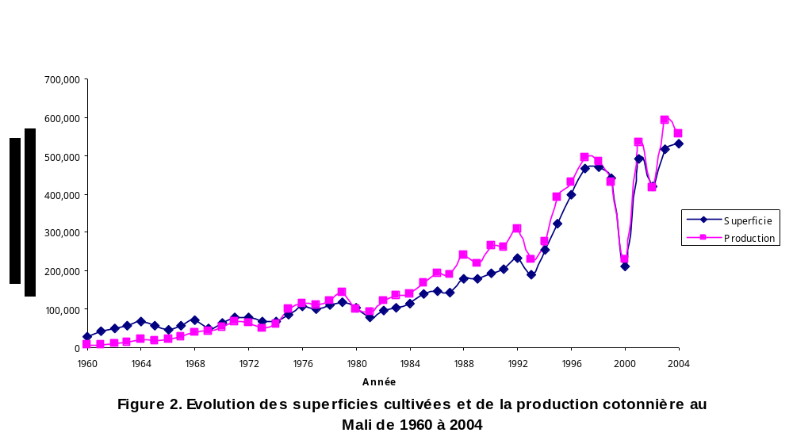

Figure 15. Changes in cotton yields and acreages in Mali (source: IER, 2006).

- Integrating Agroforestry: This specific project will consist promoting live fencing (hedges) of farms of the cotton region with Jatropha curcas. This old CMDT project will be given asecond chance now that Jatropha can promote four main aspects of development, which combine to help assure a sustainable way of life for village farmers and the land that supports them: (i) erosion control and soil improvement, (ii) promotion of women, (iii) poverty reduction, and (iv) renewable energy (World Bank, 2002). In addition, the hedges will promote crop residues management, and thus the integration of cropping systeme and animal husbandry.J atropha seeds containabout 35% of non-edible oil. The production of seeds is about 0.8 kg per meter of hedge per year, with an oil yield of 0.17 L. Currently, Mali has about 10,000 km of Jatropha hedges with a growth rate of 2.000 km per year, which represents a potential of 1,700,000 liters of oil per year. The average length of these hedges, in those areas of Mali where they are most prevalent, is between 2 and 15 km per village, with a maximum of up to 40 km per village (World Bank, 2002). The Jatropha hedge system has already resulted in: (i) reducing crop losses caused by wandering livestock or wind damage, (ii) increased rainfall infiltration, resulting in less work/irrigation water needed for local gardens, (iii) increased soil fertility by use of presscake as fertilizer, (iv) increased use of inexpensive local resources rather than expensive external resources, (v) reducing disputes between farmers and livestock owners regarding crop damage, as well as among farmers themselves regarding the boundaries of their fields, and (vi) provided local jobs, lessening the need for local villagers to migrate to cities to find (World Bank, 2002). Hedges planting will be implemented at the decentralized level (Commune and village), with technical assistance from CMDT and OHVN. The estimated cost of is about 100 millions of F CFA, which translate to about US$ 182 thousand.

An Example of Technology Options for the Rice cultivation areas of the Office de Niger Regions

- Biodrainage: Over 50 % of land is degraded in the rice cultivating area as a result of salinity, alkalinity and sodicity (Figure 16). The first wells dug by Dabin (1951) allowed access to ground water at depths averaging 47 m. Today it is almost impossible to dig a pit of 2 m in more than 251 representative sampling points of this region, because of the rising ground water table (Ballo, 2006). Surface drainage can be improved with the planned improvement of the irrigation system of the Office du Niger. However, subsurface drainage requires another strategy. Biodrainage is the vertical drainage of soil water through evapotranspiration by vegetation. In a groundwater context, biodrainage is said to be operative when the root system of trees draws water directly from the water table generally at depths greater than 2 m (Rajamani, 2005). The plant system forms a root-to-shoot conduit and groundwater is rapidly transpired into the atmosphere. Biodrainage, using a fast biodrainer like Eucalyptus, is a cost-effective technology to lower the rising saline water table to below (>1.5 m) which is the root zone of crop plants (Rajamani, 2005). It has been demonstrated that under ideal conditions, a tree canopy may lower water tables by 1–2 m over a period of 3-5 years (Kapoor, 2002; Heuperman and Kapoor, 2002; Rajamani, 2005). In this option, Eucalypts can be planted in grids in the irrigated plains. The size of the grids will follow those of secondary or tertiary irrigation canals, farms, villages, and area boundaries. Spacing of eucalypts within grids should be kept at >10 m to avoid crop shading. Eucalypts can generally be planted around ponds or unwanted waterlogged areas (Kapoor, 2002).Conventional surface and sub-surface drainage techniques are often not cost-effective, require periodic maintenance and have the problem of effluent management. In contrast, biodrainage by planting Eucalyptus will be an alternative solution to several environmental and sanitary problems of the Office du Niger. Unfortunately, Eucalypts will host birds and their nestings, which are pests to the maturing rice crop and if this option is pursued, the relative costs and benefits of this investment need to be assessed. The estimated cost of the above intervention options is about 2 billions of F CFA, which translate to about US$ 3.6 millions.

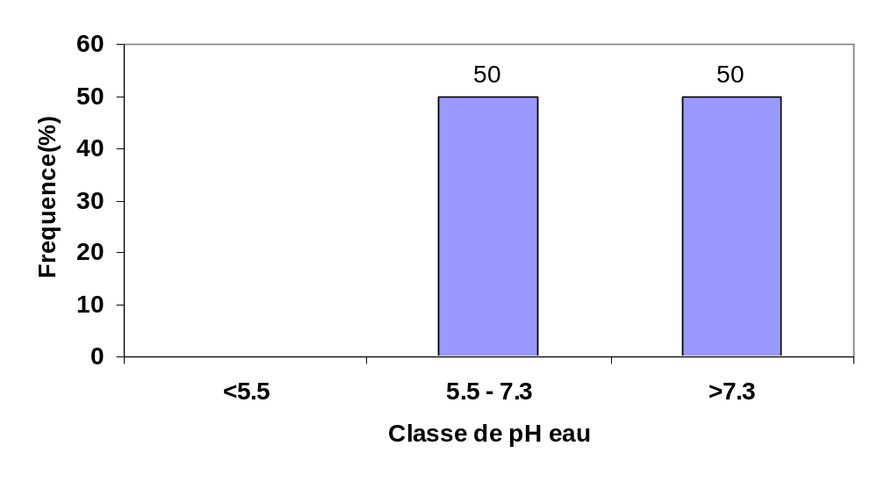

Figure 16. Distribution of soil pH in the Niono area of the Office du Niger (source: Ballo, 2006). This figure indicates that about 50% of the soils of the most intensified area of the Office du Niger are degraded (pH > 7.3) by some degree of salinity, alkalinity and sodicity.

- Soil Fertility Management: Soils of the Office du Niger are essentially acid (Dabin, 1951) with an average pH below 6.5, the optimum pH for rice and most vegetable crops. About 12% of these soils were degraded by salinity/alkalinity in 1987 (N’Diaye, 1987). Today, 20% of the soils of the Office du Niger are degraded by salinity constraints (Ballo, 2006). Distributions of soil pH in the Office du Niger and the Niono area (the most intensified area of the Office du Niger) are indicated in Figure 17. Fertilizer recommendations on the basis of 20 P (100 kg of DAP) and 120 N (220 kg of urea) have contributed to increase rice yield from about 2000 kg/ha to average yields of 5000 kg/ha (IER, 1996). Average application rates of manure are about 2500 kg/ha (MDR, 2002). Application rates greater than these, due to value/cost ratios of 12 (Kelly et al., 1998), are contributing to building high P reserves in soils, inducing K and Zn deficiency, and inducing Fe toxicity (Dembele et al., 1998; Ballo, 2006). Intervention options to improving the fertility of soils in the Office du Niger region could include: diversification of cropping systems with legumes and vegetable crops. These intervention options will be implemented though, adaptative research, training farmers and farmers’ organizations, extension techniques such as field days, guided visits, practical workshops, radio messages, on-farm tests, farmer-to-farmer visits, farmers’ school plots, etc.

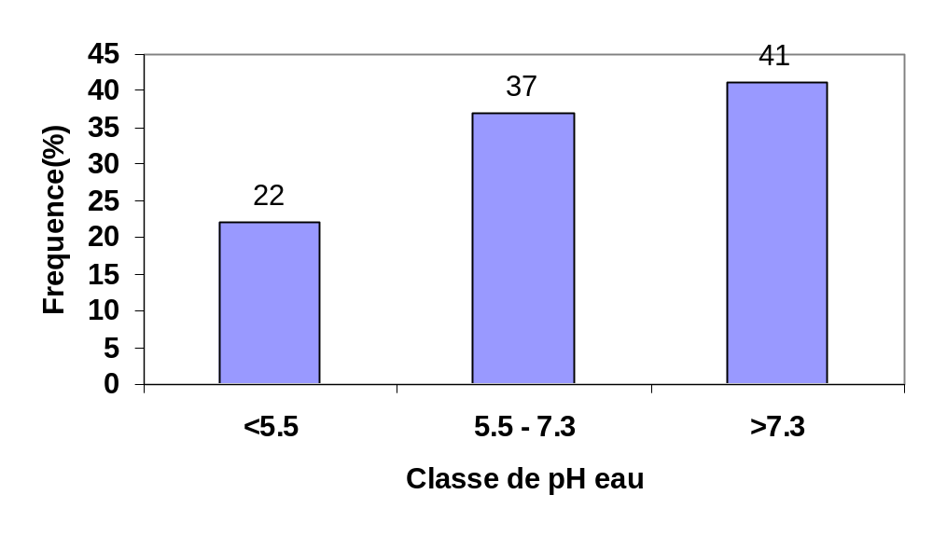

Figure 17. Distribution of soil pH in the Office du Niger (source: Ballo, 2006). This figure indicates that about 41% of the soils of the most intensified area of the Office du Niger are degraded (pH > 7.3) by some degree of salinity, alkalinity and sodicity.

An Example of Technical Options for the Northern Pastoral Regions

- Pasture Enrichment & Preservation Measures: Enriching pasture lands with Acacia albida, Acacia senegal or perennial grasses, planting hedges of Jatropha curcas, managing pasture land by rotational grazing, improved cropping systems (millet or hungry rice) and improved access to fertilizers (especially Tilemsi rock phosphate for amending pasture land) are all important to sustainable pasture management. Experience from the Mali Gourma Project shows that pastoral communities will come together and unite for any activity that directly benefits pastoral resources. Pastoral communities in the Gourma had yearly fires in the dry season that resulted in high numbers of human and cattle deaths and the destruction of valuable pasture. A technique of controlled burning was introduced to pastoral communities to ensure that fires did not easily spread from one area to another. This technique was very labor intensive, involving at least 15 men clearing 40 miles of pasture during the night and burning during the day for several weeks. This technique was so needed that there were no shortage of volunteers and other nearby communities started to use the same technique.

Figure 16 Recommended Actvities to Combat Pasture Degradation

Pasture Degradation
Restraint of Degradation
Sustainable Management of Resources
Activities directly effective to degradation
Planting appropriate grasses
Limiting livestock sizes

Incentives supporting the activities
Revised Land tenure system
Ensuring dry season pasture is available

Activities indirectly effective to degradation
Transhumance control
international conventions
Capacity development
Alternative Livelihoods
Set up of banking systems
Environmental Education
Adequate Action Planning
Others

- Integrated Pastoral Projects: Degradation of pasture due to overpopulation of livestock has not often been addressed through direct interventions because addressing the issue through limiting stock sizes has not proven very successful. The main problem is behavior change- how does a project tell pastoral communities to limit their livestock when livestock is money/wealth and status to these communities and has been so for generations. Another difficulty is how to manage the open-access resource that exists in pastoral communities. Even though each person knows that the land is degraded and the causes related to overstocking of livestock, there is no incentive to reduce livestock size because the degradation cost for one individual is borne by the entire user community (including transhumance practitioners) and there is no incentive to destock. In many cases, degradation of pastoral areas are usually addressed as part of an integrated project which focuses more on pastoral wellbeing ( livestock health, general training and capacity building) and, to a lessor extent, alternative livelihoods. For example, PRCP (Capacity strengthening of actors for pastoral participation), which is implemented in the Mopti region, aims to reinforce the capacity of pastoral communities and to organize civil society in this region so that these communities take part actively in the decentralized government and local development processes. The project promotes concerted management of natural resources, particularly forest and pastoral spaces, as well as providing alphabetization, information and formation of local development actors on pastoral production system, and easy access to potable water. It is hoped that this capacity building would enable pastoral communities to be able to engage in other livelihoods and to have a better understanding of their resources. One project, the Northern Mali Program, does try to address the management of pastoral resources through the establishment of a master plan on how to manage these resources. Although this may be successful at the ministry and district level, the real test would be the impact it has on changing behavior among pastoralists and this is clearly a project, if successful, could prove to be a model for other areas.

Other SLM Interventions

- Table 12 details other SLM interventions that could be used to ensure sustainable land management practices in Mali.

Table 12: Organizing Framework for Technical Aspects of Land Resource Management (adapted from FAO, 1995)
Objectives | SLM Practice | SLM Approach
Sustain or increase  Land productivity | - Replenish soil nutrients and control soil acidity by liming and organic inputs.  - Select and use adapted crop, forage and tree  species  - Manage grazing and eliminate the use of fires  for land clearing and pasture reclamation  - Maintain soil cover via cover crops such as  cowpea and residue recycling  - Protect and stabilize slopes  - Use water harvesting and efficient irrigation  where possible.  - Maintain drainage to prevent waterlogging and salinity build up.  - Crop rotations  - Zero tillage | - Contour plantings, vegetative strips, and  Terracing  - Grading and reservoirs to facilitate  Water harvesting and redistributione  - Improve mechanisms for  - Technology transfer  - Ensure cost-effective methods for  sustainability  - Improve rural finance systems and Tenure
Provide Adequate  Quantity of Water | - Use soil cover to enhance water infiltration and prevent soil crusting  - Use crop, forage and tree species with high  water-use efficiencies
Reduce flooding or  Waterlogging and  Associated Saliniza-  tion | - Plant deep rooted vegetation to enhance  infiltration and water consumption by plants  - Use trees such as Eucalyptus which absorb a  lot of water | - Desalinization techniques
Minimize soil  erosion | - Plant cover crops and mulches  - Integrate perennials in vegetative strips  - Conservation or no till farming  - Ridging, contouring on steep slopes | - Reduces soil carbon oxidation following  The planting of each crop
Recycle organic  nutrients | - Return all crop residues to the field of origin  - Compost vegetable residues  - Combine manure with inorganic fertilizers
Compensate for  Nutrient loss | - Add nutrients such as manure and top off  with inorganic fertilizers such as phosphorus  (Guano)  - Select and use adapted and efficient species  such as leguminous trees and crops to fix nitrogen  at low levels of available soil phosphorus | - Cost effective approach for poorer farmers

What about dune fixation and sedimentation of rivers which is the government’s highest priority
CHAPTER FIVE: OPTIONS AND FINAL RECOMMENDATIONS FOR GOING FORWARD WITH AN SLM PROGRAM IN MALI

1. Building an SLM Country Program in Mali

- For an SLM program to work in Mali, a programmatic and project approach is needed. The former should focus on examining the instititional, policy, budgetary and research framework for land management and the latter should be a means to directly address land degradation at the community level. However, any project should be a part of a nationally elaborated strategy that ensures that all projects, irrespective of donor, contribute to the fulfillment of the national SLM priorities of the country. It would also be important to ensure that the relevant research and monitoring and evaluating framework exists to map out the progress and success of the SLM program in Mali. Finally, the government, in its commitment to these priorities, should carve out follow-up resources to ensure the continuation and expansion of successful projects after donor projects have ended.

2. Requirements for Building An SLM Country Program In Mali

- Building a Sustainable Land Management program in Mali would require a shift from a donor project approach to a larger scale programmatic approach where Government takes the lead and helps define the priorities. However, defining the priorities and setting up the institutional framework to deal with these issues is not easy because SLM issues cut across environment (desertification, erosion), agriculture/pastoral (soil degradation, soil fertility management), and land (tenure), and given its multisectoral nature, a multisectoral approach is needed though the institutional framework in Mali is very sectoral. One approach would be to establish an SLM focal point in each sectoral unit that deals with a specific area of SLM. However, this is not practical given a) limited budgets and b) the fact that SLM interventions may involve more than one sector. The following section details some of the actions that would need to occur to improve SLM programs in Mali:

- Improving the Institutional Framework for land management
The STP is the current focal point in the Ministry of Environment and Sanitation for UNCCD for measures against desertification. However, because it is housed in the Ministry of Environment and Sanitation and lacks government funding to carry out its mandates, its approach is sectoral, limited and has little impact on the agricultural sector or the livestock/pastoral sector. One option is to create a strategic thinktank for coordinating the SLM agenda. However, unlike the STP, this thinktank would be a multisectoral SLM steering committee or unit that will coordinate the SLM program for Mali. Members would include representatives from each of the SLM related Ministeries. SLM financing and planning could be channelled through this group to the various Ministeries that would be in charge of implementation. This group would also be in charge of ensuring that monitoring of SLM programs occurs across sectors and that projects are well aligned to the programmatic strategy for the country. Although this thinktank or unit can be located in any of the Ministeries, in case of competition between ministeries, one option would be to house the committee in the Poverty Reduction Strategy Committee in the Ministry of Finance. This will avoid the conflict of interest among the line ministries- for example, between the Ministry of Environment and the Ministry of Agriculture.

- Strengthening coalitions, advocacy and knowledge based partnerships
This includes information sharing, coordination, harmonization and other efforts to strengthen the collective ability of all stakeholders to address barriers to sustainable land management (SLM) scale-up. Eligible activities for financing will be selective joint reviews of partners’ portfolio and shared stocktaking from existing activities and partnerships that would feed into the knowledge networks and benchmarking, specific monitoring and evaluation work, analysis of enabling conditions for good practices and success stories, constituency building and strengthening of regional coalition.

- Improving analytical underpinnings to support SLM
There is a need to pool resources to generate analytical and technical underpinnings for larger scale SLM that will lead to coalition building, harmonization and benchmarking. It will include the development of action-oriented tool boxes and guidelines for mainstreaming SLM into development plans at national and regional and commune levels and thus integratin SLM into large scale decentralized community driven investments. It would also be important to conduct public expenditures reviews for SLM to assess the cost of land degradation and the benefits of SLM practices. Finally, improving the analytical framework for SLM within the country would also require a commons set of indicators for SLM monitoring and evaluation that all donors (and public institutions, etc) could adopt.

- Developing a monitoring and evaluation framework for all donors investing in SLM
The impact of SLM projects need to be monitored over the long term in terms of their impact on agreed and measureable indicators (environmental, social, economic and capacity to name a few). It would be preferable that an institution is chosen and funded for managing this data and ensuring its continuity past the project close date (either from government or the private sector). A dedicated source of funding would need to be set aside to ensure that this data collection and analysis continues.

- Catalyzing funding at the country level
The TerrAfrica Leveraging Fund provides targeted resources and seed funding to catalyze upstream dialogues, national platform and coalition building, preparation of sector wide programs, and fund pre-identification work at country level. It may contribute to the implementation of programs that mobilize resources at the country or sub-regional level. It may provide financing to enable pilots to establish a track record to assist in leveraging longer-term support and scaling-up. One point is clear- unless funds are continuously mobilized for the SLM agenda, there will not be any significant, long-term impact on land degradation.

- Elaborating a national strategy for sustainable land management (NSSD)
A NSSD will allow the necessary debate to occur that will further define the approach to SLM in Mali and assure the creation of the required institutional frameworks. The NSSD would be a key tool for integration of all technical issues of land management and environmental prevention/rehabilitation. It would also be a reference for transversal integration of policies from all relevant departments, as well as ensure that all donor SLM projects fit the priorities outlined in the strategy. A definition of SLM and what types of projects would fall into this category should be elaborated in the NSSD.

- Establishing a TerrAfrica SLM Donor Group to support Country Programming and Improve Alignment: Given that a significant portion of resources for environment/natural resources and SLM budget is funded by external agencies, coordination among donors is key. This does not generally occur and lack of coordination was a key complaint in interviews with donor agencies. Without coordination, some projects are duplicated, important lessons are buried with the donor institutions and, in terms of results very little is achieved by this fragmented approach. The Ministry of Environment and Sanitation, led by a coordinator from GTZ (Deutsche Gesellschaft für Technische Zusammenarbeit (GTZ)), organized an environmental coordinating group among various external agencies. They are supposed to meet regularly but according to the coordinator, not all members attend and the degree of their commitment varies. The Ministry of Agriculture attempted to form a similar group for the agricultural sector about 10 years ago. However, it did not function well and was discontinued because each agency had different objectives, policies, and procedures (e.g, bilateral grant agencies vs. international development banks). Establishing a donor group will be key in developing a programmatic approach to SLM.

- Establishing Priorities at Local Levels:Once the National Strategy is elaborated. Each of the 8 administrative regions of Mali should be required to elaborate participative and regional workplans for land management or rehabilitation. Regional offices of the departments of MEA, MA, MEA and MPAT could lead this task, under the coordination of the STP. These multi-disciplinary and participative workplans will not only summarize specific land management and environmental constraints, but also propose SLM options to overcome these constraints. Elaborated workplans will be validated and prioritized. Then, key projects will be selected and implemented. Both elaboration and implementation (key projects) of these workplans will be budgeted for under the various options of intervention.

Establishing Entry Points for SLM: There are many entry points in SLM as can be seen by the list of SLM interventions already ongoing in Mali. For the Bank, the quickest entry point is the new agricultural project to be prepared in 2007/2008 which builds on past agricultural projects that have set up the framework for producer organizations, increased cotton productivity and management. The Gourma project, although a GEF and not an IDA project, also provides an entry point through scaling-up of this project to include the development of SLM initiatives in the Gourma and further north.

- Partners: The external assistance agencies should include especially TerrAfrica partners including the New Partnership for Africa’s Development (NEPAD), the World Bank, the UNCCD's Global Mechanism (GM), the UNCCD Secretariat, the GEF Family, IFAD, the FAO, UNEP, African Development Bank, the European Commission, bilateral donors, civil society and scientific organizations such as Forum for Agricultural Research in Africa (FARA) and CGIAR (Consultative Group on International Agricultural Research ) centers.

Table 13 below details the Investment Road Map for achieving an SLM Country Program in Mali, 2007-2025
Reform | Short-term actions | Intermediary Outcome | Medium Term Actions | Intermediary outcomes | Final Outcomes
Policy and  Regulatory | 1. SLM strategy is  Elaborated through a  National SLM Strategy  And that SLM elements a  Are incorporated into  Other existing strategies  -PDSEC  -National Action Plan  For the Environment  -Land Use Plans  -Agricultural Action  Plan  2. Revise and harmonize  existing laws and  regulations to ensure  increased land tenure  security, particularly for  farmers on customary  land  3. Update land use  policies, particularly  district level zoning plans  to allow relevant SLM  investments  4. Commission two  Studies to a) investigate the incentive structures for SLM  to ensure adoption at all  levels and b) to determine  how to increase program  sustainability by mobilizing  public funding.  5. SLM baselines are  established for easy  monitoring at national  and decentralised levels | -An increasingly  -Harmonized policy  and regulatory  framework for  SLM  -SLM embedded in national and local  level development  Plans | 1. Review SLM Targets  achieved in the first 3  years of the program and  determine whether policy  adjustments need to be  made to increase the  success fo the approach  2. Revise and harmonize  existing laws and  regulations to improve  land security | -land degradation is  highlighted in PRSPs  and other documents as  a key development  priority  -sector budget allocations  reflect the importance  of SLM to development  -sector programs in  SLM compliment donor  Funded activities | -Land degradation is a  Development priority  -SLM is embedded in the  National and local development  Framework  -Sector budgets reflect the  Importance of SLM (without  Donor funding)  -Resources mobilised for SLM  Implementation as well as  Innovative financial  Mechanisms and economic  Incentives explored and agreed  With farmers, other land users  And key ministeries  -Sound Land policy reform  In place that results in  a higher Level security for  land users

Reform | Short-term actions | Intermediary Outcome | Medium Term Actions | Intermediary outcomes | Final Outcomes
Institutional | 1. Establish an SLM  national steering  committee at the minister  level  2. Form a Multisectoral  Think-tank or unit  through which SLM  activities will be  coordinated, monitored  and evaluated and where  technical options will be  assessed.  - can be situated in or out of  the sector ministeries  -comprise technical and  policy staff from relevant ministeries  3. Form a donor  coordination unit to  ensure that all SLM  investment addresses the  priorities and standards  set out in the national  SLM action plan | -Improved cross-coordination  across sector units  -Champions forSLM  established at ministerial  level  -Improved coordination  between donors | -Assess the level  of coordination between  sectors and make  adjustments where  necessary  -Strenthen the  technical and  institutional capacity  for SLM at  national, and  decentralized levels  -Strengthen the  extension service  capacity to disseminate  SLM knowledge | -Strong coordination of  SLM between sectors  resulting in clear  definition of roles and  responsibilities of  different ministeries  and action plans for  moving the agenda  forward  -Operational framework  to support SLM  established  -Sector budgets reflect  SLM priorities | -Effective SLM  Program in place  -Effective SLM  Investments  Coordinated  -Sectors provide  Some SLM  Budget over the long-  Term  -Capacity to plan,  Implement and  Monitor SLM  Investments in place  At all levels

3. Options for Intervention at the Project Level

- In terms of the specifics of projects on the ground, the first priority is to build the SLM country program prior (best scenario) or simultanous with local level investment. Any option for SLM intervention will need to a) yield an environmental benefit that is measurable; b) minimize cost and maximize returns to farmers/pastoralists. A project that is ultimately sustainable is one where a stream of benefits (in the short, medium and long run) accrues to the beneficiaries. In addition, technological solutions that are complicated and expensive may be adopted in the life of the project but fail when the project ends because farmers and government do not have the resources to maintain the program. For example, costs to Segou farmers for combating erosion through the planting of live hedges were estimated at US$0.60 per plant in an area where farmers survive on less than 1 dollar a day. While such a project will make an impact once funds are available, farmers also need resources to maintain the hedgerows over time which may require replanting after droughts, watering, etc. The ability of a project to put in place income generating mechanisms that would ensure longer-term sustainability is the mark of good design.

- To assess the different types of options to combat land degradation at the community-level, it is important to define what problem any proposed project is trying to address. Once the problem has been defined, whether it is soil alkalinity, or low productivity as a result of soil erosion and soil fragility, there are two main ways of addressing the problem- either directly, or indirectly, by creating incentives and building capacity within local communities to better manage the underlying conditions that cause soil erosion . An indirect approach often used is to build capacity within the community to understand the causes of land degradation and how to address them. Other indirect approaches may relate to policy and institutional reform. Projects that use an indirect approach often ensure the sustainability of anti-degradation activities but do not necessarily focus on short-term soil restoration except in pilot areas. For example, the Natural Resources Management Project (PGRN) was a comprehensive and participative project that addressed various aspects of land degradation ranging from the formation of rural committees and inter-agency coordination as well as application of some land conservation techniques. Although this integrated approach seems comprehensive, the PGRN was not completely successful. It had many difficulties in implementation due to the bureaucratic government structure which delayed reforms. This, coupled with inadequate coordination mechanisms and a slow circuit of goods acquisition and support services for local activities, meant that the impact of the project on improving soil degradation at the farmer level was low. One possibility of improving the success of such an approach is to give some funds to local NGOs to directly work at the farmer level while addressing other institutional reforms and capacity building through the ministries. For example, PPS/GEF (Small grant fund for global environment) is a project to support local NGOs’ activities. The involvement of local NGOs may be helpful for preventive activities against soil degradation by the local communities.

Generally speaking, a combination of both direct, technical solutions, and indirect capacity building, action planning and extension is most effective for addressing land management problems (Table 13). Possible interventions are explored below for the cotton, rice and northern pastoral areas of Mali. The table highlights options for intervention at the farm, community and national level.

Table 13: Possible Project Activities to Fund on Different Levels

Levels | Activities:  Technology | Human Resources | Institutions | Policy | Monitoring and Evaluation | Possible Project Components
Farm | Soil and water conservation; agroforestry; land husbandry; soil fertility management; | Extension services, Training, Awareness of environmental issues; communication; | Farmer Groups,  Organizat-ions |  | Farmer monitoring systems,… | - Improved water management and small scale water retention for crops  - New tillage and conservation agriculture  - Increased organic fertilizers
Community | Protection of pasture; planting of improved pastoral varieties; dune fixation; agroforestry and forestry/plantation  Inititives; | Capacity building;  Elaboration of SLM development plans; farmer to farmer trainers;  Workshops; | Pastoral groups;  Women’s  Groups;  Youth  Groups | traditional land use rules in pastoral and agricultural communities should be acknowledged and enforced | Pastoral societies monitor pasture availability, quality,… | - Community based planning to include conservation areas  - Land use and information planning at general and local levels  - Small-scale woodlands in critical areas  - Pastoral management practices
National& Decentralized Levels | Dredging for removal of silt from rivers; dune fixation; | Extension agents and systems;  Technical SLM related work | Research centers university | stocktaking exercise to elaborate the degradation processes and options for SLM | Collection of baseline data,… | - Capacity building  - Information management  - Research and Extension  - Larger scale  Activities such as  Dredging, dune fixation

4. Road Map Going Forward

- In terms of what could occur in Mali, this section outlines resources, timing and a work program.

WB Activity | Deliverables | Timing | Funding Sources | Completion
Analytical Work
Diagnostic Activity on Government’s and other stakeholders engagement in SLM and Technical Options for intervention | Knowledge product examining institutional, policy and technical framework for SLM | July, 06- February, 07 | Japanese TF  IDA TF | Completed
Investment Alignment and Development
Liase with Government and Bank staff to provide input into the CAS, PRSP on SLM | CAS document, especially the CAS completion Report | July’ 06-February, 07 | GEFBB | Started, Continuous
Initiate workshop with Government to discuss Knowledge product and build consensus on SLM agenda and path | Videoconference with Government  French version of Knowledge Product with Government Comments/Validation  Final comments from internal review | February, 07  March’ 07  March, 07 | GEFBB  IDA TF for translation | Scrapped  Done, Validation to be done in April  Done
Prepare PDF request for GEF SIP investment to complement IDA operation | Work with Government on a short Concept note followed by PDF request | March, 07-April, 07 | GEFBB | To be done
Prepare PCN draft | PCN draft | April’ 07-June’ 07 (Draft) | PDF grant | To be done
Draft Completion and Review |  | June/July’ 07/08 |  | To be done

:

REFERENCES

- ATKINS International. Profil Environnemental du Mali. 2006. Bamako. Mai 2006. Commission Europeenne. pp.63.

- BALLO, A. 2006. Dégradation par alcalinisation des sols en zone Office du Niger. Mémoire de DEA. Université de Bamako. ISFRA. pp. 37.

- BISHOP J. and ALLEN. J., 1989. The on-site cost of soil erosion in Mali. The World Bank Policy and Research Staff. Environment Working Paper 21. pp. 71.

- CMDT. 2005. Rapport annuel. Campagne 2004/2005. CMDT. Direction Générale. DPA. Décembre 2005. pp. 58.

- CSLP (Cadre Stratégique de Lutte contre la Pauvreté). 2003. Plan National de lutte contre la pauvreté. Bamako. 2003. pp. 59.

- DABIN, 1951. Contribution à l'étude du delta central Nigérien. Agronomie Tropicale 6:604-635.

- DEMBELE, I., KATER, L., KONE, D., BUDELMAN, A., KANTE, S. ET SANOGO, J-L. 1998. La gestion paysanne de la fertilité des sols. Bilan partiel des éléments nutritifs. IER. CRRA de Niono. pp. 34.

- DIALLO, D., ORANGE D. ET ROOSE E. 2000. Influence des pratiques culturales et des sols sur les stocks et les pertes de carbone en zone soudanienne du sud Mali. Rapport de campagne. IPR Katibougou. pp. 23.

- DNCN (Direction Nationale de la Conservation de la Nature). 2004. Rapport annuel 2003. Bamako. DNCN. Avril 2004. pp. 84.

- DNE (Direction Nationale de l’Energie). 2002. Aperçu sur le secteur de l’énergie. Bamako. Mai 2002. MMEE. pp. 67.

- DOUMBIA, M.D., A. BERTHE, M. SENE, A. JARJU, G. UEHARA, AND R.S. YOST. 2006. Improved food production and water capture in the drought-stricken Sahel of West Africa. Folder. IER. CIRAD. SMCRSP.

- DOUMBIA, M.D., A. SIDIBE, A. BAGAYOKO, M.A. DIARRA, A. BATIONO, R.A. KABLAN, R.S. YOST, L.R. HOSSNER ET F.M. HONS. 2003. Recommandations spécifiques d’engrais: calibration et validation du module phosphore du modèle NuMaSS. African Crop Science Journal. 11: 17-25.

- DORAISWAMY, P.C., HATFIELD, J.L., JACKSON, T.J., PRUEGER, J.H., AKHMEDOV, B., STERN, A.J., 2005. Crop condition and yield simulations using Landsat and MODIS imagery. Remote Sensing of Environment. (Accepted for publication)..

- FAO, 2001. Global Forest Resources Assessment 2000. FAO Forest Paper, No. 140. FAO, Rome.

- GIGOU J., L. COULIBALY, B. WENNINK et K.B. TRAORE. 1997. Aménagements des champs pour la culture en courbes de niveau au sud du Mali. Agric. Dévelop. 14:47-57.

- GIGOU, J., KALIFA, T., GIRAUDY, F., COULIBALY, H., SOGOBA, B., ET DOUMBIA, M. 2006. Aménagement paysan des terres et réduction du ruissellement dans les savanes africaines. Cahiers Agricultures. 15 (1):1-6.

- HEUPERMAN, A. F. AND KAPOOR, A. S., Biodrainage: Principal Experiences and Applications, IPTRID, FAO, Rome, 2002, pp. 1–79.

- IER (Institut d’Economie Rurale). 1996. Synthèse des activités 1993 - 1995. IER - SEDIP BP 258. Bamako, Mali. pp. 77.

- IER (Institut d’Economie Rurale). 2004. Rapport final. Projet LSEP3-1. Recommandations specifiques d’engrais. LaboSEP. IER. 258. Bamako, Mali. pp. 34

- IFDC. 1998. Aperçu sur le secteur des engrais au Mali. Etudes diverses des engrais No. 15. IFDC-Afrique. BP 378 Lomé, Togo. pp. 103.

- KAPOOR, A. S. 2002. Biodrainage: A Biological Option for Controlling Waterlogging and Salinity, Tata McGraw-Hill, New Delhi, 2002, pp. 1–332.

- KELLY, V., REARDON, T., YANGGEN, D., AND NASEEM, A. 1998. Fertilizer in Sub-Saharan Africa: Breaking the vicious circle of high prices and low demand. Policy Synthesis 32. USAID. Washington D.C., USA. pp.

- MIDDLETON AND THOMAS. 1997. World Atlas of Desertification. UNEP, Arnold, London. UK.

- MDRE (Ministère du Développement Rural et de l’Environnement). 2000. Schéma directeur du développement rural. Volumes I, II, and III. Bamako. MDR. Décembre 2000.

- MDR (Ministère du Développement Rural). 2002. Plan national pour la gestion intégrée de la fertilité des sols au Mali. Bamako. Mars 2002. MDRE. pp. 81.

- MEA (Ministère de l’Environnement et de l’Assainissement). 2006. Rapport national sur l’etat de l’environnement 2005. Bamako. Mars 2006. MEA. PAPE/GTZ. pp. 119.

- MMEE (Ministere des Mines, de l’Energie et de l’Eau - Direction Nationale de l’hydraulique. 2005. Réformes institutionnelles du secteur de l’eau au Mali. Bamako. Mai 2005. pp. 82.

- N'DIAYE, M.K. 1987. Evaluation de la fertilité des sols de l'Office du Niger au Mali. Contribution à la recherche des causes et origines de la dégradation des sols dans le Kouroumari. Thèse Dr. Ingénieur. Institut Polytechnique. Toulouse. pp. 134.

- PANA (Projet d’Action National d’Adaptation aux Changements Climatiques). 2005. Direction Nationale de la Météorologie / Projet PANA. Deuxième rapport d’activité. Bamako. Juin 2005. pp. 44.

- PAPE (Projet d’Appui a la Politique Environnementale du Mali). 2005. Projet d’appui a laise en place de reformes institutionnelles pour une décentralisation de la gestion des ressources naturelles. Bamako. Juin 2005. MEA/FAO. pp. 59.

- PIERI C., 1989. Fertilité des terres de Savanes. Bilan de trente ans de recherche et de développement agricoles au sud du Sahara. Ministère de la Coopération et CIRAD-IRAT. France.

- PIRL. 1986. Les ressources ligneuses au Mali. Rapport technique. Projet Inventaire des Ressources Ligneuses au Mali, Gvt. République du Mali – Min. du Développement Rural / USAID / TAMS.

- PIRT. 1983. Les ressources terrestres au Mali, Planches cartographiques, Rapport technique, Projet Inventaire des Ressources Terrestres au Mali, Gvt. République du Mali – Min. du Développement Rural / USAID / TAMS.

- PSSA (Programme Spéciale pour la Sécurité Alimentaire). 2005. Programme national de sécurité alimentaire 2006 – 2015. Bamako. Novembre 2005. CSA-PSSA. pp. 125.

- RAJAMANI, V. 2005. Current Science. 2005, 89, 850–852.

- SILVIE P., DEGUINE J-P., NIBOUCHE S., MICHEL B. ET VAISSAYRE M. 2001. Potential of treshhold-based interventions for cotton pest control by small farmers in West Africa. Crop Protection. 20:297-301.

- STP/CIGQE (Secrétariat Technique Permanent du Cadre Institutionnel de la Gestion des Questions Environnementales). 2005. Répertoire des conventions, accord et traités internationaux sur l’environnement signés et/ou ratifiés par le Mali. Bamako. MEA. 2005. pp 24.

- UNEP. 1992. Status of desertification and implementation of the UN Plan of Action to combat desertification. UNEP/GCSS.III/3.

- VAN DER POL, F and TRAORE B., 1993. Soil nutrient depletion by agricultural production in Southern Mali. Fertilizer Research 36:79-90.

- World Bank. 2002. Using the indigenous knowledge of Jatropha. The use of Jatropha curcas oil as raw material and fuel. IK Notes 47. August 2002. The World Bank. Washington DC. USA. pp. 4.

ANNEX 1
Political dispute
Climate Change
Drought, Drying
Irrigation
Deforestation
Over cultivation
Over grazing
Marginal land cultivation
Inadequate land
and water management
Grazing Zone shifts
southward
Soil degradation
Vegetation degradation
Soil erosion
Production Basis Weakening
Food shortage
Poverty acceleration
Deterioration of Health and Sanitation
Frequency of dust blown up by wind
Old sand dune reactivation
Loss of Biodiversity Climate Change
Aggravation of urban problem and/or
possible conflicts with neighboring countries
Desertification
Land Degradation in arid zone
Necessity of increasing yield per unit
Shortening of Fallow period
Demand increase of Firewood & charcoal
Livestock density increase
Cultivated land Extension
Rural exhaustion
Migration
Population Pressure
Poverty
Population Increase
Inadequate Rural Policy
Acceleration of migration to urban area
and/or neighboring countries
ANNEX 1: Desertification Chart in Sahel (Research Report JICA, 1994.3)
Desertification chart in Sahel
Research Report on Assistance for Combat against Desertification, JICA 1994.3

ANNEX 2. Cost of Land Degradation
Country/Region | Authors | Types of degradation | Annual loss (or GAIL) as % AGDP | Discounted future loss as %  AGDP | Annual loss as % of GDP
Mali | Bishop and Allen (1989)  Dabo and Pillet (1997)  Drechsel and Gylele (1999) | Soil erosion  Soil Erosion  Deforestation  Soil erosion, nutrient  depletion | <1 (GAIL)  5.5-6.5 | 4 (GDFL) | 0.4-6  5.35
South  and Southeast  Asia | Young (1993) | Soil erosion, fertility  decline, salinization and  waterlogging | 7
China | Huang and Rozelle (1994)  Huang et al. (1996)  Chinese Journal of Population and Resources (2002) | Soil erosion, salinization,  fertility decline  Water Erosion  Wind Salinization  Sand Storms | <1 |  | 4%(direct cost)  16% (indirect)
Costa Rica | Solorzano et al. (1991) | Soil erosion | 5-13.3% of annual  value-added in  agriculture
Ethiopian  Highlands | FAO(1986)  Sutcliffe (1993)  Bojö and Cassells (1995)  Drechsel and Gyiele (1999) | Soil erosion  Soil erosion  Soil erosion  Soil erosion, nutrient  depletion | <1 (GAIL)  5 (GAIL)  4 (GAIL)  10-11 | 44 (GDCL)  <1 (GDFL)  <1 (GDFL)  36 (GDCL)  -
Ghana | Alfsen et al. ( 1997)  Convery and Tutu (1990)  Drechsel and Gylele (1999) | Soil erosion  Soil erosion  Soil erosion, nutrient  depletion | 5 (GAIL)  4-5 | -
India | Young (1993) | Soil erosion, fertility  decline, salinization, and  waterlogging | 5
Java (Indonesia) | Magrath and Arens (1989)  Repetto et al. (1989) | Soil erosion  Soil erosion | 3 | 40 (CLFP)
Lesotho | Bojö (1991)  Drechsel and Gyiele (1999) | Soil erosion  Soil erosion, nutrient  depletion | <1 (GAIL)  5-7 | 5 (GDFL)  5 (GDCL)
Madagascar | World Bank (1988)  Drechsel and Gyiele (1999) | Soil erosion  Soil erosion, nutrient  depletion | <1 (GAIL)  6-9
Malawi | World Bank (1992)  Drechsel and Gyiele (1999) | Soil erosion  Soil erosion, nutrient  depletion | 3 (GAIL)  9.5-11 | 18 (GDFL)  -
Mexico | Mclntire (1994) | Soil erosion | 2.7 of 1988 crop value  for maize (max. of  12.3 where erosion is  highest)
Pakistan | Young (1993) | Soil erosion, salinization | 5
Rwanda | Berry, et al (2003) |  | 3.5
Zimbabwe | Grohs (1994)  Norse and Saigal (1992)  Stocking (1986)  Drechsel and Gyiele (1999) | Soil erosion  Soil erosion  Soil erosion  Soil erosion, nutrient  depletion | <1 (GAIL)  8 (GAIL)  9 (GAIL)  2.5-4 | <1 (GDFL)  <1 (GDCL)

* Estimates of GAIL, GDCL, GDFL presented here were calculated and reported by Bojö (1996). CLFP presented here was calculated and reported by Repetto et al. (1989). Figures from Drechsel and Gyiele (1999) Convery and Tutu, Stocking and Norse and Saigal are based on the estimated cost of replacing lost nutrients; others reflect loss in productivity. The range in Drechsel and Gyiele estimates considers price variations of available fertilizers and transport.
Annual loss = the lost value for that year due to soil degradation.
CLFP: Capitalized Loss of Future Productivity (the value of the stream of future losses due to a particular year's soil degradation; similar to GDFL).
GAIL: Gross Annual Immediate Loss (the lost value for gross cropland output in a single year due to land degradation in the previous year).
GDFL: Gross Discounted Future Loss (the value of the stream of constant future annual losses due to soil degradation in a given year).
GDCL: Gross Discounted Cumulative Loss (the cumulative value of the stream of future losses due to continued soil degradation
over time).
AGDP: Agricultural Gross Domestic Product
GDP: Gross Domestic Product
Source: Dabo and Pillet 1997 and Berry et al., 2003.
ANNEX 3

Summary of External Assistance Addressing Directly or Indirectly Addressing Sustainable Land Management (SLM)

1. EUROPEAN UNION

AGIR : Support to Integrated Natural Resource Management in the Niger basins and Gambia – INDIRECT
Dates | 01/07/2000 → 31/12/2005
Thematics | Natural Resource Management (NRM), Water, Biodiversity, Environmental Policy Support
Finance | European Commission – FED
Execution | Mali : MEA - DNCN
Locations | INTERNATIONAL : Guinée Conakry, Guinée-Bissau, Sénégal and Mali  MALI : Kayes : Kéniéba
General Objectives | This regional program aimed at improvement of natural resource management at village and government level. At regional level, AGIR focuses on harmonization and integration of natural resource policies.  At national level, AGIR focus on conservation areas in the basins of Gambia and Senegal.
Specific Objectives | - Regularization of Sudano- Sahelian Grand River Regime  - Preservation of ecosystem upstream  - Improvement of living condition of the population (income generating activities)  - Basic infrastructure and economic development.
Cost | Regional – 23 millions Euros  Mali – 2 millions Euros
Contact | M. Fousseyni DIARRA, Chef de projet  Kéniéba  Tél.: ++223 251 20 53  M. DEMBELE, Point focal Bamako  DNCN  BP : 275 Bamako  Tél. : ++223 223 36 96/97  Fax : ++223 223 36 96

PREDAS – Regional program of promotion of domestic energy and alternative in Sahel
Dates | N.A.
Thematics | Forestry resource, Energy, Environmental Policy support
Finance | European Commission, German Cooperation (GTZ)
Execution | CILSS and National members
Location | INTERNATIONAL : Burkina Faso, Cap-Vert, Gambia, Guinée-Bissau, Mali, Mauritania, Niger, Sénégal, Chad  MALI : National
General Objectives | Contribute to the research on the sustainable natural resource management and poverty reduction efforts in Sahel by assuring the poorest population with forest resources and energy at low cost
Specific Objectives | - Support the national members to conceive, adapt and implement their domestic energy strategy  - Identify, reveal and develop Sahelian expertise and build collective knowledge  - Promotion of structuring of national activities and ecological monitoring of forestry resources  - Promotion of distribution of improved stoves
Cost | N.A.
Contact | PREDAS is located in the Major Policy Program “Natural Resource Management” - PM-NRM of Executive Secretariate of CILSS  E-mail : predas@cilss.bf

Support to alternative economic activities in wood harvestings in 3 communes in Kati
Dates | 01/01/2006 → 31/12/2008
Thematics | Deforestation reduction
Finance | European Commission, NGO SOS Sahel International France
Execution | NGO SOS Sahel International France
Execution Partners | Services Techniques local SLACAER and ACAER, CT
Location | Koulikoro : Kati (Sanankoroba, Dialakoroba, Bougoula)
General Objectives | Promotion of alterative economic activities to the wood harvesting for sales.
Specific Objectives | - Reinforcement of civil society organizations  - Improvement of living conditions of females  - Diversification of economic activities in rual environment and agricultural productions  - Support to value chains that contribute to integration of national economy (supplies to urban markets in Bamako) and sub-regions.  - Reinforcement of municipalities
Cost
  Total | 321.000 Euros
  European Commission | 240.750 Euros | 75%
  SOS Sahel International France | 80.250 Euros | 25%
Contact | M. Boubacar Diombélé, Chef de projet  SOS SAHEL International Mali  Sanankoroba, Siège Ben Ba Central, Ex Mairie de Sanankoroba  Tél. : (00223) 627 23 56  sossi.mali@datatech.net.ml  In France: Grégoire ALBERT - Chargé du suivi des projets -  gregoire.albert@sossahel.org  Rémi Hémeryck – Délégué général - remi.hemeryck@sossahel.org  00 33 (1) 46 88 93 76

PEALCD: Environmental Program to support combating desertification for development - DIRECT
Dates | 15/07/2001→ 31/12/2006
Thematics | Combating desertification, Energy, Environmental Education
Finance | European Commission - FED
Execution | LCE and SED : Ministry of Environment and Sanitation  PAGEEM : Ministry of National Education
Location | LCE : Mopti and Tombouctou  SED : Ségou, Mopti and Tombouctou  PAGEEM : National
General Objectives | Contribution to combating desertification for development by protection and sustainable use of natural resources in the Niger river valley and by improved information to young generations.
Specific Objectives | The project has 3 components:  - LCE (Combating siltation - Lutte contre l’ensablement): seek and expand the preventive actions for river valleys, rivers and to promote economic activities for development.  - Elaboration of a directive plan for the river valley  - Study and examination of silatation and river dynamics, and assocaietd studies  - Research action to improve LCE techniques of LCE and promote activity diversification  - Promotion and support to village organizations- private operators will support and give advice in the production of seeds and plants  - Subsidies for small equipmemt (materials, plants, wells…)  - SED (Domestic Energy Strategy - Stratégie Energie Domestique) : rational exploitation of forest resource for energy supply of villages in the Niger river area.  - Elaboration of a directive plan for forest resource suply  - Establishment of rural markets and small equipment supply  - Support to private operators for salvation of dead trees  - Promotional activities for vegetation cover (plants supply)  - Study and follow up on forest resource and markets  - PAGEEM (Program to support generalization of environmental educatio in Mali - Programme d’Appui à la Généralisation de l’Education Environnementale au Mali) : training of youths in the interest and respect of the natural heritage through formal and informal education  - Training of professors  - Introduction of environmental education to the school programs and manuals  - Elaboration of educational tools  - Communication actions  - Institutional support at the central level and school material support
Cost
  CE – FED (TOTAL)  LCE  SED  PAGEEM | 14 Millions Euros  8 Millions Euros  4 Millions Euros  2 Millions Euros
Contact | LCE et SED :  M. Niarga KEITA, Chef de Projet  Bamako,  Tél.: ++223 224 69 94  PAGEEM :  M. Malick Keïta, Chef de Projet  Tél. : ++223 222 12 13

PEP : Environmental Profile of Mali – INDIRECT
Dates | 15/01/2006 → 15/04/2006
Thematics | Information
Finance | European Commission
Execution | European Commission
Location | National
Objectives | The study presents the environmental profile of Mali and identifies the specific environmental problems and necessary actions to reduce the negative impacts.
Cost
  EC | 72.000 Euros
Contact | PEP website : http://www.delmli.cec.eu.int

Sound management of genetic resources of agroforestry and developing sustainable seed and seeding system – Africa- INDIRECT
Dates | 2005 → 2006
Thematics | Domestication of Agroforestry species
Finance | EU (DFID, Intercooperation Suisse, SIDA, IFAD, Denmark)
Execution | ICRAF (Project Leader: Antoine Kalinganire)
Location | Mali and other Sahel countries
Objectives (expected results) | - Agroforestry tree genetic resources and their associated information better characterized, documented, conserved and made available  - Informed and mobilized actors for better development of tree seed and nursery systems  - New clones and varieties developed for priority fruit trees in the Sahel
Results obtained to date | - Germoplasm collected, processed and stored for more than 40 different spcies;  - Tree seed centers established and managed in Mali and Niger;  - Plus-tree selected and collected for 3 priority fruit trees and concerned in genebanks in Mali;
Cost
  EU | 58,201 US$
Contact | DFID/ Tony Simons (ICRAF Nairobi)

Sahelian fruit trees- INDIRECT
Dates | 2006 → 2010
Thematics | Domestication of Agroforestry species
Finance | EU (DFID, Intercooperation Suisse, SIDA, IFAD, Denmark)
Execution | ICRAF (Project Leader: Antoine Kalinganire)
Location | Mali and other Sahel countries
Objectives (expected results) | - Individual fruit trees with superior attributes selected and marked in the field; farmers trained in vegetative propagation methods;  - adaptability of improved varieties tested; vegetative propagation trials established
Cost
  EU | 2,378,371 US$
Contact | EU - Royal Veterinary and Agricultural University, Denmark/ Denmark Anders (ICRAF Nairobi)

Environmental policy for environmental stewardship and rural development in Africa-INDIRECT
Dates | 2004 → 2006
Thematics | Strengthening environmental functions of agroforestry systems
Finance | EU (DFID, Intercooperation Suisse, SIDA, IFAD, Denmark)
Execution | ICRAF (Project Leader: Antoine Kalinganire)
Location | Mali and other Sahel countries
Objectives (expected results) | - Guidelines for the appropriate governance of land and trees in multi-functional landscapes are developed and disseminated
Results obtained to date | - The evaluation of the legislations of four Sahelian countries (Burkina, Mali, Niger and Senegal) made it possible to note that the various forest and land related texts do not sufficiently take into account the agroforestry systems within the framework of the positive law. All current texts approach in a different way forest law, tree tenure and land, water and pastoralism. The present situation does not favour the management of the agroforestry parklands. The only State having adopted a code that directly takes into account agroforestry parklands is Niger.
Cost
  EU | 60,000 US$
Contact | EURU-524/ Brent Swallow ICRAF Nairobi

Switzerland

Jèkasy – Support to farmers organizations for natural resource development in Sikasso-INDIRECT
Dates | 01/2005 → 12/2008
Thematics | Forestry Resources
Finance | Swiss Cooperation (DDC)
Execution | NGO IC Sahel
Execution Partners | CT, Public Services, local OP
Location | Sikasso : Kadiolo, Sikasso, Koutiala et Yorosso  Ségou: San et Tominian
General Objectives | Promotion of development of agricultural exploitation of households through the capacity building of their organizations, sustainable development of productions and improved servicing of their needs
Specific Objectives | - Implementation of organization and management plans for about 20 multi-use communal forests and about 10 lowlands, and local conventions of sylvo-pastoral systems  - Automation of production value chains of fruits trees with 20 farmers association, apiculture development with 2 associations, development of strategies to support shea butter value chain with grouping of women, and implementation of 6 rural markets of firewoods  - Development of self-evaluation tools and farmers plans  - Training of literacy, decentralization, organization, management and negotiation  - Implementation of gender strategies to allow rural women to have better access and control and exploitation of natural resource
Cost
  DDC | 1.660.000.000 FCFA
Contact | M. Amadi Coulibaly, Coordinateur Programme  Adresse :BP 215 Sikasso  Tél: +223 262 03 64  Fax:+223 262 02 47  E-mail : jekasyco@icsahel.org

Promotion of renewable energies for natural resource development
Dates |  | 06/2004 → 11/2005, possible extention for another 4 years
Thematics |  | NRM, Energy
Finance |  | Swiss Cooperation (DDC)
Execution |  | Union des Associations des Paysans pour une Agriculture Durable (UAPAD), Association des Volontaires pour le Développement du Delta (NGO AVD-Delta)
Execution partners |  | NGO IC Sahel, CT
Location |  | Ségou : Tominian
General Objectives |  | Contribute to the transformation and modernization of rural local economies in supporting the population to realize their development projects.
Specific Objectives |  | - Support rural agriculture in their efforts in adapting structural constraints. Support the measure for transformation of production system and modernization of production methods, affecting the increase of agricultural production, in particular through the creation of value added by the transformation and product development resulted from exploitation of natural resources  - Support the local collectives in their initiative and effective participation in decision making in implementation of their development programs. Support and reinforcement of associations to establish local politics in the socioeconomic dynamics
Cost
  DDC | 321.600.000 FCFA
Contact |  | M. Maxime Coulibaly, Chargé de Programme Développement Rural  Bureau de la Coopération Suisse  Adresse : 2517, Route de Koulikoro  Tél.: ++223 221 32 05 / 221-73-62  Fax: 221-81-79  E-mail : bamako@sdc.net

Support to Communities in Youwarou-INDIRECT
Dates | 08/2004 → 02/2006, possible extension for another 4 years
Thematics | NRM
Finance | Swiss Cooperation (DDC)
Execution | NGO IC Sahel
Execution partner | CT, CCC, ST, ONG locales
Location | Mopti : Youwarou
General Objectives | Reinforcement of capacity of socio-professional organization and local institutions to promote the dialogue and consultation on the natural resource management and development of productive activities.
Specific Objectives | - Reinforcement of competencies and capacities of the populations and their socio-professional organizations in development activities to strengthen the family revenues, secure the local food productions and promotion of natural resource development initiatives  - Strengthen the commencement process in Youwarou and territorial collectives in controlling the conservation, management and development of resources
Cost
  DDC | 128 Millions FCFA
Contact | Maxime Coulibaly, Chargé de Programme Développement Rural  Bureau de la Coopération Suisse  Adresse : 2517, Route de Koulikoro  Tél.: ++223 221 32 05 / 221-73-62  Fax: 221-81-79  E-mail : bamako@sdc.net

Biological and equitable cotton -INDIRECT
Dates | Phase I : 2002-2005 // Phase II 2006-2008
Thematics | Sustainable agriculture
Finances | DDC (Direction of Development and Cooperation, Swiss)  SECO (Secretariat of State of Economy, Swiss)  ICCO (Interchurch Organisation for Development Co-operation, NGO des Pay-Bas)
Execution | NGO Helvetas
Execution partners | Mobiom (Malian biological movement, Bougouni)  AMS (Agrimultiservice, research office, Yanfolila)  Setade (research office, Kolondièba)  CMDT
Location | Sikasso : Bougouni, Kolondièba and Yanfolila
General Objectives | Biological and equitable cotton program will contribute to an increasing demand of the highest qualified materials at the international markets offering alternative cotton production method without harming the environment and the health of producers in Mali and rural poverty reduction.
Specific Objectives | - Increase the producer revenue  - Contribution to cotton production in Mali in sustainable method without endangering the health  - Production of significant amount of quantity and good quality of biological and equitable cotton in Mali  - Organization of value chains and promotion of biological and equitable cotton markets and production rotation  - Facilitation of market risk deduction through vertical cahins and private and public sector partnership  - Support to the structure of cooperatives MOBIOM (Malian biological Movement) under development
Cost | Total Phase II  1,14 billion FCFA  Helvetas/DDC 380 Millions FCFA 33%  ICCO 380 Millions FCFA 33%  SECO 380 Millions FCFA 33%
Contact | Sékou DIARRA, Coordinateur du programme  Helvetas  Tél. : 640 44 87  E-Mail : sekou.diarra@helvetas.org

Decentralization Cooperation Region Centre (France) – Mopti region- INDIRECT
Dates | 12/2005 → 12/2007
Thematics | Water
Finance | Région Centre (France)
Execution | AFVP
Execution Partners | Assemblée régionale de Mopti
Location | Mopti : Youwarou, Tenenkoun, Djenné and Mopti
General Objectives | Realization of the will of two regions working together to cultural and natural resource development of Niger River
Specific Objectives | Support collectives in Mopti region in strengthening their capacity in:  - Contribute to elaboration of regional planning, in particular, across the Niger river  - Contribute to planning of actions of protection and development of natural environment across the Niger river  - Capitalization of know-how and social practices related to the Niger river  - Lead consultations among actors concerning the protection and development of natural environment across the Niger river  NB : Elaboration of regional planning will be collaborated with FENU (fonds des nations unies pour l’environnement)
Cost (Global budget and allocation among fiancers, government, and beneficiaries) | Région Centre (Budget 2006) 38 Millions FCFA
Contact | M. Kola SOW, Conseiller technique  Assemblée régionale de Mopti  Tél. : 613 95 17

Anti-poaching in Bafing-DIRECT
Dates | 01/2005 → 12/2006
Thematics | Biodiversity
Finance | MAE – France
Execution | DNCN
Execution Partners | Village and inter-village committees
Location | Kayes : Zone of Bafing
General Objectives | Protect the fauna and flora in the zone of Bafing
Specific Objectives | - Anti-poaching, sensitization of populations  - Anti-vegetation destruction by transhumant
Cost
  MAE-France | 50.000 Euros
Contact | Stéphane Bouju  SCAC, Ambassade de France  Adresse : B.P. 84, Bamako / Mali  Tél.: ++223 610 12 82  Email: environnement.malibouju@laposte.net

PGDF – Sustainable forestry management in the third region-INDIRECT
Dates | 09/1999 → 03/2005
Thematics | Forestry
Finance | French Cooperation (AFD (French Agency for Development), French GEF)
Execution | Maîtrise d’ouvrage : MEA - DNCN  Maîtrise d’œuvre : Bureau d’Etude BEAGGES
Location | Sikasso
General Objectives | Sustainable management of forestry resources in the third region (50 villages and 250.000 ha of forest), contribution to fuelwoods and forestry work of Bamako and Sikasso
Specific Objectives | - Realization of a master plan for wood supply (SDA) to Sikasso and Bamako  - Improving forest management in 50 villages by village participation  - Realization of forestry development (access routes, firebreaks, regeneration)
Cost
  Total | 3.400.000.000 FCFA
  AFD | 2.200.000.000 FCFA | 65%
  French GEF | 500.000.000 FCFA | 15%
  GRM | 730.000.000 FCFA | 21%
Contact | M. Issa Fahiri Koné,  Coordonnateur national  Tél.: ++223 671 22 10

Support to sustainable areas and resource management in Mali (FSP 2000-130) – continuation-INDIRECT
Dates | 11/2000→ 12/2005
Thematics | NRM, Information, Support to environmental policy
Finance | MAE – France
Execution | MEA – DNCN
Execution partners | IER
Location | Tombouctou : Gourma  Kidal
General Objectives | Strengthening the organization and function of environmental management in Mali- improving environmental policy making
Specific Objectives | - Institutional support to the Ministry of Environment and other public and private actors on environment  - Support of natural resource management and conservation programs in the economically and ecologically vital areas in Mali.  - Reinforcement of management tools for environmental information
Cost
  MAE - France | 10.000.000 FF
Contact | M. Stéphane Bouju  SCAC, Ambassade de France  Adresse :B.P. 84, Bamako / Mali  Tél.: ++223 610 12 82  Email: environnement.malibouju@laposte.net

Global Environment Facility (GEF)

ANCR - Auto evaluation of national capacity for better environmental management at national and global levels-INDIRECT
Dates | 02/2006 → 08/2007
Thematics | Support to environmental policies
Finances | GEF, UNDP
Execution | MEA – STP/CIGQE
Location | National
General Objectives | Strengthening the national capacity (at central and decentralized levels) to coordinate the efforts of global environmental management and integration of national strategies of sustainable development and poverty reduction.
Specific Objectives | Elaboration of a capacity development plan of action and strategies.
Cost | Total 225.000 USD  GEF 200.000 USD 89 %  UNDP 25.000 USD 11 %
Contact | M. Alamir Touré, Coordinateur  STP/CIGQE  Tél. : ++223 223 10 74

Management of native vegetation for the rehabilitation of degraded land in the arid and semi-arid zone in Africa-DIRECT
Dates | 07/2002 → 12/2007
Thematics | Biodiversity, Information
Finance | GEF, University of Oslo
Execution | Mali : MEA – DNCN
Location | INTERNATIONAL : Mali, Kenya Botswana  MALI :  Koulikoro : Nara  Mopti : Koro (Bamba)
General Objectives | Pilot demonstration of biodiversity conservation and reduction of global warming through rehabilitation of biodiversity and argumentation of the carbon fixation of arid zone of Africa.
Specific Objectives | - Establishment and strengthening of appropriate native management system  - Establishment of regional base of biological data of arid zone.  - Rehabilitation of indigenous vegetation and the degraded land  - Improvement of production and commercialization of livestock and alternative methods of existence  - Technology transfer and comparative regional training and learning  - Targeted research
Cost
   | INTERNATIONAL |  | MALI
  Total | 13.054.000 USD |  | 2.633.247 USD
  GEF | 8.724.000 USD | 67% | 1.760.000 USD | 67%
  University of Oslo | 1.680.000 USD | 13% | 339.000 USD | 13%
  Governments | 2.150.000 USD | 16% | 434.000 USD | 16%
  Others | 500.000 USD | 4% | 101.000 USD | 4%
Contact | M. Mohamed Kallé, Coordinateur  Tél. : ++223 221 79 89 / ++223 674 98 08

Sustainable Management of ruminant livestock in West Africa-DIRECT
Dates | 04/2006 → 04/2016 (GEF) ; 04/2006 → 04/2012 (African Development Bank)
Thematics | NRM, Biodiversity
Finance | GEF, African Development Bank
Execution | MEP
Partner | CIRDES
Location | INTERNATIONAL : Mali, Senegal, Gambia and Guinea  Mali : Region of Sikasso : Bougouni and Yanfolila
General Objectives | Maintenance and development of ruminant livestock activities for sustainable natural resource management
Specific Objectives | - Improvement of production system of endemic livestock  - Conservation of natural habitat of endemic livestock and project management  - Strengthening of commercialization and distribution of endemic ruminants and livestock production  - Preservation and sustainable natural resource management in the pilot project sites  - Establishment of legal policy framework at local, national and sub-regional levels for the in situ endemic ruminant livestock  - Establishment of sub-regional system of cooperation and exchange of information and coordinated support in the framework of conservation of endemic livestock
Cost
   | INTERNATIONAL |  | MALI
  Total | 44.400.000 USD |  | 12.000.000 USD
  GEF | 10.400.000 USD | 23% | 2.810.811 USD | 23%
  African Development Bank (loan and Sub) | 29.000.000 USD | 65% | 7.837.838 USD | 65%
  Governments | 5.000.000 USD | 11% | 1.351.351 USD | 11%
Contact | M. Nouhoum Sangaré, Responsable National, DNPIA

PANA – Adaptation to harmful effects from climate change -DIRECT
Dates | 04/2005 → 12/2006
Thematics | Environmental policy support
Finance | GEF
Execution | Direction Nationale de la Météorologie
Location | National
General Objectives | Elaboration of national program that contain adaptation activities immediately and urgently to address the actual harmful effects of climate change or anticipated effects
Specific Objectives | - Identify a list of priority activities to cope with the vulnerable situation of the country  - Development of adaptation measures based on the locally defined criteria  - Elaboration of national action program of adaptation of Mali  - Production of coordination framework and implementation of adaptation activities at national level through participatory approach and create synergies among the other environmental programs in development of program of specific priority action of program of climate change
Cost
  GEF | 200.000 USD
Contact | M. Abdoulaye Bayoko, Coordinateur  CNRST  Tél. : ++223 221 84 46 / ++223 672 70 11

Gourma biodiversity conservation project-INDIRECT
Dates | 2006 → 2012
Thematics | Biodiversity, environmental policy support
Finance | GEF, French GEF
Exécution | MEA - DNCN
Localisation | Mopti : Douentza  Tombouctou : Gourma-Rahrous
General Objectives | Conservation of habitats and biodiversity of Gourma
Specific Objectives | - Creation of conservation atmospheres entrusted to management organizations  - Improvement of beneficiary municipal capacity on planning method and biological resource management in their framework of development program  - Contribution to a better communal organizations of Gourma to plan and manage their land and biological resources  - Strengthening of institutional capacity as advisor and support to communities in biological resource management
Cost
  Total | 4.490.000.000 FCFA
  GEF | 2.742.000.000 FCFA | 61%
  French GEF | 1.023.000.000 FCFA | 23%
  GRM+Beneficiaries | 723.000.000 FCFA | 16%
Contact | M. Biramou Sissoko, Coordinateur du projet  DNCN  Tél.: ++223 221 58 88 / ++223 631 08 63

Desert Margin programme-DIRECT
Dates | 2002 → 2007
Thematics | Strengthening environmental functions of agroforestry systems, Desertifictaion
Finance | GEF, USAID, and others
Execution | ICRISAT (International Crops Research Institute for the Semi-Arid Tropics) (Project Coordinator: Steve Twomlow)  ICRAF (the World Agroforestry Center) (Project Leader: Antoine Kalinganire)  IFDC (International Fertilizer Development Center) (Project Coordinator: Marco Wopereis)  ILRI (International Livestock Research Institute) (Project Coordinator: Augustine Ayantunde)  TSBF-CIAT (Tropical Soil Biology Fertility Institute – Centro International de Agricultura Tropical (Project Coordinator: Andre Bationo)  CEH (Center for Ecology and Hydrology (UK)) (Coordinators: Julia Wilson/ Nicola Hall)  CIARD (Centre de cooperation internationale en recherche agronomique pour development) (Coordinator: Gregoire Leclerc)  IRD (Instiut de Recherchre pour le development) (Coordinator: Michel Lepage)
Location | Mali, Botswana, Burkina Faso, Kenya, Namibia, Niger, Senegal, South Africa, Zimbabwe
General objective | - Arrest of land degradation in the desert margins through demonstration and capacity building activities. The program addresses issues of global environmental importance, in addition to the issues of national economic and environmental importance, and in particular the loss of biological diversity, reduced sequestration of carbon, and increased soil erosion and sedimentation.
Specific objectives | - A better understanding of the causes, extent and severity of physical processes of land degradation in traditional crop, tree and livestock systems in the desert margins, and the impact and relationship between natural and human factors  - Documentation of current indigenous knowledge of processes that cause land degradation and options to alleviate theme- (a participatory approach with NGOs, NARES)  - Development and fostering of improved and integrated soil, water, nutrient, vegetation and livestock management technologies and policies to achieve greater productivity of crops, trees, livestock to enhance food security, income generation and ecosystem resilience in the desert margins  - Evaluation of the impact and assist in designing policies, programs and institutional options that influence the incentives for farmers and communities to adopt improved resource management practices.  - Enhancement of institutional capacity to undertake land degradation research and extension of improved technologies with particular regard to multidisciplinary and participative socio-economic research  - Facilitation of technology exchange and information among farmers, communities, scientists, development practitioners and policy makers  - Use of climatic change scenarios to predict shifts in resource use and incorporate these into land use planning strategies
Results obtained to date | - National launching and methodology meetings held  - National coordination units functional  - Capital equipment (e.g., vehicle, office and filed supplies) purchased  - Sites for botanical gardens identified and described  - Benchmark sites characterized in relation to bio-physical and socio-economic characteristics  - Memorandum of Understanding between stakeholders in project sites signed  - Best practices for conservation of biodiversity documented  - Training needs assessed  - Training manuals for agroforestry technologies developed  - Participation of vulnerable groups in the execution of project ensured.  - Methodologies for standardized data collection on tree biodiversity developed;  - Appropriate agroforestry technologies identified and documented (draft);  - Training needs in agroforestry for all stakeholder and target population assessed;  - Environmental policy analyzed for the Sahel
Cost
  Baseline | 28,358,055 US$
  Alternative | 77,865,362 US$
  Co-finance | 33,537,307 US$
  GEF | 15,970,000 US$
  For Mali, about 250,000 US$ annually
Contact | Saidou Koala ICRISAT : Email: s.koala@cgiar.org

PPS/GEF – Small grant fund for global environment -DIRECT
Dates | Since 1993
Thematics | NRM, Cleanup-Pollutions, Energy, Education and Environmental Information
Finance | GEF, a number of co-financing partners
Execution partners | NGO and Organisations à Base Communautaires (OCB)
Location | National
General Objectives | PPS/FEM is a mechanism to support techniques and finance innovative community projects contributing to conservation and restoration of global environment. The program will allocate a small grant directly to NGOs and community groups (maximum 50,000 USD). The program has been operational since 1993 in Mali.
Specific Objectives | - Small scale strategy development for replication to reduce the global environmental threats  - Obtain lessons and experiences at community level and share the better practices among NGO communities, financers, and government service providers  - Create of partnership links and network to strengthen the capacity of communities, NGOs and national structures to promote sustainable development and respond to environmental problems  - Introduction of the conservation strategies and sustainable development and promotion of application in the communities.
Cost
  GEF (annual allocation) | 1 Millions USD
Contact | M. Oumar Salim Mohamed Kaba, Coordinateur National  PPS/FEM Mali - PNUD  Adresse : BP 120 Bamako  Tel: 229 10 41  Email : Oumar.kaba@ikatelnet.net, Oumar.kaba@undp.org

Capacity strengthening for improvement of the quality of inventory of greenhouse effects -INDIRECT
Dates | 01/2006 → 12/2008
Thematics | Support to environmental policy
Finance | GEF
Execution | MEA - STP/CIGQE
Location | INTERNATIONAL : Francophone West and Central Africa(13 countries)  MALI : National
General Objectives | Support to the policy decisions that will be better adapted and the more appropriate intervention measures of reduction of greenhouse gas effects in the forestry, energy, agricultural, livestock and waste sectors, to identify the principal source of the greenhouse gas emissions.
Specific Objectives | - Strengthening of related national arrangements of compilation, archiving, updates and the management of greenhouse gas effects  - Creation of sustainable institutional framework  - Strengthening of technical capacities for preparation of national inventories  - Improvement of coefficients of emission and methods
Cost | N.A.
Contact | M. Sidi Konaté, Coordinateur  STP/CIGQE  Tél. : ++223 223 10 74

Canada

Bagani – River Program-INDIRECT
Dates | 07/2005 → 12/2007
Thematics | Water, Sanitation
Finance | Fondation canadienne Les Œuvres du Cardinal Léger (CLO)  ACDI
Execution | Consortium of NGOs USGL-AMEN
Execution partners | MEA – ABFN, DNCN, Office du Périmètre Irrigué de Baguineda (OPIB), CT, NGO EIP-Niger (formation)
Location | Koulikoro : Kati (Baguineda)  District of Bamako
General Objectives | Contribution to mitigation of proliferation of water hyacinth and living condition of population along the Niger river
Specific Objectives | - Reduction of the proliferation of invasive plants on the Niger river in the zone of intervention of project in Bamako and rural commune in implementing activities of recuperation (composting) and development of water hyacinth  - Improvement of socio-economic and environmental conditions of communities along the river, supporting their income generating activities, especially for women’s groups  - Strengthening of organizational capacities AMEN to better plan activities and manage financial and human resources and to act as a leader in dealing with environmental problems  - Strengthening of civil society through the structure of project partners of villagers and associations to become major actors in the protection of ecosystem of Niger river
Cost (Global budget and allocation among financiers, governments and beneficiaries) | Total 92 Millions FCFA  CLO 68 Millions FCFA 74%  ACDI 24 Millions FCFA 26%
Contact | Ibrahima Ba, Directeur AMEN pour consortium USGL-AMEN  Adresse : Rue 254 porte 395 Hippodrome Bamako  Tél. : (223) 221.90.35  E-Mail : soribacaron@yahoo.fr et sylvie@glu.org

CGIAR linkage fund in collaboration with Laval University-INDIRECT
Dates | 2005 → 2007
Thematics | Accelerating the adoption and impact of agroforestry innovations (scaling-up)
Finance | Canada (Canadian International Development Agency (CIDA)/International Development Research Center (IDRC))
Execution | ICRAF (Project Leader: ) Nicole Demers
Location | Mali and other Sahel countries
Cost
  Canada (CIDA/IDRC) | 114,024 CAN$
Contact | Laval University/Alain Olivier

Forging link between agroforestry research and development in the Sahel-INDIRECT
Dates | 2/5/2004 → 2/4/2006
Thematics | Accelerating the adoption and impact of agroforestry innovations (scaling-up)
Finance | International Development Research Center (IDRC))
Execution | ICRAF (Project Leader: ) Nicole Demers
Location | Mali and other Sahel countries
Objectives (expected results) | - Better understanding of the adoption process and impact of agroforestry-based options on different socioeconomic categories of farmers including poorer and women farmers;  - Efficient partnership built along side the research - education - development continuum;  - Increased understanding of farmer knowledge and expertise on agroforestry species and systems;  - Alternative agroforestry-based options identified;  - Increased understanding of factors and issues related to options preference, modification, adaptation, adoption or non adoption;  - Improved understanding of development partners dissemination strategies and of farmers traditional communication channels;  - Training and extension materials developed on the promising options and distributed to extension staff and farmers (including research findings, which will be communicated to extension and development partners as recommendations);  - 6 radio programmes produced by country with special focus on local radios (Senegal, Mali, Burkina Faso);  - Two development partners workshops per country, three farmers workshops per country and one farmer-to-farmer visit between regions per country (in Mali, Burkina Faso and Senegal);  - At least six master level research undertaken about social, economic, cultural and policy factors affecting the adoption of promising agroforestry options in Mali, Senegal and Burkina Faso;  - National and regional meetings and seminars to develop work plans review annual progress and share research results with stakeholders in Mali, Senegal and Burkina Faso;  - Improved links and interactions at the field level between the research, education and development institutions from Sahel and Canada and improved skills and capacity of all partners from the participating institutions through networking;  - Publications (six issues of Sahel Agroforesterie produced and distributed to 1000 subscribers, three manuscripts prepared and submitted to relevant journals for publication)
Results obtained to date | - 4 radio programs produced in Mali, 2 in Burkina, 2 in Sénégal;  - Student researches;  - National and regional workshops
Cost
  Canada (IDRC) | 198,036 US$
Contact | IDRC/Inocent Butaré and Simon Carter

Local individuals, families and collectives and agroforestry in Mali-INDIRECT
Dates | 2004 → 2007
Thematics | Accelerating the adoption and impact of agroforestry innovations (scaling-up)
Finance | Canadian International Development Agency (CIDA)
Execution | ICRAF (Project Leader: ) Nicole Demers
Location | Mali and other Sahel countries
Cost
  Canada (CIDA) | 150,000 CAN$
Contact | CIDA/ Ange Germain

Participatory Communication
Dates | 2005 → 2006
Thematics | Accelerating the adoption and impact of agroforestry innovations (scaling-up)
Finance | Canada (International Development Research Center (IDRC))
Execution | ICRAF (Project Leader: ) Nicole Demers
Location | Mali and other Sahel countries
Cost
  ICRD | 442,620 CAN$
Contact | ICRD/ Guy Basset

Enhancing Biodiversity of Agroforestry Parklands and improving the Well Being of Rural Poor in the Sahel-INDIRECT
Dates | 12/23/2003 → 12/22/2006
Thematics | Strengthening environmental functions of agroforestry systems
Finance | Canada (International Development Research Center (IDRC))
Execution | ICRAF (Project Leader: Antoine Kalinganire)
Location | Mali and other Sahel countries
Objectives (expected results) | - Increase farmers’ knowledge and expertise on agroforestry  - Identification of income generating agroforestry species and criteria of farmer’s preferences  - Distribution of social village and intervillage social agroforestry, determined by classes and types  - Identification of endangered biodiversities  - Improvement of health and nutrition of farmers through development options  - Farmers’ own management of social agroforestry  - Identification and strengthening of actors of agroforestry value chains  - Elaboration of participatory monitoring and evaluation
Results obtained to date | - Constraints and strategy of production of farmers identified  - Stratification of cultivation, access to markets of agroforetry products of villages and maps of village resources defined  - Free-ranging of animals  - Plantation options with foder plants in nurseries, protection of livstorck and support to the natural regeneration to improve biodiversityh of agroforetsry products  - CVCB installed  - Farmers survey conducted and consortium formed and operational  - Monitoring and evaluation form implemented  - Compatiblity of the project objectives and farmers’ expectations, their human resource supply for project work and loand of field for the activities of the project
Cost
  GEF | 283,647 US$
Contact | IDRC-440/Innocent Butaré and Simon Carter

PRONAREM - Project for Natural Resource Management in Mali-INDIRECT
Dates | 01/2006 → 09/2006, pilot project
Thematics | NRM
Finance | NGO World Vision Canada (private fund)
Execution | NGO Africare
Execution partners | NGO World Vision and NGO CAED
Location | Koulikoro : Kolokani  Ségou : Bla and San
General Objectives | Improvement of well being of producers in Mali
Specific Objectives | - Capacity strengthening of World Vision agents, NGOs and technical services in dissemination of agroforestry technologies (ICRAF, ICRISAT-Niger, SIM-Niger)  - Improvement of producers of engagement in innovation process and adoption of technologies by diversification of systems of environmental productions.
Cost
  NGO World Vision Canada | 70.000 USD
Contact | M. Jean-Baptiste Kamaté, Directeur National  Adresse : BP 2347  Tél. : (223) 221-5189 / 221-3820  E-Mail : jean-baptiste_kamate@wvi.org

Sahel 21 – Natural Resource Management -DIRECT
Dates | Since 1995
Thematics | NRM
Finance | Canadian foundation Marcelle et Jean Coutu
Execution | NGO Sahel 21
Execution partners | ICRAF
Location | Koulikoro : Kolokani and Nara
General Objectives | to reduce the pressure by the communities on the natural resources and improvement of soil fertility
Specific Objectives | - Promotion of commitment of rural communities to protect and restore degraded resources  - Sensitization of youth through schools to support the importance of preservation of their lands and the necessity of increased efforts to reduce desertification in Sahel  - Sensitization of households on the rational use of forestry resources through the use of improved stoves  - Capacity strengthening of village nurserymen/women to progressively develop income generating activities associations for regeneration and protection of the environment  - Capacity strengthening of decentralized collectives in elaboration of concerted community development plan  - Community support to systems of agroforestry that are adapted to their lands to effectively improve the environmental protection
Cost
  Foundation Marcelle and Jean Coutu (1995-2005) | 25.415.400 FCFA
Contact | Mme Lyne Caron, Directrice  NGO Sahel 21

The Netherlands

Integration of research and rational utilization of humid zone in the 4 eco-regions of West Africa – components: Sahel humid zones and flood-prone plains of West Africa -INDIRECT
Dates | 2003→ 2006
Thematics | Water
Finance | Directorat Général de la Coopération Internationale des Pays-Bas (DGIS)
Execution | NGO Wetlands International
Execution partners | National : MEA - DNCN  International : Atenburg and Wymenga, Consultants Ecologiques (A&W) – the Netherlands, Institut de Gestion Intégrale d’eau douce et de l’assainissement (RIZA) – the Netherlands
Location | INTERNATIONAL : Senegal, Burkina Faso, Niger, Chad, Nigeria, Cameroon and Mali  MALI :  Mopti : Djenné, Mopti, Youwarou and Tenenkou  Kayes
General Objectives | Development of recommendations and rational utilization policies for the sustainable management of humid Sahel zones that benefit the local communities and protection of biodiversity
Specific Objectives | - Contribution to the poverty reduction in proposing sustainable use of natural resource policies in the humid zones, based on the integrated analyses of ecological and socio-economic aspects  - Evaluation of socioeconomic and biological values of humid zone of Sahel in West Africa and importance of the Sahel area for the migratory water.  - Formulation of concrete and prioritized recommendations for sustainable use and management of Sahel humid zones on account of local differences  - Catalyzing and initiating of activities of local and national plans to habitat restoration and rational management, especially flood-prone forests (Acacia kirkii) and pastures of Echinochloa stagnina (Bourgou).
Cost
  DGIS | 489 938 219 FCFA
Contact | M. Bakary KONE, Coordinateur Eco régional, ONG Wetlands International  Adresse : BP, 97  Tél. : (223) 242 01 22  E-Mail :malipin@afribone.net.ml

NCAP - Assistance to studies on the climate change – Phase 2 - DIRECT
Dates | Phase 1 - 2001→2003  Phase 2 - Stage 1 : 15/01/2005 → 15/07/2006, Stage 2 under negotiation
Thematics | Information, environmental policy support
Finance | Dutch cooperation
Execution | MEA - STP/CIGQE
Execution partners | NGO Service de Développement Intégré (SDI), DONKO et Malifolkecenter
Location | Koulikoro : Banamba (Kiban)  Sikasso : Bougouni (Bougouni)  Ségou : Ségou (Diouna)
General Objectives | Realization of studies focused on adaptation of climate change with particular on the linkages among the consequences of changes and the systems of production by the most disadvantaged communities
Specific Objectives | - Identification through investigation, series of methods by which the country can improve the capacity to respond efficiently and sustainable ways to climate changes in the future  - Consideration of experiences in the management of climatic problems to anticipate the future  - Involvement of a large range of partners especially governmental institutions, civil society and private sector in the investigations  - Initiation of the policy elements of the climate changes  - Examination of the situations of the most vulnerable strata of society threatened by the climate change with particular attention for the livelihood  - Increase of awareness of the threats of climate change among the policy makers, private sector and the civil society  - Strengthening of national level, especially at the local communal level pf the knowledge of vulnerability and adaptation to climate change in the areas of water resources  - Contribution to the poverty reduction by income generating activities
Cost
  Total | 102.850 Euros
  Dutch Cooperation | 90.750 Euros | 88%
  GRM | 12.100 Euros | 12%
Contact | M. Boubakar Sidiki Dembélé, STP/CIGQE  Adresse :BP : 2357  Tél. : ++223 223 10 74 / ++223 673 15 38  Fax : ++223 223 58 67  Email : stp@timbaga.com.ml

PACOGERE – Support to the conservation and natural resource management –DIRECT BUT CLOSED
Dates | 01/01/1999 → 31/08/2005
Thematics | NRM
Finance | Dutch embassy, NGO NEF-New York
Execution | NGO NEF-Mali
Execution partners | CT (territorial collectives), ST (technical services), village associations, women’s associations and cooperatives
Location | Mopti : Douentza, Mopti, Bandiagara
General Objectives | Promotion of sustainable local natural resource management by the elaboration and implementation of management plan
Specific Objectives | - Support to the technical trainings to improve conservation and water resource management  - Encouragement of local initiatives of conservation and sustainable exploitation of resources  - Support to the responsibility by the population on the sustainable use of resource in the humid zones of the project  - Support to the implementation of legal arrangement and the mechanisms of local resource management with the current texts in force.  - Development of capacity of communities in sustainable local natural resource management  - Support to the communes in preparing the next stage of strengthening of institutional efficency and improvement local governance
Cost
  Total | 1.054.288.917 F CFA
Contact | M. Yacouba DEME, Représentant NEF-Mali  Adresse : BP 09 Douentza- Mali  Tél. : 245.20.23 / 245.20.24  E-mail : ydeme@neareast.org

PAGEIT : Support to flood prone ecosystem management of 4 areas of internal Niger delta -INDIRECT
Dates | 01/10/2004 → 30/09/2007
Thematics | NRM
Finance | Dutch embassy, Swedish Cooperation (SIDA)
Execution | IUCN-Mali
Location | Mopti : Youwarou and Mopti (DIN)
General Objectives | Support to the decentralized humid zone resource management in 4 areas of internal Niger river delta in Mali
Specific Objectives | - Implementation of management of areas of Youwarou-Akkagoun et Dentaga (component 1)  - Community management of forests and flood prone wetland pastures of areas of Bouna and Gourao (component 2)  - Implementation of global mechanism and monitoring and evaluation and the capitalization of the project impacts (component 3)
Cost
  Total | 1.029.930 Euros
  Dutch embassy | 514.965 Euros | 50%
  SIDA | 514.965 Euros | 50%
Contact | Aliou FAYE, Chef de Mission de l’UICN-Mali  Adresse : BP : 1567  Tél. : ++223 222 75 72 / ++223 674 90 87  Fax : ++223 223 00 92  Email : uicnmali@iucn.org

ICRAF-Niger Office program-INDIRECT
Dates | 2005 → 2008
Thematics | Accelerating the adoption and impact of agroforestry innovations (scaling-up)
Finance | The Netherlands
Execution | ICRAF (Project Leader: ) Nicole Demers
Location | Mali and other Sahel countries
Objectives (expected results) | Agroforestry technologies (fruit banks, woodlots, live fences, natural regeneration management) adopted in two villages in the Office du Niger zone (Mali)
Results obtained to date | Agroforestry technologies tested and adopted in two villages.
Cost
  Netherlands | 10.586 US$
Contact | Netherlands/Jan Vanden Velden

The United States

EIE – Strengthening of national capacity on environmental impacts –Indirect
Dates | 06/2005 → 12/2006
Thematics | Environmental policy support
Finance | USAID
Execution | MEA – DNACPN
Location | Central level
General Objectives | Strengthening of the capacity of MEA on analyses of environmental impacts
Specific Objectives | - Training of environmental impacts analyses  - Creation of environmental fund  - Development of pilot program of pollution control
Cost | USAID 277.000 USD
Contact | M. Mamadou Augustin Dembélé, Chargé de l’Environnement  USAID  BP : 34  Tél. :223-6829 /3602  Fax : 222 3933 /223 3338  Email : mdembele@usaid.gov

ISAG II - Initiative of food security of Goundam II-DIRECT
Dates | 10/2002 → 09/2007
Thematics | Reforestation, sustainable agriculture
Finance | USAID
Execution | NGO Africare
Execution partners | Services techniques (Service de l’Agriculture, Service socio sanitaire, DNCN, DNGR - Génie Rural), CT
Location | Region of Tombouctou : Circles of Goundam and Diré
General Objectives | Improvement of food security in the circles of Goundam and Diré
Specific Objectives | - Improvement of agricultural productivity  - Improvement of access of communities to markets and augumentation and diversification of revenues  - Improvement of health and nutrition of households  Environment :  - Protection of environment through promotion of live fences around the irrigated villages, market gardens and lakes  - Mitigation of siltation through implementation of groves in the villages and training of village nurserymen/women  - Conservation of soil nutrition values through the promotion of organic fertilizers
Cost
  USAID | 5.060.734 USD
Contact | M. Ahmed Moussa N’Game, Coordinateur du projet  Adresse : Africare / ISAG Goundam  Tél. : 293-20-81  E-Mail : ahmed_ngame@yahoo.fr

PRODEPAM – Development of agricultural production in Mali -DIRECT
Dates | 01/2004 → 12/2007
Thematics | NRM, Energy, Erosion, Agriculture, Biodiversity
Finance | USAID
Execution | CLUSA (Cooperative League of the United States of America)
Executing partners | Sheladia (Irrigation)  Land O’Lakes (animal foods)  Approtec (irrigation equipment)  IFDC (NRM, irrigated cultivation, marketing)
Location | Sikasso, Ségou, Mopti, Tombouctou, Gao, Kidal, District de Bko
General Objectives | Increase of income of producers and stimulation of sustainable economic growth with respect to the environment
Specific Objectives | - Rehabilitation and extension of irrigated areas  - Improvement of access to improved fodders  - Improvement of community based natural resource management  - Improvement of access to agricultural inputs and technologies, comprising the promption of seeds and biotechnology  Environment :  - Reduction of soil erosion and the degradation of low lands  - Reforestation  - Recuperation of degraded soil  - Promotion of production techniques of organic  - Restoration of biodiversity  - Promotion of renewable energy
Cost
  USAID (Amount on Environment) | 1.600.000 USD
Contact | Dr. Kabirou N’Diaye, PRODEPAM/IFDC Team Leader

Germany

Northern Mali program-DIRECT
Dates | 01/1994 → 12/2009 (Phase 7 : 2006-2009)
Thematics | Reforestation
Finance | GTZ, KfW, World Food Program (ECHO and UNHCR for the phase of emergency)
Execution | MEA since October 2002
Location | Tombouctou : Niafunke (Attara zone), Diré, Gourma-Rahrous, Goundam, Tombouctou
General Objectives | Support to the stabilization of intervention zone (west of Tombouctou), following the Touareg rebellion between 1990 and 1994 and development of economic potential in the Niger river valley for self-sufficiency of the rice zone and strengthening of social stability
Specific Objectives | - 1995-1997 : emergency aid and reinstallation of refugees and displaced persons  - 1997-2000 : reconstruction of public infrastructures  - Since 2000 : development of economic potential (irrigation and submersion control work)  - Since 2002 : development of microfinance system by creation of decentralized financial institutions  Environment :  - Reforestation around PIV
Cost | Finance on Environment (08/2004 - 04/2005) : 24.000.000 FCFA
  Total (excluding emergency aid) | 63.324.000 Euros
  GTZ | 36.752.000 Euros | 58%
  KfW | 23.595.000 Euros | 37%
  World Food Program | 2.977.000 Euros | 5%
Contact | Dr. Henner PAPENDIECK  Programme Mali Nord - Coopération Allemande (GTZ/KfW)  GTZ, B.P. 100, Bamako, Mali  maison 212, rue 21, Badala-Est  Tél.: (223) 223 09 71; fax (223) 223 28 95  Email : malinord@afribone.net.ml

International Fund for Agricultural Development (IFAD)

FODESA – Development of Sahel zone-INDIRECT
Dates | 01/2000 → 12/2010
Thematics | Biodiversity, Forestry, Pasture, Agriculture
Finance | IFAD, GEF
Execution | Ministry of Agriculture
Location | Environment : Mopti : Mopti, Ténenkou, Djenné and Youwarou  Others : Kayes, Koulikoro, Ségou
General Objectives | Reduce family poverty in the Sahel zone by increasing income, improving the living conditions, supporting village communities in evaluating their needs and identify micro-projects which contribute to nature areas .
Specific Objectives | - Infrastructures of production, comprising small irrigation, storage and commercialization, irrigation of market garden, reforestation, improvement of pasture and recovery of situation of access routes  - Social infrastructures, especially potable water sources, training of traditional midwifes, and basic educational equipment  - Functional literacy and management training  Environment :  Projects on biodiversity and environment in Mopti region
Cost | Total 45.000.000 USD  IFAD (loan) 28.800.000 USD 64%  GEF 6.750.000 USD 15%  GRM and beneficiaries 9.450.000 USD 21%  Finance on Environment : 6.750.000 USD (GEF)
Contact | M. Fatogoma Diarra, FODESA  BP. E 4610 - Magnambougou Faso Kanu Mangueraie, Bamako  Tél.: ++223 220 73 91  Fax: ++223 220 73 94  E-mail : fodes@afribone.net.ml / fodesa@fodesa.fidafrique.org

PIDRN – Rural investment and development in Northern regions-DIRECT
Dates | 05/2006 → 05/2013
Thematics | Mitigation of desertification, Reforestation
Finance | IFAD, West Africa Development Bank (BOAD), Belgian Cooperation (FBS)
Execution | Commission of food security
Location | Tombouctou : Gourma-Rharous, Niafunké, Goundam and Diré  Gao : Bourem
General Objectives | Contribute to reduce the vulnerability and rural poverty and reestablish economic and social base of Northern Mali.
Specific Objectives | - Capacity strengthening  - Sustainable development of agro-pastoral potential  - Improvement of quality and access to basic water services  - Contribution to policy dialogue on rural poverty reduction  Environment :  - fixation of dunes  - plantations of market gardening  - rehabilitation of wetland pastures (1000 ha)
Cost
  Total | 17,33 Milliards FCFA
  IFAD (loan) | 9.550.000 DTS | 55%
  IFAD(Sub) | 530.000 DTS | 3%
  BOAD (loan) | 5.100.000 USD | 20%
  FBS (Sub) | 5.936.000 USD | 23%
Contact | M. Mamadou Nadio, Coordinateur National des programmes et projets du FIDA au Mali  Tél.: ++223 222 03 07  Fax: ++223 223 71 32  E-mail : cnpf@afribonemali.net

African Development Bank

PLCE-BN – Silt mitigation of Niger river basin-DIRECT
Dates | 07/2005 → 12/2008
Thematics | Water, mitigation of desertification
Finance | African Development Bank
Execution | MEA - DNCN
Execution partners | Direction générale opération pêche Mopti (OPM)
Location | INTERNATIONAL : Mali, Burkina, Niger  MALI : Northern Niger river (Tombouctou and Gao)
General Objectives | Curb and stop the process of siltation directly threatening the Niger river basin and restoration of potential agro-sylvo-pastoral system and/or aquaculture through fixation of banks and dunes, better control of diverse factors of degradation and improvement of living conditions and income of local population.
Specific Objectives | - Silt mitigation in the Niger river basin in a participatory manner by fixing 5.000 ha of dune  - Strengthening of technical capacity and improvement of living conditions and income of local population, by formation and fixation of banks, restoration of agro-forestry of 1.500 ha of silted layers and plantation of 400 ha for trees and 250 ha of fruits and marketing gardens  - Strengthening of capacity of technicians with advisory support and monitoring approach of management activities in consultation with population, especially participatory approach, technologies, and logistics  - Support to establishing consultation frameworks with different regional and local levels
Cost
  Total (Mali) | 6.937.170.000 FCFA
  African Development Bank (loan) | 4.644.940.000 FCFA | 77%
  GRM + Beneficiaries | 1.405.930.000 FCFA | 23%
Contact | DNCN

Sweeden

GEDEFET – Decentralized management of forest and traditional energies in Mali
Dates | 06/2006 → 06/2011
Thematics | Forestry, Energy
Finance | Swedish Cooperation - SIDA
Execution partners | AMADER, DNCN, DNCT, ANICT
Location | National
General Objectives | Contribution to decentralized management and sustianble use of forestry resources and increase of income of disadvantaged rural population, making sure of sustainability of resources.
Specific Objectives | - Community participation  - Conflict prevention and management  - Support to finance and technologies at the local initiatives  - Support to emergence of decentralized forestry services  - Evaluation of forestry resources  - Institutional support to DNCN and AMADER  - Evaluation of impacts and capitalization of the results
Cost | SIDA 3.500.000.000 FCFA
Contact | M. Mamby Fofana, Chargé de Programme National  ASDI  BP : E 2093  Tél. : ++223 36 17  Fax : ++223 36 16  Email : mamby.fofana@sida.se

PREGESCO – Conflict prevention and management of access to and control of agro-sylvo-pastoral areas
Dates | mi 2003 → fin 2007
Thematics | NRM
Finance | Swedish Cooperation (SIDA), NGO Helvetas (Switzerland)
Execution | NGO Helvetas
Execution partners | Adissah (NGO malienne de Nioro du Sahel et Diéma) and BACR (bureau d’étude de Kita et Kassaro)
Location | Kayes : Kita, Diéma and Nioro du Sahel
General Objectives | Support to local actors to construct a system of reduction of conflicts in access and control of agro-sylvo-pastoral areas
Specific Objectives | 1. support to process of relating and strengthening organizations of actors at national, regional, and local levels  2. capacity strengthening of conflict control by concerned actors and groups  3. capacity strengthening of key actors in conflict prevention and management  4. improvement of access and controlling conditions of natural resource uses
Cost (Global budget and allocation among financiers, government and beneficiaries)
  Total | 1.175.033.970 FCFA
  SIDA | 677.223.800 FCFA | 58%
  Fonds Propres Helvetas | 497.810.170 FCFA | 42%
Contact | M. Amadou Cissé, Coordinateur Programme  ONG Helvetas Mali  Adresse : BP 1635, Hippodrome, Rue 254, porte 416, Bamako  Tél. : 221.93.16 ; 221.09.64 ; 221.09.65  E-Mail : amadou.cisse@helvetas.org ou valerie.rossi@helvetas.org

African Network for Agroforestry Education
Dates | 2003 → 2006
Thematics | Strengthening research, education and development institutionsas well as their interaction
Finance | Sweden (Swedish International Development Agency (SIDA))
Execution | ICRAF (Project Leader: Claude Adandedjan)
Location | Mali and other Sahel countries
Cost
  SIDA | 404,920 US$
Contact | SIDA-378/ August Temu

Norway

Mitigation of Land degradation -DIRECT
Dates | N.A.
Thematics | Erosion reduction, Reforestation
Finance | Norway
Execution | UNEP, ICRAF (International Center for Agroforestry), Governments
Execution partners | Center for environmental policy of University of Florida
Location | INTERNATIONAL : Burkina Faso, Mali, Mauritania, Niger and Senegal  MALI
General Objectives | Restoration of degraded ecosystems of West Africa and improvement of rural life conditions.
Specific Objectives | - Monitoring of states of land degradation through problem diagnostics, specific interventions and reliable impact monitoring  - Analysis and evaluation of policies in using environmental accounting  - Diffusion of agroforestry technologies for strengthening capacity of village communities in adaptive management and forestry conservation
Cost | N.A.
Contact | DNCN

Valuation of Forests in the circle of Kita by farmer organization -INDIRECT
Dates | 07/1998 → 12/2005
Thematics | Forests
Finance | UNDP, Norwegian Cooperation
Execution | MEA - DNCN
Location | Kayes : Kita
General Objectives | Improvement of living conditions of the population in the circle of Kita and halt the environmental degradation by participatory management and development of forestry resources.
Specific Objectives | - Establishment of conditions for sustainable management of forest resources of Kira to provide fuelwoods in cities of Kita and Bamako  - Increase of income and employment by development of class and non-class forestry products  - Formation of producer groups, associations of women, communes and technical services  - Elaboration of tools to replicate the exploitation methodology and participatory management developed by the project other regions of the country
Cost
  Total | 1,6 billion FCFA
  Norwegian Cooperation | 1.881.778 USD | 72%
  UNDP | 908.604 USD | 30%
  GRM | 135.410.000 FCFA | 8%
Contact | M. Moussa Sissoko  Services de la Conservation de la Nature  Tél. : ++223 257 30 47

An ecosystem approach to restore West African drylands and improve rural livelihoods through agroforestry-based land management interventions-DIRECT
Dates | 11/1/2004 → 10/31/2007
Thematics | Integrated land Management
Finance | Norway
Execution | ICRAF (Project Leader: Serigne Kandji)
Location | Mali and other Sahel countries
Objectives (expected results) | - Strategy to assure a large dissemination of agroforestry options in Mali and Sahel;  - Manual of popularization of agroforestry conservation for forest-park conversion  - Regional level training of researchers on conservation, agroforestry and demonstration of better options of agroforestry conservation in the pilot villages  - Investigation to obtain data base and evaluation of the adoption level of agroforestry, the performance of trees, the quality of soil and wellbeing of households in the pilot sites  - Practical training of researchers on agroforestry conservation and monitoring
Results obtained to date | - Identification of national focal points  - Signature of protocols of accord  - Identification of national partners  - National and consortium unions  - Nursery plantation  - Collection of data base
Cost
  Norway | 1.9 million US$
Contact | Gemma Shepherd (UNEP)

ECOFERM DCG-DIRECT
Dates | 2005 → 2007
Thematics | Integrated land Management
Finance | Norway
Execution | ICRAF (Project Leader: Serigne Kandji)
Location | Mali and other Sahel countries
Objectives (expected results) | - Agricultural technology development (microdose of mineral fertilizers (cereal complex) for millet and sorghum)  - Introduction and/or popularization of cash crops (niebe, sesame, peanuts)  - Livestock technology development  - Establishment of fodder banks (pterocarpus, gliricidia and niébé fodders);  - Market gardening  - Pouring cans (voluntary exploitation)  - Improved cultivation of jujube  - Natural resource management  - Awareness campaign of population
Results obtained to date | - Microdose of mineral fertilizers (cereal complex) for millet and sorghum  - Fodder banks of gliricidia  - Market gardening through improved cultivation of jujube  - Natural resource management  - Awareness campaign of population
Cost
  Norway | 50,700 NOK
Contact | NORWAY/ Jens Aune

United Nations Development Programme (UNDP)

PENRAF – Promotion of new and renewable energies for women’s advancement –INDIRECT
Dates | 03/2004 → 03/2009
Thematics | Energy
Finance | UNDP
Execution | MMEE – CNESOLER
Location | Koulikoro, Sikasso, Ségou, Mopti
General Objectives | Implementation of strategies of technology promotion of new and renewable energies to reduce the pressures on vegetation cover and environment and increase of income of beneficiaries for sustainable economic growth and integration of women in socio-economic development
Specific Objectives | - Strengthening of capacity of civil society for sustainable development by forming national dialogue on new and renewable energy and environmental protection  - Promotion and installation of new and renewable energy technologies through the private sector and local organizations for supply of recharges and repairing equipments  - Support to formulation and implementation of rural energy policy, especially the new and renewable energy technologies  - Development of capacity of wide spread adaptation of new and renewable energy, especially women, through institutional support to CNESOLER  - Improvement of living conditions and income of targeted groups by monitoring and supervision and advisory support to the beneficiaries.
Cost
  Total | 945.000.000 FCFA
  UNDP | 262.500.000 FCFA | 28%
  GRM | 682.500.000 FCFA | 72%
Contact | M. Cheik O. Traoré, Directeur National  CNESOLER  Tél. : ++223 222 68 03

Capacity strengthening of local collectives on environmental and natural resource management -INDIRECT
Dates | 16/11/2005 → 15/11/2009
Thematics | NRM, Information, environmental policy support, Desertification
Finance | UNDP, Dryland Development Center of UNDP
Execution | MEA - STP/CIGQE
Location | National
General Objectives | Contribution to sustainable development and good governance
Specific Objectives | - Institutional development and local planning  - Establishment of national system of environmental statistical data  - Establishment of communication strategy for component changes and mechanisms of implementation and monitoring of international conventions on environmental protection
Cost
  Total | 661.750.000 FCFA
  UNDP | 950.000 USD | 75%
  DDC | 100.000 USD | 8%
  GRM | 110.500.000 FCFA | 17%
Contact | M. Djiriba Traoré, Coordinateur  STP/CIGQE  Tél. : ++223 223 10 74

National capacity strengthening of natural disaster management -DIRECT
Dates | 05/2004 → 05/2006-CLOSED
Thematics | Environmental policy support
Finance | UNDP
Execution | MSIPC, DGPC
Location | Kayes, Sikasso, Mopti
General Objectives | Strengthening of capcity of Direction General of Civil Protection (DGPC), and decentralized structure and collectives to better prevent and manage natural disasters
Specific Objectives | - Education and sensitization of rural principal beneficiaries at risk of drought, civil protection and decentralized structure on risk management, decision makers  - Institutional support to civil protection to strengthen the capacity of disaster and natural risk management  - Support to elaboration and implementation of mechanisms/framework of collaboration and national plan on prevention and management of disasters in close collaboration with national and local partners and agencies of SNU
Cost
  UNDP | 350.000 USD
Contact | Colonel Traoré, Directeur National  DGPC  Tél. : ++223 223 53 63

National and local capacity strengthening of better articulation of environmental policies for poverty reduction -INDIRECT
Dates | 06/2005 → 06/2006, expected extension
Thematics | Support to environmental policy
Finance | UNDP-UNEP
Execution | Ministry of Economy and Finance and MEA-DNCN
Location | INTERNATIONAL : Kenya, Mali, Mauritania, Mozambique, Tanzania, Rwanda and Uganda  MALI : National
General Objectives | Increase of national capacity in including environment in their development strategy
Specific Objectives | - Pilot studies for evaluation of ecosystem at the local level  - Formulation of response strategy
Cost
  UNDP-UNEP | 200.000 USD
Contact | M. Nouhoum Sangaré, Responsable National  Direction Nationale Productions et Industries Animales (DNPIA)  Tél: ++223 222 20 22 / 223 12 27

United Kingdom

PRCP – Capacity strengthening of actors for pastoral participation -DIRECT
Dates | 01/2003 → 12/2007
Thematics | NRM
Finance | Comic Relief (United Kingdom)
Execution | NGO Sahel Eco
Execution partners | International : SOS Sahel International UK  National : NGO EVEIL, CCC, CT, ST, Chambers of Agriculture, civil society
Location | Mopti : Bankass and Mopti
General Objectives | Capacity strengthening of pastoral communities and civil society organization in circles of Mopti and Bankass to take active roles in decentralized government and local development process.
Specific Objectives | - Promotion of literacy and civil education in Fulfulde language  - Information and education of actors of local development on the pastoral production system  - Promotion of consultative management of natural resource (particular forests and pastures  - Facilitation of access by communities to potable water
Cost
  Comic Relief | 491 000 GBP
Contact | M. Mamadou Diakité, Chargé du Programme Mopti  ONG Sahel Eco  Adresse : BP 31 Sévaré  Tél. :2420453  E-Mail : mdiak.saheleco@afribone.net.ml

Promotion of trees for the change -DIRECT
Dates | 01/2006 → 12/2010
Thematics | Forests
Finance | Tree Aid (United Kingdom)
Execution | NGO Sahel Eco
Execution partners | International : SOS Sahel International UK  National : CT, ST, Association of natural resource management
Location | Mopti : Bankass
General Objectives | Meeting of communities’ basic needs from trees or income generated from exploitation of trees
Specific Objectives | - Strengthening of technical capcity of population in plantation and protection of trees in 120 villages of 12 communes in the circle of Bankass  - Support to elaboration and adoption of local conventions of rural forestry management and village plantation in the 12 communes;  - Support to decentralized joint forestry management of Samori  - Support to participation of local actors at the debates on natural resource managemeny policies
Cost
  Tree Aid | 162 309 GBP
Contact | M. Mamadou Diakité, Chargé du Programme Mopti  Sahel Eco  Adresse : BP 31 Sévaré  Tél. :2420453  E-Mail : mdiak.saheleco@afribone.net.ml

Food and Agriculture Organization (FAO)

Partnership program Mali / FAO-the Netherlands Phase II – Forestry component-INDIRECT
Dates | 13/09/2005 → 09/2007
Thematics | NRM, Forests, Biodiversity, Environmental policy support
Finance | FAO, GTZ
Execution | MEA - DNCN
Partners | DNCT, ANICT, CIRAD, ICRAF, IER, IUCN, competency transfer group, InterCoop-Suisse, SOS-sahel, PAPE-GTZ, PACT-GTZ, GDRN5 and other national and international NGOs on NRM
Location | Central level  Kayes : Kita (Bendougouba, Kassaro)  Sikasso : Sikasso (Fama), Kadiolo (Loulouni)  Ségou : Ségou (Sansanding, Bellen, Soignebougou)  Mopti : Bankass (Baye), Youvarou (Youvarou)
General Objectives | Support to governmental efforts in definition and implementation of national multisectoral policies on environmental strategies and strategy of integrated management of natural resources, favoring local development through consultation mechanisms and decentralized decision at all levels, including different actors
Specific Objectives | - Strengthening and implementation of policy, regulatory framework and institutional capacity in decentralized management of natural resources  - Development and implementation of approach and models on integrated evaluation of natural resources and biodiversity and monitoring and evaluation system of evolution of resources  - Development of alternative models of participatory management and utilization of natural resources and popularization of biodiversity, and improvement of living conditions of the population  - Implementation of new institutional framework for the forestry sector
Cost
  Total (2005-2006) | 450.000 USD
Contact | Mme Kanouté Fatoumata Koné, DNCN  Tél. : ++223 222 50 49

Promotion of urban and peri-urban forestry (TCP/MLI/2906)-DIRECT
Dates | 01/04/2003 → 31/05/2005
Thematics | Forests, Environmental policy support
Finance | FAO
Execution partners | MEA-DNCN
Location | Central level
General Objectives | Support to government for definition of national urban and peri-urban forestry strategy supported by medium term action plans and investment
Specific Objectives | - Improved understanding of role of forestry at the population and decision making levels  - Definition of institutional conditions for promotion of trees and areas of vegetation  - Evaluation of institutional and technical capacity of actors  - Rehabilitation or creation of average 10 nurseries at the demonstration sites  - Initiation of rehabilitation of green belt around Bamako  - Elaboration and diffusion of technical manuals/indices of creation of urban and peri-urban plantation and vegetation areas  - Definition and affirmation by the government of strategy of promotion of urban and peri-urban forestry  - Elaboration and adoption of priority action plan and investment of Bamako and other cities
Cost
  FAO (Assistance Technique) | 267.000 Euro
Contact | M. Amadou Kassambara  AMADER  Tél. : ++223 223 82 39

Support to implementation of institutional and regulatory reforms for decentralization of natural resource management (TCP/MLI/2905)-INDIRECT
Dates | 10/2003 → 04/2005
Thematics | NRM, Environmental policy support
Finance | FAO
Execution | MEA - DNCN
Location | Central level
General Objectives | Support to the government in implementation of institutional and regulatory reforms on decentralization of natural resource management
Specific Objectives | - Realization of decentralization process of natural resource management and proposition of commune-tests  - Development of methodology and transfers of competence and institutional reforms  - Identification of complementarities regarding policies, laws, and regulations on forestry  - Proposition of national program of transfer of competence, institutional reform and strengthening of human resource capacity  - Proposition of national program of institutional strengthening at communes, circles, regions and central levels
Cost | FAO (Technical Assistance) 326.000 Euro
Contact | M. Mamadou Gakou, Directeur  STP / CIGQE

Pipeline projects

Partnership program FAO/the Netherlands Phase II agrobiodiversity component (LTU: AGPP)-INDIRECT

Spain

Annual monitoring of Biomass production (Vegetation Tele-detection Spot)-DIRECT
Dates | Since 2002
Thematics | Information
Finance | NGO ACH (Accion contra el hambre - Spanish division of International Network of Action Against Hunger)
Execution | NGO ACH
Execution partners | IRD and CesBio
Location | Tombouctou, Gao and Kidal
General Objectives | Evaluation of annual biomass production
Specific Objectives | - Analysis of inter-annual and spatial variations and alert the necessity  - Identification of abnormal movements of livestock and alert the necessity by the SAP Mali
Cost | N.A.
Contact | M. Thierry Métais, Coordinateur Eau et assainissement  ACH Mali  Adresse : porte 542 rue 215, Quinzambougou - BAMAKO  Tél. : 00 223 637 96 41  E-Mail : thierry.metais@no-log.org

Multiple Finances for ICRISAT (International Crops Research Institute for the Semi-Arid Tropics) COST??

Mega-Project: Improving Agriculture in the semi-arid tropical regions of west and central Africa (WCA)-INDIRECT
Dates | 2005 → ?
Thematics | Agriculture, NRM, Policy
Finance | DFID (UK), USAID, DGIC (Belgium), SDC, DMP/GEF, African Development Bank, IFAD, ASARI EU bilateral project (Niger), World Bank Niger, United Arab Emirates, CP Water and Food, IFRC, GEF desert margins program, DGCD (Belgium), CIDA (Canada), BMZ/GTZ, Rockfeller Foundation, Syngenta Foundation, McKnight Foundation
Execution | ICRISAT
Location | Mali, and other West and Central African countries.
Project goal | Sustainable and equitable socio-economic development while maintaining ecosystems health achieved
Project impacts | - WCA research and development partners adopt and implement innovative integrated natural resource management strategies with strong emphasis on improving water and nutrient use efficiency  - Rural households and the agribusiness sector adopt improved agricultural technologies and income generating activities  - Consortia consisting NGOs, national research and extension sector, government organizations and relief agencies promote pro-agricultural policies
Sub-projects | - WCA crop improvement and seed sector reform  - WCA diversification and commercialization and integrated natural resource management systems management  - WCA pro-agricultural development policy environment for food security and disaster prevention and mitigation  - WCA building partner power
Cost
  Total | 11,283,000 US$
Contact | ICRISAT

HEURA – Household Energy and Universal Rural Access
Dates | 13/10/2004 → 31/12/2008
Thematics | Forests, energy, support to environmental policy
Finance | World Bank, GEF
Execution | Supervision :Ministry of Mines, energy and water  Agency of execution : AMADER
Location | National
Objectives | (i) accelerating the use of modern energy in rural and peri-urban areas in order to increase productivity o f small and medium enterprises, to enhance the quality and efficiency o f health and education centers, and to improve living standards;  (ii) promoting further community-based woodland management to reduce unsustainable pressure on forest resources while simultaneously encouraging interfuel substitution and energy efficiency initiatives;  and,  (iii) strengthening energy sector reform processes and related institutions to create a favorable  investment environment for increased private sector participation in decentralized energy services delivery  in rural and peri-urban areas.  Environment :  Initiation of a program aimed at removing the barriers to adoption of renewable energy technologies (RETS) under GEF Operational Program 6 in order to reduce gross calculated greenhouse gas (GHG) emissions, primarily those of carbon dioxide (CO2).
Cost | Finance on Environment : 16,97 Millions USD (32%)
  Total | 53,35 Millions USD
  World Bank (Loan and Sub) | 35.65 Millions USD | 67%
  GEF (Sub) | 3.5 Millions USD | 7%
  Various private sector (Sub) | 8.95 Millions USD | 17%
  GRM | 5.25 Millions USD | 10%
Contact | M. Amadou Tandia, Coordinateur du projet  Tél. : (223) 223 85 67

ASP - Africa Stockpiles Program
Dates | 2005 → 2008
Thematics | Pollutants
Finance | World Bank, FAO, GEF, Dutch Cooperation, and others
Execution | N.A.
Partners | DNACPN
Location | INTERNATIONAL : Tanzania, Nigeria, Ethiopia, South Africa, Tunisia, Morocco, Mali  MALI : National
General Objectives | Elimination of existing stock of pesticides in the program countries and prevention of the new accumulation.
Specific Objectives | - Reduction of sanitary and environmental risk of stock of pesticides  - Reduction of sanitary and environmental risks of the pesticide use with the measures to reduce the dependence on pesticide and the more efficient use
Cost | N.A.
Contact | M. Lassine Traoré  DRACPN  http://www.africastockpiles.org/pr/093005.html

Agricultural competitiveness and diversification project
Dates | October 15,2005 → June 30,2012
Thematics | Export development and competitiveness; Trade facilitation/market access; Rural services and infrastructure
Finance | World Bank
Execution | Responsible :Ministry of Agriculture
Location | National
Objectives | The project aims at fostering improvements in the performances of supply chains for a range of agricultural and livestock products, for which Mali has strong comparative advantage. The proposed investment is expected to reinforce the competitiveness of both traditional (cotton, rice) and nontraditional (fruit, horticulture products, oil seeds, arabic gum, cashews, etc.) agricultural crops through targeted investment to remove critical constraints, improve productivity and efficiency and build organizational and institutional capacities, both private and public, along the supply chains. In the long run, the project should contribute to increasing and diversifying rural household incomes and economic opportunities. It supports the development of a vibrant and diversified commercial agriculture as a mean to move away from subsistence agriculture, which is often synonymous to poverty for a majority of rural households.
Components | Component 1 : Innovation and dissemination of irrigation, post-harvest and value adding technologies  Component 2: Improvement of performance of agricultural supply chains  Component 3: Access to financing  Component 4: Market-oriented infrastructure  Component 5: Project management and Monitoring and Evaluation
Cost
  Total | 47.45 Millions USD
  World Bank (loan) | 46.45 Millions USD
  GRM | 1 Millions USD
Contact | TTL: Patrick Labaste, World Bank

National Rural Infrastructure Project (PNIR)
Dates | November 15, 2000 → 2011
Thematics | Rural Development, Transport, Water
Finance | World Bank, Dutch Government, Mali Government, and Beneficiaries
Execution | Responsible :Ministry of Agriculture, Ministry of Environment and Sanitation, Ministry of Livestock and Fishery, Ministry of Equipment and Transports
Location | National
Objectives | Phase I (2001-2005) of the long-term program (the "project") will have two main objectives:  (i) an institutional objective - aimed at assisting the Malian government in establishing the new institutional framework for the provision and management of rural infrastructure, which includes: (a) the redefinition of the role of the central government, local governments, local communities and the private sector; (b) the setting-up of effective mechanisms to plan, finance and manage infrastructure; and (c) improving the capacities of stakeholders at all levels in carrying out these responsibilities. As stated above, this will involve, among other things: piloting irrigation development financing mechanisms based on enhanced investment  cost recovery from beneficiaries; testing and refining the demand-driven, decentralized approach to delivering rural water supply and sanitation programs, and local transport infrastructure; putting in place a second-generation road maintenance financing mechanism (the Road Authority); and promoting the emergence of a vibrant local entrepreneur sector for decentralized service/investment delivery to rural clients.  (ii) an investment objective - aimed at supporting priority/pilot investments in irrigation development (9,300 ha), feeder road rehabilitation (472 km), water supply development (1,300 water facilities), and sanitation programs.  Phase 2 (2006 - 2010) will build on the institutional development and capacity-building activities of the first phase for expanding the investment activities nation-wide. In the case of the rural transportation component, only investments in the rehabilitation and maintenance of the local/communal roads will be financially supported during this second phase, support to the regional and national road network being undertaken under another program for the major road network.
Cost
  IDA | 265.1 million USD
  Dutch Government, Mali Government, and Beneficiaries | 54.2 million USD
  Total | 319.3 million USD
Contact | Team Leader: Eustacius N. Betubiza, World Bank  M. Yaya Diarra, National Coordinator

Agricultural Services and Producer Organizations Project (PASOP)
Dates | 01/01/2002 → 01/01/2013
Thematics | Rural Development; Poverty Reduction; Public Sector
Finance | World Bank, Mali Government, Local Farmer Organization
Execution | Responsible :Ministry of Agriculture
Location | National
Objectives | The purpose of the program is to alleviate rural poverty in Mali through sustained labor productivity increases brought about by technical change in agricultural and non-agricultural rural productive activities. Sustained technical change will result from increasing the efficiency of the national technology generation and disseminations system by (i) building the capacity of farmers and other rural producers to identify and articulate their needs and to manage their access to service providers; (ii) making service providers responsive and accountable to their clients; and (iii) improving the capacity of the delivery system by fostering a national agricultural knowledge supply system that integrates research, extension and technical and organizational/ managerial education, rely on public as well as private delivery capacities and has strong linkages with the regional and international research systems. Achieving this broad objective entails major institutional reform and investments in social capital, and requires long-term support. Therefore, a 11-year Program has been designed in three phases. It will be implemented through an Adaptable Program Loan (APL), which will support a phased approach of Progressive restructuring and strengthening of: (i) the Ministry of Rural Development (MDR) to focus its activities on the provision of core public goods (policy-making and regulatory functions), re-align its internal management and structure to its core functions (in particular through decentralization) and strengthen its human resources capacity and management; (ii) national extension and research services, to make them more accountable to producers and improve their technical capacity, cost-efficiency and financial sustainability; and (iii) producer organizations, so that they have the technical and organizational/managerial capacity to formulate their demands, apply leverage, particularly financial, to make their voices heard as to the nature and quality of services they require.
Cost
  IDA | 123.5 million USD
  Mali Government and Local farmers organizations | 24.9 million USD
  Total | 148.4 million USD
Contact | Mr. Abdoulaye Toure, Coordinator of PASAOP  Tel: 21 48 07 Fax: 21 48 07 Email: Pasaop-Mali@Timbagga.Com.MI

Rural Community Development Project
Dates | 12/15/2005 → 06/17/2012
Thematics | Rural services and infrastructure; Other rural development; Decentralization; Other environmental management
Finance | World Bank, Mali Government, Local Farmer Organization
Execution | Responsible : Ministry of Social Development, Solidarity and Senior Citizens.
Location | National
Objectives | The Project aims to improve the living conditions of project-supported rural communities in terms of (1) access to basic socio-economic services and (2) a sustainable increase in incomes, while promoting improved natural resource management practices. There are four project components. Component A, Capacity Building, improves the governance and managerial capacity of targeted communes and local communities. Component B, the Communal Initiatives Fund, improves access to and sustainability of basic socioeconomic services for the targeted communes. Component C, the Local Productive Initiatives Fund, increases income with support service contracts. Component D, Project Management, Monitoring and Evaluation and Knowledge Management, ensures that beneficiaries are efficiently involved and that project data is regularly disseminated.
Cost
  IDA | 60 million USD
  Beneficiaries | 4 million USD
  Total | 64 million USD
Contact | Olivier Durand, Team Leader, World Bank

Annex 4: Institutional framework of the MEA
MEA
Sécrétariat Général
STP/CIGQE
DNCN
DNACPN
SCN
DRCN
ANNEX 5. Institutional framework of the MA
MA
Sécrétariat Général
CPS
CNRA
DNA
CMDT
OHVN
Office du Niger
Other Offices
IER
CRRA
Services de L’Agriculture
DRA

Land degradation, in turn, is “a reduction or loss, in arid, semi-arid and dry sub-humid areas, of the biological or economic productivity of terrestrial ecosystems, including soils, vegetation, other biota, and the ecological, biogeochemical and hydrological processes that operate therein (Reynolds 2001).
Desertification is defined as land degradation in arid, semi-arid and dry sub-humid areas resulting from various factors, including climatic variations and human activities. Although desertification often is described in physical terms, socioeconomic and political factors can be influential drivers of the process. One measure is the UNDP’s Human Development Index. A combination of sub-national or national HDI values with population within dry lands would help identify populations most at risk. This is fairly well-documented in the global map of human-induced soil degradation (GLASOD), but is not available at a scale suitable for country-level analyses. (DRYLANDS POPULATION ASSESSMENT II, UNDP).
Mali at a Glance World Bank.
Report number No. 30326-ML. Project Appraisal Document. Agricultural Competitiveness and Diversification Project, June 6, 2006.
MINISTERE DU PLAN ET DE L’AMENAGEMENT DU TERRITOIRE Direction Nationale de la Statistique et de l’Informatique. ENQUETE MALIENNE SUR L’EVALUATION DE LA PAUVRETE (EMEP), 2001. PRINCIPAUX RESULTATS. BANQUE MONDIALE. PROJET D’APPUI AUX INITIATIVES DE BASE (PAIB). JUIN 2004
FAO Paper, 2001. Livestock and the environment interactions: Issues and options 10.PANA - Programme d’Action National d’Adaptation aux Changements Climatiques. 2006. Février 2006. pp. 44.
Atkins International, 2006- Profil Environnemental du Mali. 2006. Bamako. Mai 2006. Commission Europeenne. pp. 63.
(DNE-Direction Nationale de l’Energie. 2002. Aperçu sur le secteur de l’énergie. Bamako. Mai 2002. MMEE. pp. 67.).
MMEE. Ministère des Mines, de l’Energie et de l’Eau – Politiquer nationale de l’eau. Bamako. Novembre 2004.
Millenium Ecosystem Assessment 2005: Ecosystems and Human Well-Being- Desertification Synthesis
Inter-States Permanent Committee for Combat against Drying in Sahel (Le Comité Permanent Inter Etats de lutte contre la Sécheresse dans le Sahel) was created in September 1973. This committee consists of 9 countries: Burkina Faso, Cap Vert, Chad, Gambia, Guinea-Bissau, Mali, Mauritania, Niger, and Senegal. The mandate or the objective is to invest into studies on Food Security and Drying/Desertification for new ecological equilibrium in Sahel.
Kigomo, Bernard, 2003. Forest and Woodlands Degradation in Dryland Africa: A Case of Urgent Global Attention
Bishop et Allen (1989)
Ministère du Développement Rural et de l’Eau (1998) Etude environnementale de la zone de l’Office du Niger
Ministère du Développement Rural et de l’Eau (2002) Expériences de l’OHVN en gestion des ressources naturelles
F. Bodnar (2005) Monitoring for impact : Evaluating 20 years of soil and water conservation in southern Mali, Wageningen University, pp219
T.A. Benjaminsen et al. (2005) A critical political ecology of soil fertility in the Malian cotton zone, Geoforum
PNAE/PAN-CID, Ministère de L'environnement, 1998
Fertilizer nutrient consumption is very low at 11 kg/ha in Mali in 2000 (and other countries in sub-Saharan Africa), and about 82% is used for cotton, and only small amount is used for food crops. This compared to more than 10 to 20 times as much in most of developing Asia and the industrialized countries (e.g., United States 105kg/ha, India 103kg/ha, Brazil 140/ha, China 279kg/ha, Vietnam, 365ha/ha, Netherlands 578kg/ha). In Mali, domestic fertilizer production is extremely limited and cost of import and transportation is very high (Source: FAO statistics).
Source: http://www.cgiar.org/Newsroom/releases/news.asp?idnews=381. (last access July 17, 2006)
Source: https://www.cia.gov/cia/publications/factbook/geos/ml.html#People in 2001 for labor force data and Mali Ministry of Agriculture for total cereal land data in 2005/2006.
- using an annual per capita Gross National Income (GNI) of US$330 in Mali in 2004? and an agricultural per capita income of US$ 124 in 2000?).
Policies for Reducing Agricultural Sector Vulnerability to Climate Change in Mali, Tanveer A. Butt^{1*}, Bruce A. McCarl¹, and Alpha O. Kergna, mimeo, undated.
The sector has continued to consume the majority of expenditures on economic services, with an average of about 40% of total investment spending. However, the country is dependent on external financing and domestic private and parapublic sector contributions, with the Government's own resources provided only about 20-25% of the total finance.
Ministère de l’Environnement et de l’Assainissement’ (MEA) or Ministry of Environment and Sanitation.This department is mainly in charge of defining and implementing policies in terms of environment and environmental rehabilitation. The mandate includes land, wildlife, water, and forestry management. This department is the Focal Point of most international conventions on land and environmental issues.
Dabo and Pillet, 1997.Analyze Economique De L’Environnment au Mali. Pourquoi une Telle Analyse et Comment L’introduire dans la Procedure d’Eie? PNAE/CID, Republic du Mali.
- Within the government’s recent budgetary framework, (The medium budget framework for 2006-2008) some objectives are directly related to sustainable land management. These include: (i) the development of 10,000 of land of which 5,000 ha will be planted with crops resistant to seasonal climate changes; (ii) the development and restoration of forests and natural habitats; (iii) the fixation of dunes around the water points; (iv) the creation and revitalization of 500 associations to combat land degradation; (v) the provision of improved stoves to 50,000 women to reduce firewood dependence; (vi)the training of women on techniques on water and soil conservation; and (vii) the promotion of ecological environments and renewable energy.
Since it was difficult to obtain exactly all the activities on sustainable land management in Mali, the list is comprehensive but not exhaustive.
No distinctions of projects/programs among Government, external assistance, and the private business sector were made in this section. However, Annex 3 details some of these projects if they are current and additional information can be obtained from this table.
Source: PRODEPAM Semi Annual Report April 2006.
Source: ICRISAT
Source: Natural Resource Management and Fertilizer Complementarities - Theory and Practice by Valerie Kelly, David Weight, Mamadou Lamine Sylla, and Marcel Galeba ICRAF Workshop on NRM Adoption, Nairobi, July 2000.
This paragraph 12. is drawn from Natural Resource Management and Fertilizer Complementarities - Theory and Practice by Valerie Kelly, David Weight, Mamadou Lamine Sylla, and Marcel Galeba ICRAF Workshop on NRM Adoption, Nairobi, July 2000.
Source: ICRAF
PGRN, whose origin came from National Combat Plan against Desertification adopted in 1986 by Malian Government, is one of a lot of program conceived by the government in the political and strategic frame to stop and overturn the serious degradation of natural resources and it was implemented from 1997 to 2002. The evaluation study on the project was rendered by European Union in 2002.
Modified from SLM-IM guidelines

